Bullseye Lab

Ethan Evans, Aiden Almazan, Libby Kotowski, Faith Adesida

Alhambra High School

B. Barr-Wilson

AP Physics, Period 6

Submitted 18 September 2022

The source code of the data and calculations used in this lab is freely available under the MIT License at <https://github.com/ethanavatar/ApPhysics-hs#bullseye-lab>

# 

# Abstract

In this experiment, we roll a ball bearing down a ramp and off a table. The task was to find the position the ball would land on the ground using only measurements made before it actually hits the ground. Using a photogate, the velocity was estimated as the ball left the ramp, and the estimated target could be calculated by factoring in the time it spends in the air. The target position was estimated to be 46.6 *cm* whereas the actual landing position was measured to be 42.5 *cm*. The results are in agreement only when enough attention is put into reducing errors in measurements and consistency between trials.

# Materials

* 1 metal ball bearing 25 *mm*
* 1 meter stick
* A length of string enough to measure the height of the drop
* 1 plumb bob
* 1 photogate
* 1 sheet of carbon paper
* 1 printed target
* 2 C-channeled metal beams to make a ramp

# Procedure

The experiment was conducted in the following manner:

1. The 2 C-channel beams were arranged in a ramp shape with the exit placed at the end of a table so that the ball could roll down and off the table.
2. Using a plumb bob at the end of a string, measure the physical height of the drop from the end of the ramp to the ground.
3. Using a photogate placed at the end of the ramp, measure the time that the laser was tripped by the ball rolling down the ramp without letting the ball touch the ground.
4. Using the gathered data, estimate where the ball would land if it hit the ground.
5. Place the target with the bullseye placed at the estimated target position and a sheet of carbon paper on top.
6. Let the ball roll off the ramp and hit the ground and compare the actual position with the estimated one.

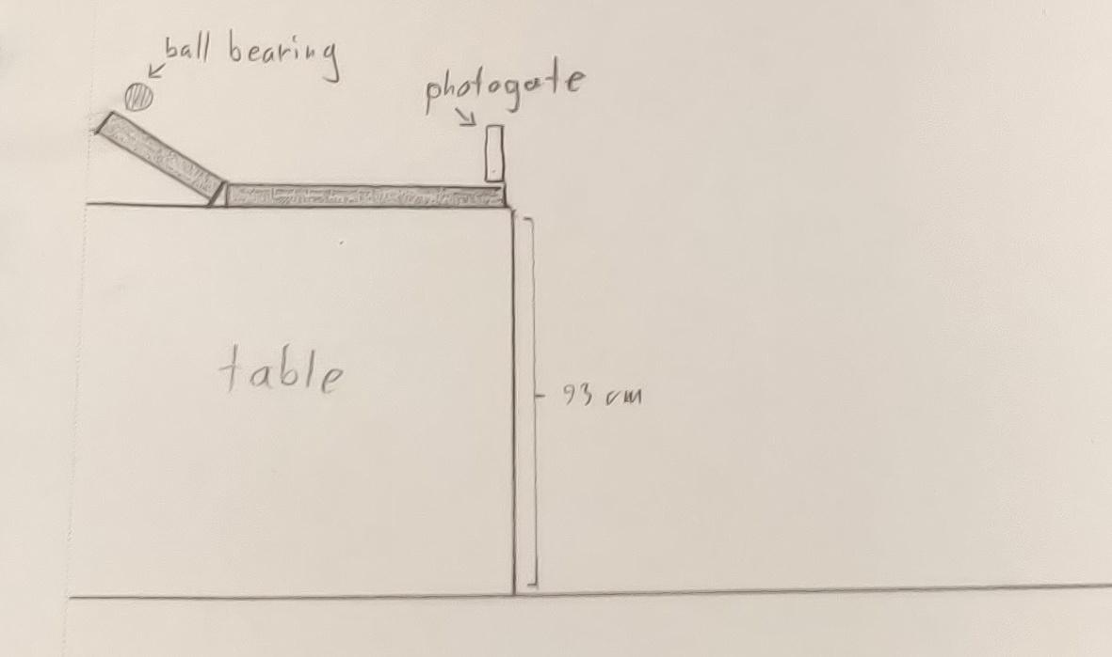

Figure 1. Diagram for the experiment apparatus

# Results

| Variable | Value | Found |
| --- | --- | --- |
| Time (*s*), *t* | 2.3375e-2 *s* | The duration of the tripped light gate as the ball bearing passed through it. The mean of 4 trials of [23.1, 23.6, 23.8, 23.0] *ms* converted to seconds |
| Width of the ball bearing (*m*), *d* | 2.5e-2 *m* | Given/Measured using calipers |
| The velocity of the ball as it leaves the ramp (*m/s*), *v* | 1.070 m/s | *v = d / t*; (2.5e-2) / (2.3375e-2) = 1.070 *m/s* |
| The height of the drop (*m*), *h* | 0.930 *m* | Measured the length of the string from the end of the ramp to the floor using a plumb bob |

Table 1. All known initial variables, their value, and the way they were found.

Using the measured variables (Table 1.), the time the ball spends in the air can be calculated using the following formula.



Where:

* *ta* is the time the ball spends in the air
* *h* is the height of the drop, 0.930 *m*
* *g* is the magnitude of the acceleration due to gravity, -9.81 *m/s2*

The above results in *ta* = 0.434 s

The distance can be found by using the calculated velocity, *v*, and canceling out its seconds (*s*) factor using the newly found airtime, *ta*.

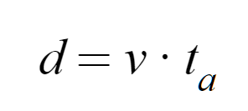

The above equation finds *d* to equal 0.466 *m* (46.6 *cm*). This is the estimated landing position of the ball bearing.

The actual landing position was found to be 0.425 *m* (42.5 *cm*). Using the actual landing position, dividing it by the calculated airtime, *ta*, the velocity was found to be 0.98 *m/s*, which in comparison to the calculated value of 1.070 *m/s*, is approximately a 9% error.

# Discussion

The target position was estimated to be 46.6 *cm* whereas the actual landing position was measured to be 42.5 *cm*. This deviation is acceptable when comparing theory to reality, as there are lots of minute differences that could result in as much as 4 *cm* of consequence. The accuracy of the theoretical value could be improved significantly by simply making sure that the apparatus is exactly the same between trials, or making sure that the photogate is aimed at the exact center of the ball and as close to the end of the ramp as possible to ensure that friction is playing a minimal part.

The difference between the theoretical and real results is that the experiment should be arranged in a way to reduce the number of things that the theoretical can’t realistically account for. As an example, we don't have a way to measure the coefficient of friction of the ramp’s material or its contact area with the ball, so we position the photogate at the end of the ramp so that the measured velocity is affected by the ramp as little as possible going from the position that the measurement is taken to when it leaves the ramp.

The actual position was 8.8% lower than the estimated value. Lab techniques are generally used to reduce that difference as much as possible or to a percentage deemed acceptable by the scenario.

# Error Analysis

When the actual position was used to calculate the velocity, there was a 9% difference between the measured velocity and the calculated one. That means something went wrong in the measurement of the velocity factors used in the original estimation. As we noticed shortly after concluding the lab, our photogate was aimed around a millimeter higher than the center of the ball bearing. This caused the measured duration to be less, and the resulting velocity to be faster than it really is. After adjusting the photogate and rerunning part of the procedure, the estimated position was found to be 0.446 *m* (44.6 *cm*) which is a pretty significant improvement for such a small change in apparatus. Perhaps simply running more trials with the corrected photogate could have landed on a more accurate result.

The remaining error could be a multitude of things, all of which with relative uncertainty as to how significant their contribution is.

For one, the position of the ball starting at the top of the ramp was marked with tape. More consistency could be achieved if there was some sort of stopper at the top of the ramp to ensure the same starting position every time.

The position of the ramp structure could be more secure as ours was loosely taped to the table and any shifting can have a bearing on the resulting landing position.

# Conclusion

This lab shows that it is possible to estimate the destination of a falling object using only data collected before it hits the ground. The estimated position of 46.6 *cm* and the actual position of 42.5 *cm* differ by around 8.8% and that deviation can be reduced enough to accurately hit the bullseye in this particular lab environment.