**Table of Contents**

1. Application Overview
2. System Processes (use case diagram)
3. System Flow (activity & sequence diagram)

**Technical Design**

**1. Application Overview**This is a web application built with Spring Boot to display current weather for 3 Austrian cities: Sydney, Melbourne and Wollongong. There will be a dropdown list on the web page for city selection, when city is changed, corresponding real-time weather information will be displayed. Currently it only supports Openweathermap.

**2. System Process**

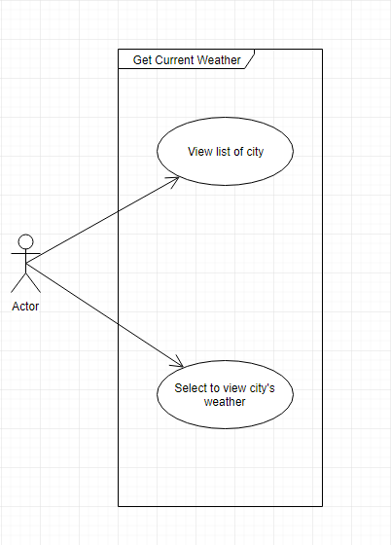

**3. System Flow**

