Gold Standard for the Global Goals
Key Project Information & Project Design Document (PDD)



Version 1.1 – August 2017

KEY PROJECT INFORMATION

Title of Project: | Gezin Solar Power Project (Gezin SPP)
Brief description of Project: | The main purpose of this Project activity is to generate electricity from a micro-scale solar power plant and supply of power generated to the Turkish national utility grid. The generated energy will be fed into Gezin Distribution Center which is connected to the grid through Hazar-1 Substation. Gezin SPP is a bundled project, involves installation and operation of 3 unlicensed (GEZİN 3, GEZİN 4, GEZİN 5) solar power projects. The total installed capacity of the project is 2.97 MW.  The generated power from this Project activity will be supplied to the grid. The generation of electricity from solar power is a clean technology as there is no fossil fuel fired or no GHGs are emitted during the process.
Expected Implemetation Date:  Expected duration of Project: | 15/01/2018  25 years
Project Developer: | Life İklim ve Enerji Ltd. Şti.
Project Representative: | Life İklim ve Enerji Ltd. Şti.
Project Participants and any communities involved: | Lahit Elektrik Üretim A.Ş. (Bundling Agency)  Petrojes Elektrik Üretim A.Ş.
Version of PDD:  Date of Version: | Version 1.1  August 2017
Host Country / Location: | Turkey
Certification Pathway (Project Certification/Impact Statements & Products | Project Certification
Activity Requirements applied:  (mark GS4GG if none relevant) | GS4GG
Methodologies applied: | AMS I.D. Version 18.0
Product Requirements applied: | NA
Regular/Retroactive: | Retroactive
SDG Impacts: | 1 – SDG7 Affordable and Clean Energy  2 – SDG8 Decent Work and Economic Growth  3 – SDG13 Climate Action
Estimated amount of SDG Impact Certified | 3,062 tCO2e

  - Description of project

    - Purpose and general description of project

Lahit Elektrik Üretim A.Ş. (hereafter referred to as “Lahit”) and Petrojes Elektrik Üretim A.Ş. invested into a new Solar Power Project called Gezin Solar Power Project (hereafter referred to as the “Project” or “Gezin SPP”). Gezin SPP involves installation and operation of 3 unlicensed (GEZİN 3, GEZİN 4, GEZİN 5) solar power projects. “Lahit” is the bundling agency in this project. The total installed capacity of the project is 2.97 MW. The generated energy will be fed into Gezin Distribution Center which is connected to the grid through Hazar-1 Substation. In the same project field, there are second and third unlicensed solar plant.

An estimated electricity net generation of 5,400 MWh (1800 MWh/y for each unlicensed SPP) per year by the efficient utilization of the available solar energy by project activity will replace the grid electricity, which is constituted of different fuel sources, mainly fossil fuels. The electricity produced by project activity will result in a total emission reduction of 3,062 tonnes of CO2e/year. The total emission reduction by the project activity is estimated to be 15,310 tonnes of CO2e for the first crediting period, which is 15/01/2018 to 14/01/2023. Moreover, project activity will contribute further dissemination of solar energy and extension of national power generation. The acceptance of 2.97 MW unlicensed plant took place on 15/01/2018 and generation started on 15/01/2018. Thus, first crediting period started on 15/01/2018.

The project will help Turkey to stimulate and commercialize the use of grid connected renewable energy technologies and markets. Furthermore, the project will demonstrate the viability of grid connected solar farms which can support improved energy security, improved air quality, alternative sustainable energy futures, improved local livelihoods and sustainable renewable energy industry development. The specific goals of the project are to:

- Reduce greenhouse gas emissions in Turkey compared to the business-as-usual scenario,
- Help to stimulate the growth of the solar power industry in Turkey,
- Create local employment during the construction and the operation phase of the solar plant,
- Reduce other pollutants resulting from power generation industry in Turkey, compared to a business-as-usual scenario,
- Help to reduce Turkeys increasing energy deficit,
- and differentiate the electricity generation mix and reduce import dependency.

As the project developer, Lahit believes that efficient utilization of all kinds of natural resources with a harmony coupled with responsible environmental considerations is vital for sustainable development of Turkey and the World. This has been a guiding factor for the shareholders towards the concept of designation and installation of a solar power project. Other than the objective of climate change mitigation through significant reduction in greenhouse gas (GHG) emissions, the project has been carried out to provide social and economic contribution to the region in a sustainable way. The benefits that will be gained by the realization of the project compared to the business-as-usual scenario can be summarized under four main indicators:

Environmental

The project activities will replace the grid electricity, which is constituted of different fuel sources causing greenhouse gas emissions. By replacing in the consumption of these fuels, it contributes to conservation of water, soil, flora and faunas and transfers these natural resources and also the additional supply of these primary energy sources to the future generations. In the absence of the project activity, an equivalent amount of electricity would have been generated from the power plants connected to the grid, majority of which are based on fossil fuels. Thus, the project is replacing the greenhouse gas emissions (CO2, CH4) and other pollutants (SOX, NOX, particulate matters) occurring from extraction, processing, transportation and burning of fossil-fuels for power generation connected to the national grid.

Economical

Firstly, the project will help to accelerate the growth of the solar power industry and stimulate the designation and production of renewable energy technologies in Turkey. Then, other entrepreneurs irrespective of sector will be encouraged to invest in solar power generations. It will also assist to reduce Turkey’s increasing energy deficit and diversify the electricity generation mix while reducing import dependency, especially natural gas. Importantly, rural development will be maintained in the areas around the project site by providing infrastructural investments to these remote villages.

Social

Local employment will be enhanced by all project activities during construction and operation of the solar plant. As a result, local poverty and unemployment will be partially eliminated by increased job opportunities and project business activities. Construction materials for the foundations, cables and other auxiliary equipment will preferentially be sourced locally. Moreover as contribution of the project to welfare of the region, the quality of the electricity consumed in the region will be increased by local electricity production, which also contributes decreasing of distribution losses.

Technological

Implementation of the proposed project will contribute to wider deployment of solar power technology in local and national level. It will demonstrate the viability of larger grid connected solar power plants, which will support improved energy security, alternative sustainable energy, and also renewable energy industry development. This will also strengthen pillars of Turkish electricity supply based on ecologically sound technology.

    - Eligibility of the project under Gold Standard

“Gezin Solar Power Project, Turkey” is classified in the Renewable Energy Source category as electricity from non-fossil and non-depletable energy sources, in this case from solar, is fed into the Turkish electricity grid.

This is not a grouped project activity. The project activity is a bundle of 2 project participants.

The project activity meets the eligibility criteria as per section 3.1.1 of GS4GG Principles & Requirements

document as described below.

- The project applies methodology AMS I.D., which is an approved methodology under Gold Standard.

- The project is micro-scale and the type is solar which is an eligible project type as it is in accordance with 1.1.1 a) and 1.1.1 b) of the Eligible Project Types & Scope under Renewable Energy Activity Requirements.

- The project activity results in displacement of electricity from solar power stations while contributing to sustainable development of Turkey. Hence, the project contributes to the Gold Standard Vision and Mission.

- This project activity is not associated with geo-engineering or energy generated from fossil fuel or

nuclear, fossil fuel switch, nor does it enhances or prolongs such energy generation.

    - Legal ownership of products generated by the project and legal rights to alter use of resources required to service the project

The project participant “Lahit” is the legal owner of the project and has the legal rights for the credits.

    - Location of project

      - Host Country
The host country is Republic of Turkey

      - Region/State/Province etc.
Project area is in Elazığ province, Küçükova village in the Maden district.

      - City/Town/Community etc.
The project is close to Maden district of Elazığ.

      - Physical/Geographical location
Location of the project is given below in Map 1 and Map 2.

The project site is located in Maden district of Küçükova village, in Elazığ province of Turkey. The closest village is Küçükova village. The closest settlement is 1,130 m away from the top view. Geographical coordinates of the project site is given in Table 1.

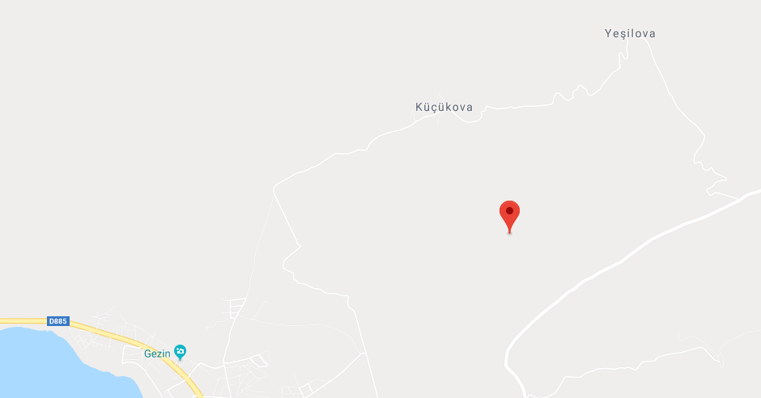
Map 1: Location of Gezin Solar Power Project

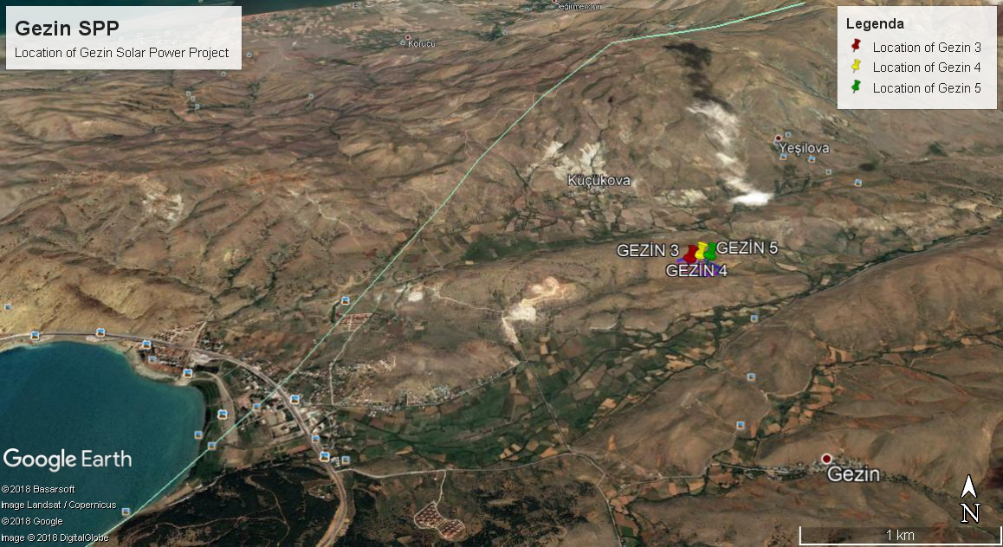
Map 2: Location of Gezin Solar Power Project

Table 1: Geographical coordinates of the project activity
Project | Latitude (N) | Longitude (E)
GEZİN 3 | 38º 31’ 55.7’’ | 39º 33’ 04.6’’
GEZİN 4 | 38º 31’ 56.05’’ | 39º 33’ 06.00’’
GEZİN 5 | 38º 31’ 56.05’’ | 39º 33’ 07.13’’

    - Technologies and/or measures

The technology being employed, converts solar energy into electrical energy. The technology is an environment friendly technology since there are no GHG emissions associated with the electricity generation.

The proposed PV project will use crystalline silicon based solar PV modules. Since the project activity is a Greenfield installation there was no electricity generation at the project site prior to its implementation. Technical specifications of typical modules will be as follows:

Table 2: Technical specifications

Technical detail of the equipment of 0.999 MWe unlicensed plant |  | Remark
The Project | Gezin 3 | Gezin 4 | Gezin 5
Type of system | Grid-connected Photovoltaic (PV) Power Plant
Type of PV modules | CSUN270-60P Polycrystalline PV Modules
Number of modules | 4334 | 4312 | 4312
Capacity of each module | 1170,18 kWp | 1164,24 kWp | 1164,24 kWp
Module supplier | CSUN
Inverter capacity | 50kW but 1 invertor is set to 35 kW*
Number of inverters | 20
Inverter type | KACO blueplanet 50.0 TL3 M1
Module guarantee | 10 years of physical resistance  25 years of performance guarantee
Inverter guarantee | At least 5 years product guarantee
* To not exceed the installed capacity, an invertor in each power plant was set to 35 KW.

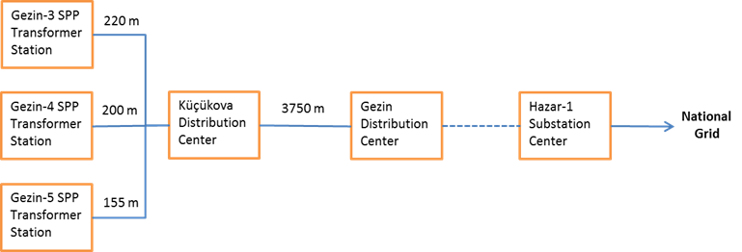

Picture 1: Electrical single-line diagram

Technical life time of Lahit is determined by using the ‘Tool to determine the remaining lifetime of equipment ’’ (v. 1) . In the tool it is stated that;

Project participants may use one of the following options to determine the remaining lifetime of the equipment:

(a) Use manufacturer’s information on the technical lifetime of equipment and compare to the date of first commissioning;

(b) Obtain an expert evaluation;

(c) Use default values.

For the project option (a) is used. According to the equipment agreement, the system has 25 years of 80.7% performance warranty.

The project activity will achieve emission reductions by avoiding CO2 emissions from the business-as-usual scenario electricity generation produced by mainly fossil fuel-fired power plants within the Turkish national grid (Figure 2) Total emission reduction over the 5 year crediting period is expected to reach 15,310 tCO2e with the assumed total net electricity generation of 5,400 MWh per year (for details see B.2.)

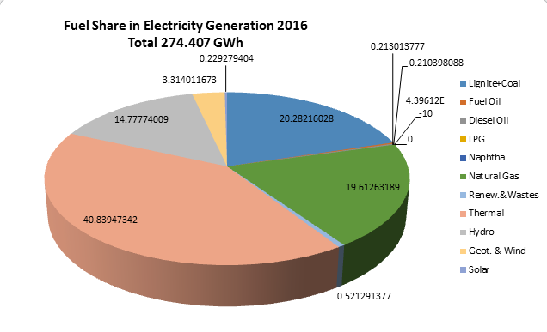

Figure 1: Share of Sources in Installed Capacity 2016

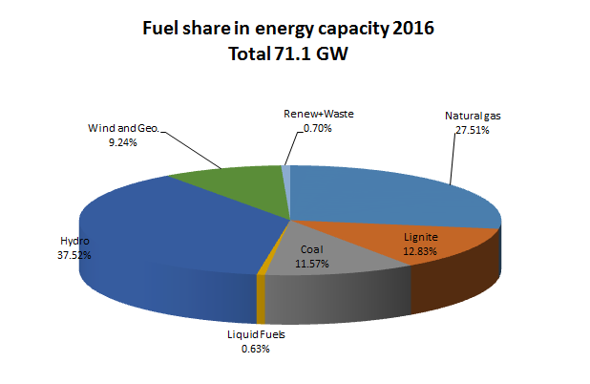

Figure 2: Share of Sources in Electricity Generation 2015

The emission reductions would not occur in the absence of the proposed project activity because of various real and perceived risks that impede the provision of financing. Gezin SPP, as a small scale solar power plant project, will serve as a perfect project to demonstrate long-term potential of solar energy as a means to efficiently reducing GHG emissions as well as to diversifying and increasing security of the local energy supply and contributing to a sustainable development. The Gold Standard for the Global Goals certification shall help to realize this seminal technology by providing an adequate compensation for the lacking financial incentives in the Turkish renewable energy market.

Generation of emission reduction and by the way crediting period will start with the first day of documented electricity supply to the national grid. The first 5-year crediting period is from 15/01/2018 to 14/01/2023 after the completion of commissioning. Applying the approved methodology to the project (detailed in the Section B) annual average amount of 3,062 tCO2e emission reductions is estimated to be achieved by producing 5,400 MWh/year electricity. In each year the amount of VERs actually generated by the project will vary depending on the metered net electricity supplied to the grid, but totally 15,310 tCO2e emission reductions is expected over the period of 5 years and distribution of minimum quantity versus years is listed in Table 3.

Table 3: Estimated annual emission reductions of the project over the crediting period
Year | Estimation of project activity emissions  (tonnes of CO₂e) | Estimation of baseline emissions  (tonnes of CO2e) | Estimation of leakage  (tonnes of CO2e) | Estimation of overall emission reductions (tonnes of CO₂e)
15/01/2018  31/12/2018 | 0 | 2,945 | 0 | 2,945
2019 | 0 | 3,062 | 0 | 3,062
2020 | 0 | 3,062 | 0 | 3,062
2021 | 0 | 3,062 | 0 | 3,062
2022 | 0 | 3,062 | 0 | 3,062
01/01/2023  14/01/2023 | 0 | 117 | 0 | 117
Total (tonnes of CO2e) | 0 | 15,310 | 0 | 15,310

    - Scale of the project
The project is a micro scale project.

    - Funding sources of project
The project activity does not have any public funding or Official Development Assistance (ODA) funding.

    - Assessment that project complies with ‘gender sensitive’ requirements

Question 1: Does the project reflect the key issues and requirements of Gender Sensitive design and implementation as outlined in the Gender Policy? Explain how.
Response: As per Gold Standard Gender Policy, p. 10 “Foundational gender-sensitive requirement - This strengthens Gold Standard’s ‘do no harm’ approach and addresses safeguards to prevent or mitigate adverse impacts on women or men. Such action is mandatory for all projects seeking Gold Standard certification and includes compliance with the gender ‘do no harm’ safeguards, gender gap analysis and gender sensitive stakeholder consultations.” The project being a renewable energy project is not gender sensitive project. The project does not adversely impact women or men.

Question 2: Does the project align with existing country policies, strategies and best practices? Explain how.
Response: Turkey is party to “Convention on the Elimination of All Forms of Discrimination against Women” and the project is aligned its labour policies which does not discriminate on gender.

Question 3: Does the project address the questions raised in the Gold Standard Safeguarding Principles & Requirements document? Explain how.
Response: The Project shall complete the following gender assessment questions below:
- Is there a possibility that the Project might reduce or put at risk women’s access to or control of resources, entitlements and benefits?
Response: No, the Project being a solar project does not reduce access to or control of resources for women.
- Is there a possibility that the Project can adversely affect men and women in marginalised or vulnerable communities (e.g., potential increased burden on women or social isolation of men)? Response: No, the Project beneficiaries in terms of employment and social upliftment of the area are common for both the gender. Further the project has carried out various CSR activities leading to welfare of community at large. However, due to lack of interest of women to these kinds of jobs stemming from norms of society, impact of the project to this indicator is expected to be neutral.
- Is there a possibility that the Project might not take into account gender roles and the abilities of women or men to participate in the decisions/designs of the project’s activities (such as lack of time, child care duties, low literacy or educational levels, or societal discrimination)?
Response: No, the CSR activities carried our by the project proponent are discussed with the community consisting both the genders.
- Does the Project take into account gender roles and the abilities of women or men to benefit from the Project’s activities (e.g., Does the project criteria ensure that it includes minority groups or landless peoples)?
Response: Yes, the project takes into account gender roles and abilities of women/men. Job profile is allocated based on the type of work to be carried out.
- Does the Project design contribute to an increase in women’s workload that adds to their care responsibilities or that prevents them from engaging in other activities?
Response: No, on the contrary the project leads to increased availability of electricity in the regional grid thereby uplifiting the living standards.
- Would the Project potentially reproduce or further deepen discrimination against women based on gender, for instance, regarding their full participation in design and implementation or access to opportunities and benefits?
Response: No, since the project is a renewable electiricity generation project, thus it will not have discriminated against women.
- Would the Project potentially limit women’s ability to use, develop and protect natural resources, taking into account different roles and priorities of women and men in accessing and managing environmental goods and services?
Response: No, in fact, the project leads to improved electricity in the regional grid thereby leading to less usage of fueil for lighting.
- Is there a likelihood that the proposed Project would expose women and girls to further risks or hazards?
Response: No, in fact, due to improved electricity availability the usage of fuel for lighting would be reduced as well as indoor air quality would be improved.

Question 4: Does the project apply the Gold Standard Stakeholder Consultation & Engagement Procedure Requirements? Explain how.
Response: The project is currently a CDM project applying for retroactive GS registration. The project is retroactive thus LSC meeting is not required. However, Stakeholder engagement prosedur will be followed and SFR will be implemented.

  - Application of selected approved Gold Standard methodology

    - Reference of approved methodology

Title: Grid Connected Renewable Electricity Generation

Reference: AMS I.D. (Version 18)

It has been referred from the list of approved methodologies for CDM project activities in the UNFCCC website. The approved methodology also refers to latest approved versions of “Tool to calculate the emission factor for an electricity system, version 04.0.” for determination of baseline scenario of the proposed project activity.

    - Applicability of methodology

Since the project is below 15 MW installed capacity, small scale methodology AMS I.D. version 18 is used. The applicability criteria are described as follows;

Applicability Criteria | Applicability to the project
1. This methodology comprises renewable energy generation units, such as photovoltaic, hydro, tidal/wave, wind, geothermal and renewable biomass a) supplying electricity to a national or a regional grid; or b) Supplying electricity to an identified consumer facility via national/regional grid through a contractual arrangement such as wheeling. | The project is renewable energy generation through installation of solar photovoltaic modules. The project will supply electricity to the national grid, sale to grid as well as third party. Thus, the project activity complies with this criterion.
2. Illustration of respective situations under which each of the methodology (i.e. AMS-I.D, AMS-I.F and AMS-I.A2) applies is included in Table 2 | The 1st and 3rd option of Table 2 of AMS I.D. Version 18 is applicable (please refer footnote 5)
3. This methodology is applicable to project activities that (a) Install a Greenfield plant; b) Involve a capacity addition in (an) existing plant(s); (c) Involve a retrofit of (an) existing plant(s); (d) Involve a rehabilitation of (an) existing plant(s)/unit(s); or (e) Involve a replacement of (an) existing plant(s). | This methodology is applicable to the project activity as, it’s an Greenfield project where Option (a) i.e. install a new power plant at a site where there was no renewable energy power plant operating prior to the implementation of the project activity (Greenfield plant) .  Hence the project activity fulfils the applicable criterion.
4. Hydro power plants with reservoirs that satisfy at least one of the following conditions are eligible to apply this methodology:  -The project activity is implemented in an existing reservoir with no change in the volume of reservoir;  -The project activity is implemented in an existing reservoir, where the volume of reservoir is increased and the power density of the project activity, as per definitions given in the Project Emissions section, is greater than 4 W/m2;  -The project activity results in new reservoirs and the power density of the power plant, as per definitions given in the Project Emissions section, is greater than 4 W/m2. | The Project activity is not a Hydro Power Project, therefore this eligibility criterion is not applicable to the proposed project activity.
5. If the new unit has both renewable and non-renewable components (e.g., a wind/diesel unit), the eligibility limit of 15 MW for a small-scale CDM project activity applies only to the renewable component. If the new unit co-fires fossil fuel, the capacity of the entire unit shall not exceed the limit of 15 MW. | The project activity has only renewable component, i.e., solar PV generated power with 2.97 MW capacity, which meets the eligibility of 15 MW for a small scale CDM project activity. The capacity of the project shall remain the same for the entire crediting period. Further, the project does not involve any use of fossil fuel. Thus, this criterion is not applicable to the project activity.
6. Combined heat and power (co-generation) systems are not eligible under this category. |  | The project activity generates only power and hence is not a cogeneration system. Thus, this criterion is not applicable to the project activity.
7. In the case of project activities that involve the capacity addition of renewable energy generation units at an existing renewable power generation facility, the added capacity of the units added by the project should be lower than 15 MW and should be physically distinct from the existing units. |  | The project activity is the new installation of small scale solar PV generated power project and doesn’t involve the addition of new unit to any of existing renewable power generation facility therefore the given criterion is not applicable to the project activity.
8. In the case of retrofit, rehabilitation or replacement, to qualify as a small-scale project, the total output of the retrofitted, rehabilitated or replacement power plant/unit shall not exceed the limit of 15 MW. |  | Not applicable, project activity is neither retrofit nor modification of existing facility. The installed capacity of the project will be 2.97 MW, which is not exceeding the limit for small scale projects. The entire project is a Green field project activity and not the enhancement or up gradation project.
9. In the case of landfill gas, waste gas, wastewater treatment and agro-industries projects, recovered methane emissions are eligible under a relevant Type III category. If the recovered methane is used for electricity generation for supply to a grid then the baseline for the electricity component shall be in accordance with procedure prescribed under this methodology. If the recovered methane is used for heat generation or cogeneration other applicable Type-I methodologies such as “AMS-I.C.: Thermal energy production with or without electricity” shall be explored. |  | Not applicable as the project activity is neither a landfill gas, waste gas, wastewater treatment and agro-industries projects, nor a recovered methane emissions project.
10. In case biomass is sourced from dedicated plantations, the applicability criteria in the tool “Project emissions from cultivation of biomass” shall apply. |  | Not applicable as the project is not a biomass project.

    - Project boundary

The project spatial extend of Gezin SPP is the project power plant and all power plants connected physically to the electricity system which is discussed and applied with calculation of combined margin in accordance of “Tool to calculate the emission factor for an electricity system”.

Project boundary diagram is depicted in the diagram below:

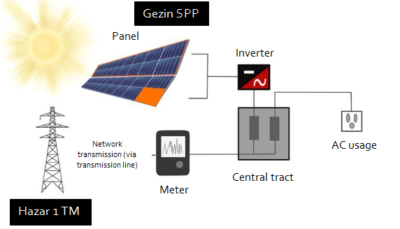

Figure 3: Project boundary diagram

For the purpose of GHG mitigation/sequestration following table shall be completed.

Table 4: Emissions sources included in or excluded from the project boundary
Source |  | GHGs | Included? | Justification/Explanation
Baseline scenario | Grid | CO₂ | Yes | Main emission source: Fossil fuels fired for electricity generation cause CO₂ emissions. It is included to baseline calculation to find the displaced amount by the project activity.
Baseline scenario | Grid | CH₄ | No | Excluded for simplification. This is conservative
Baseline scenario | Grid | N₂O | No | Excluded for simplification. This is conservative
Project scenario | No Emissions | CO₂ | No | Minor emission source
Project scenario | No Emissions | CH₄ | No | Minor emission source
Project scenario | No Emissions | N₂O | No | Minor emission source

    - Establishment and description of baseline scenario

According to the guidelines of the applicable small scale approved methodology AMS.I.D (Version 18), “The baseline scenario is that the electricity delivered to the grid by the project activity would have otherwise been generated by the operation of grid-connected power plants and by the addition of new generation sources into the grid.” Thus, proposed project activity will evacuate power to the National Grid complying with the stated guideline.

To describe the baseline and its development for the project activity, long-term electricity demand and supply projections for Turkey are assessed.

When Table 5 and Figure 4 are examined, electricity demand is expected to exceed 340 billion kWh in 2026 with an average increase of 2.6% for the low scenario, for the baseline scenario, electricity demand is expected to increase by 3.2% on average to exceed 370 billion kWh; it is expected that electricity demand will exceed 400 billion kWh with an average increase of 3.8% for the high scenario.

Table 5: Low and High Demand Projection Scenarios for Ten Years Period (TWh)
Scenarios | 2017 | 2018 | 2019 | 2020 | 2021 | 2022 | 2023 | 2024 | 2025 | 2026
High Scenario | 289.93 | 302.26 | 315.28 | 328.31 | 341.72 | 355.63 | 368.88 | 382.56 | 396.08 | 409.68
Low Scenario | 278.06 | 285.63 | 293.75 | 301.67 | 309.68 | 317.64 | 325.45 | 333.04 | 340.18 | 347.15

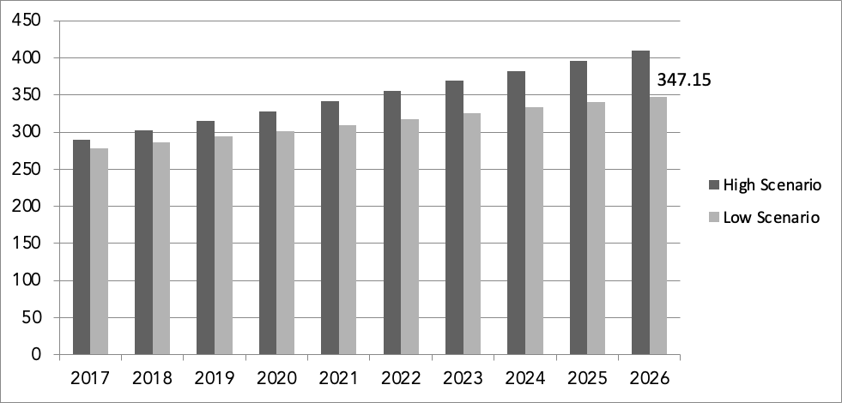
409.68
Figure 4: Electricity Demand Projections for Ten Years

In this projection, electricity supplies are also forecasted taking into account all power plants, which are in operation, under construction, solar production facilities within the scope of Public and pre-licensed/licensing phase/licensed/YEKA project, unlicensed biomass, wind, cogeneration production facilities and private sector power plants with licenses, which are expected to be commissioned on the prescribed dates. Generation projection based on project generation is given in:

Table 6: Projection of Total Generation Capacity by Fuel Types (TWh)
YEARS | 2016 | 2017 | 2018 | 2019 | 2020 | 2021 | SHARE IN 2021 (%)
LIGNITE | 62.367 | 64.467 | 70.091 | 70.091 | 71.088 | 69.267 | 12.4
HARDCOAL & ASPHALTIT | 5.214 | 5.214 | 5.214 | 5.214 | 5.214 | 5.214 | 0.9
IMPORT. COAL | 49.569 | 59.570 | 59.617 | 59.155 | 69.679 | 89.492 | 16.0
NATURAL GAS | 187.446 | 214.234 | 213.124 | 211.094 | 210.568 | 217.817 | 38.8
GEOTHERMAL | 6.314 | 7.828 | 7.967 | 8.096 | 8.096 | 8.096 | 1.4
FUEL OIL | 2.613 | 2.693 | 2.693 | 5,297 | 5,297 | 5,297 | 0.5
DIESEL | 7 | 7 | 7 | 7 | 7 | 7 | 0.0
NUCLEER | 0 | 0 | 0 | 0 | 0 | 0 | 0.0
OTHER | 520 | 948 | 1.198 | 1.241 | 1.241 | 1.241 | 0.2
BIOGAS+WASTE | 3.261 | 3.511 | 3.743 | 3.796 | 3.796 | 3.796 | 0.7
HYDRO | 91.548 | 95.219 | 96.538 | 101.262 | 107.542 | 108.751 | 19.4
WIND | 18.476 | 21.422 | 25.007 | 28.448 | 32.593 | 33.697 | 6.0
SOLAR | 2.081 | 6.300 | 11.850 | 13.375 | 16.921 | 20.657 | 3.7
TOTAL | 429.416 | 481.415 | 497.051 | 504.472 | 529.440 | 560.729 | 100.0%

According to the 5-year projection it is clear that fossil fuels will remain the main sources for electricity generation (68.8 % in 2021). Natural gas will continue to dominate the market. Hydro will account for 19.4% of the mix whereas all non-hydro renewable combined (geothermal/biogas/waste/wind/solar) will only account for 11.8% of all electricity generation. This projection is consistent with continuing fossil fuel dependent characteristics of Turkish electricity sector, which is given in Figure 5.

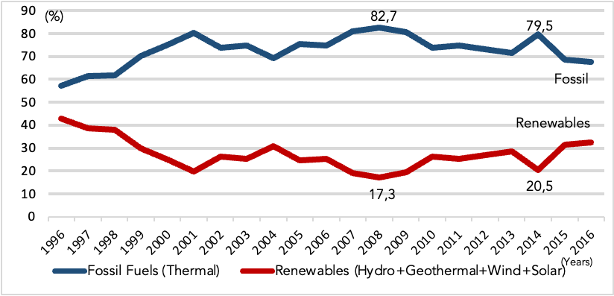
80.3
19,7
69,3
30,7
28,5
71,5
Figure 5: Fossil Fuels and Renewable in Turkish Electricity Mix (1996-2016)

In the shed of above analysis for the baseline scenario (continuation of current situation) it can be concluded that:

• Conclusion-1: Energy demand in Turkey has been increasing with significant rates since ten years, and it is expected to continue at least for next ten years.

• Conclusion-2: Even all operational plants, construction phase plants and licensed ones are taken into account lack of supply is projected after five operational years. So, there is significant need for electricity generation investments to satisfy demand, which means electricity to be generated by the project activity would otherwise be generated by new power plants to avoid power shortage in coming years.

• Conclusion-3: Fossil fuels will hold the dominance in generation mix till the end of 2021 with 68.8% share. Hydro included renewable will remain low with 31.2% share and non-hydro energy contribution will stay with only 11.8% of total share by the end of that period. This also shows that most of new capacity additions will be fossil fuel fired power plants.

The combination of aforementioned trends indicates that if Gezin SPP would not be built, power from a new grid-connected thermal plant would be the most likely scenario.

    - Demonstration of additionality

The project is a micro-scale project. Therefore, there is no additionality.

Milestones indicating the project implementation schedule are given below:

Date | Activity (Gezin3 & Gezin 4 & Gezin 5)
15.04.2016 | Call Letter for Connection Agreement
02.05.2017 | Connection Agreement Date
28.07.2017 | EPC Agreement with Girişim Elektrik
01.08.2017 | Construction Start Date
15.01.2018 | System Connection Agreement date (Commercial Start Date) Crediting Period Start Date

    - Sustainable Development Goals (SDG) outcomes

      - Relevant target for each of the three SDGs

- SDG7 Affordable and Clean Energy: The project is expected to generate 5,400 MWh clean energy per annum.
- SDG8 Decent Work and Economic Growth: The project provides local employment during the construction and activity phases.
- SDG13 Climate Action: The project would lead to reduction of approx.3,062 tCO2 per annum.

      - Explanation of methodological choices/approaches for estimating the SDG outcome

SDG 7 Affordable and Clean Energy
The baseline for the project is no project, thus leading to generation in the relevant grid which is dominated by fossil fuel. The clean energy generated by the project is calculated based on the amount of electricity generated by the project per annum. The project is expected to generate 5,400 MWh of clean energy per annum.

SDG 8 Decent Work and Economic Growth
The project leads to employment opportunities which would not have been possible in the baseline scenario. The project provides local employment during the construction and activity phases. All employees have social sequrity and they were trained.

SDG13 Climate Action
The project leads to mitigation of 3,062 tCO2 per annum.

Baseline scenario is identified and described in B.4. Emission reductions due to project activity will be calculated according to “Tool to calculate the emission factor for an electricity system”(v5) (Tool) as indicated in AMS I.D.

Stepwise approach of „Tool to calculate the emission factor for an electricity system” version 05.0.0 is used to find this combined margin (emission coefficient) as described below:

Step 1. Identify the relevant electric systems

There are 21 regional distribution regions in Turkey but no regional transmission system is defined. In Article 20 of License Regulation it is stated that:

“TEIAS shall be in charge of all transmission activities to be performed over the existing transmission facilities and those to be constructed as well as the activities pertaining to the operation of national transmission system via the National Load Dispatch Center and the regional load dispatch centers connected to this center and the operation of Market Financial Reconciliation Center”.

As it can be understood from this phrase, only one transmission system, which is national transmission system is defined and only TEİAŞ is in the charge of all transmission system related activities. Moreover, a communication with representative of TEIAS, which indicates that: “There are not significant transmission constraints in the national grid system which is preventing dispatch of already connected power plants” is submitted to the DOE. Therefore, the national grid is used as electric power system for project activity. The national grid of Turkey is connected to the electricity systems of neighboring countries. Complying with the rules of the tool, the emission factor for imports from neighboring countries is considered 0 (zero) tCO₂/MWh for determining the OM. There is no information about interconnected transmission capacity investments, as TEİAŞ, who operates the grid, also didn’t take into account imports-exports for electricity capacity projections.Because of that, for BM calculation transmission capacity is not considered.

Step 2. Choose whether to include off-grid power plants in the Project electricity system (optional)

According to Tool project participants may choose between the following two options to calculate the operating margin and build margin emission factor:

Option I: Only grid power plants are included in the calculation.

Option II: Both grid power plants and off-grid power plants are included

For this project Option I is chosen.

Step 3: Select a method to determine the operating margin (OM);

The calculation of the operating margin emission factor (EF_{grid,OM,y}) is based on one of the following methods:

(a) Simple OM; or
(b) Simple adjusted OM; or
(c) Dispatch data analysis OM; or
(d) Average OM.

The Simple Operating Margin (OM) emission factor (EF_{grid, OM, y}) is calculated as the generation weighted average CO₂ emissions per unit net electricity generation (tCO₂/MWh) of all the generating plants serving the system, excluding low-cost/must-run power plants. As electricity generation from solar and low cost biomass facilities is insignificant and there are no nuclear plants in Turkey, the only low cost /must run plants considered are hydroelectric, wind and geothermal facilities. The Turkish electricity mix does not comprise nuclear energy. Also there is no obvious indication that coal is used as must run resources. Therefore, the only low cost resources in Turkey, which are considered as must-run, are Hydro, Renewables and Waste, Geothermal and Wind (according to statistics of TEIAS).

Table 1: Share of Low Cost Resource (LCR) Production 2012-2016 (Production in GWh)
Share of Low Cost Resource (LCR) Production 2012-2016 (Production in GWH)
 | 2012 | 2013 | 2014 | 2015 | 2016
Gross production | 239,496.8 | 240,153.95 | 251,962.82 | 261,783.3 | 274,407.7
TOTAL LCR Production | 65,345.8 | 69,512.7 | 52,961.4 | 83,981.00 | 89,938.1
Hydro | 57,865.0 | 59,420.47 | 40,644.70 | 67,145.8 | 67,230.9
Renewables and Waste | 720.7 | 1,171.20 | 1,432.59 | 1,758.2 | 2,371.6
Geothermal and Wind | 6,760.1 | 8,921.04 | 10,884.12 | 15,077.0 | 20,335.6
Share of LCRs | 27.28% | 28.95% | 21.02% | 32.08% | 32,08%
Average of last five years | 27.33%

As average share of low cost resources for the last five years is far below 50% (26,94%), the simple OM method is applicable to calculate the operating margin emission factor (EF_{grid,OM,y}).

For the simple OM, the emissions factor can be calculated using either of the two following data vintages:

- Ex ante option: A 3-year generation-weighted average, based on the most recent data available at the time of submission of the CDM-PDD to the DOE for validation, or
- Ex post option: The year, in which the project activity displaces grid electricity, requiring the emissions factor to be updated annually during monitoring.

The ex-ante option is selected for Simple OM method, with the most recent data for the baseline calculation stemming from the years 2011 to 2015.

Step 4. Calculate the operating margin emission factor according to the selected method

The simple OM emission factor is calculated as the generation-weighted average CO₂ emissions per unit net electricity generation (tCO₂/MWh) of all generating power plants serving the system, not including low-cost/must-run power plants. The calculation of the simple OM emission factor can be based on

- Option A: data on net electricity generation a CO₂ emission factor of each power unit, or
- Option B: data on the total net electricity generation of all power plants serving the system and the fuel types and total fuel consumption of the project electricity system.

Option B is chosen to calculate the Simple OM, as there is no power plant specific data available, renewable power generation are considered as low-cost power sources and amount of electricity supplied to the grid by these sources is known.

Where Option B is used, the simple OM emission factor is calculated based on the net electricity supplied to the grid by all power plants serving the system, not including low-cost / must-run power plants, and based on the fuel type(s) and total fuel consumption of the project electricity system, as follows:

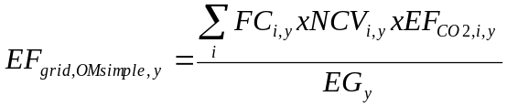 (1)

Where:
EF_{grid,OMsimple,y} | = | Simple operating margin CO₂ emission factor in year y (tCO₂/MWh)
FC_{i,y} | = | Amount of fossil fuel type i consumed in the project electricity system in year y (mass or volume unit)
NCV_{i,y} | = | Net calorific value (of fossil fuel type i in year y (GJ / mass or volume unit)
EF_{CO2,i,y} | = | CO₂ emission factor of fossil fuel type i in year y (tCO₂/GJ)
EG_{y} | = | Net electricity generated and delivered to the grid by all power sources serving the system, not including low-cost / must-run power plants / units, in year y (MWh)
i | = | All fossil fuel types combusted in power sources in the project electricity system in year y
y | = | three most recent years for which data is available at the time of submission of the PDD to the DOE for validation

For the calculation of the OM the consumption amount and heating values of the fuels for each sources used for the years 2014, 2015 and 2016, is taken from the TEİAŞ annual statistics, which holds data on annual fuel consumption by fuel types as well as electricity generation amounts by sources and electricity imports. All the data needed for the calculation, including the emission factors and net calorific values (NCVs), are provided in excel table that shows OM emission factor, Excel Table 8 Fossil Fuel Consumption Amounts and Excel Table 9 Net Calorific Values. Total CO₂ emission due to electricity generation in Turkey for the years of 2014, 2015 and 2016 are given in Table 12.

Table 2: CO₂ emissions from electricity production 2014-2016 (ktCO₂)
 | 2014 | 2015 | 2016
CO2-Emmissions | 122,715 | 113,727 | 123,437

Table 13 presents the gross electricity production data by all the relevant energy sources. Low-cost/must run resources like hydro, wind, geothermic and biomass do not emit fossil CO₂ and thus are not taken into account in calculations.

Table 3: Gross electricity production by fossil energy sources 2014-2016 (GWh)
Gross Electricity Production by Energy Source 2014-2016 [GWh]
Natural Gas | 120,576.0 | 99,218.70 | 89,227.10
Lignite | 36,615.4 | 31,335.70 | 38,569.90
Coal | 39,647.3 | 44,829.90 | 53,703.20
Fuel Oil | 1,662.9 | 980.4 | 969.1
Motor Oil | 482.4 | 1,243.60 | 957.20
Naphtha | 0.0 | 0.0 | 0
LPG | 0.0 | 0.0 | 0
Total fossil fuels | 198,984.0 | 177,608.3 | 183,426.5

Above table shows gross data, but EG_{y} in the above described formula means electricity delivered to the grid, i.e. net generation, the following table shall help to derive net data by calculating the net/gross proportion on the basis of overall gross and net production numbers.

Table 4: Net/gross electricity production 2014-2016 (GWh)
Relation Net/Gross Electricity Production 2014-2016
Gross Production [GWh] | 251,962.82 | 261,783.30 | 274,407.70
Net Production [GWh] | 239,448.83 | 249,889.50 | 261,936.80
Relation | 95.03% | 95.46% | 95.46%

Multiplying these overall gross/net relation percentages with the fossil fuels generation amount does in fact mean an approximation. However this is a conservative approximation as the consumption of plant auxiliaries of fossil power plants is higher than for the plants that are not included in the baseline calculation. In the end this would lead to a lower net electricity generation and therefore to a higher OM emission factor and higher emission reductions.

Table 15 shows the resulting net data for fossil fuel generation and adds electricity imports.

Table 15: Electricity supplied to the grid, relevant for OM (GWh)
Net El. Production by fossil fuels and Import 2014-2016 [GWh]
Net El. Prod. by fossil fuels | 189,101.2 | 169,538.9 | 175,090.4
Electricity Import | 7,953.5 | 7,135.50 | 6,330.30
Electricity supplied to grid by relevant sources | 197,054.7 | 176,674.4 | 181,420.7

Electricity import is added to the domestic supply in order to fulfill the Baseline Methodology requirements. Imports from connected electricity systems located in other countries are weighted with an emission factor of 0 (zero) tCO₂/MWh.

Step 5. Calculate the build margin (BM) emission factor

Option 1: For the first crediting period, calculate the build margin emission factor ex ante based on the most recent information available on units already built for sample group m at the time of CDM-PDD submission to the DOE for validation. For the second crediting period, the build margin emission factor should be updated based on the most recent information available on units already built at the time of submission of the request for renewal of the crediting period to the DOE. For the third crediting period, the build margin emission factor calculated for the second crediting period should be used. This option does not require monitoring the emission factor during the crediting period.

Option 2: For the first crediting period, the build margin emission factor shall be updated annually,

ex post, including those units built up to the year of registration of the project activity or, if information up to the year of registration is not yet available, including those units built up to the latest year for which information is available. For the second crediting period, the build margin emissions factor shall be calculated ex ante, as described in Option 1 above. For the third crediting period, the build margin emission factor calculated for the second crediting period should be used. Again, the project proponents can chose between two options according to the calculation tool: calculate the BM ex-ante based on the latest available data or update the BM each year ex post. Option 1, the ex-ante approach, is again chosen.

The sample group of power units m used to calculate the build margin should be determined as per the following procedure, consistent with the data vintage selected above. The last plant of the sample group is built in 2010 and until the end of the 2013 which is the latest year for official statistics published for plants put in operation. VER plants are excluded from sample group. While identifying the sample group dismantled, revised, retrofits are not included. Only new capacity additions (power plants / units) are taken into account. All power plants in operation by 2013 are given in Excel Table 12 Sample Group for BM Factor Calculation (Latest Power Plants put in Operation in Turkey). Total electricity generation in 2016 is 261,783.304 GWh and 20% of this generation is 52,387.4 (AEGSET->20%) GWh. Total electricity generation of last five power plants in operation is 369 GWh (AEGSET-5-units) which is lower than 20% total generation in 2016. Since AEGSET->20% is bigger than AEGSET-5-units , SET->20% is chosen as SETsample. Also in the sample group there is no power plant started supply electricity to grid more than 10 years ago, steps d, e and f are ignored.

Sample group for BM emission factor is given below table. The derivation of the values presented in Table 16 is contained in a separate excel file which is available for validation.

Energy Source | 2010 | 2011 | 2012 | Sample Group Total Generation (GWh)
Natural Gas | 8,702.3 | 11,815.1 | 10,540.0 | 31,057.4
Lignite | 0.0 | 0.0 | 40.0 | 40.0
Coal | 8,012.0 | 4,320.0 | 201.0 | 12,533.0
Fuel Oil | 0.0 | 701.2 | 0.0 | 701.2
Hydro | 3,336.8 | 3,730.4 | 5,354.0 | 12,421.2
Renewable | 2.4 | 150.0 | 677.0 | 829.4
TOTAL | 20,053.5 | 20,716.7 | 16,812.0 | 57,582.17

Table 16: Sample group generation for BM emission factor calculation (GWh)

The build margin emissions factor is the generation-weighted average emission factor (tCO₂/MWh) of all power units m during the most recent year y for which power generation data is available, calculated as follows:

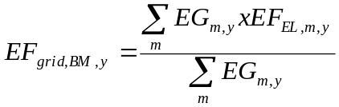 (2)

Where:
EF_{grid,BM,y} | = | Build margin CO₂ emission factor in year y (tCO₂/MWh)
EG_{m,y} | = | Net quantity of electricity generated and delivered to the grid by power unit m in year y (MWh)
EF_{EL,m,y} | = | CO₂ emission factor of power unit m in year y (tCO₂/MWh)
m | = | Power units included in the build margin
y | = | Most recent historical year for which power generation data is available

Because of only fuel types and electricity generation data are available for the sample group, Option B2 of Simple OM method is used to calculate emission factor. The formulation of emission factor is given below:

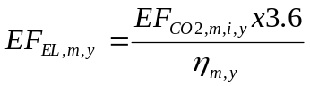 (3)

Where:
EF_{EL,m,y} | = | CO₂ emission factor of power unit m in year y (tCO₂/MWh)
EF_{CO2,m,i,y} | = | Average CO₂ emission factor of fuel type i used in power unit m in year y (tCO₂/GJ)
η_{m,y} | = | Average net energy conversion efficiency of power unit m in year y (%)
y | = | Three most recent years for which data is available at the time of submission of the PDD to the DOE for validation

BM emission factor calculation and resulted BM factor is given in Table 17. For BM factor calculation, since no official emission factors for different fuel types are available, lower confidence default values of IPCC Guidelines are applied. Explanation of emission factor selection for each energy sources and references are given in Excel Table 11: EGm,y [GWh] Sample Group for BM.

Table17: BM emission factor calculation using equation (2) and (3)
Energy Source | Sample Group Total Generation (GWh) | Effective CO₂ emission factor (tCO₂/TJ) | Average Efficiency (η_{m,y}) | CO₂ Emission (ktCO₂)
Natural Gas | 31,057.4 | 54.3 | 60.00% | 10,118.5
Lignite | 40.0 | 90.9 | 50.00% | 26.2
Coal | 12,533.0 | 89.5 | 50.00% | 8,076.3
Fuel Oil | 701.2 | 72.6 | 46.00% | 398.4
Hydro | 12,421.2 | 0.0 | 0.00% | 0.0
Renewables | 829.4 | 0.0 | 0.00% | 0.0
Total | 57,582.17 |  |  | 18,619.3
EF_{grid,BM,y} (tCO₂/MWh) | 0.3234

EF_{grid,BM,y} ₌ 0.3234 tCO₂/MWh

Step 6. Calculate the combined margin emission factor

The calculation of the combined margin (CM) emission factor (EFgrid,CM,y) is based on one of the following methods:
(a) Weighted average CM; or
(b) Simplified CM.

The combined margin emission factor is calculated as follows:

(4)

Where:
EF_{grid,BM,y} | = | Build margin CO₂ emission factor in year y (tCO₂/MWh)
EF_{grid,OMy} | = | Operating margin CO₂ emission factor in year y (tCO₂/MWh)
w_{OM} | = | Weighting of operating margin emissions factor (%)
w_{BM} | = | Weighting of build margin emissions factor (%)

According to the Tool for solar power generation project activities: w_{OM} = 0.75 and w_{BM} = 0.25.

Emission reductions are calculated as follows:

ER_{y} = BE_{y} − PE_{y} − LE_{y} (5)

Where:
ER_{y} = Emission reductions in year y (t CO₂/yr).
BE_{y} = Baseline emissions in year y (t CO₂/yr).
PE_{y} = Project emissions in year y (t CO₂/yr).
LE_{y} = Leakage emissions in year y (t CO₂/yr).

Project emissions
The proposed project activity involves the generation of electricity by development of a solar plant. The generation of electricity does not result in greenhouse gas emissions and therefore is taken as 0 tCO₂/year.

Leakage
No Leakage emissions are considered. The main emission potentially giving rise to leakage in the context of electrical sector projects is emission arising due to activities arising such as power plant construction and upstream emission from fossil fuel use (e.g. extraction, processing, and transport). These emission sources are neglected.

Then: ER_{y} = BE_{y}

Baseline emissions
Baseline emissions include only CO₂ emissions from electricity generation in fossil fuel fired power plants that are displaced due to the project activity, calculated as follows:

BE_{y} = (EG_{y} - EG_{baseline}) x EF_{grid,CM,y} (6)

Where:
BE_{y} = Baseline emissions in year y (tCO₂/yr).
EG_{y} = Electricity supplied by the project activity to the grid (MWh).
EG_{baseline} = Baseline electricity supplied to the grid in the case of modified or retrofit facilities (MWh). For new power plants this value is taken as zero.
EF_{grid,CM,}y = Combined margin CO2 emission factor for grid connected power generation in year y calculated using the latest version of the “Tool to calculate the emission factor for an electricity system”.
The project activity is the installation of a new grid-connected renewable power plant so, EG_{baseline} = 0

      - Data and parameters fixed ex ante for monitoring contribution to each of the three SDGs

- SDG7 Affordable and Clean Energy: The project is expected to generate 5,400 MWh clean energy per annum.
- SDG8 Decent Work and Economic Growth: The project provides local employment during the construction and activity phases.
- SDG13 Climate Action: The project would lead to reduction of approx.3,062 tCO2 per annum.

Relevant SDG Indicator | SDG13 Climate Action
Data/parameter | EG_{y}
Unit | MWh
Description | Net electricity generated by power plant/unit m, k or n (or in the project electricity system in case of EGy) in year y or hour h
Source of data | Turkish Electricity Transmission Company (TEIAS), Annual Development of Electricity Generation- Consumption and Losses in Turkey (2000-2016) TEIAS, see  https://www.teias.gov.tr/sites/default/files/2017-10/59%282000-2016%29.xls
Value(s) applied | See Table 13, Table 14, Table 15
Choice of data or Measurement methods and procedures | TEIAS is the national electricity transmission company, which makes available the official data of all power plants in Turkey. Thus, for reliability, TEIAS data is used.  Net electricity generation is calculated using gross and net production for all fuel types. This data is used to find relation between the gross and net electricity delivered to the grid by fossil fuel fired power plants (Table 14).  Also, gross and net electricity production for related fuel types and Import and Export data are used to find total net electricity fed into the grid in the years of 2014, 2015 and 2016 (Table 15).
Purpose of data | Data used for emission reduction calculation
Additional comment

Relevant SDG Indicator | SDG13 Climate Action
Data/parameter | HVi,y
Unit | Mass or volume unit
Description | Heating Values of fuels consumed for electricity generation in the years of 2014, 2015 and 2016
Source of data | Heating Values Of Fuels Consumed In Thermal Power Plants In Turkey By The Electric Utilities, TEİAŞ. See:  https://www.teias.gov.tr/tr/iv-turkiye-termik-santrallarinda-kullanilan-yakit-miktarlari-isil-degerleri-ve-kojenerasyon (Excel File 75)
Value(s) applied | See, Excel Table 7: Heating Values of Fuels (Tcal)
Choice of data or Measurement methods and procedures | TEİAŞ is the national electricity transmission company, which makes available the official data of all power plants in Turkey.  There is no national NVC data in Turkey. However, TEİAŞ announces Heating values of fuels. This data is used to calculate annual NCVs for each fuel type.
Purpose of data | Data used for emission reduction calculation
Additional comment

Relevant SDG Indicator | SDG13 Climate Action
Data/parameter | FCi,y
Unit | Mass or volume unit
Description | Amount of fuel type i consumed in the project electricity system in year y
Source of data | Annual Development of Fuels Consumed In Thermal Power Plants In Turkey by The Electric Utilities, TEİAŞ. See: https://www.teias.gov.tr/tr/iv-turkiye-termik-santrallarinda-kullanilan-yakit-miktarlari-isil-degerleri-ve-kojenerasyon  (Excel File 73_1)
Value(s) applied | See, Excel Table 8: Fossil Fuel Consumption AmountsError: Reference source not found
Choice of data or Measurement methods and procedures | TEİAŞ is the national electricity transmission company, which makes available the official data of all power plants in Turkey.
Purpose of data | Data used for emission reduction calculation
Additional comment

Relevant SDG Indicator | SDG13 Climate Action
Data/parameter | NCVi,y
Unit | GJ/mass or volume unit
Description | Net Calorific Value of fuel types in the years of 2014, 2015 and 2016
Source of data | Calculated by using HVi,y to FCi,y as Net Calorific Values of fuel types are not directly available in Turkey.
Value(s) applied | See, Excel Table 7: Heating Values of Fuels, Excel Table 8: Fossil Fuel Consumption Amount , Excel Table 9: Net Calorific Values of Fuels and Emission Factor
Choice of data or Measurement methods and procedures | TEİAŞ is the national electricity transmission company, which makes available the official data of power plants in Turkey. Calculation of NCVs from national HVi,y and FCi,y data is preferred to default IPCC data as these are more reliable.
Purpose of data
Additional comment

Relevant SDG Indicator | SDG13 Climate Action
Data/parameter | Sample Group for BM emission factor
Unit | Name of the plants, MW capacities, fuel types, annual electricity generations and dates of commissioning.
Description | Most recent power plants which compromise 20% of total generation
Source of data | Annual Development Of Fuels Consumed In Thermal Power Plants In Turkey By The Electric Utilities, TEIAS:  http://www.epdk.org.tr/TR/Dokumanlar/Elektrik/YayinlarRaporlar/UretimKapasiteProjeksiyonlari
Value(s) applied | See, Excel Table 11: Sample Group for BM
Choice of data or Measurement methods and procedures | TEIAS is the national electricity transmission company, which makes available the official data of all power plants in Turkey. http://www.epdk.org.tr/TR/Dokumanlar/Elektrik/YayinlarRaporlar/UretimKapasiteProjeksiyonlari
Purpose of data
Additional comment

Relevant SDG Indicator | SDG13 Climate Action
Data/parameter | EF_{CO2,i,y}
Unit | tCO₂/GJ
Description | CO₂ emission factor of fuel type i in year y
Source of data | IPCC default values at the lower limit of the uncertainty at a 95% confidence interval as provided in table 1.4 of Chapter1 of Vol. 2 (Energy) of the IPCC Guidelines on National GHG Inventories.  http://www.ipcc-nggip.iges.or.jp/public/2006gl/pdf/2_Volume2/V2_1_Ch1_Introduction.pdf
Value(s) applied | See, Excel Table 10: Total CO₂ Emission due to Fossil Fuels for Electricity Generation
Choice of data or Measurement methods and procedures | No plant specific and national emission factor data is available in Turkey. So, IPCC default data is used.
Purpose of data
Additional comment

Relevant SDG Indicator | SDG13 Climate Action
Data/parameter | η_{m,y}
Unit | -
Description | Average energy conversion efficiency of power unit m in year y
Source of data | Annex I the “Tool to calculate the emission factor for an electricity system”(v.5)
Value(s) applied | See, Excel Table 11: Sample Group for BM
Choice of data or Measurement methods and procedures | For efficiency rates of Coal and Lignite Power Plants See Annex-1 of the Tool (highest rate is applied to be conservative)  For Natural Gas and Oil plants efficiencies, default value given in the tool is applied:  http://cdm.unfccc.int/methodologies/PAmethodologies/tools/am-tool-07-v2.pdf
Purpose of data
Additional comment

      - Ex ante estimation of outcomes linked to each of the three SDGs

Baseline emissions

As per AMS I.D, the baseline emissions are calculated as the net electricity generated by the project activity, multiplied with the baseline emission factor for the project grid. Baseline emissions calculated as explained in section B.6.1 above are summarized as below.

BEy = (EGy - EGbaseline) x EFgrid,CM,y , EG_{baseline} = 0

Where,

EGy = the net electricity exported to the grid system during the year y (5,400 MWh/annum)

EFy = the emission factor of the grid to which the project exports electricity (0.5670 tCO2/MWh)
EF_{grid,BM,y} | = | Build margin CO₂ emission factor in year y (tCO₂/MWh)
EF_{grid,OMy} | = | Operating margin CO₂ emission factor in year y (tCO₂/MWh)
w_{OM} | = | Weighting of operating margin emissions factor (%)
w_{BM} | = | Weighting of build margin emissions factor (%)

To calculate EF_{grid,OMsimple,y}:

 | 2014 | 2015 | 2016
CO2-Emmissions (ktCO2) | 122,715 | 113,727 | 123437
Net Electricity Supplied to Grid by relevant sources (GWh) | 197,054.7 | 176,674.4 | 181,420.7
EFgrid,OMsimple,y (ktCO2/GWh) | 0.6227 | 0.6437 | 0.6804
3-year Generation Weighted Average EF_{grid,OMsimple,y} (ktCO₂/GWh) | 0,6483

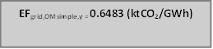

Hence,

w_{OM} = 0.75 and w_{BM} = 0.25. Then:

EF_{grid,CM,y} = 0.6483 tCO2/MWh * 0.75 + 0.3234 tCO2/MWh * 0.25

= 0.5670 tCO2/MWh

ER_{y} = BE_{y} = EG_{y} * EF_{grid,CM,} = 5400 MWh/year * 0.5670 tCO₂/MWh = 3,062 tCO₂/year

Project emissions

The proposed project activity involves the generation of electricity by development of a solar plant. The generation of electricity does not result in greenhouse gas emissions and therefore is taken as 0 tCO₂/year.

Leakage
No leakage emissions are applicable.

Emission reductions

ERy = ER_{y} = BE_{y} − PE_{y} − LE_{y} = 3,062 – 0 – 0
ERy = 3,062 tCO2 (ERy = BEy)

      - Summary of ex ante estimates of each SDG outcome

SDG 13 Climate Action

Year | Estimation of project activity emissions  (tonnes of CO₂e) | Estimation of baseline emissions  (tonnes of CO2e) | Net Benefit (tonnes of CO₂e)
15/01/2018  31/12/2018 | 0 | 2,945 | 2,945
2019 | 0 | 3,062 | 3,062
2020 | 0 | 3,062 | 3,062
2021 | 0 | 3,062 | 3,062
2022 | 0 | 3,062 | 3,062
01/01/2023  14/01/2023 | 0 | 117 | 117
Total (tonnes of CO2e) | 0 | 15,310 | 15,310
Total Number of Crediting Years | 5 years
Annual average over the crediting period | 0 | 3,062 | 3,062

SDG 8 Climate Action Decent Work and Economic Growth

The project leads to employment opportunities which would not have been possiblein the baseline scenario. The project provides local employment during the construction and activity phases. All employees have social sequrity and they were trained.

SDG7 Affordable and Clean Energy

Year | Estimation of project activity emissions  (MWh) | Estimation of baseline emissions  (MWh) | Net Benefit (MWh)
15/01/2018  31/12/2018 | 5,193 | 0 | 5,193
2019 | 5,400 | 0 | 5,400
2020 | 5,400 | 0 | 5,400
2021 | 5,400 | 0 | 5,400
2022 | 5,400 | 0 | 5,400
01/01/2023  14/01/2023 | 207 | 0 | 207
Total (MWh) | 27,000 | 0 | 27,000
Total Number of Crediting Years | 5 years
Annual average over the crediting period | 5,400 | 0 | 5,400

    - Monitoring plan

      - Data and parameters to be monitored

Relevant SDG Indicator | SDG 7 : Affordable and Clean Energy  SDG13 : Climate Action
Data / Parameter | EG_{facility,y}
Unit | MWh/yr
Description | Quantity of net electricity generation supplied by the project plant to the grid in year y
Source of data | On site measurement from the meters.
Value(s) applied | 5,400 MWh/year
Measurement methods and procedures | For the un-licensed plant; main data source will be the PMUM data. TEIAŞ reciprocal agreement meter records will be used for cross checking.  There are 6 meters in total: 3 main meter and 3 back-up meter for the 2.97 MW unlicensed plant. These meters are sealed by Fırat EDAŞ and intervention by project proponent is not possible. The fact that the meters are installed in a redundant manner keeps the uncertainty level of the only parameter for baseline calculation low. High data quality of this parameter is not only in the interest of the emission reduction monitoring, but paramount for the business relation between the plant operator and the electricity buyers.  Meters specification are mentioned in Page 35.
Monitoring frequency | Continuous measurement and at least monthly recording
QA/QC procedures | According to the Article 2 of the Communiqué of Meters in Electricity Sector: ‘The meters to be used in the electricity market shall be compliant with the standards of Turkish Standards Institute or IEC and have obtained “Type and System Approval” certificate from the Ministry of Trade and Industry.’ Therefore, Ministry of Trade and Industry (Ministry) is responsible from control and calibration of the meters. Also according to Article 11 of this Communiqué, meters shall be in class of 0.5s, which means error interval for measuring is in +-0.5% range which is well acceptable according to rules.  Paragraph b) of the Article 9 of the 'Regulation of Metering and Testing of Metering Systems' (Regulation) of Ministry states that: ‘ b) Periodic tests of meters of electricity, water, coal gas, natural gas and current and voltage transformers are done every 10 years.’ Therefore periodic calibration of the meters will be done every 10 years according to the regulation. However, meters on the plant will be calibrated by the supplier firm on an annual basis.  Also according to Article 67 (page 20) of this regulation, the calibration shall be done in calibration stations which have been tested and approved by Ministry of Trade and Industry. Article 10 d) of Communiqué requires the meters shall be three phase four wire and Article 64 of Regulation clearly states how calibration shall be performed for this kind of meters.  As above mentioned, the data acquisition and management and quality assurance procedures that are anyway in place, no additional procedures have to be established for the monitoring plan.
Purpose of data | Calculation of Baseline and Project Emission
Additional comment | Plant Manager will be responsible for monitoring data.

Relevant SDG Indicator | SDG 8: Decent Work and Economic Growth
Data / Parameter | Number of Employment Generation
Unit | Number
Description | Number of people employed directly due to the project activity
Source of data | Plant records
Value(s) applied | 3
Measurement methods and procedures | The total number of persons working in the plant would be monitored by Social Security registries.
Monitoring frequency | Once in a month.
QA/QC procedures | NA
Purpose of data | Demonstration of employement amount created by project activity.
Additional comment

      - Sampling plan
There is no sampling method applied.

      - Other elements of monitoring plan

As the necessary baseline emission factors are all defined ex ante (Operating and Built Margin, see baseline description), the most important information to be monitored is the amount of electricity fed into the grid by Gezin SPP. This value will be monitored continuously by redundant metering devices, one of them being the main one in the substation, which provides the data for the monthly invoicing to TEİAŞ.

For the un-licensed plant; main data source will be the PMUM data. TEIAŞ reciprocal agreement meter records will be used for cross checking.

There are 6 meters in total: 3 main meter and 3 back-up meter for the 2.97 MW unlicensed plant. These meters are sealed by EDAŞ and intervention by project proponent is not possible. The fact that the meters are installed in a redundant manner keeps the uncertainty level of the only parameter for baseline calculation low. High data quality of this parameter is not only in the interest of the emission reduction monitoring, but paramount for the business relation between the plant operator and the electricity buyers.

Meter specification is as follows:

 | Gezin 3 |  | Gezin 4 |  | Gezin 5
 | Main Meter | Back-Up Meter | Main Meter | Back-Up Meter | Main Meter | Back-Up Meter
Type | MAKEL C510-58.51
Production Standard and Class | C
Serial Number | 65002578 | 65002507 | 65002640 | 65003077 | 65002425 | 65002695
Accuracy Class | 0.5S
Meter delivery date | 11/01/2018

Personnel at the plant keep records for electricity generation amount and reports to operation manager on a monthly basis. Records are kept in electronic format for 2-years basis. The data is monitored via electricity meters. There are 6 meters in total for the projects. Meters are remotely read by (via OSOS system) by distribution company (Fırat EDAŞ) monthly. Yearly electricity generation will be calculated by summing up monthly meter reading records. Data monitored will be kept in electronic form and hard copy until the end of second year after the end of crediting period. These records can be used for monitoring in case of any problem will arise in meters. Technical specifications of the meters are given below. Calibration of the meters will be conducted on a 2-year basis.

The collected data will be kept by Lahit during the crediting period and until two years after the last issuance of VERs for the Gezin SPP activity for that crediting period.

Given a data vintage based on ex ante monitoring and selection of a renewable 5-year crediting period, the Combined Margin will be recalculated at any renewal of the crediting period using the valid baseline methodology.

Potential leakage emissions in the context of power sector projects are emissions arising due to activities such as power plant construction, fuel handling and land inundation. However, according to the methodology, those emission sources do not need to be taken into account.

Operational and Management Structure

As described before, there are two main factors important for the calculation of emission reductions. The only relevant data that have to be monitored is only net electricity generation (EGfacility,y) per year. Since project emission is zero no additional monitoring is required. The generation data are subject to the strict internal quality control systems of both parties. The monthly meter reading documents are stored by Lahit and Fırat EDAŞ (distribution company). The settlement notification, which is issued by Fırat EDAŞ and includes the meter reading data, is stored on a Fırat EDAŞ file server and accessible for Lahit and Petrojes that can read them manually when they want . The meters themselves can always be read as plausibility check for verification. The other important parameter is the emission factor. It is approved according to strict quality control parameters from an independent external party. With this, no additional structures or processes have to be implemented to insure the availability and high quality of the necessary data for monitoring.

At the end of each monitoring period, which is planned to generally last one year, from the monthly meter reading records the net electricity generation amounts as calculated by electricity supplied to the grid minus withdrawn from the system, will be added up to the yearly net electricity generation and total project emissions will be subtracted from this amount and result data will be multiplied with the combined margin emission factor with the help of an excel spread sheet that also contains the combined margin calculation. Thus, the complete baseline approach is always transparent and traceable. For the elaboration and quality assurance of the monitoring report, Life Enerji, an expert in the project mechanisms who already supported in the project design, is assigned. However, in order to continue improving the monitoring procedures and therefore also the future monitoring reports, internal quality check shall be fulfilled by Life Enerji. The monitoring reports are checked and in cases of mistakes and inconsistencies in the monitoring report, revisions with improvements shall be done. Furthermore, external year verification assures that the emission reductions calculations are transparent and traceable.

Lahit will keep all the data needed for the calculation of emission reductions during the crediting period and until two years after the last issuance of GS4GG VERs for Gezin SPP. Organizational structure is as follows:

There is an operation engineer from Lahit who is in charge of the projects. For the operation and maintenance works. Besides, there are 3 security personnel in total at the plant. They will be working on different shifts. Organizational structure is provided below:

Operation Technician (Lahit)
Security personnel

Because of the data acquisition and management and quality assurance procedures that are anyway in place, no additional procedures have to be established for the monitoring plan. Dedicated emergency procedures are not provided, as there is no possibility of overstating emission reductions due to emergency cases.

Name of entity determining the baseline:
Rüya Balcı
Life İklim ve Enerji Ltd. Şti (Life Enerji) (Project consultant)
Oğuzlar Mah. 1377. Sok. No:19/9, 06460, Çankaya/Ankara
Tel : +90 312 481 21 42
Fax : +90 312 480 88 10
e-mail: ruya.balci@lifeenerji.com
Contributor: Life İklim ve Enerji Ltd. Şti.

  - Duration and crediting period

    - Duration of project
      - Start date of project
According to the related GS4GG rules, the project start date is the date of a big financial agreement. Thus, the project activity begins on 28/07/2017 which is the date of equipment agreement for 2.97 MW unlicensed plant GEZİN SPP.

      - Expected operational lifetime of project
The expected technical lifetime of Gezin SPP is 25 years.

    - Crediting period of project
      - Start date of crediting period
Start date of crediting period is 15/01/2018

      - Total length of crediting period
The length of the first crediting period is 5 years, 0 months.

  - Safeguarding principles assessment

    - Analysis of social, economic and environmental impacts

Safeguarding principles | Assessment questions | Assessment of relevance to the project (Yes/potentially/no) | Justification | Mitigation measure (if required)
SOCIAL AND ECONOMIC
Principle 1-Human Rights | 1. The Project Developer and the Project shall respect internationally proclaimed human rights and shall not be complicit in violence or human rights abuses of any kind as defined in the Universal Declaration of Human Rights.  2. The Project shall not discriminate with regards to participation and inclusion. | No | 1. The project is not a conflit with the economic livelihood of the local community. Then, the Project does not cause any human rights abuse and respects internationally proclaimed human rights issue.  2. Turkey has ratified the United Nations Human Rights Rules and regulations. The project adheres to the host country’s commitment to Universal Declaration of Human Rights (UDHR) International Covenant on Economic, Social and Cultural Rights, Turkey Accession 24 October 1945 International Covenant on Civil and Political Rights Ratification in 23 September 2003 . | Not Required
Principle 2 – Gender Equality and Women’s Rights | The Project shall complete the following gender assessment questions in order to inform Requirements, below:  1. Is there a possibility that the Project might reduce or put at risk women’s access to or control of resources, entitlements and benefits?  2. Is there a possibility that the Project can adversely affect men and women in marginalised or vulnerable communities (e.g., potential increased burden on women or social isolation of men)?  3. Is there a possibility that the Project might not take into account gender roles and the abilities of women or men to participate in the decisions/designs of the project’s activities (such as lack of time, child care duties, low literacy or educational levels, or societal discrimination)?  4. Does the Project take into account gender roles and the abilities of women or men to benefit from the Project’s activities (e.g., Does the project criteria ensure that it includes minority groups or landless peoples)?  5. Does the Project design contribute to an increase in women’s workload that adds to their care responsibilities or that prevents them from engaging in other activities?  6. Would the Project potentially reproduce or further deepen discrimination against women based on gender, for instance, regarding their full participation in design and implementation or access to opportunities and benefits?  7. Would the Project potentially limit women’s ability to use, develop and protect natural resources, taking into account different roles and priorities of women and men in accessing and managing environmental goods and services?  8. Is there a likelihood that the proposed Project would expose women and girls to further risks or hazards?  The Project shall not directly or indirectly lead to/contribute to adverse impacts on gender equality and/or the situation of women. Specifically, this shall include:  a) Sexual harassment and/or any forms of violence against women – address the multiple risks of gender-based violence, including sexual exploitation or human trafficking.  b) Slavery, imprisonment, physical and mental drudgery, punishment or coercion of women and girls.  c) Restriction of women’s rights or access to resources (natural or economic).  d) Recognise women’s ownership rights regardless of marital status – adopt project measures where possible to support to women’s access to inherit and own land, homes, and other assets or natural resources.  Projects shall apply the principles of nondiscrimination, equal treatment, and equal pay for equal work, specifically:  1. Where appropriate for the implementation of a Project, paid, volunteer work or community contributions will be organised to provide the conditions for equitable participation of men and women in the identified tasks/activities.  2. Introduce conditions that ensure the participation of women or men in Project activities and benefits based on pregnancy, maternity/paternity leave, or marital status.  3. Ensure that these conditions do not limit the access of women or men, as the case may be, to Project participation and benefits.  The Project shall refer to the country’s national gender strategy or equivalent national commitment to aid in assessing gender risks | No | 1. The project does not decrease women´s access to or control of resources, entitlements or benefits  2. No, there is no possibility of adverse effect.  3. No, the Project does not disconsider gender roles and in fact try to engages both women and men.  4. The project does not discriminate on basis of gender, caste or religion.  5. No the Project was not designed to increase women´s workload or add care responsibilities.  6. The project does not discriminate on basis of gender, caste or religion. Thus there is no place to discriminate women.  7. The Project will not limit women´s ability regarding natural resources. The project being solar project thus does not have any major impact on natural resources of the region.  8. No the Project will not expose women and girls to further risks or hazards.  a) There is no such risk for the project.  b) There is no such risk for the project.  c) The Project will not restrict women´s rights or access regarding natural resources. The project proponent does not discriminate on gender, caste, religion etc.  d) Marital status is completely irrelevant to the Project. The project proponent does not discriminate on gender, caste, religion etc.  1. Yes, the Project has equal opportunity for women and men to contribute both in volunteer and working positions.  2. The project proponent has a stipulated policy that takes into account participation by both men and women.  3. There is no limit on the access to Project participation and benefits from either of these conditions.  The project is aligned to the country’s National Action Plan Gender Equality
Principle 3 – Community Health, Safety and Working Conditions | The Project shall avoid community exposure to increased health risks and shall not adversely affect the health of the workers and the community. | No | There are no perceived health risks due to the project activity. Safety of employees would be taken care and safety training to each employee is carried out. | Not Applicable
Principle 4 – Cultural Heritage, Indigenous Peoples, Displacement and Resettlement | Does the Project Area include sites, structures, or objects with historical, cultural, artistic, traditional or religious values or intangible forms of culture (e.g., knowledge, innovations, or practices)?  Does the Project require or cause the physical or economic relocation of peoples (temporary or permanent, full or partial)?  Does the Project require any change to land tenure arrangements and/or other rights?  For Projects involving land-use tenure, are there any uncertainties with regards land tenure, access rights, usage rights or land ownership?  Are indigenous peoples present in or within the area of influence of the Project and/or is the Project located on land/territory claimed by indigenous peoples? | No | No cultural heritage is observed on the project site, thus no harm observed.  The site below gives the list of cultural heritage sites in Turkey by UNESCO from which it is clear that the project site does not form a cultural heritage site.  The Land for the project has been approved by the local authorities.  The proponent obtained license for establishing the plant. The project does not involve and is not complicit in involuntary resettlement in any way.  The project activity does not have any major impact on land use patterns. In accordance with Article 1 of the International Covenant on economic, Social and Cultural Rights the project does not complicit in involuntary resettlement.  No cultural heritage/ indigenous people are displaced due to the project. | Not Applicable
Principle 5 – Corruption | The Project shall not involve, be complicit in or inadvertently contribute to or reinforce corruption or corrupt Projects. | No | Indulgence in corruption is an illegal activity in the host country and the local labour compliance takes into account of the same.  The project abides by the United Nations Convention Against Corruption. Turkey signed on 10 December 2003 and ratified the same on 9 November 2006. | Not Required
Principle 6 – Economic Impacts | 1. The Project Developer shall ensure that there is no forced labour and that all employment is in compliance with national labour and occupational health and safety laws, with obligations under international law, and consistency with the principles and standards embodied in the International Labour Organization (ILO) fundamental conventions  2. Child labour, as defined by the ILO Minimum Age Convention is not allowed  3. The Project Developer shall ensure the use of appropriate equipment, training of workers, documentation and reporting of accidents and incidents, and emergency preparedness and response measures. | Potential | 1. The project developer does not complicit in any form of forced or compulsory labor. All the workers have work contract in the terms of the legislation.  2. The project neither employs nor intends to employ child labour. Turkey ratified on 30 October 1998 ( minimum age specified 15 years old)  3. Turkey has ratified the United Nations Human Rights Rules and regulations.  The project adheres to the host country’s commitment to Universal Declaration of Human Rights (UDHR) International Covenant on Economic, Social and Cultural Rights, Turkey sign on 15 August 2000 . | Not Required
ENVIRONMENTAL AND ECOLOGICAL
Principle 1 – Climate and Energy | Will the Project increase greenhouse gas emissions over the Baseline Scenario?  Will the Project use energy from a local grid or power supply (i.e., not connected to a national or regional grid) or fuel resource (such as wood, biomass) that provides for other local users? | No | The project will reduce greenhouse gas emissions and fossil fuel use compared to the baseline scenario.  On the contrary the project generates renewable energy and supplies to the grid. | Not Required
Principle 2 – Water | Will the Project affect the natural or pre-existing pattern of watercourses, ground-water and/or the watershed(s) such as high seasonal flow variability, flooding potential, lack of aquatic connectivity or water scarcity? | No | The project is a solar project thus there is no impact of water resources due to the project. | Not Required
Principle 3 – Environment, ecology and land use | Does the Project physically affect or alter largely intact or High Conservation Value (HCV) ecosystems, critical habitats, landscapes, key biodiversity areas or sites identified? | No | The environmental impact of the proposed project was considered negligible. | Not Required

  - Local stakeholder consultation

    - Solicitation of comments from stakeholders
The project is a retroactive project thus LSC meeting is not required. However, Stakeholder engagement prosedur will be followed and SFR will be implemented during the registration process.

    - Summary of comments received
Will be completed after SFR Project.
    - Report on consideration of comments received
Will be completed after SFR Project.

- Contact information of project participants
Organization name | Lahit Elektrik Üretim A.Ş. | Petrojes Elektrik Üretim A.Ş.
Registration number with relevant authority
Street/P.O. Box | Sırakapılar Mah. Mimar Sinan Cad. 6 1 Merkezefendi
Building
City | Denizli
State/Region
Postcode | 20125
Country | Turkey
Telephone
Fax
E-mail
Website
Contact person | Ramazan Aslan
Title
Salutation | Mr.
Last name | Aslan
Middle name | -
First name | Ramazan
Department
Mobile
Direct fax | 00903124808810
Direct tel. | 00903124812142/19
Personal e-mail | ramazan.aslan@lifeenerji.com

- Summary of post registration design changes

Revision History

Version | Date | Remarks
1.1 | 24 August 2017 | Updated to include section A.8 on ‘gender sensitive’ requirements
1 | 10 July 2017 | Initial adoption

Please see provisional acceptance certificate for unlicensed plant
Google Earth Software was used.
Google Maps Software was used. https://www.google.com.tr/maps/place/38%C2%B031'54.5%22N+39%C2%B032'56.9%22E/@38.5315595,39.5437106,14.5z/data=!4m5!3m4!1s0x0:0x0!8m2!3d38.5317944!4d39.549125?hl=pt-PT
Google Earth Software was used.
Google Earth Software was used.
Please see: EPC agreement and signed acceptance letters
Please see: http://cdm.unfccc.int/methodologies/PAmethodologies/tools/am-tool-10-v1.pdf
Please see: EPC Agreement
Please see: https://www.teias.gov.tr/sites/default/files/2017-10/59%282000-2016%29.xls
Please see: https://www.teias.gov.tr/sites/default/files/2017-10/9.xls
Please see: http://hrlibrary.umn.edu/research/ratification-turkey.html
Project typeAMS-I.AAMS-I.DAMS-I.F1 Project supplies electricity to a national/regional grid n.a.√n.a.2 Project displaces grid electricity consumption (e.g. grid import) and/or captive fossil fuel electricity generation at the user end (excess electricity may be supplied to a grid) n.a.n.a.√3 Project supplies electricity to an identified consumer facility via national/regional grid (through a contractual arrangement such as wheeling) n.a.√n.a.4 Project supplies electricity to a mini grid3 system where in the baseline all generators use exclusively fuel oil and/or diesel fuel n.a.n.a.√5 Project supplies electricity to household users (included in the project boundary) located in off grid areas √ n.a.n.a.
Please see: https://www.teias.gov.tr/sites/default/files/2017-06/10Y%C4%B1ll%C4%B1kTalepTahminleriRaporu2016%282%29.pdf
Please see: https://www.teias.gov.tr/sites/default/files/2017-06/10Y%C4%B1ll%C4%B1kTalepTahminleriRaporu2016%282%29.pdf
Please see: https://www.teias.gov.tr/sites/default/files/2017-12/KapasiteProjeksiyonu2017a%C4%9Fustos.pdf
Please see: http://www.teias.gov.tr/sites/default/files/2017-10/46.xls
https://www.teias.gov.tr/sites/default/files/2017-12/KapasiteProjeksiyonu2017a%C4%9Fustos.pdf
Please see: Signed site delivery protocol document
Please see: https://cdm.unfccc.int/methodologies/PAmethodologies/tools/am-tool-07-v5.0.pdf (version 05)
Please see, www.enermet.com.tr/upload/mce/.../1._electricity_market_licensing_regulation.doc (Page 21)
Please see, http://www.epdk.org.tr/TR/Dokumanlar/Elektrik/YayinlarRaporlar/UretimKapasiteProjeksiyonlari
Please see: https://www.teias.gov.tr/sites/default/files/2017-10/59%282000-2016%29.xls
Please see: https://www.teias.gov.tr/sites/default/files/2017-10/59%282000-2016%29.xls
Please see: https://www.teias.gov.tr/sites/default/files/2017-10/56%2893-2016%29.xls
See, www.epdk.org.tr/TR/Dokuman/3156
See, http://www.mevzuat.gov.tr/Metin.Aspx?MevzuatKod=7.5.6381&MevzuatIliski=0&sourceXmlSearch=
https://treaties.un.org/Pages/ViewDetails.aspx?src=IND&mtdsg_no=IV-3&chapter=4&lang=en
http://www.gcc.ca/pdf/INT000000019b.pdf
https://treaties.un.org/PAGES/ViewDetails.aspx?src=TREATY&mtdsg_no=IV-4&chapter=4&clang=_en
Please see: http://www.huksam.hacettepe.edu.tr/English/Files/NAP_GE.pdf
http://whc.unesco.org/en/statesparties/tr
http://www.unodc.org/unodc/en/corruption/ratification-status.html
http://www.ilo.org/dyn/normlex/en/f?p=1000:11300:0::NO:11300:P11300_INSTRUMENT_ID:312283
http://www.gcc.ca/pdf/INT000000019b.pdf
https://treaties.un.org/PAGES/ViewDetails.aspx?src=TREATY&mtdsg_no=IV-4&chapter=4&clang=_en

