Student ID: 103619438

Name: Ethan Downer

# Setup Screenshot

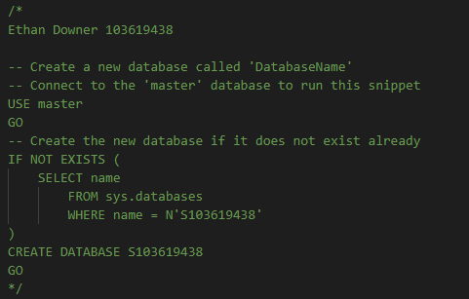

Task 1 Screenshot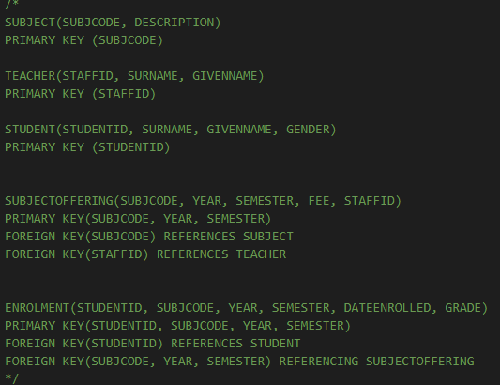

# Task 2 Screenshot

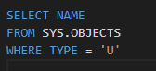

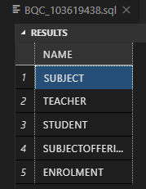

Task 3 Screenshot

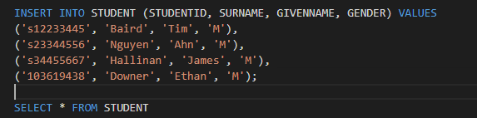

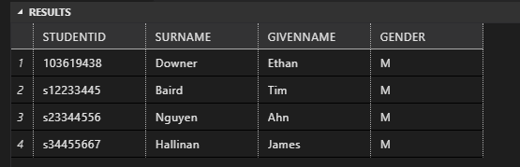

Task 4 Screenshot

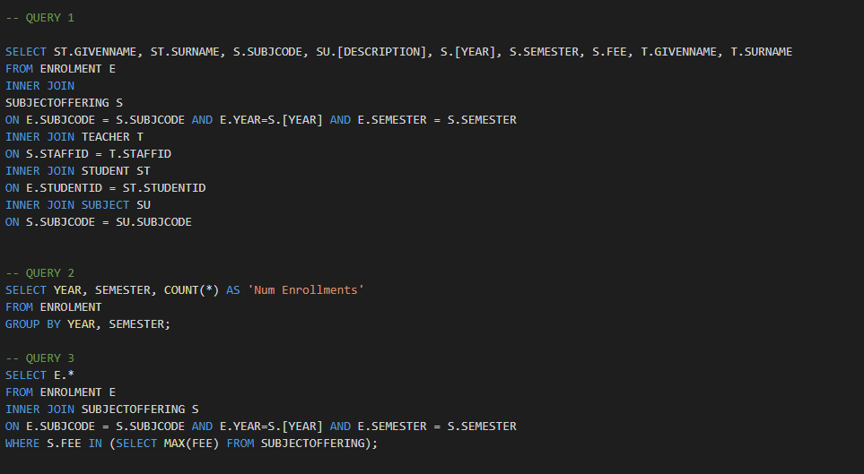

Task 5 Screenshot

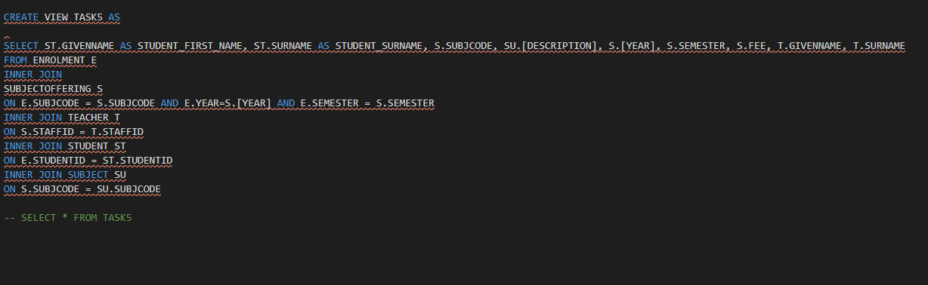

Task 6 Screenshot

