Number of bikes available at a sample station relative to the number available at the start of the day, in 5-minute intervals. Note the increase in available bikes in the morning and decrease in afternoon/evening.

Every day of the month plotted from 3 to 10 pm to get a sense of the optimal evening time frame to use. Most days are relatively constant in the early afternoon before steadily dropping from 4 to 8 pm and then steadying off again so this time frame was used.

Every day of the month plotted from 6 am to noon to get a sense of the optimal morning time frame to use. Most days are relatively constant in the early morning before increasing rapidly from 8 am to noon so this time frame was used.

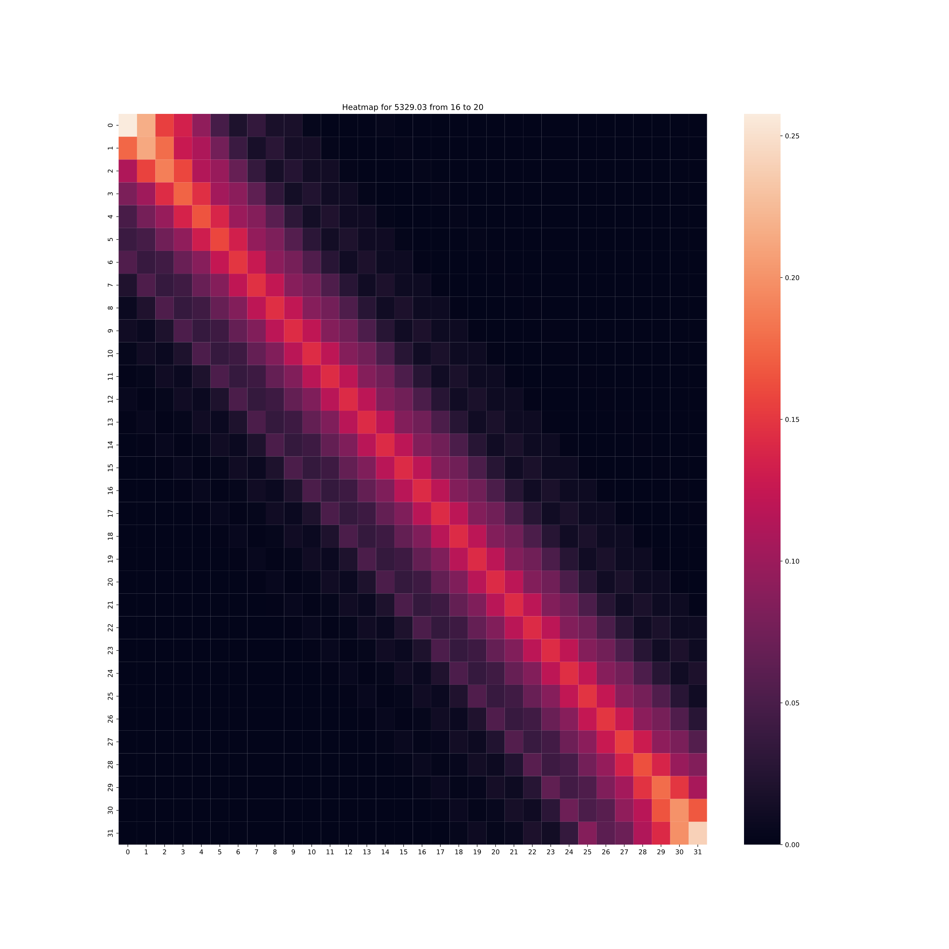

A heatmap illustrating the Markov Chain describing station with ID 5329.03 in the evening. The main diagonal is relatively high density indicating that it is unlikely that the number of available bikes will fluctuate greatly in a 5 minute interval.

Expected long run frequency of each inventory level for station 5329.03 in the evening from 5-minute intervals. (note: overall long run average is 11.99)

Long run averages for 3 heavily trafficked stations in the morning and evening using sampling intervals of both 5 and 10 minutes (in comparison to listed capacity)