**IST 263 Project Milestone 4 – Wireframes**

**Name**: Ethan Hale

**Description:**  
Please paste your project description from Project Milestone 1 here (or most current if you’ve changed your project idea).

**Research:**

Write down the urls of three websites you looked at to research layout for the type of site you are creating. For example, if I was creating an auction website, I might look at pages on <https://www.ebay.com/>.

|  |  |
| --- | --- |
| **url1** | **https://www.biography.com/** |
| **url2** | **https://www.biographyonline.net/** |
| **url3** | **https://www.anb.org/** |

**Wireframes:**

Use MockFlow or another diagraming software to create layouts for your pages. Consider the following:

1. Where is your navigation going to be located on every page.
2. Will you need a footer?
3. How can you make a layout that is visually interesting and helps communicate your site content?
4. Don’t forget you must have at least 2 distinctly different page layouts.

**Paste Your 3 Page Layouts Below**

**Home page:**

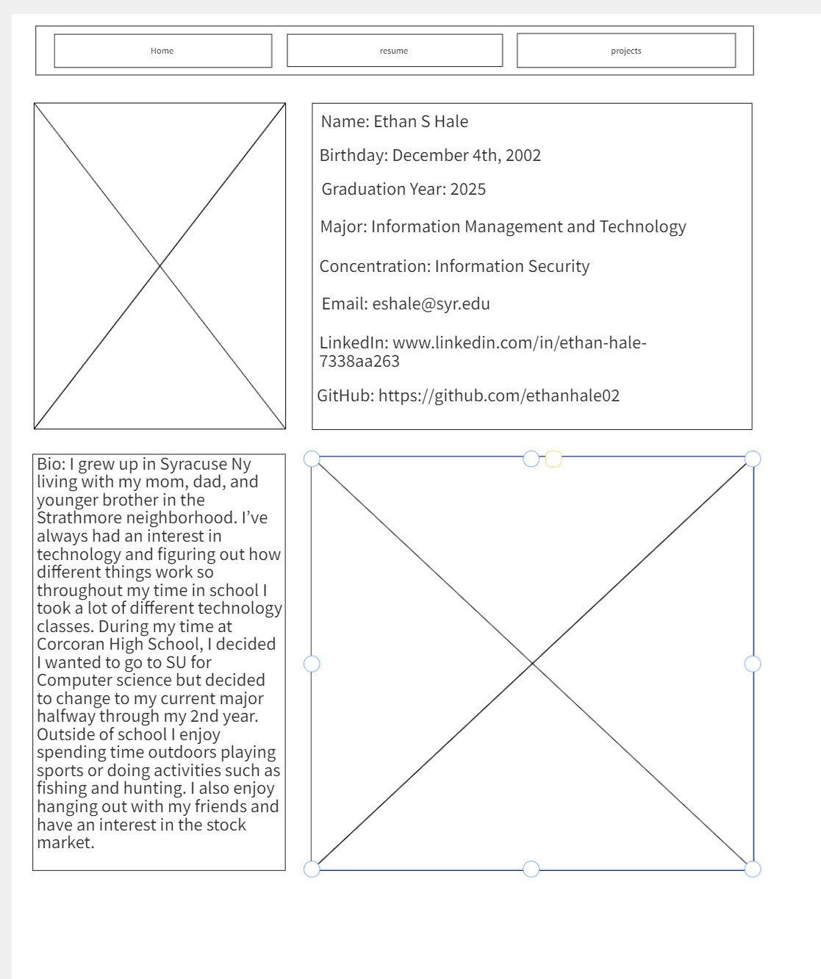

**Resume page:**

**Projects page:**

