实验目的

1. 学会使用类，接口，抽象类，对象。
2. 掌握文件的输入输出流，包括scanner类。

1. 设计  
   (1)形状接口、(2)积木块抽象类、(3)三角形类、正方形类、圆形类和矩形类，  
   其中(2)实现了(1)，(3)继承了（2），然后编写主函数分别定义它们的对象，并显示其值。

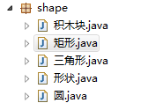

**package** shape;

**public** **interface** 形状 {

**int** *边*=0;

**void** 面积();

}

**package** shape;

**public** **abstract** **class** 积木块 **implements** 形状 {

**int** 边 = 0;

**public** **abstract** **void** 面积();

}

**package** shape;

**public** **class** 三角形 **extends** 积木块 {

**int** 边 = 3;

**int** a = 0, b = 0, c = 0;

三角形() {

**this**.a = 0;

**this**.b = 0;

**this**.c = 0;

**this**.边 = 3;

}

三角形(**int** a, **int** b, **int** c) {

**this**.a = a;

**this**.b = b;

**this**.c = c;

}

@Override

**public** **void** 面积() {

// **TODO** Auto-generated method stub

**int** p = (a + b + c) / 3;

System.*out*.println("面积为" + Math.*sqrt*((p - a) * (p - b) * (p - c)));

}

}

**package** shape;

**public** **class** 圆 **extends** 积木块 {

**int** 边 = 1;

**int** 半径 = 0;

圆() {

**this**.半径 = 0;

**this**.边 = 1;

}

圆(**int** r) {

**this**.半径 = r;

}

@Override

**public** **void** 面积() {

// **TODO** Auto-generated method stub

System.*out*.println("面积为" + Math.*PI* * 半径 * 半径);

}

}

**package** shape;

**public** **class** 矩形 **extends** 积木块 {

**int** 边 = 4;

**int** a = 0, b = 0;

矩形() {

**this**.a = 0;

**this**.b = 0;

**this**.边 = 3;

}

矩形(**int** a, **int** b) {

**this**.a = a;

**this**.b = b;

}

@Override

**public** **void** 面积() {

// **TODO** Auto-generated method stub

System.*out*.println("面积为" + a * b);

}

**public** **static** **void** main(String args[])

{

三角形 triangle=**new** 三角形(3,4,5);

圆 cirle=**new** 圆(5);

矩形 square=**new** 矩形(3,4);

triangle.面积();

cirle.面积();

square.面积();

}

}

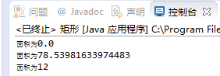

2.分别建立两个线程，产生并显示[100,10000]和[20000,30000]之间的随机数各10000个，并分别求和显示出来。

**import** java.util.Random;

**public** **class** Hello {

**public** **static** **void** main(String args[]) {

Thread1 t1 = **new** Thread1(100, 10000, "1");

Thread2 t2 = **new** Thread2(20000, 30000, "2");

t1.start();

t2.start();

}

**static** **class** Thread1 **extends** Thread {

**int** max = 100;

**int** min = 10000;

String threadname;

Thread1(**int** themin, **int** themax, String name){

max = themax;

min = themin;

threadname = name;

}

**double** sum = 0;

Random random = **new** Random();

**public** **void** run() {

**for** (**int** i = 0; i < 10000; i++) {

**int** tmp = random.nextInt(max) % (max - min + 1) + min;

sum += tmp;

System.*out*.println(tmp+" ");

}

System.*out*.println("thread"+ threadname + " sum" + sum);

}

}

**static** **class** Thread2 **extends** Thread {

**int** max = 100;

**int** min = 10000;

String threadname;

Thread2(**int** themin, **int** themax, String name){

max = themax;

min = themin;

threadname = name;

}

**double** sum = 0;

Random random = **new** Random();

**public** **void** run() {

**for** (**int** i = 0; i < 10000; i++) {

**int** tmp = random.nextInt(max) % (max - min + 1) + min;

sum += tmp;

System.*out*.println(tmp+" ");

}

System.*out*.println("thread"+ threadname + " sum" + sum);

}

}

}

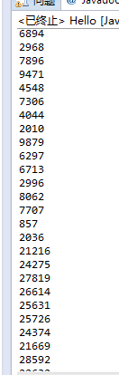

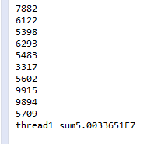

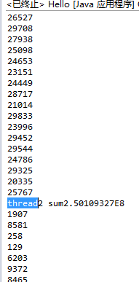

3.建立两个线程分别不断读取两个文本文件中的数据并求和，并显示求和结果。

**import** java.io.File;

**import** java.io.FileNotFoundException;

**import** java.util.Scanner;

**public** **class** t {

**public** **static** **void** main(String args[]) {

Thread1 t1 = **new** Thread1();

t1.start();

Thread2 t2 = **new** Thread2();

t2.start();

}

}

**class** Thread1 **extends** Thread {

**public** **void** run() {

String text = "D://javaworkspace1//HelloWorld//src//a.txt";

Scanner in = **null**;

**try** {

in = **new** Scanner(**new** File(text));

} **catch** (FileNotFoundException e) {

// **TODO** Auto-generated catch block

e.printStackTrace();

}

**int** sum = 0;

**while** (in.hasNextInt()) {

sum +=in.nextInt();

}

System.*out*.println(text+" sum " + sum);

}

}

**class** Thread2 **extends** Thread {

**public** **void** run() {

String text = "D://javaworkspace1//HelloWorld//src//b.txt";

Scanner in = **null**;

**try** {

in = **new** Scanner(**new** File(text));

} **catch** (FileNotFoundException e) {

// **TODO** Auto-generated catch block

e.printStackTrace();

}

**int** sum = 0;

**while** (in.hasNextInt()) {

sum +=in.nextInt();

}

System.*out*.println(text+" sum " + sum);

}

}

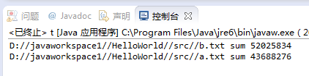

4.已经存在一个文本文件"a.txt"，请使用Scanner类读取其内容，并统计总分，分别显示出来。  
该文件的各行内容格式是：  
学生学号（int）\t学生姓名(String)\tJava考试成绩（double）\r\n  
................  
**import** java.io.*;

**import** java.util.*;

**public** **class** score {

**public** **static** **void** main(String args[]) {

FileReader fin = **null**;

**double** sum = 0;

**try** {

fin = **new** FileReader("D://javaworkspace1//HelloWorld//src//a.txt");

} **catch** (FileNotFoundException e) {

// **TODO** Auto-generated catch block

e.printStackTrace();

}

Scanner sc = **new** Scanner(fin);

**while** (sc.hasNext()) {

**if** (sc.hasNextInt()) {

sc.nextInt();

**continue**;

}

**if** (sc.hasNextDouble()) {

sum += sc.nextDouble();

**continue**;

}

sc.next();

}

System.*out*.println(sum);

}

}

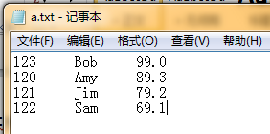

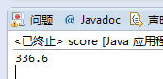

5. 将杨辉三角形的结果保存到一个文本文件“c.txt”中。  
**import** java.io.FileNotFoundException;

**import** java.io.PrintStream;

**import** java.util.Scanner;

**public** **class** triangle {

**public** **static** **void** main(String args[]) {

PrintStream ps = **null**;

**try** {

ps = **new** PrintStream("D://javaworkspace1//HelloWorld//src//c.txt");

} **catch** (FileNotFoundException e) {

// **TODO** Auto-generated catch block

e.printStackTrace();

}

System.*out*.print("请输入行数：");

Scanner input = **new** Scanner(System.*in*);

**int** row = input.nextInt();

**int** col = row;

**int**[][] array = **new** **int**[row][col];

**for**(**int** i = 1; i < row; i++){

**for**(**int** j = row; j > i; j--){

ps.print(" ");

}

**for**(**int** j = 1; j <= i; j++){

**if**(i == j || j == 0){

array[i][j] = 1;

}**else**{

array[i][j] = array[i-1][j-1] + array[i-1][j];

}

ps.print(array[i][j] + " ");

}

ps.println();

}

}

}

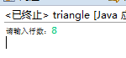

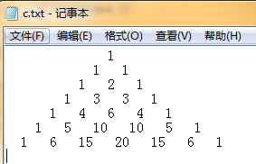

6.有一个文本文件"c.txt"有多行内容，各行首部都包含一个行号和冒号，请按行号对各行进行排序，并在尾部写入冒号和本行字符数，然后保存在另一个文本文件"d.txt"之中。  
比如：文件"c.txt"内容格式如下：  
4: 第14届亚洲地区英语语言测试研讨会在西安交大举行  
2: 教育部高校科研管理方法研讨会暨青委会西北片区成立大会在西安交...  
1: 西安交大召开创先争优活动总结大会  
3: 法国巴黎南十一大学代表团访问西安交大

**import** java.io.*;

**import** java.util.ArrayList;

**import** java.util.List;

**class** strs **implements** Comparable<strs> {

**private** String name;

**private** Integer order;

**public** String getName() {

**return** name;

}

**public** **void** setName(String name) {

**this**.name = name;

}

**public** Integer getOrder() {

**return** order;

}

**public** **void** setOrder(Integer order) {

**this**.order = order;

}

@Override

**public** **int** compareTo(strs arg0) {

**return** **this**.getOrder().compareTo(arg0.getOrder());

}

}

**public** **class** formater {

**static** BufferedReader *in*;

**static** BufferedWriter *out*;

**public** **static** **void** main(String[] args) **throws** IOException {

*in* = **new** BufferedReader(

**new** FileReader(**new** File("D://javaworkspace1//HelloWorld//src//c.txt")));

*out* = **new** BufferedWriter(**new** FileWriter(

**new** File("D://javaworkspace1//HelloWorld//src//d.txt")));

**int** i = 0;

String str;

List<strs> ss = **new** ArrayList<strs>();

**while** ((str = *in*.readLine()) != **null**) {

strs tmp = **new** strs();

tmp.setName(str);

tmp.setOrder(Integer.*parseInt*(str.charAt(0) + ""));

ss.add(tmp);

i++;

}

**for** (strs tmp: ss){

*out*.write(tmp.getName());

*out*.write(" :" + tmp.getName().length() + "");

*out*.write("\r\n");

}

*in*.close();

*out*.close();

}

}

