第6次实验：  
1.编写一个swing图形界面程序查询某个地区的天气预报信息，其中天气预报信息保存在一个数据库中。

package Weather;

import java.awt.event.ActionEvent;

import java.awt.event.ActionListener;

import javax.swing.JButton;

import javax.swing.JLabel;

import javax.swing.JTextArea;

import javax.swing.JTextField;

import javax.swing.JTextPane;

import javax.swing.WindowConstants;

import javax.swing.SwingUtilities;

import Weather.Weather;

public class NewJFrame extends javax.swing.JFrame {

private JButton jButton1;

private JTextField jTextField1;

private JLabel jLabel2;

private JLabel jLabel1;

private JTextPane jTextPane1;

public static void main(String[] args) {

SwingUtilities.invokeLater(new Runnable() {

public void run() {

NewJFrame inst = new NewJFrame();

inst.setLocationRelativeTo(null);

inst.setVisible(true);

}

});

}

public NewJFrame() {

super();

initGUI();

}

private void initGUI() {

try {

setDefaultCloseOperation(WindowConstants.DISPOSE_ON_CLOSE);

getContentPane().setLayout(null);

this.setTitle("weather");

{

jButton1 = new JButton();

getContentPane().add(jButton1);

jButton1.setText("search");

jButton1.setBounds(50, 200, 100, 50);

jButton1.addActionListener(new ActionListener() {

public void actionPerformed(ActionEvent evt) {

jButton1ActionPerformed(evt);

}

});

}

{

jTextPane1 = new JTextPane();

getContentPane().add(jTextPane1);

jTextPane1.setBounds(200, 100, 200, 100);

}

{

jLabel1 = new JLabel();

getContentPane().add(jLabel1);

jLabel1.setText("info");

jLabel1.setBounds(250, 50, 50, 50);

}

{

jTextField1 = new JTextField();

getContentPane().add(jTextField1);

jTextField1.setBounds(50, 100, 100, 50);

}

{

jLabel2 = new JLabel();

getContentPane().add(jLabel2);

jLabel2.setText("city");

jLabel2.setBounds(100, 50, 50, 50);

}

pack();

this.setSize(800, 500);

} catch (Exception e) {

e.printStackTrace();

}

}

private void jButton1ActionPerformed(ActionEvent evt) {

String a=this.jTextField1.getText();

Weather weather=new Weather(a);

jTextPane1.setText(weather.search());

}

}

package Weather;

import java.sql.Connection;

import java.sql.DriverManager;

import java.sql.PreparedStatement;

import java.sql.ResultSet;

public class Weather {

private String city;

public Weather(String city) {

super();

this.city = city;

}

public String search(){ // 查询

String weather = null;

try {

Class.forName("org.sqlite.JDBC");

Connection con=

DriverManager.getConnection(

"jdbc:sqlite://c://Users//Rex//Documents//GitHub//hello//src//123.db3"

);

PreparedStatement ps=

con.prepareStatement(

"SELECT * FROM tianqi WHERE city=\""+city+"\""); //

ResultSet rs=ps.executeQuery();

if(rs.next()){

weather = rs.getString(2);

}else{

weather = "no this city";

}

ps.close();

con.close();

} catch (Exception e) {

weather = "no this city";

}

return weather;

}

}

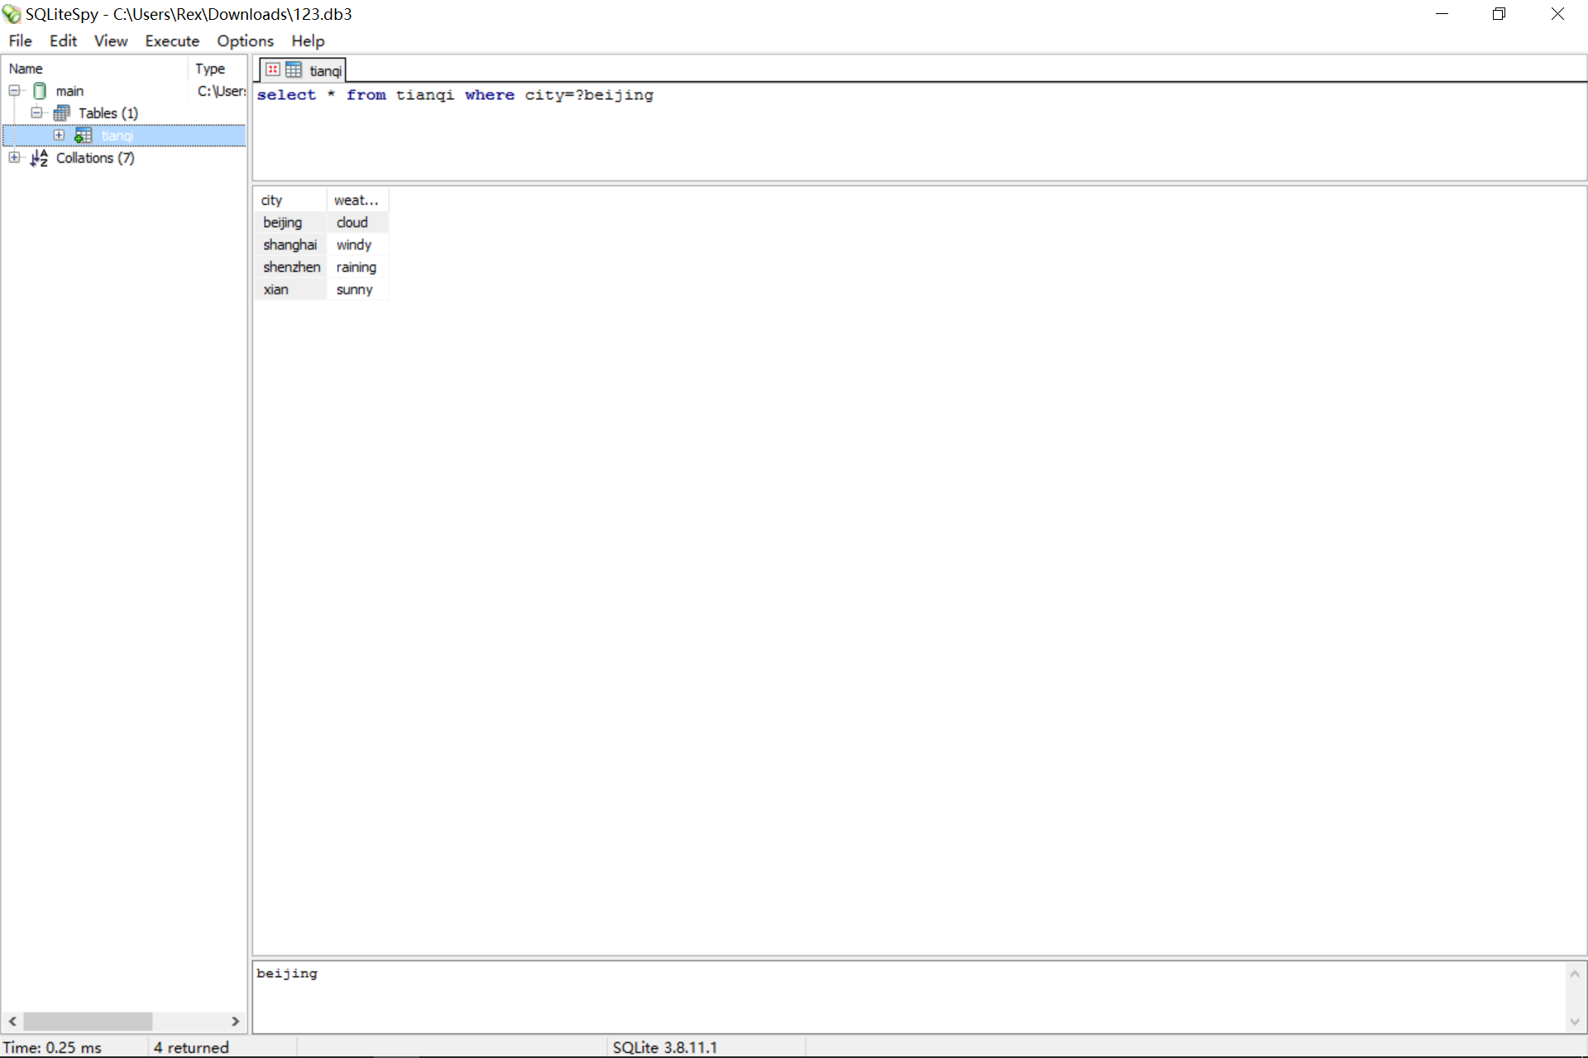

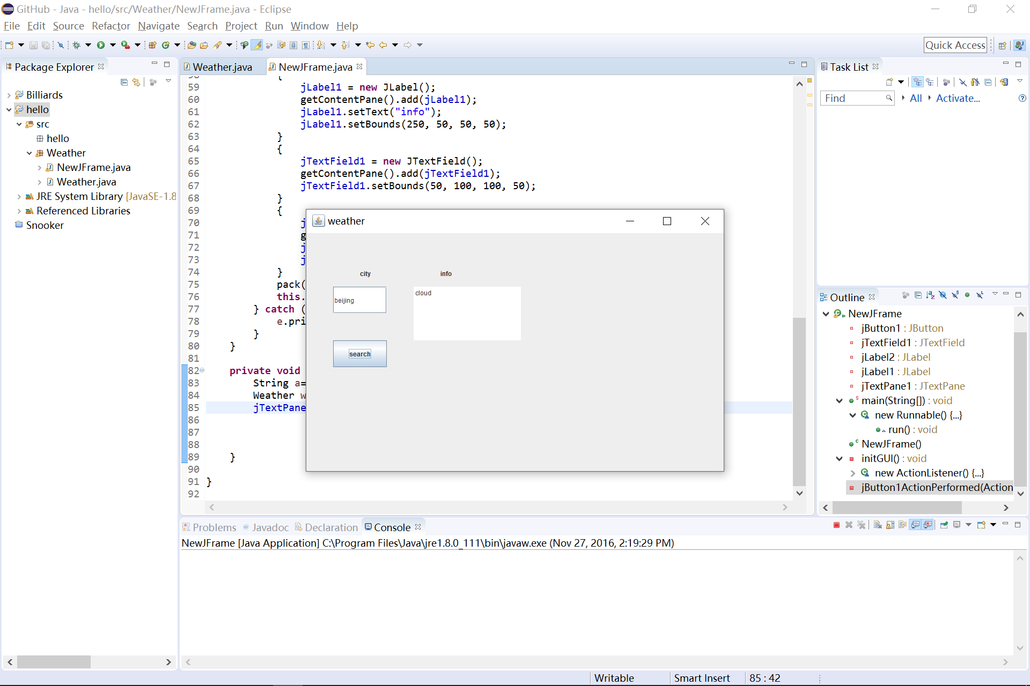

3.设计一个JSP网页，能够对输入的任意整数数组进行排序，并显示排序后的结果。

|  |
| --- |
| <!-- index.jsp--> |
| <%@ page contentType="text/html; charset=GBK" %> |
| <html> |
| <head><title>sort array</title></head> |
| <body> |
| <form method="post" action="sort.jsp"> |
| <input type="text" name="text" size ="20" > |
| <br> |
| <input type="submit" name="submit" value="submit"> |
| </form> |
| </body> |
| </html> |

|  |
| --- |
| <!-- sort.jsp--> |
| <%@ page language="java" session="true" import="java.util.*" |
| contentType="text/html; charset=GBK" %> |
| <html> |
| <head><title>sort array</title></head> |
| <body> |
| <% String arr=""; |
| try{arr=request.getParameter("text"); |
| String[] strarr=arr.split(" "); |
| int[] intarr=new int[strarr.length]; |
| for (int i=0;i<strarr.length;i++){ |
| intarr[i]=Integer.parseInt(strarr[i]); |
| } |
| Arrays.sort(intarr); |
|  |
| for (int i=0; i<intarr.length; i++) {%> |
| <%= "" + intarr[i] + '\t' %> |
| <% } |
| }catch(Exception e){ |
| arr=""; |
| } |
| %> |
| <br> |
| <jsp:include page="index.jsp" flush="true" /> |
| </body> |
| </html> |

