**Lab 10:**

**Programming Fundamentals CS130-02 Total=100**

Open Eclipse IDE and create a new class for each of the following questions: Choose class name that most appropriately defining the problem. Take a print screen of the code with console output.

1. Create a person class and display you and all of your class mates name and age using proper constructor

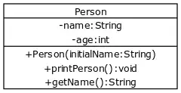

1. The following figure repeats the Time example. It illustrates the UML class diagram for current time. Display current time in Hr, minute and second.

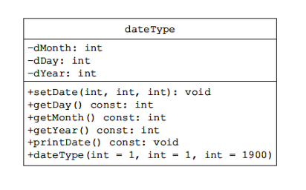

1. Create your own Math class and test all the methods. Underscore used to define the static methods.

|  |
| --- |
| Maths |
| + E: double = 2.718 {read only}  + PI: double = 3.1415 {read only}  - randomNumberGenerator: Random |
| - Maths()  + getRandomNumber: int  + max(int,int): int  + max(long, long): long  + sin(double) : double  + cos(double) : double  + log(double) : double  + floor(double): double  + ceil(double): double  + pow(double double) : double |

1. Explain the difference between default, public, private, and protected access modifiers with suitable examples

Public can be freely accessed without the use of a getter, private must be accessed using a getter function, protected is similar to private, but cannot be accessed outside of its package, and default is used when an access modifier is not specified.