**Lab 11:**

**Programming Fundamentals CS130 Total=100**

Open Eclipse IDE and create a new class for each of the following questions: Choose class name that most appropriately defining the problem. Take a print screen of the code with console output.

1. What is Inheritance in Java? How to use Inheritance in Java?

Inheritance is where a parent class can pass down its information to all child classes. All aspects of the parent class will be present in every child class, and any changes to the parent will affect all of the child classes.

Inheritance can be used with the line:

*class XYZ extends ABC {*

where XYZ is the child class, and ABC is the parent class.

1. What is the difference between Inheritance and Encapsulation?

Inheritance allows for the altering of a parent class in order to affect all of the child classes, whereas encapsulation must be changed individually.

1. What is Aggregation ans how it is different from from Inheritance?

Aggregation is the practice of connecting 1 or more classes through the use of a class variable. Unlike inheritance, it cannot be altered at once.

1. Implement the following UML disgram and display the student and department informations.

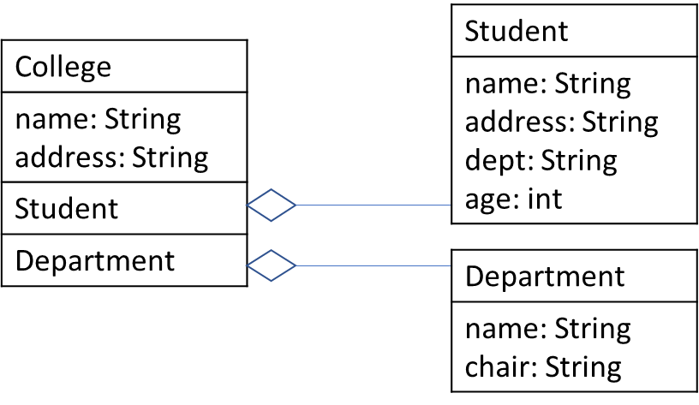

1. Implement the following UML disgram and display the Author and Book informations.

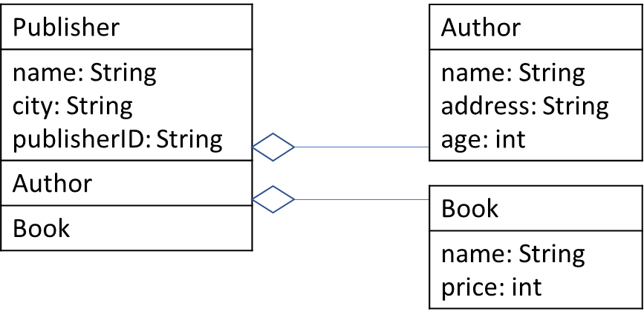

1. When classes extend the properties of each other level by level is known as multilevel inheritance. For instance, class Z extends Y and class Y extends X. Implement the multilevel inheritance and print all of the information. All of the methods are here void so it will return some meaningful information about the watch.

