**Lab 12 Programming Fundamentals (CS-130-02) CS 130-02 FA22 Total=100**

**Name:**

1. **What is the length of the following array: byte[] data = { 12, 34, 9, 0, -62, 88 };**
2. 1
3. 5
4. 6
5. 12

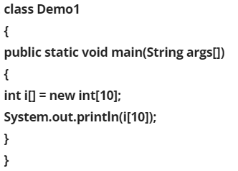

1. 0
2. Out-of-bound exception
3. Garbage value
4. Error
5. **_________________ is a collection of elements used to store the same type of data.**
6. Array
7. Switch
8. Loop
9. Case
10. **For the array:**

**int stats[3];**

**What is the range of the index?**

1. 0 to 3
2. 0 to 2
3. 1 to 3
4. 0 to 4
5. **int [] nums = {2, 3, 5, 8, 9, 11};**

**How would you access the fourth element in nums?**

1. nums[3]
2. nums[4]
3. nums(3)
4. nums(4)

1. 1
2. 2
3. 3
4. 4
5. **double [] average = new double [20];**

**average[20] = 15.25;**

1. A cast is required
2. data not initialized
3. A two-dimensional array is required
4. Array Out-of-bounds error

1. Same
2. Not same
3. Error
4. **An array uses ____________ indexing to keep track of each memory allocation unit in the array.**
   1. one-based
   2. zero-based
   3. 10-based
   4. 100-based
5. **Which statement is not true in java language?**
   1. A public member of a class can be accessed in all the packages.
   2. A private member of a class cannot be accessed by the methods of the same class.
   3. A private member of a class cannot be accessed from its derived class.
   4. A protected member of a class can be accessed from its derived class.
   5. None of the above.

**Programming Questions:**

1. **Print all the even and odd numbers from a list of arrays in the range 0 to 10 like:**

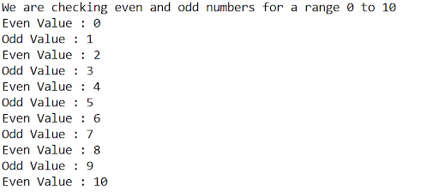

* 1. Create arraylist1 with the following names: Olivia, Emma, Ava, Charlotte, Sophia
  2. Create arraylist2 with Noah, Liam, William, Mason, James
  3. Marge arraylist2 to array list1
  4. Sophia name has spelling error. Update it with Sophie
  5. Add Anne in between Ava and Charlotte
  6. Check if the arraylist1 contains the name Liam?
  7. Check if the arraylist1 contains the name Sam?
  8. Remove Emma from the arraylist1
  9. Check the size of the array list
  10. Loop through the array list and print each of the entries along with its index using for loop and for each loop.

