**Lab 3**

**Programming Fundamentals (CS-130-02)**

**CS 130-02 Fall 2022 Total=100**

Open Eclipse IDE and create a new class for each of the following questions:

**Question 1. Write the code that will print the pattern exactly as the following example: (Only use the print method) 10 points**

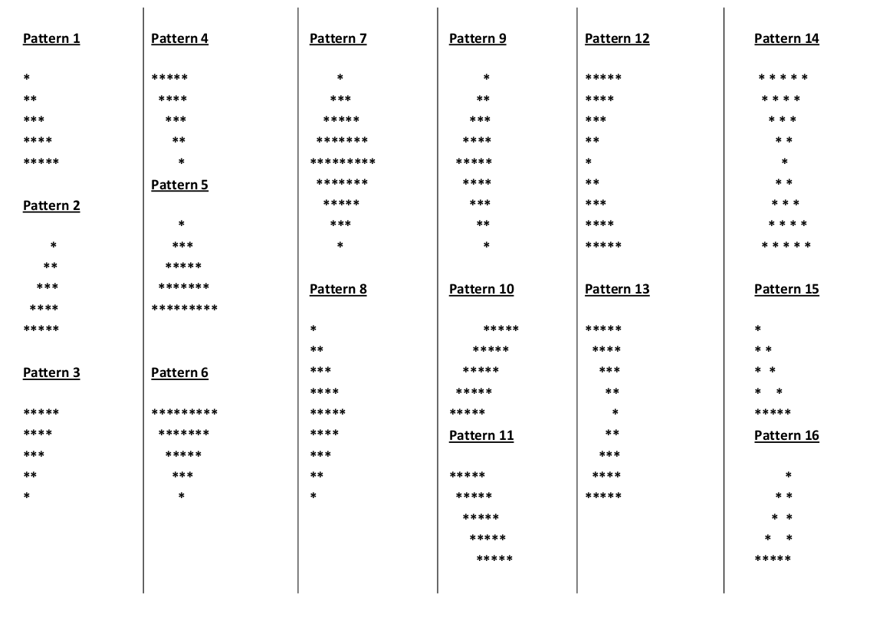

**Question 2. Write a program that will convert an integer number to double using automatic conversion and convert the double back to float then convert it back to int using explicit conversion. Integer 🡪 Double 🡪 Float->Integer**

**Your program should produce the following output:**

**Class name: AutoExplicit**

**The integer number is 30**

**The double number is 30.0**

**The floating point number is 30.0**

**The integer number is 30**

**Question 3. Write a program that will prompt for three integers and print their average.  Your program should produce the following output:**

**Enter the first integer number: 1**

**Enter the second integer number: 2**

**Enter the third integer number: 3**

**You entered: 1, 2, and 3.**

**The average is 2**

**Question 4. Write an application that asks the user to enter two floating point numbers and prints their sum, difference and product using assignment operator (+=, *=).**

**Your program should produce the following output:**

**Class name: FloatMath**

**Enter the first floating point number: 29.7  
Enter the second floating point number: 32.8  
The sum is 62.50  
The difference is -3.10  
The product is 974.16**

**Question 5. Write an application to calculate the MPG for a tank of gas for a car. Prompt the user for the number of miles driven and the number of gallons of gas in the tank.  Below is a sample of your output:**

**Class name= MilePerGalon**

**Enter the number of miles driven: 340   
Enter the number of gallons in the tank: 15   
The MPG is 22.666666666666668.**

