Project 2: 200 points

1. **Automated ATM machine**

The main features of the project are:

1. Create an automated application with user’s account and password,
2. Create bank account (Checking/ Saving),
3. Withdraw (if no money let the user know),
4. Deposit money into the account (Checking/Saving) based on user choice,
5. View account balance

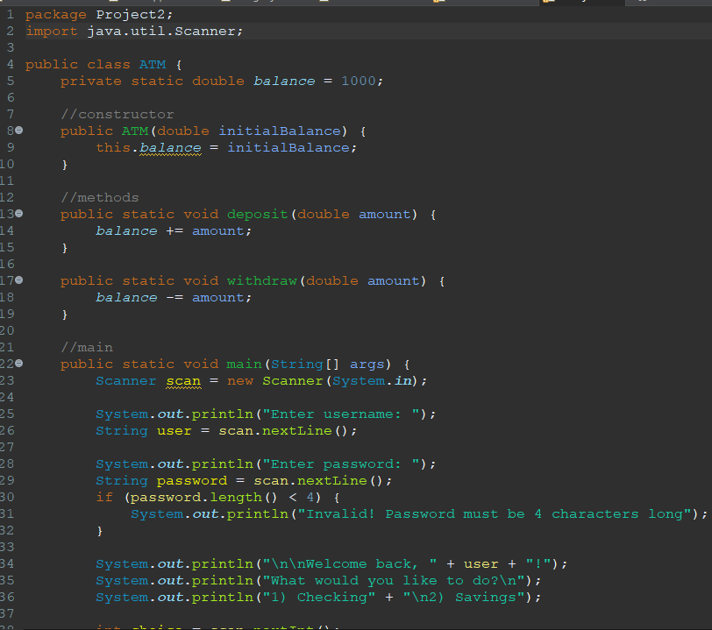

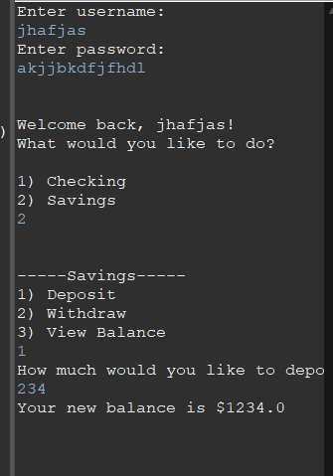

1. **Employee Management System**

The main features of the project are:

1. Adding a new hire employee details like name ,ID, contact, etc. into your system.
2. Searching an employee from the Data in Files of organization based on unique id.
3. Editing the details of the employee like salary, contact no, mail-id etc.
4. Displaying the working employees associated with an organization.
5. **Management of Flight Booking: Delta airlines at SDF airport**

The main features of the project are:

1. Display all the available routes direct from Louisville
2. Display the average price of tickers based on how many days after the person wanted to travel
3. Book the flight for the person
4. Display all of the ticket booking information
5. Add a cancellation policy
6. **Online Bookstore**

The main features of the project are:

1. Display all the available items with prices based on different categories like (textbooks, t shirt, mug..) in the bookstore
2. A person is select an item (or more), add the item in the cart (think about a list for multiple items)
3. Ask the person to pay that amount by selecting (Cash/Credit/debit)
4. After payment complete generate a record of the purchase history
5. **Food delivery Application**

The main features of the project are:

1. Ask the user pickup or delivery
2. Give a list of restaurants
3. After selection of restaurant give list of at least 15 different food items
4. Ask the person to pay that amount by selecting (Cash/Credit/debit)
5. After payment complete generate a record of the purchase history

**You can always elevate your project. The project presentation 04/12 during lab time**