Ethan Horrigan

project design

Ethan Horrigan | G00350712

# Project Description

# CalPlan is a Calorie Planner which generates a meal plan depending on your BMR (Basal Metabolic Rate) aka Calorie Intake per day.

# This app calculates your BMR & then generates a meal plan (Breakfast, Lunch & Dinner) depending on your BMR.

## features

User enters Gender, Age & Weight to calculate BMR using formula adapted from: <https://www.bodyandsoul.com.au/nutrition/nutrition-tips/this-is-the-correct-amount-of-calories-you-should-be-consuming-a-day/news-story/3353257b266ea8c1a316c9c2ade5493c>

The BMR is then used to make a search to generate a meal plan depending on your BMR.

e.g.

Breakfast, Lunch & Dinner plan will be generated without exceeding your BMR.

## API

I plan on using Spoonacular API to get data to allow me to generate meal plans.

**https://spoonacular.com/**

## Other resources

Photoshop –

Creation of the Logo



Adobe Color

Color Scheme

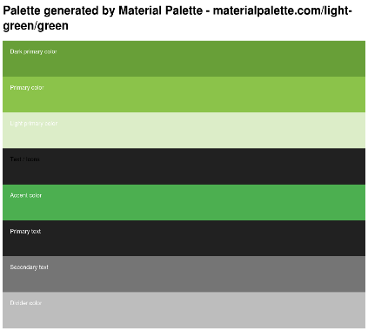

## Design

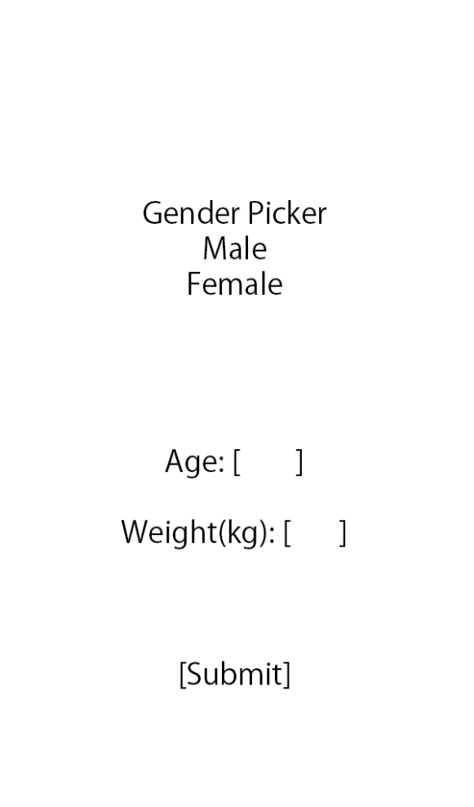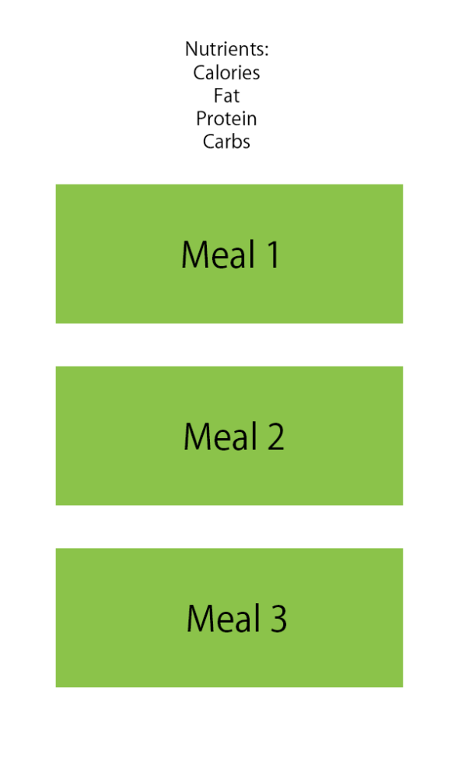

## Additional notes

When first deciding what to create, I wanted to create something that would benefit me personally, something that I would use.

As I brainstormed, I came up with this idea to help me generate meal plans with the click of a button, every time it generates a meal plan its always different.