
AIRMATE
Advanced Remote Air Testing Equipment
Ethan Huang | 1/1/23 | NZQA Scholarship Digital Technology

Contents
Abstract 3
Background 3
Causes and Effects of Bad Air Quality 3
Air Quality Taxonomy: Pollutants and Factors 3
Particulate Matter 3
Volatile Organic Compound (VOC) 3
Carbon Oxides 4
Temperature and Humidity 4
Causes 4
Effects 4
Stakeholders and Concerns 5
Government 5
Education Institutions 5
Companies 5
Individuals 6
Problems with the Current Solution 6
Assumptions 6
Current Practice 7
Description 7
Advantages 7
Disadvantages 7
Why is High Spatial Resolution Important? 7
Are There Air Quality Variances in Space? 8
Home 10
Hardware Store and Auto Parts Store 12
School 17
Vertical Dimension 19
Conclusion 19
Proposed Solutions 20
Implementation 22
Planning – Automated Mobile System 22
Mobile Platform on Wheels 22
Drone/Quadcopter 23
Development 24
Why DIY Drone? 24
Parts Selection 24
Building 25
Integration 26
Testing 26
Deployment 26
Evaluation 27
Stakeholder Feedback 27
Personal Reflection 27
Improvements 27
Appendix 27
A: Portable Sensor Unit 27
Component Research 27
Individual Sensor Testing 31
Prototype 33
B: Data Gathering and Processing 39
Data Gathering 39
Data Processing 41
C: Iterative Design Process 45
Sensor Grid Drops Down 45
Sensor Grid in Walls 47
Crowd Sourcing 47
Automated Mobile Air Quality Sensor 48
D: AIRMATE 49
References 49

Abstract
Air quality is a measure of its suitability for breathing. Good air has a low concentration of particles and chemical pollutants, excess of which can cause long-term and short-term adverse health effects. Measurements of air quality are crucial for making informed decisions. However, current practices of monitoring air quality could improve their spatial and temporal resolution. These limitations, in turn, limit precision in decision-making. Low-resolution measurements also limit analytical models used for planning and design. Although higher resolution measurement is possible, it is constrained by its cost, deployment time and engineering impracticality. This article explores potential solutions for understanding air quality at a higher spatial resolution without these limitations.

Background
Pollution occurs when harmful concentrations of particles, liquids and gases are introduced into the environment (Manisalidis, Ioannis, et al.) Unfortunately, as the world develops and access to clean fuels or technologies remains limited, the air will become more polluted. Consequently, avoiding exposure to areas with bad air quality is challenging, whether from ambient air or household air pollution. Widespread exposure has short and long-term health effects. For example, the World Health Organization estimates that “nine out of ten people breathe polluted air.” EHINZ reports 3,317 premature deaths, representing 11% of all deaths in New Zealand in 2016.

Causes and Effects of Bad Air Quality

Air Quality Taxonomy: Pollutants and Factors

Particulate Matter
Particulate matter (PM) are solid and liquid particles in the air, ranging in size but small enough to be inhaled by humans. The most common sources of particulate matter are domestic fires and motor vehicles (EHINZ). Particulate matter smaller than 10 micrometres can penetrate the lungs. Finer particles less than 2.5 micrometres can be absorbed into the bloodstream (Ministry for the Environment).

Volatile Organic Compound (VOC)
Volatile organic compounds (VOCs) are chemicals that easily vaporise in air and dissolve in water. Using automatic insect spray dispensers, cleaning products, and building materials like paints, solvents, and adhesives has increased the concentration of volatile organic compounds in indoor areas (Manisalidis et al.). At the same time, heavy industry emissions also contribute to ambient air VOCs.

Carbon Oxides
Carbon dioxide and monoxides are products when a reactant undergoes combustion, like in gas stoves, engines or industrial processes. Although harmless, higher carbon dioxide concentrations reduce the oxygen available for inhalation. Meanwhile, carbon monoxide binds to haemoglobin, preventing oxygen exchange and transport. The carbon monoxide bond is approximately 250 times stronger than the oxygen bond with haemoglobin (Carbon monoxide poisoning). Therefore, while carbon dioxide is relatively harmless at low concentrations, carbon monoxide can be hazardous even at low levels of exposure.

Temperature and Humidity
The temperature in space will affect the variance in air quality (UCAR) due to the properties of gases and thermodynamics. Warmer air rises near the ground rises, and colder air sinks. This process moves pollutants from the floor to higher altitudes. Therefore, the temperature gradient of a space is directly proportional to the variance in air quality, as it affects the rate at which pollutants rise and fall. Furthermore, greater humidity reduces air circulation, which means more pollutants are trapped in the air (How does humidity affect air quality? all you need to know).

Causes
There are several causes and sources of bad air quality. Ambient sources of air pollution include vehicle emissions, industrial activities, dust, and wildfires. These sources emit particulate matter, nitrogen oxides, and volatile organic compounds. For instance, wildfires can release significant amounts of particulate matter (Wiedinmyer, C., et al.), while industrial activities release volatile organic compounds and particulate matter.
However, the problem is not limited to ambient sources; household sources can also cause bad air. Cooking, heating, smoking, building materials and cleaning products are common sources of indoor air pollution. Gas stoves and heating appliances release carbon, nitrogen, and particulate matter oxides. In contrast, tobacco smoke emits volatile organic compounds and particulate matter. Even e-cigarettes, often touted as a safer alternative to traditional cigarettes, produce aerosols containing nicotine and particulate matter and “low levels of toxins that are known to cause cancer” (Electronic smoking devices and secondhand aerosol - American nonsmokers’ rights foundation). Building materials and cleaning products may also emit volatile organic compounds.

Effects
Inhaling bad-quality air can have short and long-term adverse health effects.
Particulate matter, which can easily penetrate our respiratory defences, can irritate the eyes, throat, and lungs in the short term while worsening existing respiratory conditions like asthma (Why Air Quality Matters). Long-term exposure to particulate matter increases the risk of cardiovascular diseases, lung cancer and infant mortality (How air pollution is destroying our health).
The effects of volatile organic compounds are less well known, given the variety of these compounds. However, common short-term effects may include irritation of the eyes, nose and throat. In contrast, prolonged exposure may involve toxic reactions (Terry Gibb).
Finally, the short-term effects of oxides of carbon are similar. People temporarily exposed to high concentrations of carbon oxides may experience headaches and dizziness. Brief exposure to carbon monoxide may also cause nausea, leading to vomiting and, finally, a loss of consciousness. If people are exposed to carbon monoxide for extended periods, “hypoxia, ischemia, and cardiovascular disease are observed” (Manisalidis et al.).
Exposure to bad air can also reduce attention span, memory recall and concentration.
Consequently, it is estimated that one-third of deaths from stroke, lung cancer and cardiovascular disease are due to exposure to air pollution (How air pollution is destroying our health). In New Zealand, poor air quality is responsible for around 13,000 hospitalisations and cases of childhood asthma (EHINZ).
Air pollutants can settle onto land and water, which plants and animals will absorb. These pollutants will impede plant growth and affect animals the same way they affect humans. Furthermore, these contaminants will eventually end up in humans as they inevitably work up the food chain or through drinking water. High concentrations of bad air may also reduce visibility by scattering or absorbing light, potentially increasing the chances of accidents (Ministry for the Environment).

Stakeholders and Concerns

Government
The government plays an essential role in decision-making. They are responsible for allocating resources and programs to promote healthy living and prevent unnecessary strain on the healthcare system. It is estimated that “the global cost of health damages associated with exposure to air pollution is $8.1 trillion” (World Bank.) The local and national government’s policies directly affect those under their jurisdiction. Therefore, this stakeholder must obtain high-resolution data to make informed decisions on effectively allocating resources.

Education Institutions
Schools are also critical stakeholders since they significantly impact children’s health and well-being. Children are among the most vulnerable stakeholders to the impacts of long-term exposure to polluting air. The United Nations Framework Convention on Climate Change estimates that “polluted air affects more than 90% of children”. With high-resolution air-quality data, schools may make precise decisions that improve their students’ health and alter their activities accordingly.

Companies
In most countries, there are laws to ensure employers protect their employees’ and clients’ health and safety, though to varying extents. Companies can assess the impact of air pollution on their operations and take steps to mitigate it with high-resolution air quality data. This can improve their working environment and customer satisfaction, benefitting the business’s operations. Even from an altruistic perspective, high-resolution data may allow some corporations to differentiate their products and services from competitors and make the claim of having a service with a more significant positive environmental impact. This may attract environmentally conscious consumers and employees, gaining a larger market share.

Individuals
People should be able to make informed judgements since breathing polluted air harms their health. Children and the elderly are the most vulnerable (World Health Organization). Individuals can lower their risk of health problems by making informed decisions regarding their activities and pollution exposure.

Problems with the Current Solution
It is significant to clarify that this paper does not concern any solutions for reducing poor air quality or extensive analysis of potential actions stakeholders can take if they acquire such data. It offers some initial concepts to illustrate the feasibility of utilising high-resolution measurements. Instead, this paper proposes a solution regarding how such data is gathered. The decision to use the data collected is up to the stakeholder.

Assumptions
The cost-benefit analysis of the solutions considers four factors: monetary cost, technical feasibility, practicality and potential externalities. The monetary cost will be the cost of purchasing sensor unit(s), which is approximately $108.03 per unit (refer to the table below), along with the linkage cost. The technical feasibility will consider the cost of data storage and alternative solutions, such as using WIFI to transmit data instead of linkage. Practicality is evaluated by considering deployment time, whether or not sensor units will interfere with useable space and if it is possible to repurpose the sensors for outdoor space usage.
The following table provides a comprehensive breakdown of the costs associated with each component to estimate each potential solution’s monetary cost.
Linkage | $0.60 / m
Arduino UNO (microcontroller) | $48.20 / unit
DHT22 (temperature and humidity sensor) | $2.55 / unit
MHZ19 (CO2 sensor) | $28.73 / unit
PMS5003 (particulate matter sensor) | $22.86 / unit
MQ135 (VOC Sensor) | $1.77 / unit
DS3231 (real-time clock) | $3.32 / unit

This table lists some assumptions made about the sensor and indoor room volume.
Average Room Volume | $$8m×10m ×3m = 240m^{3 }$$
Effective Sensor Unit Coverage | $$0.3m ×0.3m ×0.3m = 0.027m^{3 }$$
The four factors considered will not exhaustively represent every variable, and some crucial aspects may have been omitted or simplified. Nonetheless, these factors will provide a general idea in determining the feasibility of potential solutions and identifying potential bottlenecks that could hinder its success.

Current Practice

Description
The current practice for measuring air quality is installing a single sensor per room or a single sensor to cover every unit space for outdoor locations. While this approach has several advantages, it also has a significant limitation.

Advantages
One key advantage of this approach is that it is the most economical solution. Each sensor unit will cost approximately $108.03, with negligible wiring costs. Furthermore, this results in negligible technical issues. In an average home, there is enough WIFI bandwidth and channels for the sensors to send data to the cloud. If the data is stored locally, the low sensor count means data storage of sensor data will be negligible. Consequently, the current practice can afford a high temporal resolution due to the low storage cost. These sensors are relatively small and do not interfere with usable space, making them aesthetically pleasing.

Disadvantages
However, as mentioned in the assumptions, an air quality sensor’s adequate sensor unit coverage is $0.026 m^{3}$. This means the air quality of an entire space will be approximated and does not accurately represent the quality across the space. The spatial resolution of the sensor is limited.

Why is High Spatial Resolution Important?
Spatial resolution matters as air quality can vary significantly across space due to various factors. The location of pollution sources and how the pollutants move across the space means different areas will be more concentrated than others. This means that depending on the location of the mounted sensor, there is a chance of detecting false positives, even though the air quality elsewhere is fine, or false negatives, where the air quality detected is fine but elsewhere is not. This problem only scales up with space volume. The lack of spatial resolution hampers the ability to pinpoint specific areas of bad air. Identifying local pollution sources and areas will be challenging.
Different stakeholders require high-resolution data for different reasons.
Governments are responsible for allocating resources and programs to promote healthy living and prevent unnecessary strain on the healthcare system. The local and national government’s policies directly affect those under their jurisdiction. High-resolution measurements of air quality data mean that government and local councils can identify the sources and patterns of air pollution in different areas and, at times, precisely map and identify pollution “hotspots”. This allows them to implement measures to reduce emissions, such as building green spaces in areas with high concentrations of pollutants. These measurements also allow the government to evaluate their green policies’ effectiveness precisely. Furthermore, the data gathered can be extrapolated to inform the public about current and forecasted air-quality levels and advise them to avoid certain areas, stay indoors or wear masks. This idea can be extended to targeted messaging of vulnerable groups.
Schools are responsible for the children’s health. Schools can utilise high-resolution measurements to improve students’ health. The data can inform schools regarding the suitability of outdoor activities or the need to adjust ventilation in classrooms, gymnasiums or changing rooms. At a minimum, it can inform the schools when and when not to open windows to improve indoor air quality. Schools can use this data to identify and adapt the ideal learning environment.
Companies are responsible for their employees’ and clients’ health. High-resolution data benefits businesses as it allows them to identify and resolve sources of pollution, resulting in a healthier and potentially more productive workforce by reducing health issues stemming from poor air quality. Services can gather high-resolution air quality data, which can help promote greater accountability regarding environmental regulations. Furthermore, high-resolution data can foster innovation, allowing businesses to create goods and services that aim to address air quality concerns.
Finally, individuals should be able to make informed judgements since breathing polluted air harms their health. High-resolution measurements mean they can plan their activities according to their location’s current and forecasted air quality levels. It can inform individuals whether or not to wear masks, use air purifiers, stay indoors when there is terrible air or even where to avoid in a building or outdoors.

Are There Air Quality Variances in Space?
A case has to be made on whether or not air quality varies between spaces and times. A portable sensor unit can be constructed and manually conduct systematic air quality measurements across different spaces. Analysing the data will enable us to determine the extent of variance in air quality across space, observe potential patterns and determine whether or not it is necessary to pursue further research and solutions.
The table below is a brief overview of the components. The portable sensor unit’s design, testing and integration will be discussed in Appendix A.
Component | Function
Microcontroller | Reads sensor data and saves data to SD card
Temperature and Humidity Sensor | Records temperature and humidity
CO2 Sensor | Records CO2 concentrations
VOC Sensor | Records VOC concentrations
Real-Time Clock | Records timestamps for data logging
SD Card Reader | Interfaces SD card with microcontroller

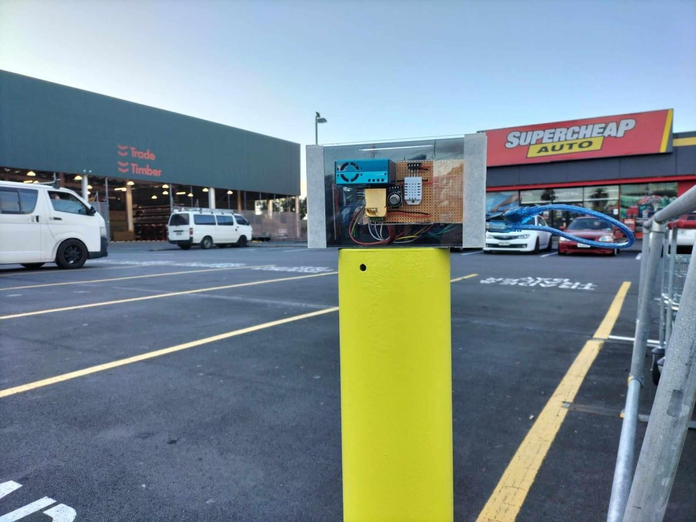
The image below is the completed sensor unit.
Various sensors are continuously collecting diverse data points. A pollution concentration index derived from a weighted combination of sensor readings will serve as the benchmark to assess relative air quality in different environments.
The formula gives the pollution concentration index:
$$PCI = 0.05*Temperature+0.2*Humidity+0.5*VOC+0.1*CO2+0.7*PM1.0+0.4*PM2.5+0.3*PM10$$
By recording timestamped GPS coordinates from the phone, it is possible to match the sensor data with location information. Air quality data has been gathered from the following locations: home, school and hardware stores.
Data gathering and processing will be discussed in Appendix B.

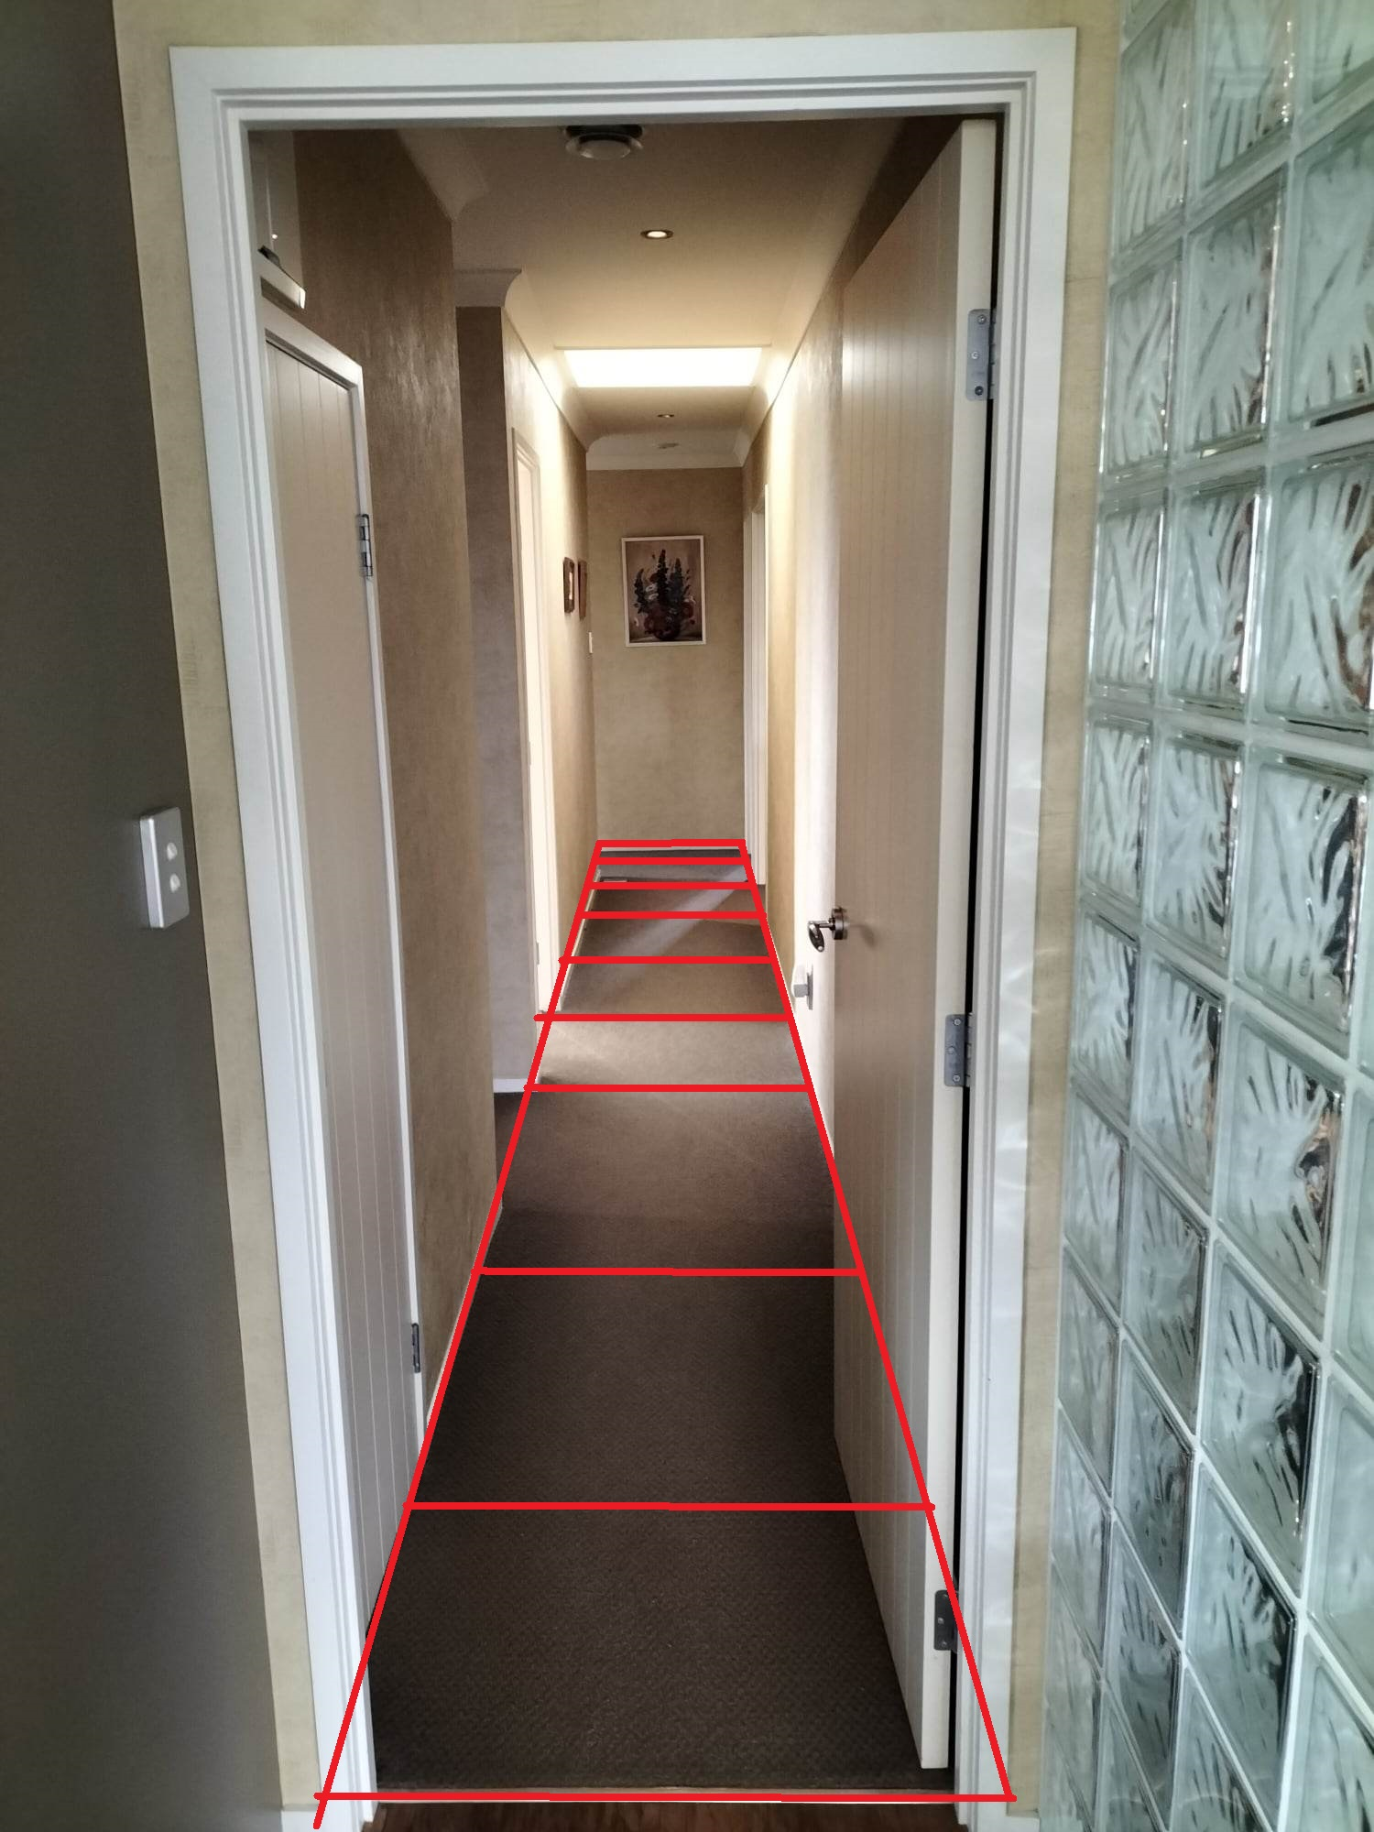
Home
The air quality measurements at home resulted in the following pollution concentration index. The sensor took periodic readings at each section, marked by the red grids in the photo. For graph understanding purposes, section one is the red box the furthest away from the camera, and section eight is the red box closest to the camera.
One key detail to note is that the air quality readings were taken when cleaning was happening around the house. This home measurement aims to see if there are variances in air quality in adjacent spaces. If the hypothesis is confirmed, we should see significant changes in the pollution concentration index due to changes in VOC for easy analysis. If there are no air quality variances, we should expect the pollution concentration index to remain steady.
The table below is the average data for each section.
Temperature | Humidity | VOC PPM | CO2 PPM | PM1.0 ug/m3 | PM2.5 ug/m3 | PM10 ug/m3 | PCI
22.28 | 61.31 | 266.88 | 1399.85 | 0.05 | 0.05 | 2.90 | 287.726
22.44 | 60.95 | 248.52 | 1026.65 | 0.00 | 0.45 | 2.95 | 241.302
22.61 | 60.64 | 295.82 | 1209.35 | 2.00 | 6.15 | 6.15 | 287.8085
22.82 | 60.45 | 417.71 | 881.60 | 0.35 | 3.90 | 3.90 | 313.221
23.04 | 59.85 | 459.84 | 761.55 | 1.00 | 1.35 | 1.35 | 320.842
23.21 | 60.01 | 927.60 | 729.10 | 0.55 | 1.85 | 3.35 | 552.0025
23.40 | 59.75 | 1256.28 | 825.60 | 4.10 | 8.85 | 9.75 | 733.155
23.61 | 58.71 | 1354.25 | 774.65 | 1.60 | 4.25 | 6.20 | 772.1925
23.79 | 57.72 | 838.60 | 677.00 | 1.15 | 2.65 | 3.75 | 502.7235

The graph below shows the variances in the pollution concentration index.
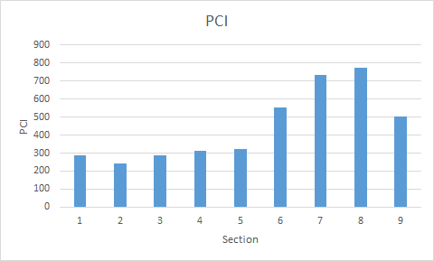
The graph notes that the pollution concentration index from sections one to five remains constant. However, from sections six to nine, there is a sudden change in the pollution concentration index. This shows that there are variances in air quality within space. This corresponds to what was happening on that day as well.
Section six is next to the bathroom. The bathroom was cleaned a few minutes ago with chemicals that contain volatile organic compounds. The table shows that the volatile organic compound concentration doubled, from 459.84 ppm to 927.60 ppm.
Section seven is next to the laundry room, where all the volatile organic compounds are stored and used. The sensor has correctly measured a further increased concentration of volatile organic compounds.
Sections eight and nine started approaching the wooden floor not shown in the picture. The chemicals were also used to clean the wooden floor, and the air quality measurements reflected this.
The lack of temperature, humidity and carbon dioxide variances is trivial and requires no analysis. However, there is no clear explanation for why particulate matter concentrations vary. One possible explanation may be that this area has been vacuumed before measurement, which may have disturbed the dust particles.
This experiment has proven that there can be variances in air quality within a small space. However, due to the unique experimental conditions (during cleaning), variances in air quality are almost guaranteed. In most cases, there may not be a drastic difference in air quality in small spaces; therefore, further testing and analysis must be conducted.

Hardware Store and Auto Parts Store
The point of this investigation is to see whether or not there are variances in air quality for large indoor spaces. A hardware store was chosen as businesses were one of the essential stakeholders discussed before. It is a well-known fact, and from personal experience, that hardware stores have less-than-ideal air quality conditions. However, no work has been done to quantify it.
The air quality measured will be at a large hardware store franchise and the auto parts store next door.

The auto parts store primarily sells various chemicals (volatile organic compounds). From the graph above, it is reasonably apparent which sections represent auto parts stores. The pollution concentration index peaked near 11600. The space outside had a pollution concentration index of around 200. This meant the air quality within Supercheap Auto was approximately sixty times worse than outdoors. Due to the abnormal, though expected, values of auto parts store, most data points are no longer visible. Therefore, A more detailed analysis should be conducted at a more micro-scale. The graph will be split into four sections: the pollution concentration index inside the hardware store, the walk to the auto parts store, the auto parts store, and the outside of the auto parts store.
Inside the hardware store, there are two noticeable peaks. The two peaks identified from the data processing pipeline were when the sensor was at the woodworking section. The high particulate matter concentration from all the wood dust led to a high pollution concentration index.

However, these two abnormal peaks meant other data points became invisible. Removing the two peaks and analysing points 0 to 2400 yields hidden details. As seen in the graph below, there seems to be a periodic increase in the pollution concentration index. While there are no explanations for this periodic pattern apart from the distinct route taken when measuring the air quality resulting in this pattern, this pattern does prove that there are variances in air quality in small spaces.

On further analysis, the periodic difference in air quality can be justified by the layout of the hardware store. As mentioned in Appendix B, the sensor moved across the aisles, as seen in the store map.
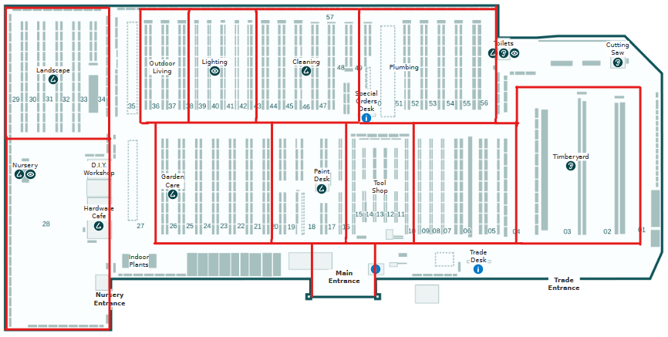
Traversing each aisle within the hardware store reveals a distinct pattern in the concentration of airborne pollutants, characterised by an initial ascent, a peak concentration at the midpoint, and a subsequent decline. Conversely, the sensor’s exposure to pollutants is notably limited when progressing across the aisles within communal areas, owing to enhanced air circulation. This discrepancy can be attributed to the enclosed nature of traversing aisles, wherein the sensor becomes enshrouded by more pollutants. As one enters the aisle, the envelopment of pollutants around the sensor remains relatively constant due to the constrained measurement area. However, the air inflow from the shared space between aisles decreases when one walks further into the aisle—consequently, the pollution concentration increases as the airflow does not blow away. With this logic, we should expect the centre of the aisle, the location that experiences the least airflow, as it is furthest away from the shared space, to have higher concentrations of pollutants. Upon walking towards the aisle’s exit, analogous principles apply, akin to the conditions observed upon initial entry. The pollution concentration index graph supports this hypothesis. Matching the data points of one of the periodic readings with the location information confirmed this theory.

The air outside the hardware store while walking towards the auto parts store remained relatively constant.

Not much data analysis is required for the auto parts store. This is because the pollution concentration index is so large any variances in the air quality inside the store has little to no effect.

As the sensor left the auto parts store, the PCI immediately decreased, eventually converging to 250. This meant the air outside the auto parts store was approximately the same as outside hardware store. This may initially seem counterintuitive given the high concentration of pollutants in Supercheap Auto; however, it is expected behaviour. Inside the auto parts store, there was barely any ventilation. This meant it was hard for the volatile organic compounds to diffuse into the surroundings unless the door was opened.

School
The point of this investigation is twofold: to see whether or not there are variances in air quality in outdoor spaces and to see whether or not there are variances in air quality indoors under normal conditions. The home experiment only showed variances during cleaning. This investigation will measure air quality during a typical day. Schools are one of the important stakeholders.
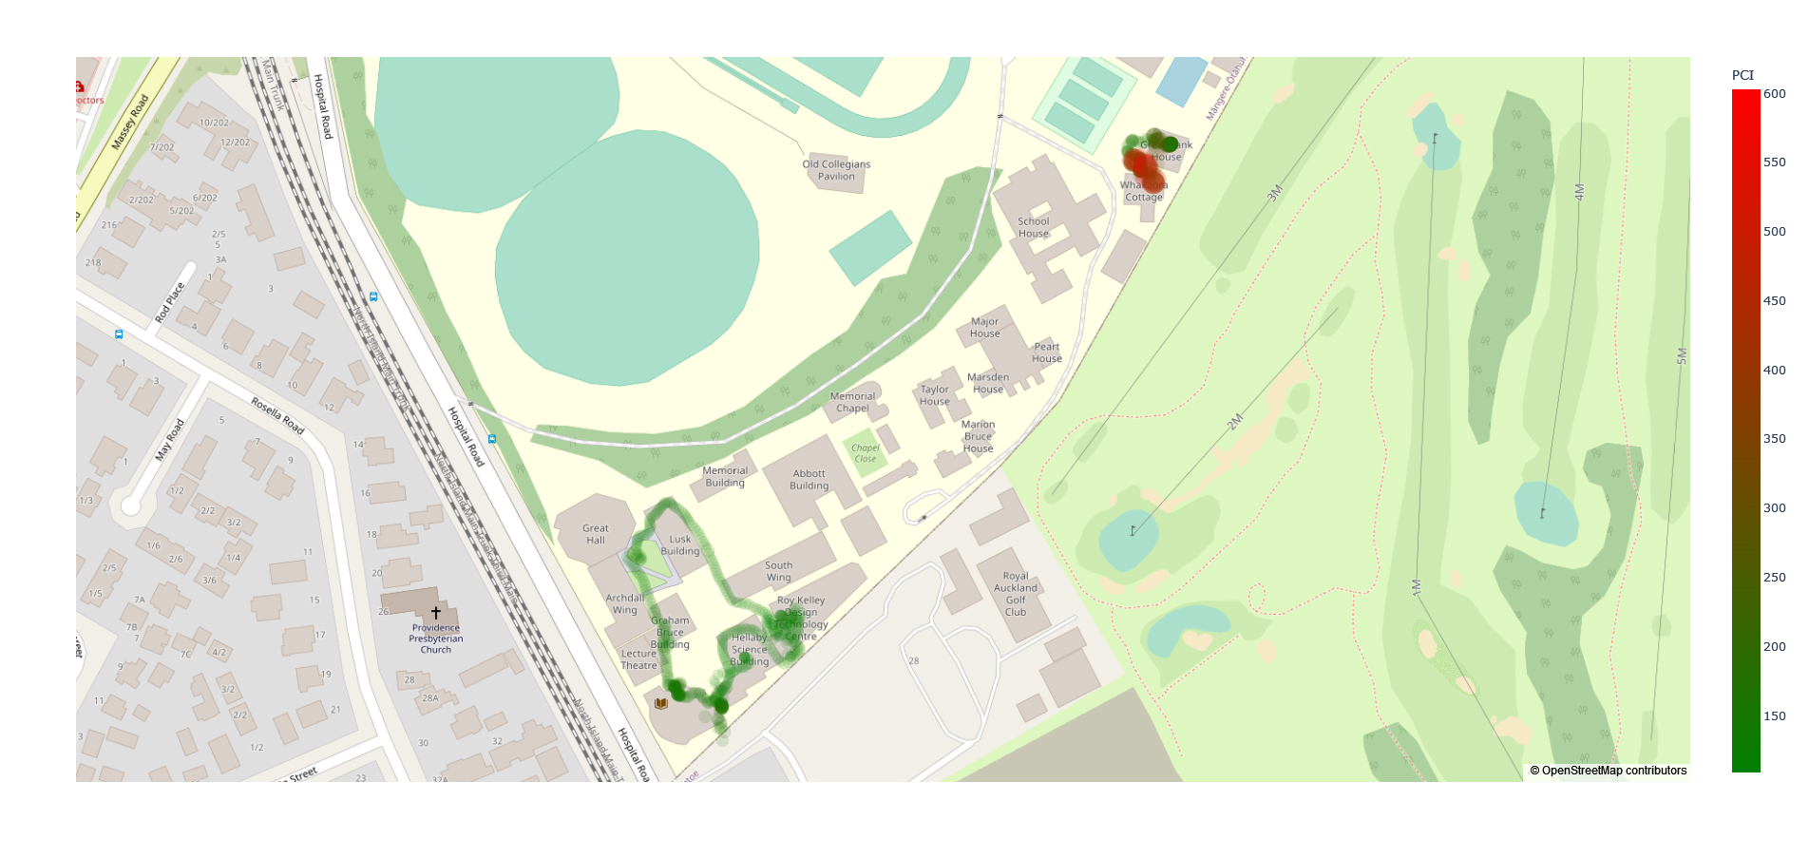
From the image above, it is clear that there are distinct sections of drastically varying air qualities in a large area. A more detailed analysis should be conducted at a more micro-scale. At the macroscale, there will always be variances in air quality.
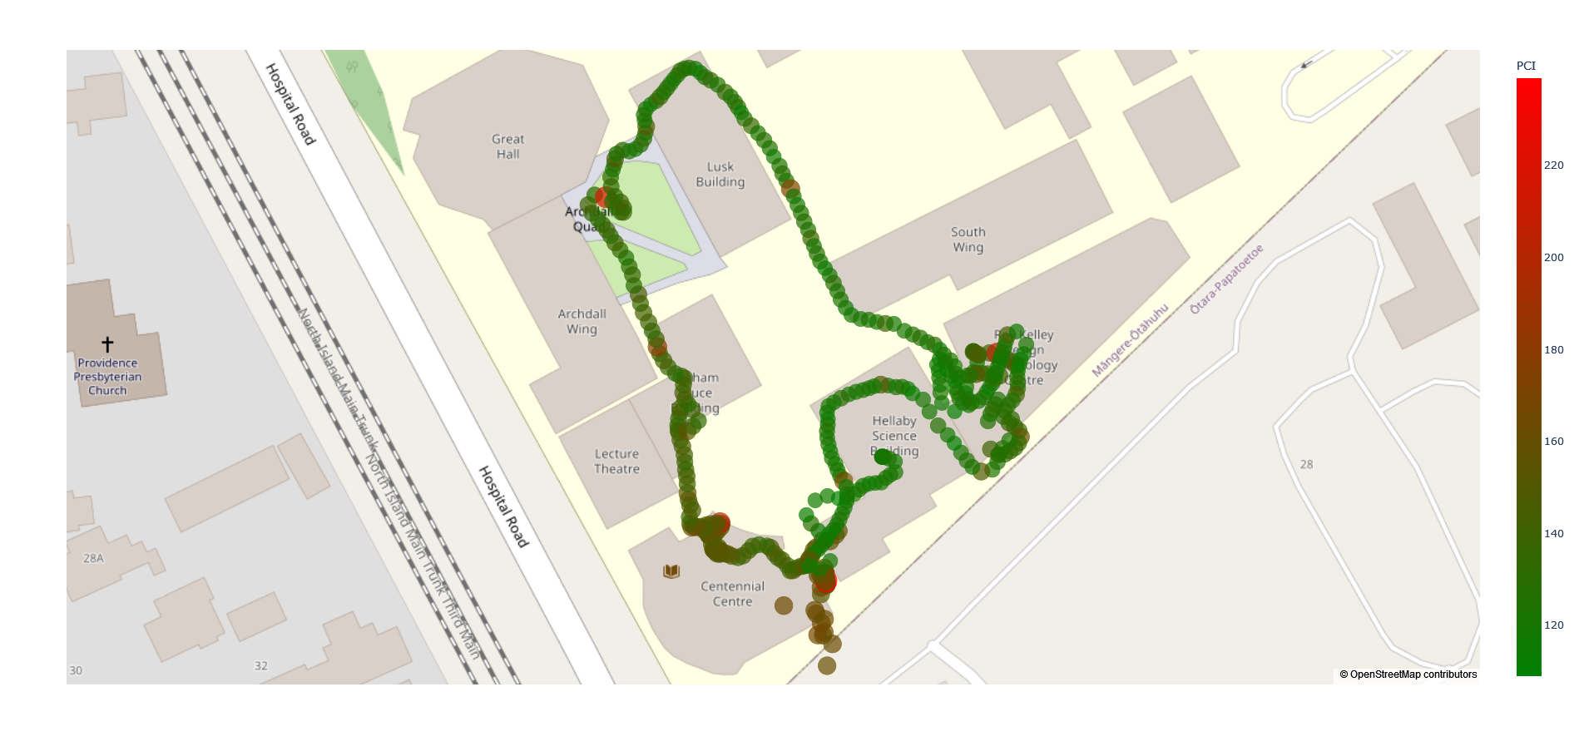
The trail on the map shown is all the data points the air quality sensor measured when walking around the central area of the school. To interpret the data, the redder the point is, the greater the pollution concentration index, the worse the air quality. From the picture above, it can be noted that there are distinct sections where there are variances in air quality.
Starting from the top left corner, around the Great Hall area, there is a distinct red point surrounded by off-green data points. This coincides with what is happening, which is a construction of a new building in that area. Following the data points around the Lusk building, the air quality gradually becomes better as it becomes further away from the construction. However, there is a single point of bad air, which could not be explained.
The next section of bad air quality is around the technology building. Again, this coincides with reality as there is much woodworking in the technology building, thus higher concentrations of particulate matter. Although this graph does not show this, the sensor measured values of the art department, which is on the third floor of the technology department building. The paints may have contributed to less-than-ideal air quality in this section.
Finally, around the Centennial Center, the air quality was consistently worse than elsewhere. However, there was nothing the source of pollution could not be pinpointed. A hypothesis of why air quality is terrible around here maybe because it is relatively close to Hospital Road. This means car emissions may drift towards the school. This hypothesis is partially supported by the fact that subsequent data points close to Hospital Road are distinctly worse than data points further away from the road. If this is the case, this is particularly concerning for pre-schools situated right next to busy roads. As discussed previously, younger children are at risk.
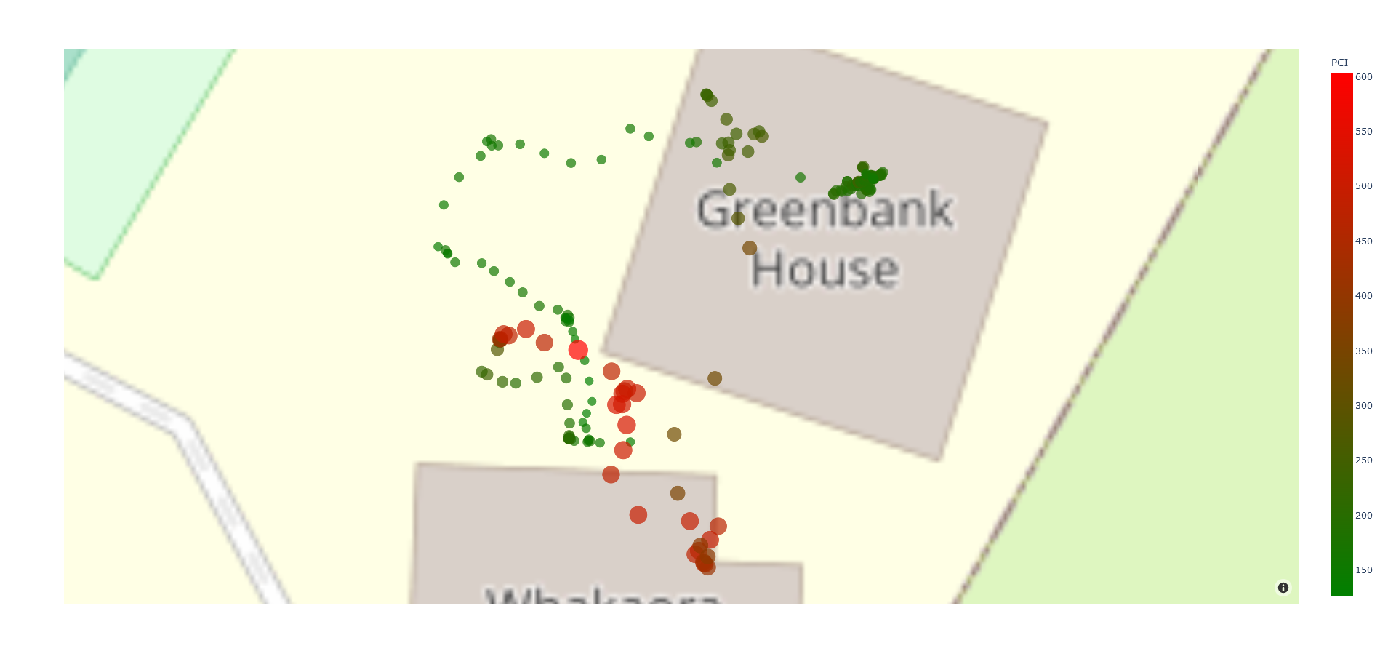
Analysing the Greenbank area, we notice less-than-ideal air quality around certain areas inside the house. From the image, the left side of the house, where the bad air is, is the bathroom and the lockers. Other places inside the house are fine.
The place of concern is the area outside of the house. However, there was nothing noteworthy to justify the immediate increase in air quality. Since the air quality sensor has consistently shown expected data, the most likely explanation is that there may be an error in the GPS. GPS has an error of around 5 meters. However, if this were a GPS error, then the air quality measurements would correspond to spaces inside the house, which is equally as concerning.

Vertical Dimension
The point of this investigation is to determine whether or not air quality varies with height. If it did not, then proposed solutions do not need to consider the third dimension, increasing simplicity and reducing cost.


Conclusion
Through this investigation, one can confidently argue that there are indoor and outdoor air quality variances.
However, as the graph on the left notes, if we look at all the points indoors, variances in air quality are negligible. This partially disproves the investigation of a corridor at home. Indoor air quality does not vary as much during everyday use and will only vary if there are other factors, such as ongoing cleaning. Approximate the air quality of an average-sized room with a single sensor is acceptable. However, if we look at different places indoors, there are still noticeable changes in air quality. The air quality in the Lusk building is very different from the air quality in the technology building, which is also different from the air quality in the science building and the Centennial building. Therefore, an assertion can be made that there are negligible variances in air quality for an average room size. The data in the hardware store further proves that while each individual room may have negligible air quality variances, it can still be very different in separate rooms.
Meanwhile, outdoor measurements can vary dramatically depending on different factors such as construction, wind and traffic conditions.

Proposed Solutions
Since there are many approaches to this problem, an iterative design process will be implemented where a series of iterations of solutions attempt to improve on prior ones by addressing their shortcomings. In this design process, each major design iteration attempts to refine the solution by adjusting the variables to maximise the advantages of current practices and high-resolution measurements while minimising the disadvantages, like a gradient ascent algorithm. Eventually, this process aims to converge at an optimal high-level solution that effectively balances the costs and achieves the desired outcomes. From then on, further refinements on the high-level solution can be made.
The table below demonstrates the benefits and limitations of each proposed solution. Refer to Appendix C for detailed analysis of each solution. For the cost, the greater the number, the more the solution costs. The current practice will be given a cost and resolution value of 0. Subsequent solutions will be given a score relative to this baseline. For resolution, the greater the number, the higher the resolution. Kill factors are the reasons why this idea was not acceptable.
 | Cost (0-10) ∞ represents impossible |  |  | Resolution (0-10)
Idea | Monetary | Practical | Technical | Spatial | Temporal | Kill Factor
Current Practice | $108.03 | 0 | 0 | 0 | 0 | Spatial resolution  Temporal resolution
A sensor in every cubic inch of space | $960398.35 | ∞ | ∞ | 10 | 10 | Monetary cost  Practicality cost  Technical challenge
Sensor grid drop-down | $97534.79 | 10 | ∞ | 10 | 5 | Monetary cost  Practicality cost  Technical challenge
Sensor grid in walls | $3889 | 7 | 5 | 5 | 10 | Practical cost - localised sensor units
Crowdsourcing | $108.03 x n | 2 | 1 | 8 | 5 | Practical cost - not automated
Mobile air quality sensor | $500.00 | 2 | 1 | 8 | 5

We encounter a trade-off between cost and spatial resolution. Localised sensor installations incur cubically increasing costs as the number of sensors increases. The number of sensors has to decrease to reduce cost, and data has to be extrapolated. However, localised sensors do not address the outdoor measurements, as they are fixed in one position. If we make the sensors mobile, they can capture data outdoors. While there may be a decrease in temporal resolution due to dead spots when moving, it remains comparable or better than extrapolating data due to higher spatial resolution measurements. Moreover, employing robotic systems minimises human involvement.
For indoor measurements, unless the space of a room is huge or is undergoing cleaning, the analysis in the previous section shows that variances in air quality for most of the time are minimal. Therefore, the necessity for numerous sensors in a space may be debatable for everyday use. It can be argued that a health-conscious user could install a single air quality sensor in each room for regular use. This is the case with Ormiston College. Every classroom in that school has an air quality sensor installed, though the purpose remains unclear. The only use case for high-resolution data may be to identify areas of high pollution concentration at one time. Through careful analysis, it becomes evident that the current practice aligns with the most economical approach from a business perspective while the science also supports the business justification.
Therefore, the solution of data measurement will only concern outdoor air quality measurements. The mobile air quality sensor excels in this respect.

Implementation

Planning – Automated Mobile System
There are many possibilities when considering making the air quality sensor mobile. Therefore, the section “Are There Variances in Space” and Appendix C will outline a similar iterative design process.

Mobile Platform on Wheels
A platform can move around by controlling its motors. The sensor will be mounted on the platform, enabling it to move across space. The advantage of a wheeled platform is the ease of development and adaptability. Building such a mobile platform and mounting a sensor on it is trivial, and many off-the-shelf solutions for a mobile platform may already exist.
However, there are limitations to this solution. One of the significant limitations of a mobile platform on wheels is its dependence on design, which can restrict its ability to traverse certain terrains. The wheels’ configuration and size may not be suitable for rugged or uneven landscapes, limiting the platform’s mobility in such environments. This can lead to incomplete data collection, as the platform might struggle to access critical pollution sources hidden in challenging terrains. Additionally, the platform’s performance could be compromised in adverse weather conditions, affecting its effectiveness during rain, snow, or extreme temperatures.
Another notable disadvantage of the wheeled approach for air quality monitoring is its confinement to a specific space. A wheeled platform’s movement is inherently limited by its distance and the speed at which it can reach various points within that space. This spatial confinement can affect the comprehensiveness and accuracy of air quality data collection, especially in scenarios where pollutants disperse over larger areas or are influenced by factors beyond the platform’s restricted range.
When monitoring air quality in urban or industrial settings, pollutants often spread across substantial distances, influenced by wind patterns, topography, and pollution sources. A wheeled platform’s limited mobility might hinder its ability to effectively capture these dispersion patterns over significant distances. Moreover, the constrained speed of the platform can impact the efficiency of data collection, potentially leading to delayed or incomplete readings.
To mitigate these limitations, one might need to deploy multiple wheeled platforms strategically across the monitored area. This approach, however, introduces additional complexity regarding coordination, synchronisation, and data integration from various sources. Ultimately, while a wheeled platform can offer valuable insights within its confined space, it may struggle to provide a comprehensive picture of air quality dynamics across larger areas that demand swift and versatile mobility.
Furthermore, the sensor has to be mobile on the z-axis. This requirement necessitates a mechanism for the sensor to move up and down. However, this introduces challenges when considering both lift height and the practical constraints of the platform’s design.
Incorporating a lift to achieve vertical movement can be cumbersome. The lift’s height becomes a limiting factor in the maximum altitude at which air quality data can be collected. Suppose the lift height is insufficient to reach the desired monitoring altitude. In that case, the platform’s effectiveness in assessing higher-level pollution patterns is compromised. Furthermore, even if the lift height is adequate, the sensor’s dimensions and mechanism become concerning. For instance, a screw lift similar to those found in 3D printers could lead to an impractical design, with the height of the platform dictating the maximum altitude that can be measured. This becomes especially problematic if the goal is to measure air quality at human head height, resulting in a platform design that is bulky and unwieldy.
Scaling this approach to reach higher altitudes becomes increasingly challenging. The size and weight of the lift mechanism would grow proportionally, affecting the platform’s mobility and stability. While alternatives like scissor lifts might mitigate some size constraints, they introduce new complexities. Extending the lift’s reach would require longer scissor arms, contributing to added weight and compromising the platform’s manoeuvrability.
In conclusion, the limitations of a wheeled platform are the inability to traverse across different terrain, the distance it can travel and the cumbersome nature of lifting the sensor on the z-axis. Fortunately, all these issues could be addressed with a drone.

Drone/Quadcopter
A quadcopter is an unmanned helicopter with four rotors. The quadcopter can carry a payload, such as the air quality sensor. The advantage of the quadcopter is that it mitigates all the problems experienced by a wheeled platform.
One of the primary advantages of using a drone is its ability to effortlessly navigate in the z dimension. Unlike a wheeled platform that requires intricate lift mechanisms, a drone can ascend and descend rapidly, enabling it to capture air quality data at various altitudes. Furthermore, drones can easily reach higher altitudes, even beyond human height, providing insights into pollution dynamics that ground-based sensors cannot capture. This eliminates the need for complex lifting designs and ensures that pollution patterns at different heights can be accurately assessed.
Drones also excel at overcoming spatial constraints. They can cover large distances in shorter time frames, making them well-suited for monitoring air quality across expansive areas. Unlike wheeled platforms confined to specific spaces, drones can traverse diverse environments as they fly over them, including rugged terrains, urban landscapes, and remote regions. This versatility starkly contrasts wheeled platforms, which might struggle with specific geographies, limiting their access to critical pollution sources. This capability ensures that pollution sources and dispersion patterns are comprehensively captured, providing a more accurate representation of air quality dynamics.
One potential drawback of using drones for air quality monitoring is the disturbance caused by the drone’s propellers. The air currents generated by the propellers could alter the surrounding air composition, potentially affecting the accuracy of air quality measurements. However, this concern needs to be evaluated in context. Studies, as outlined in the Development section, could be conducted to determine the extent of this disturbance and its impact on data accuracy.
One can conduct controlled experiments to measure the magnitude of air disturbance caused by drone propellers to mitigate this issue. By comparing the resulting air quality data with ground-based measurements, it’s possible to assess the significance of this disturbance. Furthermore, if there are significant disturbances, measuring the air quality manually with and without a drone is possible. From the difference in values, a relationship may be established. Therefore, the “incorrect” air quality readings could be converted into an approximate value. Also, the variance of the air quality will not change as the drone will disturb the air in the same way at each point it samples air quality. The relative air quality can still be found if calibrated.
Another potential limitation arises from a drone’s payload capacity. Depending on the size and model of the drone, there might be constraints on the weight of the sensors and equipment it can carry. This could limit the complexity and number of sensors deployed on the drone, affecting the comprehensiveness of air quality measurements.
To address this issue, one can explore ways to enhance a drone’s payload capacity. This might involve using more powerful motors or optimising the drone’s design to support additional weight. Alternatively, considering lighter and more compact sensor technologies can help maintain the drone’s ability to carry a meaningful payload without compromising its flight stability.

Development

Why DIY Drone?
From the previous analysis, a drone is more suitable for making the air quality sensor mobile. While buying an off-the-shelf drone and securing the air quality sensor within budget constraints is possible, the drone will not have significant payload-carrying capacity. Furthermore, there will be no software integration between the drone and the sensor unit. This factor will be explored in the following paragraphs.
A DIY drone kit will be used. These kits typically include all the essential components necessary to construct a functional drone, simplifying the process and eliminating the need to source parts individually and check for compatibility. Furthermore, there are many guides online, reducing the development time.
Most DIY drones use the open-source Ardupilot platform. The MAVLink protocol allows external devices to communicate with the flight controller. This means the Arduino in the air quality sensor can pull GPS data from the GPS module of the drone, and the drone can respond appropriately depending on air quality measurements.

Parts Selection
A DIY drone requires these parts to function minimally, excluding the frame: flight controller, electronic speed controllers, motors, propellors, GPS sensor, and buzzer. The flight controller contains other sensors, such as accelerometers and gyroscopes.
As for the reason why the specific parts were chosen, the main limiting factor was the cost and what was already available. The development of the drone was allocated $300; thus, components were chosen that would maximise feature count per unit cost. Furthermore, some parts, such as the motors, battery, propellors, remote controller and receiver, were already available. Therefore, parts that needed to be brought had to accommodate and be compatible with the existing components. All parts are sourced from Aliexpress to save cost.

Flight Controller
There are two main types of flight controllers: APM2.8 and Pixhawk 2.4.8. The main difference is that the Pixhawk has newer, more powerful and efficient components at the expense of the cost.
Initially, the APM2.8 would be the flight controller of the drone. However, upon reading the documentation, the latest software no longer supported this model. A workaround would be using an older software version, which means any fixed software bugs will not be reflected. Consequently, the Pixhawk 2.4.8 was chosen as the flight controller. However, the additional cost meant that the quality of the drone frame had to be compromised.

Building
The following paragraphs document the issues encountered during this phase of development. For the most part, building the drone was following the instruction manual.

Issue: Telemetry
Drone telemetry is the data gathered about the aircraft and is sent back to the operator. Telemetry is a prerequisite, and the drone cannot fly without telemetry. The drone kit did not come with a dedicated telemetry radio. Therefore, a workaround must be used. There is a service called Andruav. It uses the phone to act as telemetry. While regular telemetry will transmit radio signals, which will be received by a receiver attached to a laptop, Andruav instead connects the flight controller to the phone. Since the phone has a mobile network connection, it uses the internet to send telemetry data to the laptop. This resulted in an unexpected twist where long-range telemetry is possible. Regular radio-based telemetry only has an effective distance of one kilometre, but now, hypothetically, it is possible to control the drone anywhere.
The issue is that if the phone is connected to the flight controller, it is impossible to connect it to the mobile air quality sensor. As explored earlier, the Arduino from the air quality sensor can integrate directly with the flight controller, and it is possible to use the MAVlink protocol to send the air quality data along with telemetry data to the laptop. However, further research yields that this is an undocumented process. While hypothetically possible, no one has attempted it. Even for those who have attempted to do this, the conclusion of every post was essential to “write your software drivers for each individual sensor to make it compatible with the MAVlink protocol.” Attempting this is too complex, especially when the results are unproven.
Fortunately, using a USB hub solves this problem. This solution means the phone can receive data from the flight controller and the air quality sensor. While we cannot use GPS data from the drone, one must remember that we still have GPS data from the phone. By running three simultaneous applications, Andruav for telemetry, Phyphox for GPS logging and USB Serial Terminal for data logging, all the data is available and can be processed by the same data pipeline mentioned in Appendix B.

Issue: Incompatibility Between Frame and Antivibration Platform
An antivibration platform mounted on the frame will prevent the flight controller from vibrating as much due to the motors. This means that the sensor data will not be as noisy. However, there was a misalignment of mounting holes with the frame. While a 3D-printed adapter seemed logical, the 3D printer was not operational. Instead, cutting a piece of polycarbonate and drilling the adapter holes yielded the same result. Standoffs also provided the necessary spacing for screws, eliminating direct contact between the screws and the flight controller. Interestingly, this solution led to an unexpected benefit: the increased space resulting from the standoff arrangement allowed for more efficient cable management. This unanticipated positive outcome improved the overall organisation and aesthetics of the drone’s internal components.

Issue: Antivibration Platform Deterioration
The photo below shows the antivibration platform.
There are four blue silicon feet. However, they were found to be susceptible to tearing. This created a weak point in the build, and if the feet entirely tore off, the flight controller would detach from the drone frame. A simple solution was to replace the feet with earplugs. The compressible and expandable attributes of the earplugs conferred resilience against tearing, thus ensuring the durability and integrity of the assembly while upholding the requisite vibration-damping functionality.

Issue: GPS Sensor Wiring
During the assembly process, it was discovered that the GPS sensor’s wiring was configured for an older model of the flight controller, resulting in incompatible pin arrangements. The solution involved repositioning and swapping pins to align with the correct configuration.

Issue: Barometer Not Discovered in Software
The Pixhawk schematics are readily accessible in an open-source capacity, affording manufacturers the opportunity to produce diverse iterations of Pixhawk flight controllers. Consequently, it becomes plausible for certain Pixhawk models to incorporate sensor configurations that deviate from the specifications of the official variant. In the specific context of the Pixhawk 2.4.8, its integration entails the utilization of the MS5611 barometric sensor. An unforeseen complication surfaced wherein the prevailing flight controller firmware exhibited a bug, rendering it incapable of recognizing this particular iteration of the barometric sensor. However, by down grading the firmware from 4.3.8 to 4.3.0 solved the issue.

Integration
Combining sensor to box

Testing
Video / photo of final solution flying and so on

Deployment
Real-life data of outdoor spaces

Evaluation

Stakeholder Feedback

Personal Reflection

Improvements

Appendix

A: Portable Sensor Unit

Component Research

Microcontroller
The role of a microcontroller in a sensor unit will be to read sensor data and save the data to an SD card. The Arduino family of microcontrollers, Raspberry Pi and NVidia Jetson are potential microcontrollers worth considering.
The microcontroller has several requirements:
- Low power consumption. Due to space limitations in the final miniature solution, the chosen microcontroller will prioritise low power consumption. While an external supply can power a prototype, any feasible final design will not have sufficient room to accommodate an ample supply. Therefore, designing a system that requires low power consumption during the prototyping phase is crucial.
- Small form factor.
While Arduinos, Raspberry Pis, and NVidia Jetsons offer compact options, Raspberry Pis and NVidia Jetson devices resemble lightweight personal computers, featuring WiFi connectivity, multiple USB ports, and HDMI ports. They require an operating system to be installed on their storage drive, and these additional features contribute to increased power consumption. In contrast, Arduinos are suitable options as they only execute the program stored in their EPROM. They are low-level boards with minimal built-in IO, allowing for the addition of relevant sensors and IO specific to the sensor unit. This approach reduces both the monetary cost and power consumption.

Temperature and Humidity Sensor
There are two temperature and humidity sensor variants, DHT11 and DHT22. Both these sensors contain a capacitive humidity sensor and a thermistor.
A capacitive humidity sensor operates on changes in the capacitance of a material when exposed to moisture. When humidity increases, moisture is absorbed by the dielectric material, causing it to increase in volume. There is a change in distance between the two conductive plates. Capacitance is inversely proportional to the distance of the conductive plates, so depending on humidity levels, capacitance varies. By measuring the capacitance, humidity can be determined after calibration.
A thermistor operates based on changes in its electrical resistance with temperature. It consists of semiconductor material. When temperature changes, the movements of charged particles within the semiconductor lead to changes in its conductivity, which affects the flow of current, leading to a change in resistance. The resistance of a thermistor is inversely proportional to temperature. By measuring the resistance, the temperature can be determined after calibration.
The table below highlights the key between these two models.
 | DHT11 | DHT22
Humidity Accuracy | 20%-80% humidity readings, $±5\%$ accuracy | 0%-100% humidity readings, $±2.5\%$ accuracy
Temperature Accuracy | 0-50 degrees, $±2$ degrees accuracy | -40-80 degrees, $±0.5$ degrees accuracy
Sampling Rate | 1 Hz | 2 Hz
While the range of humidity and temperature readings is sufficient for the DHT11, the accuracy of DHT22 is significantly higher. Since the sensor unit is required to detect minor variances in space nearby, it demands high precision from the sensors. The sampling rate is not a problem as one reading per second differs from two readings per second as the humidity and temperature do not fluctuate drastically within this period.
From this brief analysis, it could be concluded that the DHT22 is the superior temperature and humidity sensor.

CO2 Sensor
There are two main CO2 sensors, MG811 and the MHZ-XX model. Both these sensors operate differently.
The MG811 adopts a solid electrolytic cell principle. A redox reaction occurs in the electrochemical cell when exposed to CO2. This generates an electromotive force by Nernst’s equation $E=E^{∅}-\frac{RT}{zF}ln(Q_{c})$. The greater the CO2 concentration, the greater the electromotive force produced. By measuring the electromotive force, CO2 concentration can be determined after calibration.
The MHZ-XX family of sensors uses infrared absorption to detect CO2. An infrared source illuminates gas inside the measurement chamber. Some wavelengths get absorbed by the gas. An optical detector detects the unabsorbed wavelengths. Since the infrared spectrum of CO2 is unique, it is possible to identify the presence of this gas by matching the detected wavelengths with the expected wavelengths, otherwise known as fingerprinting. The CO2 concentration levels can be calculated by the intensity of the light reaching the detector. The intensity of light is inversely proportional to CO2 concentration.
The table below highlights the key difference between these two sensor models.
 | MG811 | MHZ-XX
Range | 350-10000 ppm | 0 – 10000 ppm (model dependent)
Accuracy | No data | $±50$ ppm
Response Time | No data | $<90, <120$ (model dependent)
Preheat Time | No data | 1-3 minutes (model dependent)
Ideal Operating Conditions | ${25}^{o}C±2^{o}C, 65\%±5\%$ humidity | No data
Range-wise, there are no significant differences between these sensor moduli. However, since the MG811 measures CO2 concentration by the chemical properties of CO2, the effectiveness of such reactions will have a range. There is a range of ideal operation conditions. Since this proof of concept is trying to measure variances in air quality, some spaces will inevitably fall out of the ideal operating conditions of the MG811, making this sensor unsuitable. On the other hand, since MHZ-XX sensors measure CO2 concentrations based on the physical properties of CO2, the physical properties of CO2 will remain constant for the temperatures that will be measured.
As noted above, there are various models of the MHZ-XX family of sensors. The table below highlights the key differences between them.
 | MH-Z14 | MH-Z14A | MH-Z14B | MH-Z19B | MH-Z19C
Ranges | 0-5000 ppm | 0-10000 ppm | 0-10000 ppm | 0-10000 ppm | 0-5000 ppm
Preheat Time | 3 minutes | 3 minutes | 30 seconds | 3 minutes | 1 minute
Response Time | $$<90s$$ | $$<120s$$ | $$<90s$$ | $$<120s$$ | $$<120s$$
Accuracy | $±50$ ppm | $±50$ ppm | $±50$ ppm | No data | No data
The MH-Z14B sensor is equal to or superior to other models in every category. From this brief analysis, it could be concluded that the MH-Z14B is the superior CO2 sensor.

VOC Sensor
Choosing an appropriate VOC sensor was challenging due to the vast number of models available and ways of implementation. There are three types of VOC sensors: electrochemical sensors, metal oxide sensors and photoionisation sensors. This paper will focus on the following models: MQ135, CCS811, BME680 and SGP40.
As the CO2 Sensor (MG811) mentions, an electrochemical sensor functions by a redox reaction, which occurs when electrodes are exposed to volatile organic compounds. The concentration of such compounds is determined by the voltage produced by the redox reaction.
A metal oxide sensor operates on the same principle as the thermistor. When the metal oxide is exposed to the volatile organic compound, the resistivity of the metal oxide changes. The resistance of the metal oxide determines the concentration of the volatile organic compounds.
A photoionisation sensor uses the concept of the photoelectric effect. UV light emits high-energy photons, which the volatile organic compound absorbs. Consequently, the molecule gains energy, and an electron is ejected from the molecule, forming a positively charged ion. A small current, which can be amplified, is measured from the ejected electron. Volatile organic compound concentration can be determined by the current produced. However, it is essential to note that this sensor can also be affected by factors such as humidity, interfering gases, and lamp ageing, which may require periodic calibration and maintenance to ensure accurate measurements. Disregarding these factors, if ceteris paribus, the photoionisation sensor offers all sensor types the greatest response, accuracy and precision. However, a single sensor costs $800, which is out of budget. Thus, this type of sensor will not be considered in the following analysis.
The specifications of MQ135, CCS811, BME680 and SGP40 are different. Each sensor module contains differing additional features, such as temperature and humidity measurements for BME680 or integrated algorithms to consider environmental factors for SGP40 and CCS811. However, many of the additional features these sensors offer could be achieved through software and the integration of additional external sensors, which this air quality sensor unit will use. This means a fair comparison between sensor modules is impractical and unnecessary. The MQ135 is a basic VOC sensor without any additional functions, and its accuracy will be improved through the sensor integration with the DHT22. Consequently, the MQ135 is also the cheapest option.
Due to the presence of other sensors, it is possible to use an inferior sensor as the other sensors in the air quality sensor unit will compensate for it. Therefore, the MQ135 will be used due to lower costs.

Particulate Matter Sensor
The particulate matter sensor measures particulate matter. There are two different versions of particulate matter sensors: the PMS family of sensors and the DSM501 dust sensor. Both of these sensors operate in the same way.
As air actively passes through the sensor, it will pass through a laser light, typically in the infrared or visible spectrum. The particulate matter will interact with the light in such a way that results in the scattering of the light, otherwise known as Mie scattering. The intensity of Mie scattering is dependent on the particle size. A larger particle will result in more significant scattering. A photoelectric sensor detects such scattering and returns the concentration of the sampled air.
A comparison table is not required for this analysis as the DSM501 has a significant shortcoming of no factory calibration. This means any air quality reading from this sensor will only qualitatively indicate whether a space has good air relative to prior measurements. This project should avoid manual calibration, considering its focus on high-precision measurements. Attempting to calibrate the sensor independently may introduce unforeseen errors, particularly in the context of the non-optimal air quality within the calibration spaces. Furthermore, the DSM501 does not have a fan to actively pull air, which means the volume of air it samples will be inconsistent.
As for choosing which PMS family of sensors, the datasheet specifies that the accuracy and precision of the PMS5003 and PMS7003 are the same; however, the PMS7003 was redesigned to be thinner and draw less power. Consequently, the newer generation means a higher monetary cost; thus, the PMS5003 will be used for this project, albeit with a greater power draw and slightly larger dimensions.

Real-Time Clock
A real-time clock is a clock that is independently powered by the microcontroller, so it continues to track the time even if the microcontroller is off. There are no specific requirements for a real-time clock, so whichever model was available was used.

SD Card Reader
An SD card reader can read and write on an SD card. In this case, the SD card reader will write the data from the microcontroller to an SD card so that the data can be logged and processed later. There are no specific requirements for a SD card reader, so whichever model was available was used.

Individual Sensor Testing
Before making a more robust design, testing each sensor is essential. This can be easily achieved by mounting the sensors on a breadboard. As for the code, pre-written libraries would speed up development time.
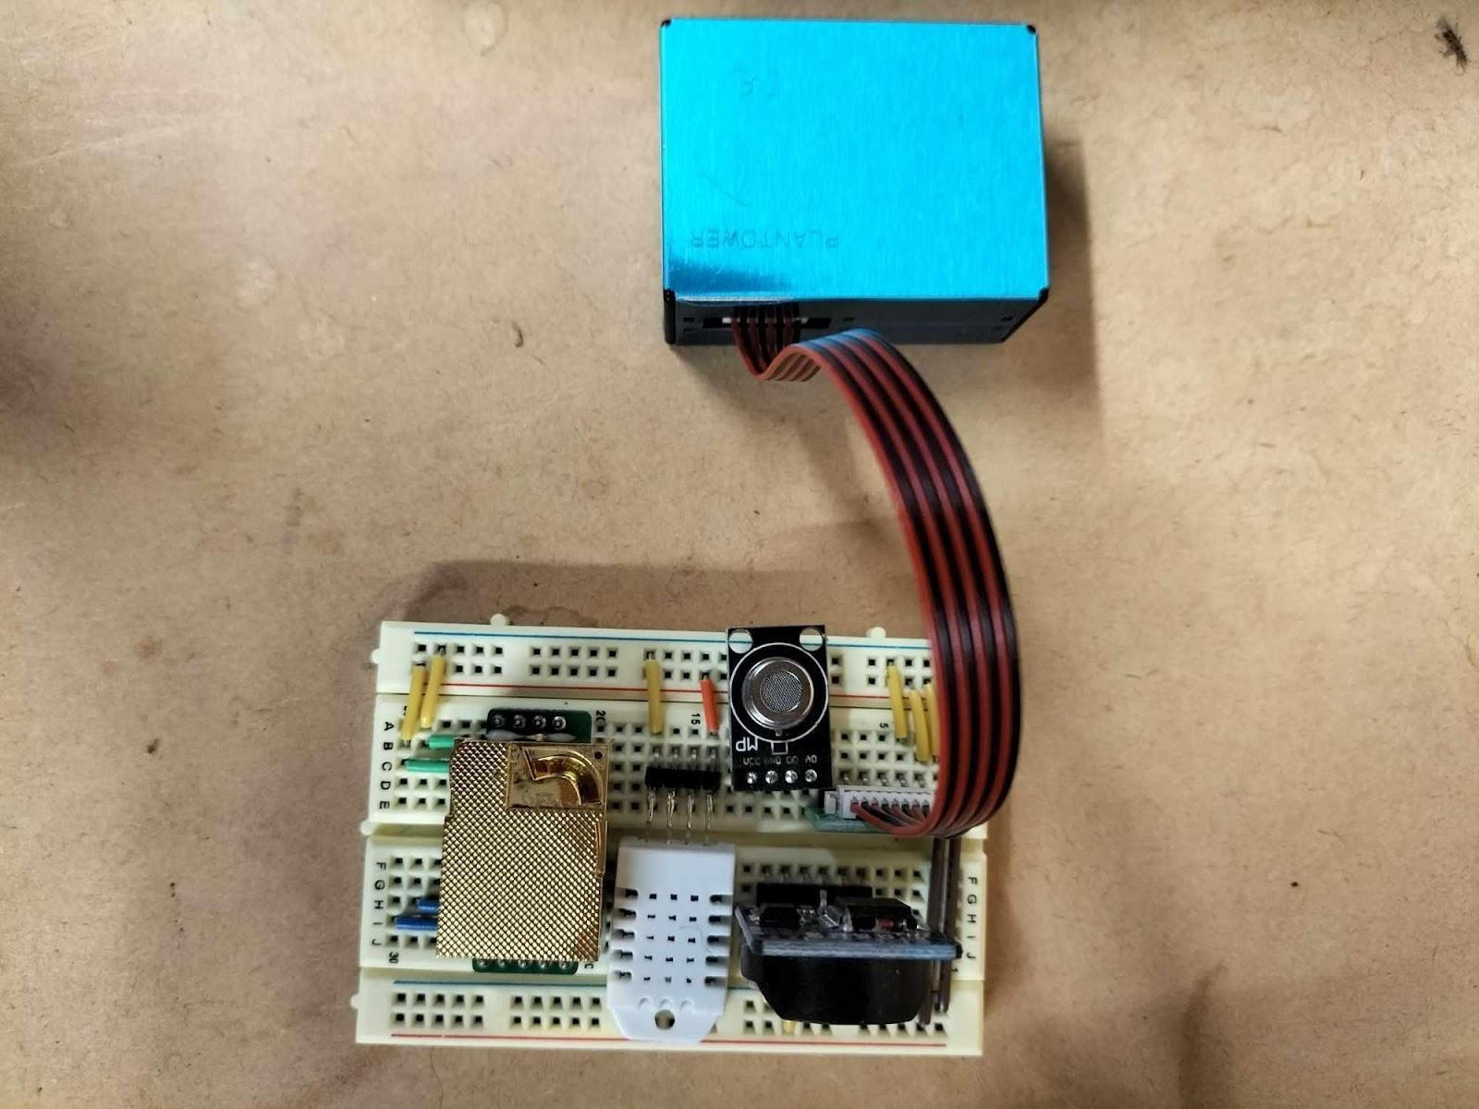
The following paragraphs document the issues encountered during this phase of development.

Issue: Particulate Matter and CO2 Sensor Not Working Individually
A recurring issue with the particulate matter sensor during testing was that the sensor failed to provide any readings, only to mysteriously start working after a few weeks and then stop working again.
Various troubleshooting steps were taken to address this problem. By trying a different sensor, it is possible to determine whether or not it was a sensor fault. However, the replacement sensor also exhibited the exact behaviour. Thus, the problem was something else. Another possibility was a software bug, so different libraries were tried, yet the behaviour continued.
Another problem was that the CO2 sensor consistently provided inaccurate readings. The sensor always reported a CO2 concentration of 0 ppm and a temperature of -17 degrees. Similar troubleshooting steps as the particulate matter sensor was implemented, yet these steps did not yield any results.
Upon further investigation, the root cause of both these sensor’s malfunctions was an elementary misunderstanding regarding the serial communication protocol. Serial communication involves transmitting data between devices via the sending device’s transmitter (TX) pin and the receiving device’s receiver (RX) pin.
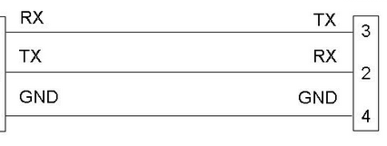
The problem was the incorrect assumption that, like regular input/output ports, the RX and TX pins should be wired to identical pins between devices. The CO2 and particulate matter sensor had the RX pin connected to the RX port and the TX pin connected to the TX port on the microcontroller. Serial communication requires a cross-wiring approach, with the transmit pin of one device wired to the receive pin of the other and vice versa. During component testing, the wiring was sporadically wired “incorrectly” and ironically led to the right results. This explained the periodic results.

Issue: Particulate Matter and CO2 Sensor Not Working Together
While the example code for each sensor worked flawlessly, they did not work together. This was a limitation in the SoftwareSerial library. The SoftwareSerial library allows communication on other digital pins of an Arduino board through emulation, allowing the Arduino to interact with multiple sensors using the serial protocol. However, the library allows for only one instance of serial communication. It was not possible to use two sensors using serial protocol through the SoftwareSerial library.
However, the Arduino has a dedicated serial port (hardware serial). By assigning one of the two sensors to the hardware serial port, only one sensor will use the SoftwareSerial library. However, a drawback of utilising the hardware serial port is that it shares the same bus with the USB connection. Conflicts arose during the upload of code. The hardware serial pin had to be disconnected during upload and later reconnected. While this solution works, it is inconvenient due to the additional steps involved.

Issue: Serial Buffer Overflow
To illustrate this problem, a simpler pseudo-code will be used. When printing the data individually, for example, like the pseudo-code below
$print($PARTICULATE_MATTER_DATA$)$
$print($CO2_CONC_DATA$)$
$print($TEMPERATURE_DATA$)$
it would output
$$1, 2, 3$$
$$300$$
$$25$$
This is expected behaviour.
However, for better data parsing later, the data was formatted like this as a string variable first before printing the variable.
$string =String("PM: " +$ PARTICULATE_MATTER_DATA$+ "CO2: "+$ CO2_CONC_DATA$)$
$$print(string)$$
Unfortunately, this did not output the desired format of $PM: 1, 2, 3 CO2: 300$ but rather $PM: 1, 2, 3 C???????$.
The problem was the Arduino’s memory limitation and the String class’ implementation. The String class creates a copy of the original string literal and allocates dynamic memory for it at runtime. Therefore, both the original string literal and the dynamically allocated string coexist in memory. If the original string stores many bytes, the Arduino may run out of SRAM. As a result, data in the $string$ variable becomes corrupted.
Furthermore, the serial buffer overflowed due to the immediate display of so many bytes of data, resulting in data loss and unsuccessful printing. To resolve this, unnecessary text was removed, reducing the size of the data sent through the serial port. Furthermore, smaller chunks of the string were printed, resulting in the desired format while working within the memory constraints.

Prototype

Robust Installation
After confirming that each sensor works together, a more robust attachment method is required, as the breadboard is only for prototyping. The sensors were soldered to a Veroboard, reducing the risk of loose connections or intermittent failures.

Issue: Wire Connections
An issue arose when attempting to establish a reliable connection between the Veroboard and the Arduino. Initially, a male Dupont wire was cut, with one end soldered to the Veroboard and the other end plugged into the Arduino’s header. Unfortunately, the thin wires of the Dupont cable were prone to breakage, resulting in the need for frequent resoldering. To address this problem, a more effective solution was implemented. Instead of cutting the male Dupont wire, the decision was made to directly solder a robust header onto the Veroboard while plugging the other end into the corresponding header on the Arduino. This approach eliminated the vulnerability of the fragile wires and ensured a more reliable and durable connection between the Veroboard and the Arduino, mitigating the need for frequent repairs.
The image below illustrates the wiring setup, revealing an issue with the initial connection approach. On the right side of the image, the blue wire is visibly detached from its solder joint, and the white wire is starting to show signs of potential breakage. The new implementation is demonstrated on the left side of the image. This revised approach involves directly attaching the wires using a sturdier method, ensuring a secure and resilient connection.
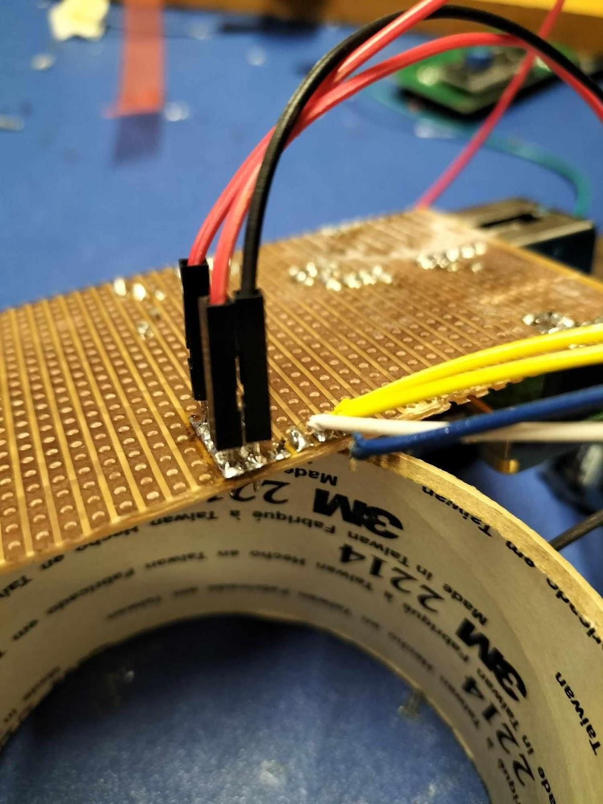

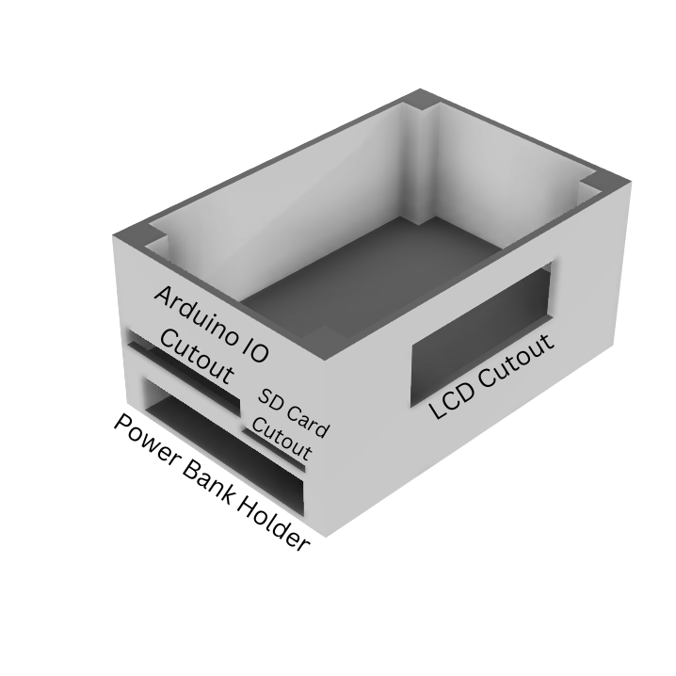
Enclosure Design
The enclosure intended to contain the sensors and a power bank, enabling portability of the sensor unit, was designed using Fusion360 computer-aided design software and subsequently fabricated via 3D printing. Test fitting of the components within the enclosure was then conducted.
The diagram on the left illustrates the enclosure’s design and each cutout’s functions.
The photos below highlight how each component fits inside the enclosure.

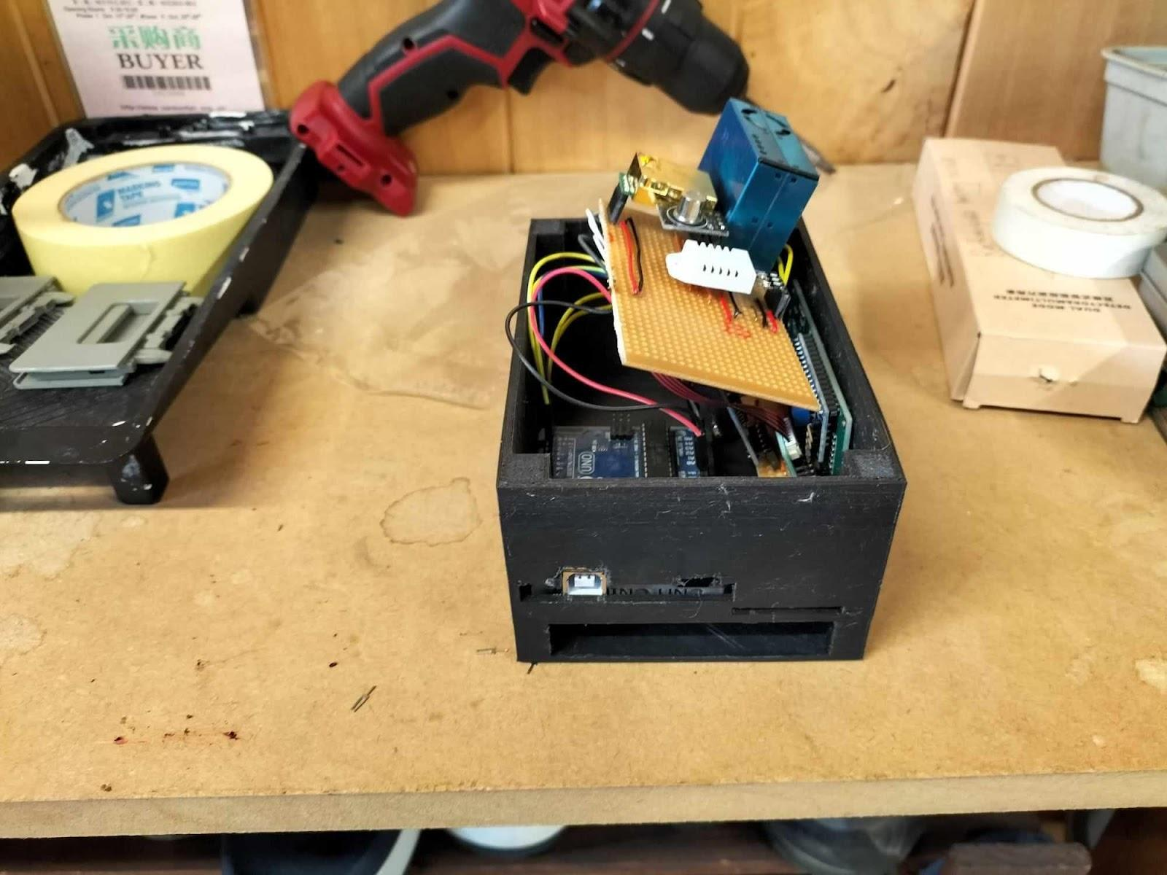
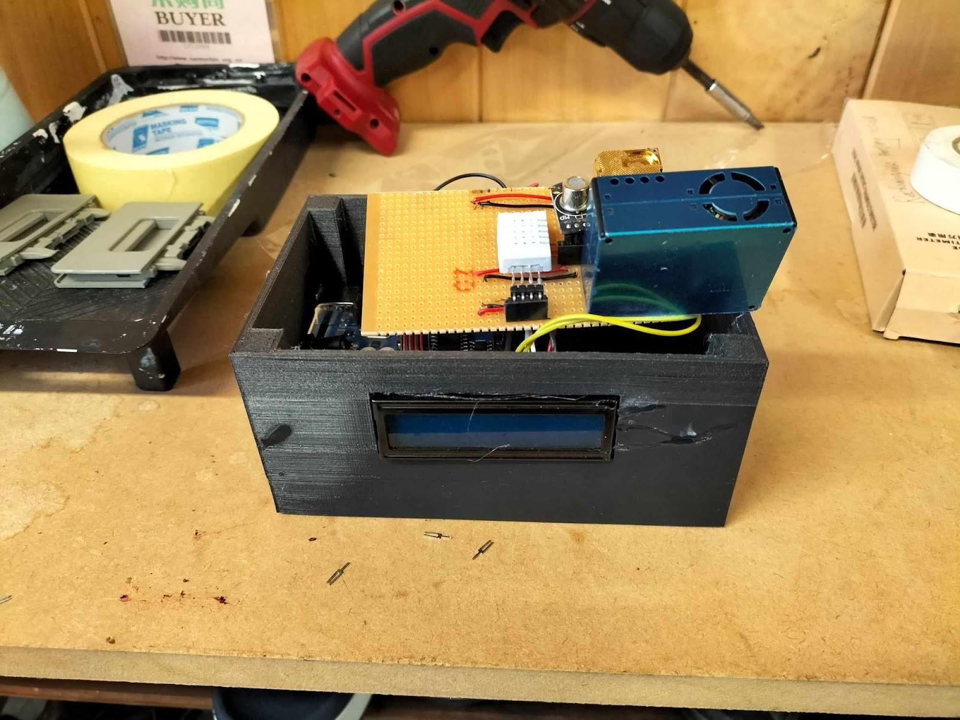
Issue: Incorrect Dimensions
Due to measurement errors, the dimensions for the Arduino IO cutout in the enclosure were incorrect. To remedy this, plastic was cut out from the enclosure to create sufficient space for the IO, as seen in the picture below.
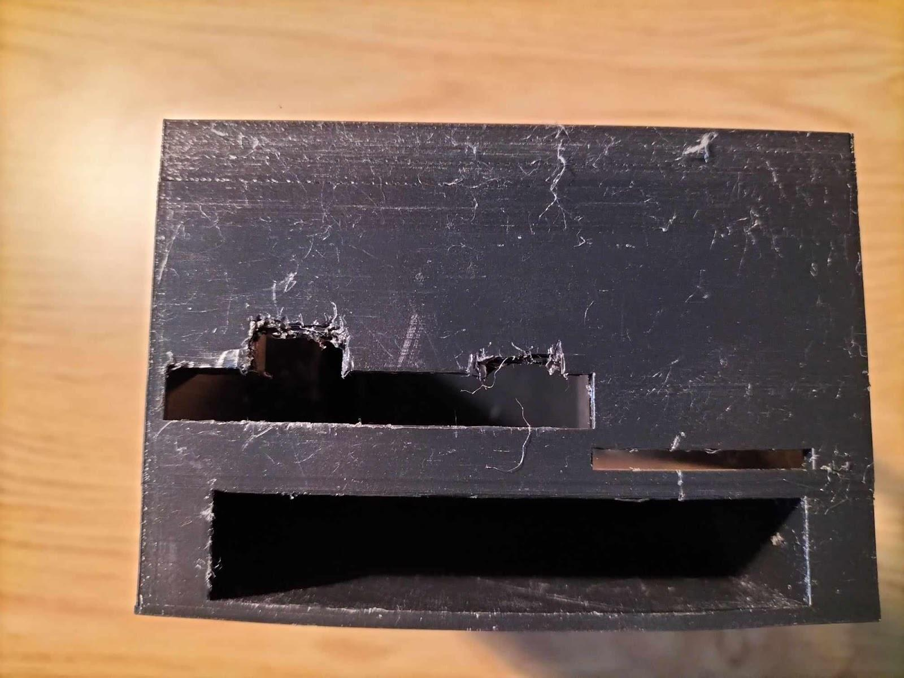
Furthermore, the LCD module has a notch, circled in the figure below, that prevents it from mounting flush with the rectangular cutout.
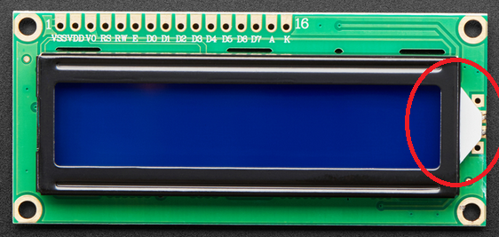
Attempts were made to cut out a hole in the enclosure for the LCD notch, but this only resulted in cracking of the case. Therefore, it was decided not to cut a notch, temporarily deal with a misaligned LCD and use super glue on any cracks that formed, as seen in the picture below.
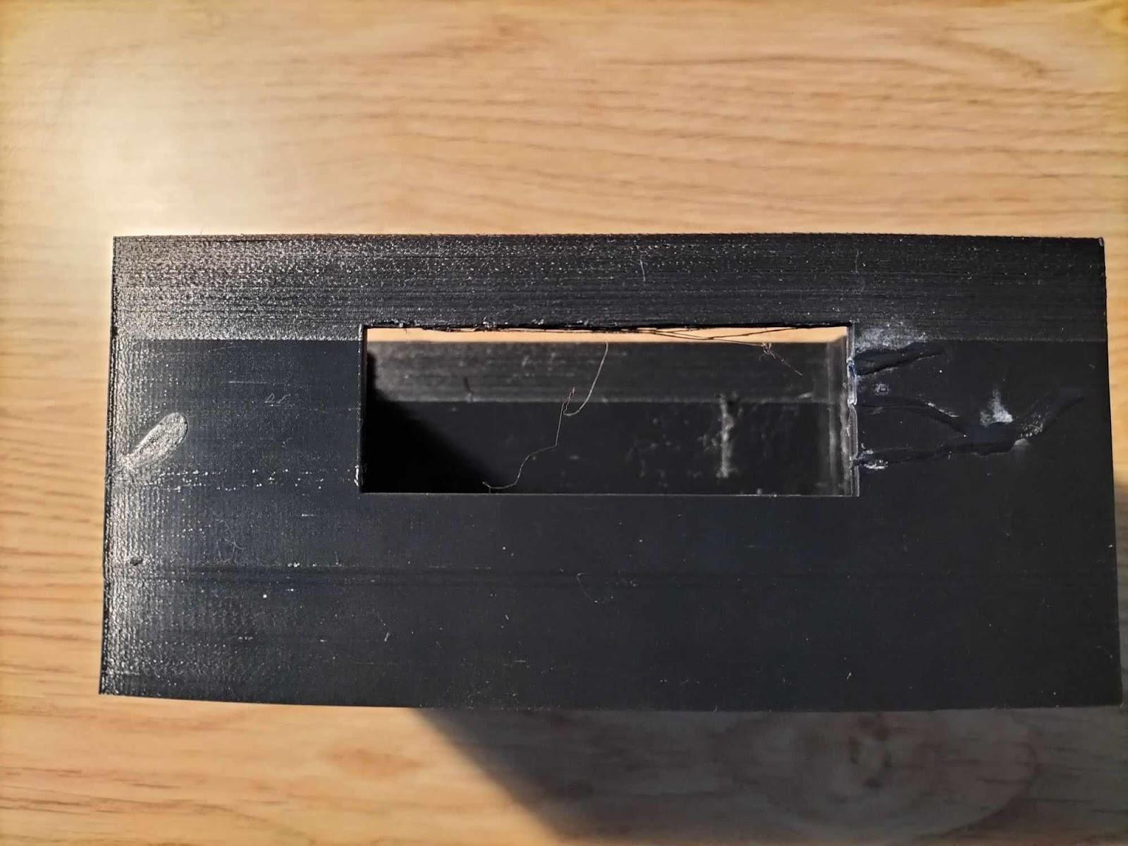
Modifications were made to account for the measurement errors and allow the components to fit together correctly within the enclosure. This enclosure’s future designs will be modified in CAD accordingly before printing.

SD Card Reader Integration

Issue: SPI, Serial and I2C Protocol Conflict
Another issue arose when attempting to incorporate SD card functionality into the project. Appending a write-to SD card code to the project prevented everything else from working. The conflict was attributed to the use of the SoftwareSerial library.
To address this issue, a switch was made from SoftwareSerial to AltSoftSerial library. This library was chosen based on its compatibility with SPI and Serial communication. However, as mentioned in the documentation, “some libraries may disable interrupts for longer than 1-bit time. If they do, AltSoftSerial will not work properly.” While the sensors work with the SD card reader, the real-time clock and the LCD module, both of which use the I2C protocol, stopped working. It was hypothesised that the issue lay in the warning from the documentation.
To overcome various issues and streamline the system, a complete pivot was made in the project. Instead of using an SD card reader, the sensor unit was redesigned to leverage the Arduino’s connection to a mobile phone via an OTG (On-The-Go) connector. This approach eliminated a few components and reduced the complexity of the sensor unit. There was no need for a separate SD card reader; a phone has logging capabilities and provides power to the Arduino via USB, further eliminating the need for a power bank. Additionally, since the phone has its own timekeeping capabilities, a real-time clock was no longer required. An unintended externality of using this approach was that since a phone supported running two simultaneous applications at once, one application would log the data from the Arduino with respect to time, while another application would log the phone’s location with respect to time. Now, the air quality measurements could be matched to geolocation by comparing the times.

Final Prototype
To address the CAD design flaws and the change in the architecture of the sensor unit, a redesign was undertaken, considering the correct height for the Arduino IO, eliminating the redundant SD card slot, and rectifying the missing tab for the LCD screen hole. Additionally, modifications were made to the battery holder to accommodate the use of a phone for power supply.
The image below shows the following modifications to account for the previous incorrect measurements. Additional cutouts accommodate the Arduino IO and a tab for the LCD module to be mounted flush against the case.
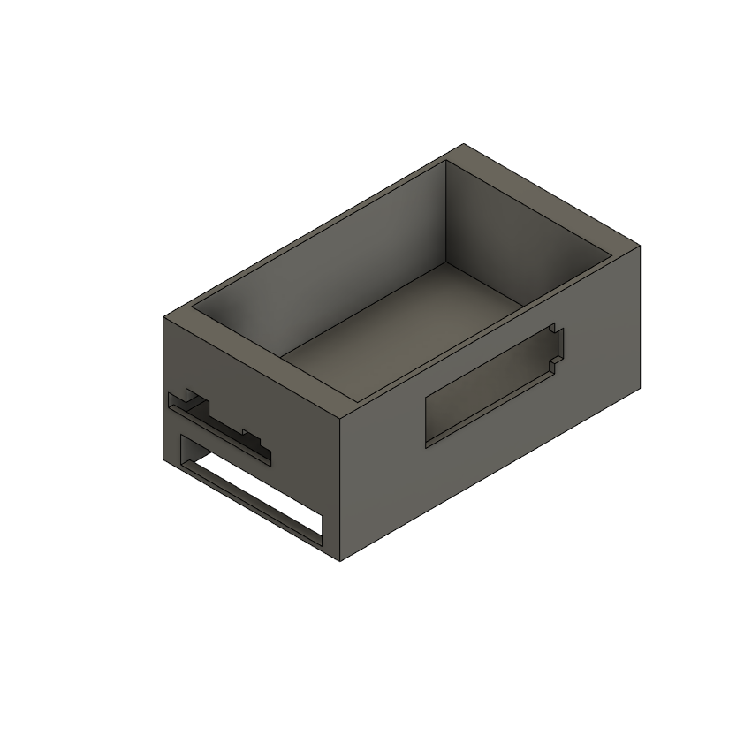
The image below shows a cutout in the battery holder part to allow for visibility of the phone screen during operation.
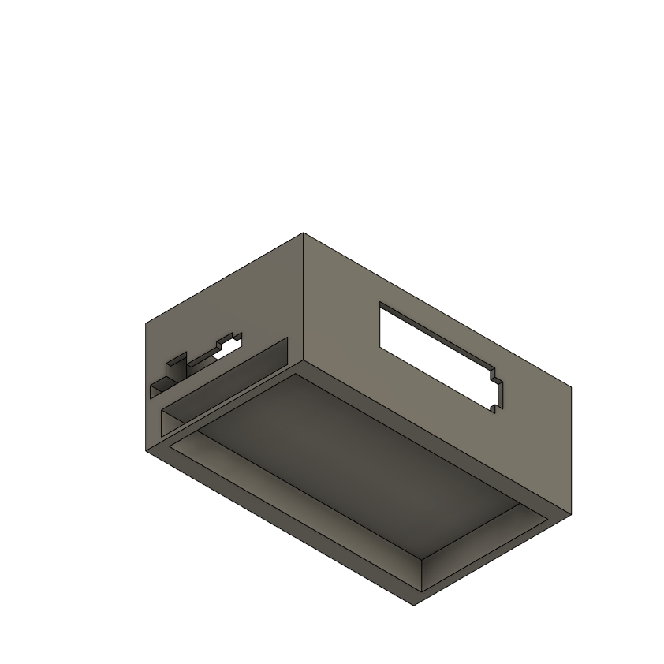
The Veroboard was attached to a piece of polycarbonate sheet, which was taped on the top, and the phone cutout also had a polycarbonate layer to prevent the phone from falling out of the box.
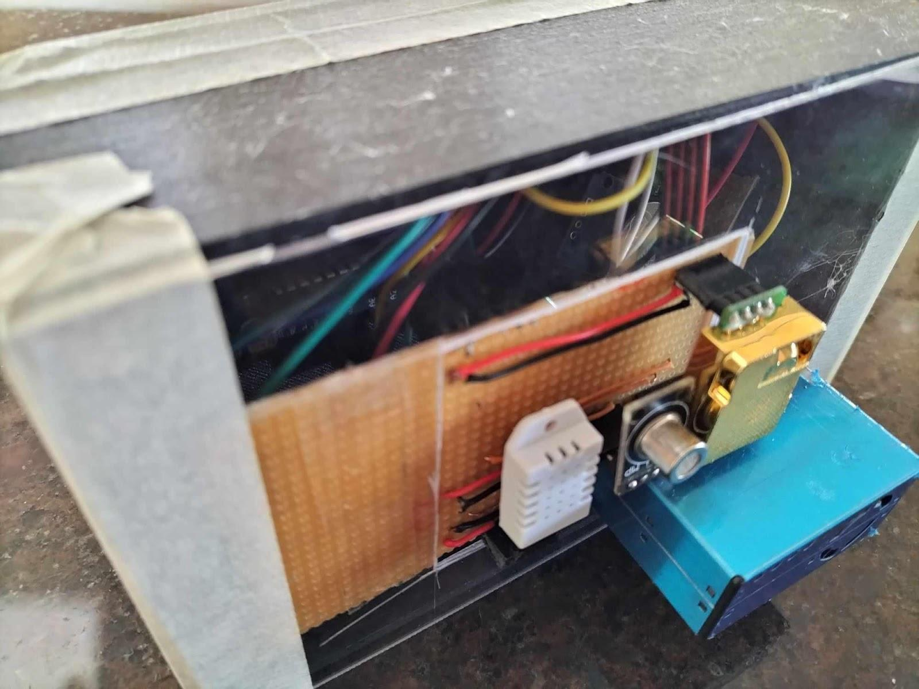
The images below show the final prototype of the sensor unit.

B: Data Gathering and Processing
Since the data gathering and processing stages were happening in parallel, the method of data gathered at home and processed will be different than at the hardware store, which will also be different than at school. The data processing pipeline gradually refined as data was gathered from different locations. This will be discussed during the data processing section.

Data Gathering
As mentioned in the “Are There Air Quality Variances in Space?” data will be gathered by continuously running the sensor while moving around. The Serial USB Terminal app records the data. One interesting feature of this app is the dedicated logging feature, which adds timestamps to each data log. This means the real-time clock is redundant, simplifying the sensor unit.
Matching the location and the data log for the first two investigations, at home and a hardware store, a map of the locations was subdivided into sections.
The image below shows that the hardware store is divided into sections.
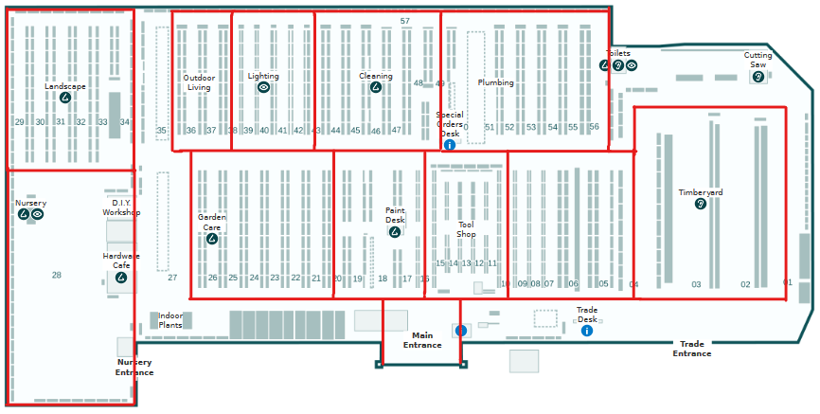
The image below shows how the sensor moved through the hardware store. Each large section is subdivided into smaller subsections and numbered. Since we know where the sensor is at all times, the timestamps can be manually noted at each section. For example, in section one, the data recorded will be between the timestamps of 10:00 and 10:01.
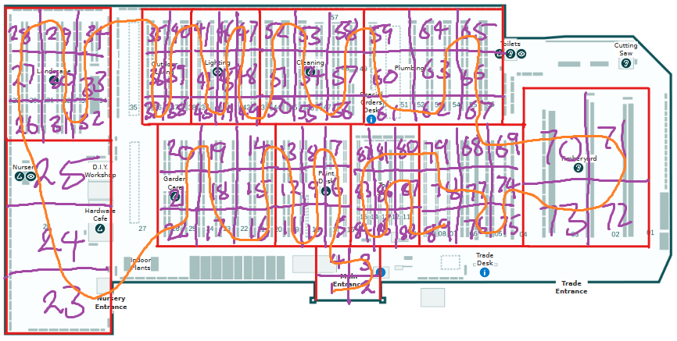
While this method worked for the home measurements, this method does not scale up. Notifying down the timestamps and planning a predetermined path for every space takes too much time. The time taken to record the measurements of the hardware store was one hour.
However, the phone which is logging data also has a GPS. By recording timestamped GPS coordinates from the phone, it is possible to match the sensor data with location information. The Phyphox app logs GPS coordinates against time, and the data can be exported. The phone supports multitasking, so Phyphox and Serial USB Terminal will run simultaneously. This method saved much time, as recording the measurements at school only took twenty minutes.

Data Processing
How the data was processed for analysis depended on how the data was gathered.
At home, there was a small number of data points. Therefore, an Excel spreadsheet was used to calculate the pollution concentration index.
However, this method will not work for the data gathered at the hardware store. The data collected is continuous; therefore, the data needed to be somehow separated according to the corresponding timestamps by each section. A Python script was created to do this separation automatically. The user will input their desired timestamp range, and the script will modify the data accordingly. In this case, the script will highlight the sections in red.
from openpyxl import load_workbook
from openpyxl.styles import PatternFill
from datetime import datetime

def get_times(file):
times = []
with open(file) as f:
startchunk = False
f = list(f)
for i, line in enumerate(f):
lin = line.split()
if not startchunk:
time1 = lin[0]
startchunk = True
if lin == []:
# the previous line
time2 = f[i-1].split()[0]
times.append([time1, time2])
startchunk = False

return times

def modify_excel_file(location_file):
times = get_times(location_file)
wb = load_workbook(filename="output.xlsx")
ws = wb.active

redFill = PatternFill(start_color='FFFF0000', end_color='FFFF0000', fill_type='solid')

for cell in ws['A']:
for time in times:
time1 = datetime.strptime(time[0], '%H:%M:%S.%f')
time2 = datetime.strptime(time[1], '%H:%M:%S.%f')
if(type(cell.value) != str):
if time1.time() <= cell.value <= time2.time():
cell.fill = redFill

wb.save("processed.xlsx")

def func(location_file, data_file):
times = get_times(location_file)
with open(data_file) as f:
f = list(f)
for i, line in enumerate(f):
for time in times:
time1 = datetime.strptime(time[0], '%H:%M:%S.%f')
time2 = datetime.strptime(time[1], '%H:%M:%S.%f')
check = datetime.strptime(line.split()[0], '%H:%M:%S.%f')
if time1.time() <= check.time() <= time2.time():
print(line, "A POINT")
else:
print(line, "NOT A POINT")

if __name__ == "__main__":
#print(get_times("outdoors.txt"))
func(“outdoors.txt”, “raw.txt”)
modify_excel_file("outdoors.txt")

However, this method still requires manual work. Since each section is highlighted, it serves as a marker for a human to manually create graphs on each section. As mentioned earlier, this still takes time and will not scale up as the space size increases.
All of this was greatly simplified after using timestamped GPS coordinates. A Python script could read the GPS and recorded data timestamps, combine them, and save them in a separate file. Utilising GPS coordinates obviates the necessity of partitioning the measured space into distinct sections, as each recorded GPS point inherently represents its self-contained section. Furthermore, Python libraries allow the coordinates to be plotted on a map. The possibilities are limitless. For this case, each point will be given a colour and size. The colour represents the relative pollution concentration index. The more red the colour, the greater the pollution concentration index.
The following code combines the timestamps into one file.
import pandas as pd
from datetime import datetime, timedelta
import re
import utm

# Input raw data files logged from phyphox and sensor data
location_file = “school.xls”
air_data_file = "school.txt"

# Read location data excel file into a dataframe
location = pd.ExcelFile(location_file)
location_data = pd.read_excel(location, "Raw Data")
# Create new columns in data frame to store sensor data and local location data
#location_data["x"] = ""
#location_data["y"] = ""
location_data["PCI"] = -1 # Pollution concentration index
location_data["Temperature_(C)"] = -1
location_data["Humidity_(%)"] = -1
location_data["VOC_(PPM)"] = -1
location_data["CO2_(PPM)"] = -1
location_data["PM1.0_(ug/m3)"] = -1
location_data["PM2.5_(ug/m3)"] = -1
location_data["PM10_(ug/m3)"] = -1

# Extract the start time of location data from metadata
time_data = pd.read_excel(location, "Metadata Time")
start_time = datetime.strptime(time_data["system time text"][0].split(" ")[1], "%H:%M:%S.%f")

# Read sensor data file into a list
with open(air_data_file, "r") as file:
text_lines = file.readlines()

for i, timestamp in enumerate(location_data["Time (s)"]):
# Convert timestamp in seconds to a datetime, and remove microseconds (for easier comparisons between times)
location_time = (start_time + timedelta(seconds=timestamp)).replace(microsecond = 0)
# Update the timestamp in the dataframe
location_data["Time (s)"][i] = location_time
# Convert the longitude and latitude to UTM coordinates or x, y (https://en.wikipedia.org/wiki/Universal_Transverse_Mercator_coordinate_system)
#location_data["x"][i], location_data["y"][i], zone_number, zone_letter = utm.from_latlon(location_data["Latitude (°)"][i], location_data["Longitude (°)"][i])
# Iterate through the sensor data list
for data in text_lines:
# Convert datetime string into datetime object, and remove microseconds (for easier comparisons between times)
data_time = datetime.strptime(data.split(" ")[0], "%H:%M:%S.%f").replace(microsecond = 0)
# If the time of the location data and sensor data match (to the nearest second), then GPS location = sensor location
if location_time.time() == data_time.time():
# Add sensor data to the dataframe
parsed_data = data.split()
location_data["Temperature_(C)"][i] = float(re.sub("[^0-9.]", "", parsed_data[2]))
location_data["Humidity_(%)"][i] = float(re.sub("[^0-9.]", "", parsed_data[4]))
location_data["VOC_(PPM)"][i] = float(re.sub("[^0-9.]", "", parsed_data[6]))
location_data["CO2_(PPM)"][i] = float(re.sub("[^0-9.]", "", parsed_data[8]))
location_data["PM1.0_(ug/m3)"][i] = float(re.sub("[^0-9.]", "", parsed_data[10]))
location_data["PM2.5_(ug/m3)"][i] = float(re.sub("[^0-9.]", "", parsed_data[12]))
location_data["PM10_(ug/m3)"][i] = float(re.sub("[^0-9.]", "", parsed_data[14]))
location_data["PCI"][i] = 0.05*location_data["Temperature_(C)"][i] + 0.2*location_data["Humidity_(%)"][i] + 0.5*location_data["VOC_(PPM)"][i] + 0.1*location_data["CO2_(PPM)"][i] + 0.7*location_data["PM1.0_(ug/m3)"][i] + 0.4*location_data["PM2.5_(ug/m3)"][i] + 0.3*location_data["PM10_(ug/m3)"][i]

# Truncate any GPS point which does not have a matching sensor data point
location_data = location_data[location_data[“PCI”] != -1]
# Save the data to a new Excel file
location_data.to_excel(location_file.split(".")[0]+"_modified.xlsx", index = False)

The following code plots the combined data on a map.
import plotly.express as px
import pandas as pd

location_file = "house_modified.xlsx"
location = pd.ExcelFile(location_file)
location_data = pd.read_excel(location, "Sheet1")

color_scale = [(0, ‘green’), (1, ‘red’)]

fig = px.scatter_mapbox(location_data,
lat="Latitude (°)",
lon="Longitude (°)",
hover_name= “PCI”,
hover_data=["Temperature_(C)", "Humidity_(%)", "VOC_(PPM)", "CO2_(PPM)", "PM1.0_(ug/m3)", "PM2.5_(ug/m3)", "PM10_(ug/m3)"],
color= “PCI”,
color_continuous_scale=color_scale,
size= “PCI”,
zoom=8)

fig.update_layout(mapbox_style="open-street-map")
#fig.update_layout(margin={"r":0,"t":0,"l":0,"b":0})
fig.show()

The code produces graphs that look like this:
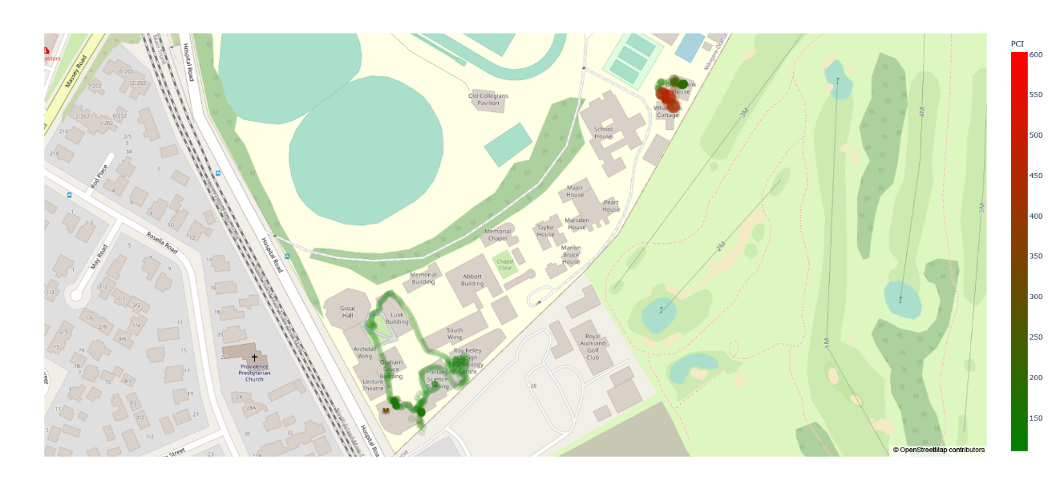

This data pipeline requires no human input. It is fully automated. All subsequent data recorded by walking around with the sensor or using the mobile air quality sensor will use this data pipeline.

C: Iterative Design Process

Sensor Grid Drops Down

Description
The only way to reduce the costs associated with the high-resolution measurement solution is to reduce the number of sensors deployed. However, this means each sensor must cover a greater volume to achieve the exact spatial resolution as the proposed solution. Since each sensor unit coverage volume is fixed, the only way for it to cover greater volume without sacrificing spatial resolution is for it to be mobile. An approach to this objective involves employing mobile sensors within a grid arrangement. This grid will be suspended on the room’s ceiling and can descend and ascend using a winching mechanism. This allows for fewer sensors to cover the same volume of space.
[INSERT PHOTO]

Advantages
There are a few noteworthy advantages of adopting this mobile sensor grid system. Firstly, it achieves comparable spatial resolution to the prior solution, which occupies less physical space. Moreover, the winching motion of the sensor grid means the sensor would gather continuous spatial data rather than discrete point data; thus, it can be argued that spatial resolution along the z-axis may improve. However, the greatest advantage lies in the substantial reduction of sensors required by orders of magnitude, leading to a drastic reduction in monetary cost.

Cost Analysis
Based on the specified assumptions, the sensor mesh requires 888 sensors, calculated by dividing the ceiling area by the adequate sensor coverage. Each sensor module requires a minimum of three meters of linkage, corresponding to the average room height. As a result, the estimated monetary cost of this solution amounts to $97,534.79. The cost of this solution has been reduced by a factor of 10 compared to the prior solution. However, deploying this sensor grid is expected to be time-consuming as a technician needs to install a ceiling-sized grid on the roof. Additionally, during operation, the winching motion of the system will impede usable space; the consequences of such were discussed earlier. The greatest contrast between this and the prior solution is that during the operation of this sensor grid, it will be hanging on the ceiling, as opposed to the prior idea where it had to be completely disassembled. While there will be a reduction in technical cost as only a single installation is required without disassembling, from an aesthetic standpoint, a mounted sensor grid on the ceiling during operation may not be visually appealing. Regarding technical costs, using WiFi to transmit data will still be impossible as the 888 sensors are greater than the 376 WiFi channel bands available. It is also important to note that this solution is unsuitable for outdoor measurements.

Reflection
The observed monetary, practical and technical costs can still be attributed to this idea’s high number of sensors. However, as discussed in the “Proof of Concept” section, while there are air quality variances indoors, they are minor. Therefore, data can be extrapolated.
The observed practical, technical, and cost-related issues can be attributed to the high number of sensors employed in the current approach. However, by extrapolating the available data, it is evident that even with a decrease in resolution, the resulting spatial resolution remains superior to the original solution and is likely deemed acceptable for the intended purpose. This realisation opens avenues for improvement by reducing practicality, technical, and monetary costs associated with the system. By strategically optimising the sensor count while maintaining an acceptable level of resolution, it becomes possible to address the aforementioned challenges. This approach ensures a more streamlined deployment process, mitigates technical complexities, and significantly reduces the overall financial investment.

Sensor Grid in Walls

Description
When considering data extrapolation, covering the entire wall with an extensive array of sensors is unnecessary. A more efficient approach would involve strategically placing nine sensors per wall and reducing the frequency of data recording to sampling once every hour. By implementing a sensor grid on all four walls, it becomes feasible to extrapolate data by assuming specific properties of gases. This approach allows for a more streamlined and cost-effective data collection process, enabling accurate extrapolation and analysis.

Advantages
The primary advantage of this approach is that it requires fewer sensors, making it a more cost-effective solution. It also does not interfere with the usable space in the room, and the installation process is relatively easy. Since the sensors are fixed in specific locations, it provides a reasonable spatial resolution that is good enough for most applications. Additionally, by reducing the number of sensors, it may be possible to increase the temporal resolution, resulting in more frequent measurements.

Cost Analysis
The proposed solution offers a cost-effective approach with a total cost of $3889. This estimation considers the utilisation of 36 sensors, where each is priced at $108.03. The cost of the necessary linkages is negligible and not included in the calculation. However, installing sensors on the walls of a room, even with a reduced number, may still be considered impractical and aesthetically unappealing. This solution completely solves the technical issues. The reduced sensors mean there are enough WiFi channels to transmit data, and data storage is nearly negligible. However, this solution still does not work for outdoor measurements.

Reflection
To address the limitations of spatial resolution posed by fixed sensors without increasing sensor numbers, a potential solution could involve fully delocalising the sensors and making them mobile. Unlike the “Sensor Grid Drops Down” solution, which still partially relies on sensor numbers to maintain high-resolution measurements, a fully delocalised and mobile sensor mesh will use fewer sensors but extrapolate data to predict the air quality.

Crowd Sourcing

Description
The solution employs wearable air quality sensors individuals wear to gather data in different locations, creating a spatial air quality map. This strategy eliminates the need to measure air quality in vacant areas, optimising data collection. The system’s scalability ensures finer data resolution with more participants.

Advantages
The solution aligns data collection with human mobility, conserving resources by focusing on populated areas. Its scalability enhances data granularity and is universally applicable indoors and outdoors. The non-intrusive nature and minimal spatial impact make it a practical choice.

Cost Analysis
Monetary costs are directly proportional to the number of participants (n), with each wearable sensor priced at $108.03. The overall cost is $108.03 * n. Linkage costs are minimal. Swift deployment arises from the seamless assimilation of sensors into daily routines. The allocated bandwidth proves adequate, contingent upon the number of sensor-endowed individuals.

However, a potential challenge lies in user fatigue from prolonged sensor carriage. Furthermore, the approach demonstrates diminished spatial and temporal resolution due to the inherently erratic trajectories of individuals. Moreover, the participants are susceptible to suboptimal air conditions during data collection. Furthermore, this method exhibits constraints regarding vertical coverage.

Reflection
Crowdsourcing solves many of the issues previously mentioned in other solutions. However, there will be inconsistencies due to the human nature of this solution. The way people move will determine what data will be gathered. Furthermore, since data is only gathered where people are going, it means the people wearing the air quality device will inadvertently be exposed to harmful air for public data.
The simplest way to overcome these problems will be automating the data collection. Suppose a robot could instead move around and take measurements. In that case, the locations air quality is sampled will be consistent, and humans will not be involved in the process, saving time and money.

Automated Mobile Air Quality Sensor

Description
The solution employs a robot to gather data in different locations, creating a spatial air quality map. Otherwise, it is the same as crowdsourcing.

Advantages
This solution has all the advantages of crowdsourcing. However, in an automated way, it is not dependent on the human factor. This eliminates all the disadvantages exclusive to crowdsourcing.

Cost Analysis
The expense associated with implementing an automated mobile air quality sensor surpasses that of crowdsourcing but remains markedly lower compared to alternative proposed solutions. Yet, it can be contended that over time, costs diminish owing to the inherent economising effects of robotic systems. Since this is a high-level overview of a concept, the actual cost of the solution may vary depending on how it is implemented.

Reflection
This solution will likely not be deployed indoors as it will interfere with usable space. However, this issue is negligible since this project only considers outdoor spaces.

D: AIRMATE

References
https://www.citationmachine.net/bibliographies/a8b9da0c-c59c-4dc3-a923-e239a3c1da8f
“Carbon Monoxide Poisoning.” MyHealth.Alberta.ca Government of Alberta Personal Health Portal, myhealth.alberta.ca/Health/Pages/conditions.aspx?hwid=zm2552. Accessed 23 Feb. 2023.
“Children Are Dying from Air Pollution. Here’s How We Can Protect Them.” World Economic Forum, www.weforum.org/agenda/2021/11/how-we-can-protect-children-dying-from-air-pollution/. Accessed 11 Mar. 2023.
Education, UCAR Center for Science. “Center for Science Education.” How Weather Affects Air Quality | Center for Science Education, scied.ucar.edu/learning-zone/air-quality/how-weather-affects-air-quality. Accessed 27 June 2023.
“Electronic Smoking Devices and Secondhand Aerosol - American Nonsmokers’ Rights Foundation.” No, 18 Jan. 2023, no-smoke.org/electronic-smoking-devices-secondhand-aerosol/.
“First in Air Quality.” IQAir, www.iqair.com/au/newsroom/how-does-outdoor-air-pollution-affect-my-indoor-air-quality. Accessed 14 June 2023.
“Health Effects of Air Pollution.” EHINZ, www.ehinz.ac.nz/indicators/air-quality/health-effects-of-air-pollution/. Accessed 15 Feb. 2023.
“How Air Pollution Is Destroying Our Health.” World Health Organization, www.who.int/news-room/spotlight/how-air-pollution-is-destroying-our-health/. Accessed 15 Feb. 2023.
“How Does Humidity Affect Air Quality? All You Need to Know.” How Does Humidity Affect Air Quality? All You Need to Know - Airly WP | Air Quality Monitoring. Monitor in UK & Europe. Airly Data Platform and Monitors, airly.org/en/how-does-humidity-affect-air-quality-all-you-need-to-know/. Accessed 27 June 2023.
Manisalidis, Ioannis, et al. “Environmental and Health Impacts of Air Pollution: A Review.” Frontiers in Public Health, vol. 8, 2020, https://doi.org/10.3389/fpubh.2020.00014.
“Polluted Air Affects More than 90% of Children.” Unfccc.Int, 29 Oct. 2018, unfccc.int/news/polluted-air-affects-more-than-90-of-children.
Sharma, Akula. “Meth Detected in Downtown Auckland Air, Study Shows.” NZ Herald, 13 Apr. 2023, www.nzherald.co.nz/nz/meth-detected-in-downtown-auckland-air-study-shows/ASEZG5WVUZCG5FYEPGNUYRVT5Q/.
Terry Gibb, Michigan State University Extension. “Indoor Air Quality May Be Hazardous to Your Health.” MSU Extension, 21 Jan. 2022, www.canr.msu.edu/news/indoor_air_quality_may_be_hazardous_to_your_health.
“Why Air Quality Matters.” Ministry for the Environment, 3 Aug. 2021, environment.govt.nz/facts-and-science/air/why-air-quality-matters/.
Wiedinmyer, C., et al. “The Fire Inventory from NCAR (Finn): A High Resolution Global Model to Estimate the Emissions from Open Burning.” Geoscientific Model Development, vol. 4, no. 3, 2011, pp. 625–641, https://doi.org/10.5194/gmd-4-625-2011.

