**Assignment #1**

Ethan Liao

CS 4800

Software Engineering

**Objective**

Create a calculator application that can add, subtract, multiply, and divide number. We are required to have a user interface (meaning we need inputs/buttons and a display for number outputs).

We must log the time spent on the project and categorize the time between:

*Requirements, Analysis, & Design*

*Development*

*Testing*

Record the number of bugs or defects found during testing.

Compare your total time spent with your initial estimate

**Results**

**Initial projected time** for project was **7 hours**.

Requirements, Analysis, & Design -> 1 hour

Development -> 4 hours

Testing/Debugging -> 2 hours

**Actual projected time** was **5 hours, 57 minutes**

Requirements, Analysis, & Design -> 46 minutes

Development -> 4 hours, 14 minutes

Testing/Debugging ->57 minutes

(SEE LOGS)

**HOW TO ACCESS CALCULATOR / VIEW SOURCE CODE:**

Through the web: [www.ethan-calculator.herokuapp.com](http://www.ethan-calculator.herokuapp.com) (no source code)

Through GitHub: <https://github.com/ethanlmaoi/calculator-cs4800>

1. Clone the Repo / Download ZIP
2. Open “calculator-cs4800-master” folder
3. Open “index.html”

**Requirements, Analysis, & Design**

|  |  |  |
| --- | --- | --- |
| **Date** | **Timestamps** | **Accomplished** |
| 9/26/18 | Start -> 3:11 PM  End -> 3:30 PM  Time Elapsed: **19 minutes** | * Deciding what language to code the project in * Decided to create a web app * Prepared the tools to be used: * Languages: HTML, CSS, JS * Framework/Libraries: Node.js, Express.js, jQuery, Bootstrap * Tools: Adobe Dreamweaver (front-end design), C9 IDE (back-end structure) * Deployment: Heroku * Created HTML, CSS, JS files in Dreamweaver * Created GitHub repository |
| 9/26/18 | Start -> 4:53 PM  End -> 5:00 PM  Time Elapsed: **7 minutes** | * Started pseudocode for evaluateOutput (function that converts a string of integers and operations to a number) * For example: 6 x 3 + 10 – 1 -> 27 * Account for precedence (M/D before A/S) * (View **below** for pseudocode) |
| 9/28/18 | Start -> 3:45 PM  End -> 4:05 PM  Time Elapsed: **20 minutes** | * Created C9 Project * Installed NPMs (Express and EJS) * Added HTML, CSS, JS Files |

**Development**

|  |  |  |
| --- | --- | --- |
| **Date** | **Timestamps** | **Accomplished** |
| 9/26/18 | Start -> 4:00 PM  End -> 4:53 PM  Time Elapsed: **53 minutes** | * Added Bootstrap & jQuery * Created container for the calculator * Designed first few buttons (using bootstrap) * Added general output (where numbers will appear after each input/button press) * Added general click functions (using jQuery) * (see **Picture 1)** |
| 9/26/18 | Start -> 5:00 PM  End -> 5:20 PM  Time Elapsed: **20 minutes** | * Started coding for evaluateOutput() * See pseudocode **below** |
| 9/26/18 | Start -> 6:30 PM  End -> 6:50 PM  Time Elapsed: **20 minutes** | * Finished getLeftNum and getRightNum functions using string parse |
| 9/26/18 | Start -> 6:50 PM  End -> 7:48 PM  Time Elapsed: **58 minutes** | * Finalized multiply and divide functions |
| 9/26/18 | Start -> 11:30 PM  End -> 11:46 PM  Time Elapsed: **16 minutes** | * Work on addition and subtraction functions * Finished said functions * (easier because it is similar to the m and d functions) |
| **9/28/18** | Start -> 11:50 AM  End -> 12:37 PM  Time Elapsed: **47 minutes** | * Added a Clear button * Added styling for the web page * Added click function for the clear function * Selected fonts and color scheme * UI Design complete |
| 9/28/18 | Start -> 4:05 PM  End -> 4:45 PM  Time Elapsed: 4**0 minutes** | * Created route to home page * Made first C9 commit to GitHub * Login to Heroku * Deployed to Heroku master |

**Pseudocode for evaluateOutput()**

currentOutput ← string that we will iterate

(until single number) {

(until there are no more x or /)

iterates the string until it finds the first ‘x’ or ‘/’ (higher precedence)

Get numbers on the right and left side

Calculate the product or quotient

Replace the section with product or quotient

(until there are no more + or -)

Iterates the string until it finds the first ‘+’ or ‘-’

Get numbers on the right and left side

Calculate the sum or difference

Replace the section with sum or difference

}

**Testing**

|  |  |  |
| --- | --- | --- |
| **Date** | **Timestamps** | **Accomplished** |
| 9/26/18 | Start -> 11:46 PM  End -> 12:00 AM  Time Elapsed: **14 minutes** | * Worked on accommodating for invalid inputs * Fixed multiple operator inputs * For example: inputting -> 5 x x / - 3 |
| **9/28/18** | Start -> 11:31 AM  End -> 11:49 AM  Time Elapsed: **18 minutes** | * More testing * Discovered new bug: double equals makes the input incorrect (see **Picture 2)** |
| 9/28/18 | Start -> 3:30 PM  End -> 3:40 PM  Time Elapsed: **10 minutes** | * Fixed a bug which allowed the user to input operations when user is not allowed to (for example, you can’t begin an expression with “+” * Added a constraint so user doesn’t have invalid inputs |
| 9/28/18 | Start -> 4:45 PM  End -> 5:00 PM  Time Elapsed: **15 minutes** | * Deployment to Heroku failed * Didn’t add start script * Added “start: node app.js” to package.json * Deployed again, but this time it was successful |

**Bugs / Defects**

Invalid Inputs:

Multiple operators (for example: 5 + + + 3)

User being able to enter unlimited amount of numbers.

Click the equals button more than once created a visual bug (See **Picture 2**)

User could begin expression with an operation (for example: + 45 – 53)

Deployment to Heroku failed at first (didn’t specify start script)

**Picture 1**

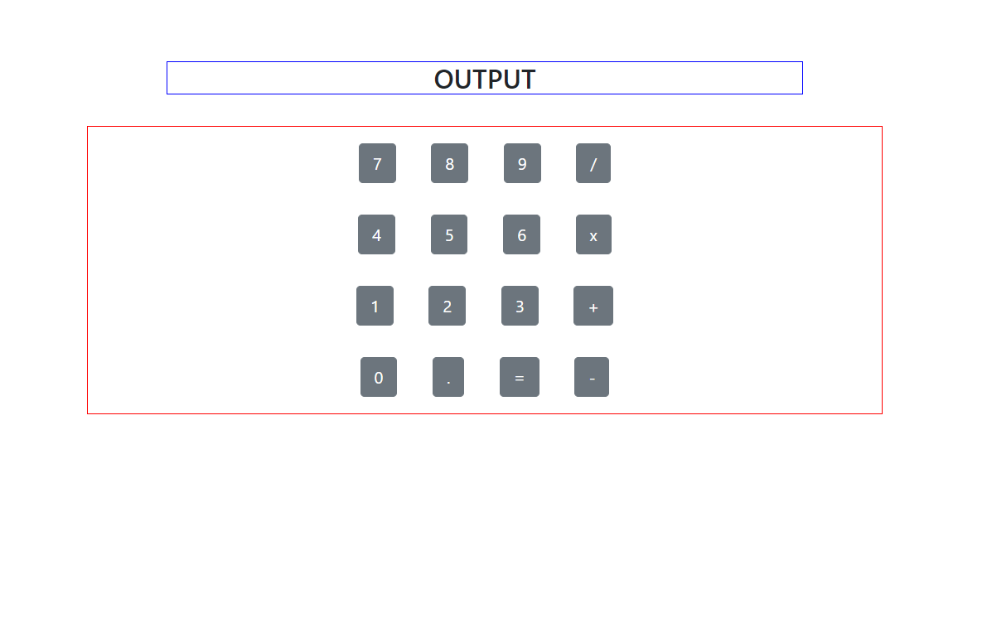

**Picture 2**

