**Codepen.io** (Write HTML, CSS, and JS code)

Source:

<https://cdnjs.cloudflare.com/ajax/libs/react/15.6.1/react-dom.min.js>

JavaScript

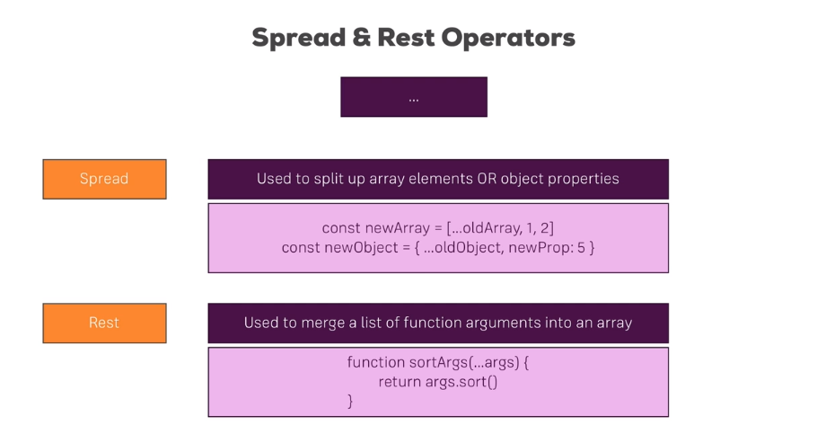

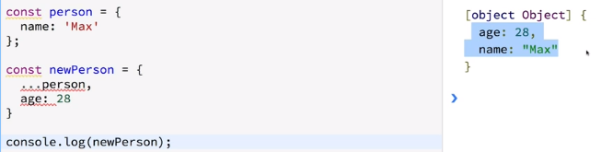

NOTES: Inheritance in new JavaScript

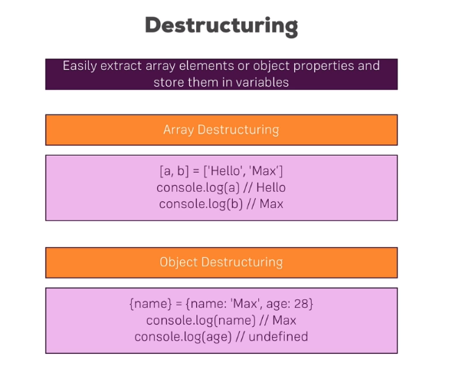

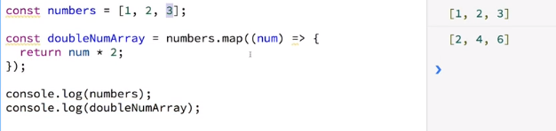

**Installing Node and creating first project**

**Run in Console :**

npm install create-react-app -g

create-react-app [name of folder]

npm start

**JSX**

JSX looks like HTML but it is NOT HTML

It is actually Javascript but it is syntax we can use to write html but not actually writing it.

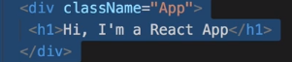 PICTURE OF JSX

return React.createElement('div', {className: 'App'}, React.createElement('h1', null, "Does this work now?"));

Results in:

**https://lh5.googleusercontent.com/KZu2otHsfvyIZVqJvaWq1lz8U6QMZtlDREhOVsYd281pw_H61BWnlXplM_Qkcssanzr-tCN8uZnGw5ZEYd3THIy3XDN1WBap-EgLHcDCxVRz2eyFBE-PD3hyorFbSV1AgwDLbPy8**

**Must use className and not class because class is a reserved word for JS**

**Creating first functional component**

1. **Create Person Class**
2. 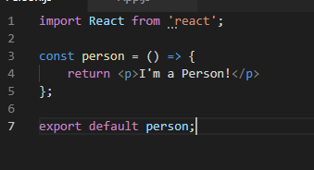

**3) https://lh4.googleusercontent.com/tQBOGF8joOKMXybgKcKqBVoA5eTZYORJd5b6vx3BVmaAPg7aFiQ-AcJe9Hqcnu-UfKeEQm939LJVNbyJqrE4plCXxCmYiTvMwNT_Nh97VCOyaFRGGVsA981dzPenrslo5tBB-_Zc**

**https://lh4.googleusercontent.com/AnbM_Iulbfy0eDEjiax2WLL6piav_2AQoShWgN-M1eHWlhS5yOvvILvVJvTiQThhgQFa9KocmjhlBNb0gccUipnRC9vDSlpPGHP0ENwq5fzCUdzyDnU3Al28D1gyadcwoaSx-vqb ← Self closing same as <Person></Person>**

**CHEAT SHEET**

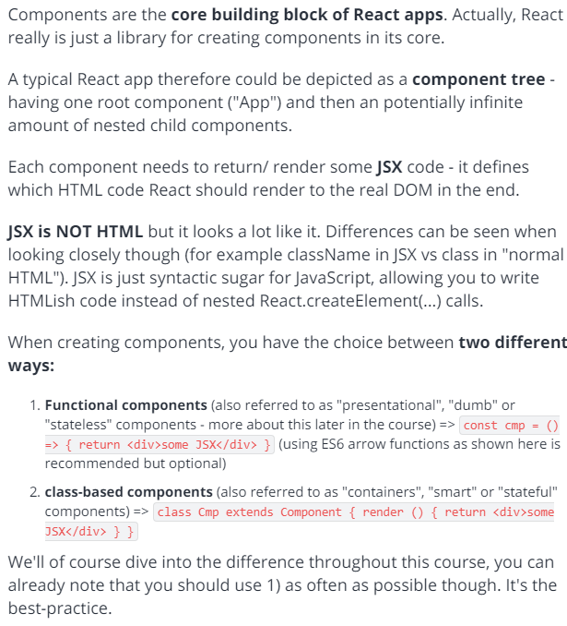

**Wrap dynamic content in curly braces**

**https://lh3.googleusercontent.com/YjbYwRt5j6UNL-l9nEbZnJPtDmRaHV0h7TacfV7bD3N0DixIfYVt11n7pfl5nbt_rDvi6RrqDEqCFnbJr0eVHSaVotJaBVMY59gaslqYngD9P1Cz32_i4xi-eNo10oX3RjR42q26**

**How to be able to use Props**

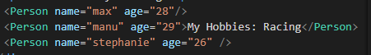

**https://lh5.googleusercontent.com/0aFBlZXEkoduQDrLuI21-AASC0sevJPqOcct7acCmt9gEoxFgVnKqOCtjix5hUbM1bvmXLQNoo5ky5Dw3d8WTHO4EI9W4r2o6-qaEu0UwhUuk76YqKZ0hKT6dBusnQwTvzub3Pl9**

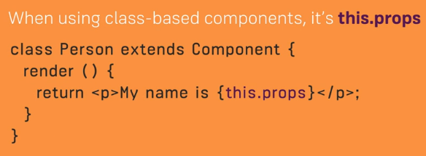

**Otherwise**

**https://lh5.googleusercontent.com/laX0tN_sPkWjo3vDqEoR0aStN3w4v_RytHcf2OdywaFJ87Zi9RNAoGNhhoGQl-QYLg4kYIiw0JQdf2SzkTq5jQBHFsfZNIfV9P1nfRi-0qSiwhxwxEps1yVk42ZfRn7P0a2zEjsT**

**Using Children Property**

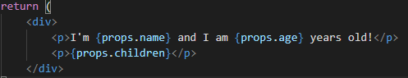

**We use props.children to output**

**https://lh5.googleusercontent.com/mcyK3gkX-KudcfhEuMU3tHkaGE0UYQVSCGQPwk5USDWh4-vOuskmvEf_1gMBv6OjbseQuPcLi0oV8B37UrliQVT9ZF0Uh2Gd81mgJ7qwOhPW2vr1oe7G3Mo-GI9qmmgWnR92M6QT**

**Making a button**

**https://lh6.googleusercontent.com/0X1hchhIWwbDDWezQMmW3hBlI367BvIn1Srj_L7FV6eRjek8J6UKarn0J62yR38yeVbGW9NVfLN7bWc1IuJo98VvVWjdXOmiuqK3KriHWQHsB4PIi9WSUYX64aDzcUYMfFsJoB-O**

**https://lh6.googleusercontent.com/sM83WRal2bwMOL-sZCMMeJoNYzHcVnaFWzgS_rHrX-PuYDdliDDLs5ZiktGZ7m4ictBk-uL_XZohQ3HJAU4fQ2GmD1yCcobB-jgwIJLkDaG61UniLw5VR3jhC11xJRloocHB1I1y NOTE when you call switchNameHandler don’t add ()**