CMPEN-441: Operating System and System Programming
Homework 6: Intro to Threads

Objectives
By completing this assignment, students should be able to:
- Understand the concept of thread.
- Understand the difference between process and threads.
- Understand concurrency and parallelism.
- Understand race condition

Implementation (20 points)
To test if your study meets the objectives, you are required to answer the following questions.
Question 1(4 points)
Basic Concepts
- In Figure 1, what are the four components of a process?
Answer:____________________________________________________________________ ___________________________________________________________________________

- In Figure 2, what are the four components of a thread?
Answer:____________________________________________________________________ ___________________________________________________________________________

- What are the segments that multi-threads share in a process?
Answer:____________________________________________________________________ ___________________________________________________________________________

- What are the segments in which multi-threads are uniquely used in a process?
Answer:____________________________________________________________________ ___________________________________________________________________________

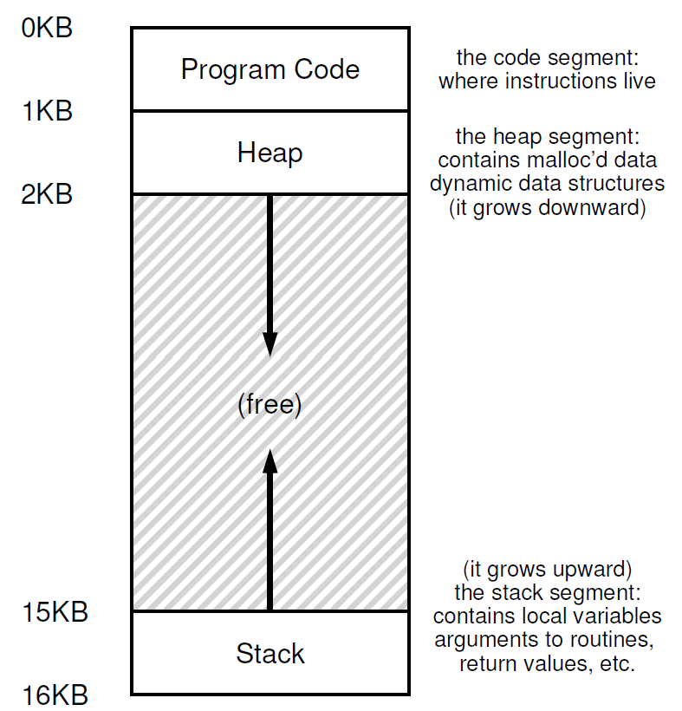
Figure 1: The single-thread Process

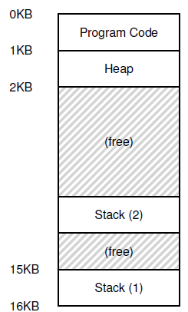
Figure 2: The multi-thread Process

Question 2(2 points)
Basic Concepts
What are two reasons that we prefer to use threads, rather than processes?

Answer:____________________________________________________________________
___________________________________________________________________________

Question 3(4 points)
Basic Concepts
- Which library will be used for thread creation?
Answer:____________________________________________________________________ ___________________________________________________________________________

- Which system call will be used to create a thread?
Answer:____________________________________________________________________ ___________________________________________________________________________

- Which system call will be used to make the main process wait until the thread completion?
Answer:____________________________________________________________________ ___________________________________________________________________________

- Which system call will be used to make the parent process wait until the child process’s completion?
Answer:____________________________________________________________________ ___________________________________________________________________________

Question 4(4 points)
Challenging questions
Given the program shown in Figure 3, try to answer the following questions.
- How many process(es)? How many thread(s)?
Answer:____________________________________________________________________
___________________________________________________________________________

- What are outputs?
Answer:____________________________________________________________________
___________________________________________________________________________
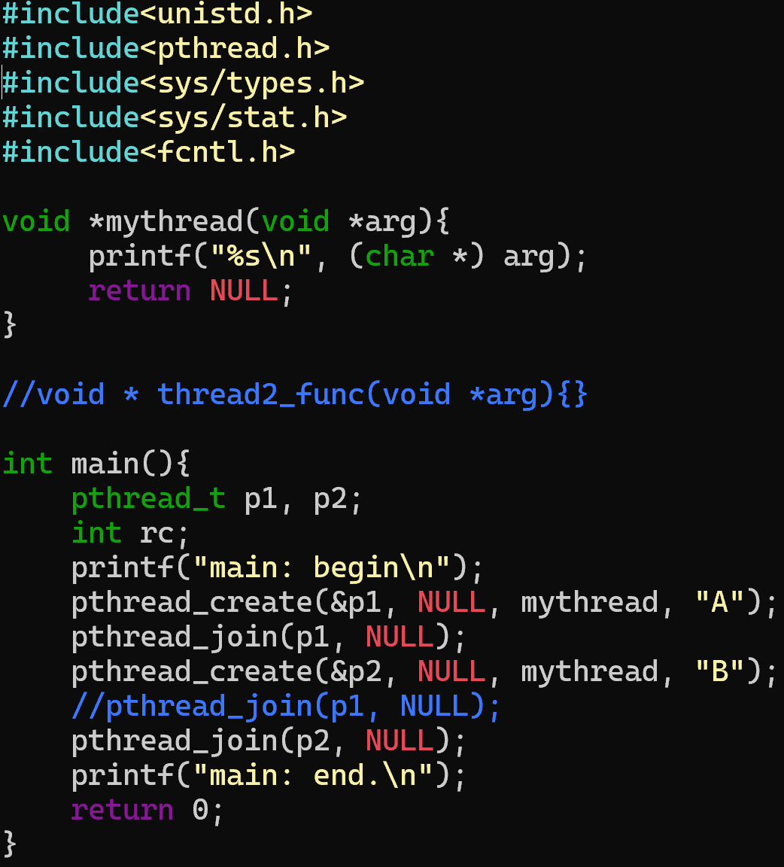
Figure 3: Thread program

Question 5 (6 points)
Challenging questions
Based on the thread program shown in Figure 4, how can you solve the issue of the race condition? You’d better write a program as the solution.

Answer:____________________________________________________________________
___________________________________________________________________________

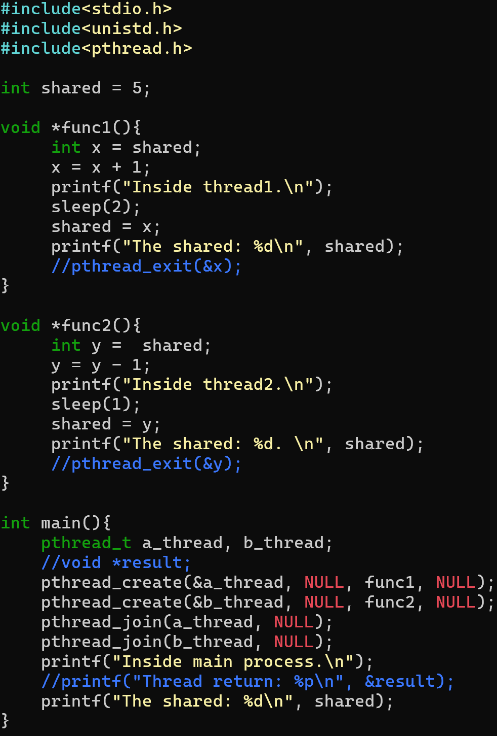
Figure 4: Another thread program

Submission
Follow the name convection shown below and submit the file(s) to Canvas before the deadline:
- HW6_YourFirstnameLastname.doc
OR
- HW6_YourFirstnameLastname.docx

