CMPEN-441: Operating System and System Programming
Homework 1: Basic Concepts of OS

Objectives
By completing this assignment students should be able to:
- Understand the basic concept of Operating Systems
- Understand how to run a program on a computer
- Understand OS management

Implementation (20 points)
To test if your study meets the objectives, you are required to answer the following two questions. You can type your solutions above the lines and submit the WORD file to Canvas's Dropbox.
Note: if you have more words as your answer, which is beyond two lines, you can extend the lines.

Task 1(10 points)
In Fig.1, describe what the CPU does to run a program, and fill your description with the three steps below. (Please type your answer to the place above the lines)

(You can fill in your answers above the lines. If you need more space, you can extend the lines to fill in your answers.)
Step 1: Fetch instruction from memory using PC

Step 2: Decode instruction and load data into registers

Step 3: Execute operation

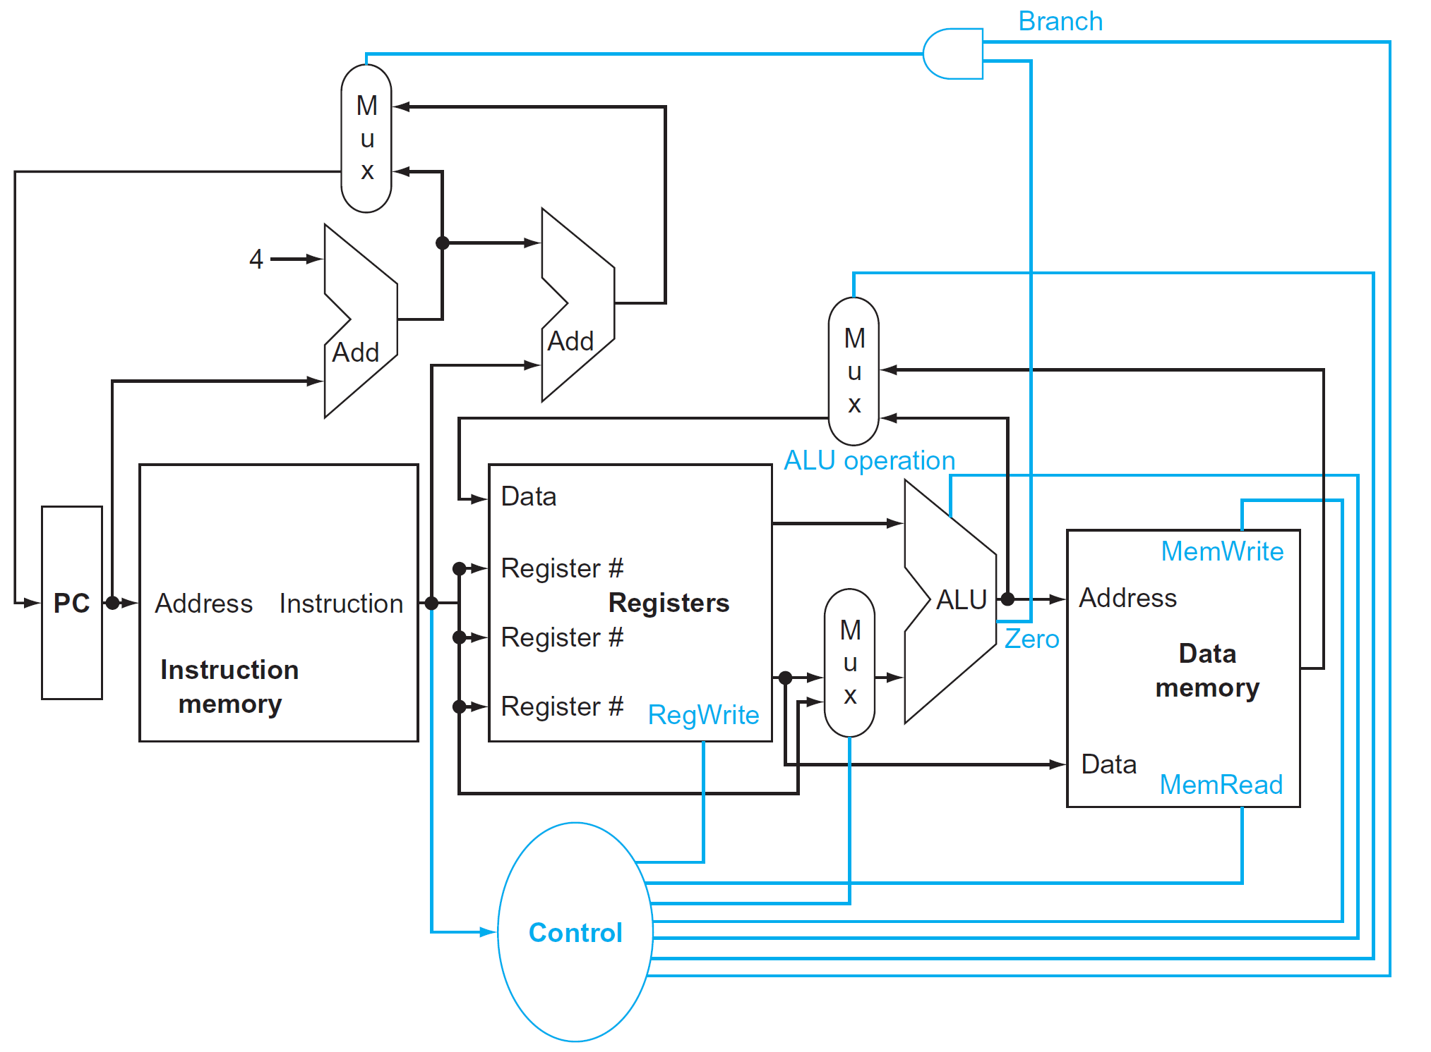
Fig.1: An abstract view of the implementation of the MIPS subset showing the
major functional units and the major connections between them [1]

Task 2(10 points)
What does the OS do?
(You can fill in your answers above the lines. If you need more space, you can extend the lines to fill in your answers.)
1). Manage CPU

2). Manage program memory

3). Manage external devices

Submission
Follow the name convection shown below and submit the file(s) to Canvas before the deadline:
- HW1_YourFirstnameLastname.doc
OR
- HW1_YourFirstnameLastname.docx

Reference
[1]. David A. Patterson, “Computer Organization and Design RISC-V Edition: The Hardware Software Interface”

