CMPSC 474: Operating System and System Programming
Homework 2: The Processes Abstraction

Objectives
By completing this assignment, students should be able to:
- Understand the process combination
- Understand the process states

Implementation (20 points)
To test if your study meets the objectives, you are required to answer the following two questions. You can type your solutions above the lines and submit the WORD file to Canvas's Dropbox.
Note: If your answer includes more words than lines, you can extend the lines.

Task 1(4 points)
Basic concept
1). What are the four combinations of a process?

Answer: Instruction, data, stack, heap

2). Among the four process combinations, which is(are) stationary? Which is(are) dynamic?
Answer: (Fill your answer above the lines)
- Stationary: Instruction, data
- Dynamic: H

Task 2(16 points)
Case study
1). The table in Fig.4.3 below tracks states in two processes. How long does Process0 take to complete the execution? How long does Process1 take to complete the execution? (Assume each time stamp takes one second.)
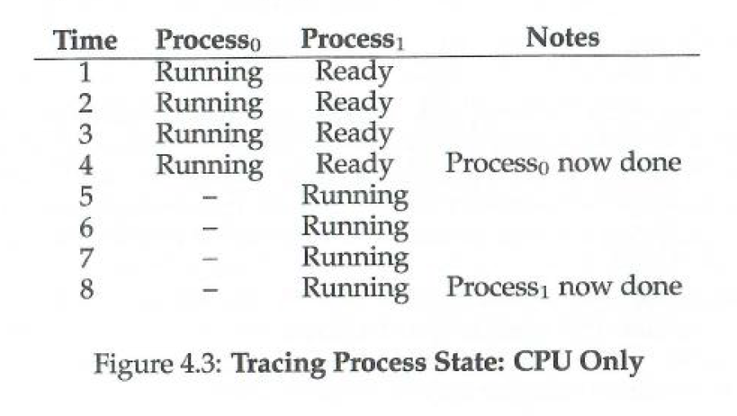
Answer: (Fill your answer above the lines)
- Process0: 4sec
- Process1: 8sec

2). In Figure 4.4, with the time spent waiting for I/O resources, if each time unit takes 1 second, how long does Process0 take to complete the execution? How long does Process1 take to complete the execution?
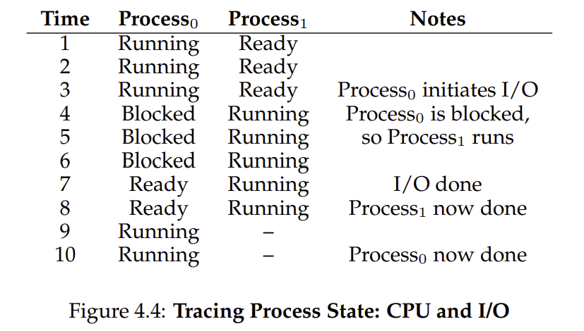
Answer: (Fill your answer above the lines)
- Process0: 10sec
- Process1: 8sec

3). In Fig.4.4, at Time 7, process 0 gets I/O resources with the process state --- READY and waits for the CPU resource until process 1 is done. However, let’s change the scheduling policy to use the CPU resource differently. Once process 0 gets the I/O resource, the CPU will immediately switch from process 1 to process 0. This time, how long does Process0 take to complete the execution? How long does Process1 take to complete the execution?

Answer: (Fill your answer above the lines)
- Process0: 8sec
- Process1: 10sec

4). Compared with the two scheduling policies mentioned in 2) and 3), do you think which is better? Why?

Answer: First scheduling policy, since in the second policy, the CPU has to switch processes an additional time.

Submission
Follow the name convection shown below and submit the file(s) to Canvas before the deadline:
- HW2_YourFirstnameLastname.doc
OR
- HW2_YourFirstnameLastname.docx

