CMPSC 474: Operating System and System Programming
Homework 3: Process API and System Calls - 2

Objectives
By completing this assignment students should be able to:
- Understand the basic concept of system calls
- Enable to use fork(), wait(), sleep( ), execl( ) for the system program

Implementation (20 points)
To test if your study meets the objectives, you are required to answer the following questions.

Question 1(4 points)
What is the importance of using the system call — wait () from the perspective of process management and recycling?
Answer: wait() allows parent to wait until a child terminates, allowing operating system to release its resources

Question 2(4 points)
Compare the following two programs – one using wait( ) and the other using sleep( ). Do the wait( ) and sleep( ) work the same in the program?
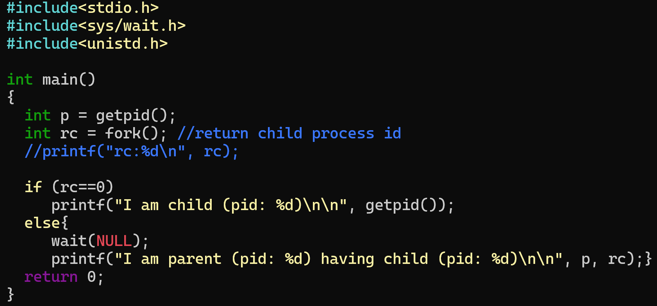

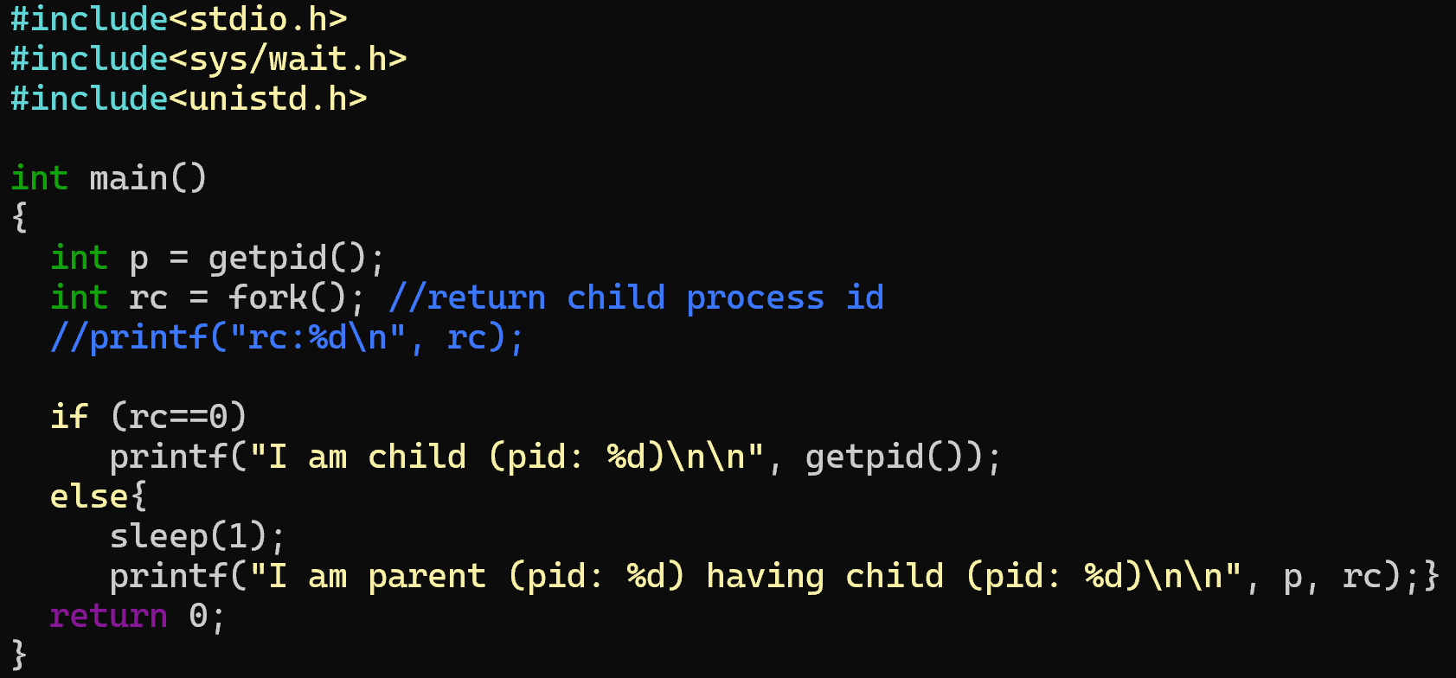

Answer: no, they do not. Wait pauses the parent process until the child terminates, sleep only delays execution for a given amount of time

Question 3(4 points)
Write the following program on your computer, compile and execute it. How can you identify the existence of a zombie process in the system?

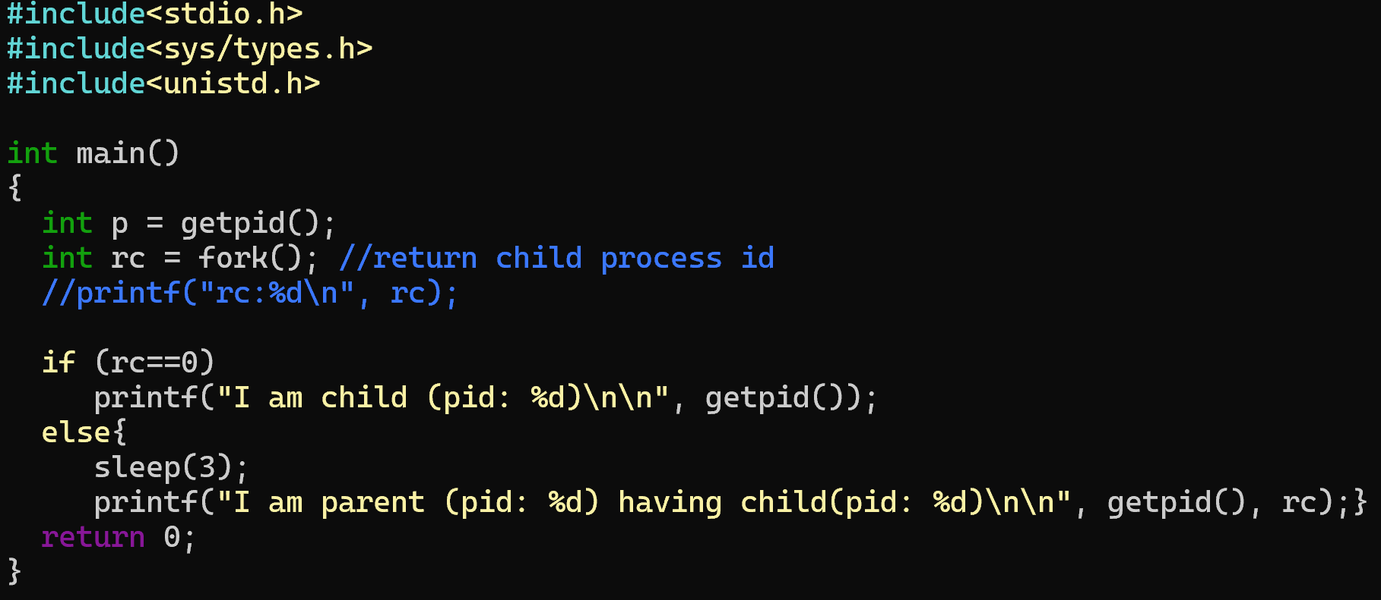

Answer: ps in bash, process is <defunct>

Question 4(4 points)
Q2. Based on the above program, modify it as the program of having an orphan process.
Answer:
(Hint: Fill your program in the following window.)

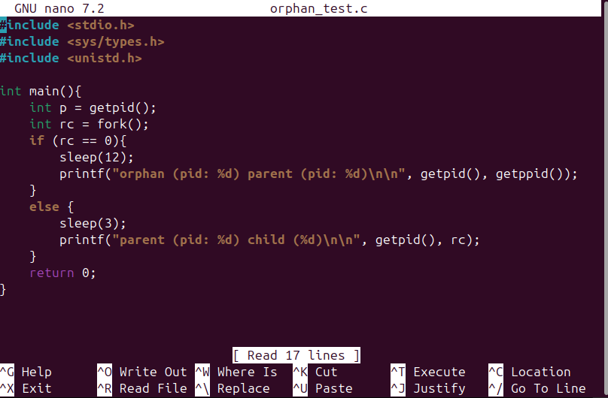

Question 5(4 points)
According to Question 4, How can you identify the existence of an orphan process in the system?
Answer: parent pid doesn’t match with child ppid

Submission
- Program filled in Question 4 could be snipped and pasted.

- Follow the name convection shown below and submit the file(s) to Canvas before the deadline:
- HW3_YourFirstnameLastname.doc
OR
- HW3_YourFirstnameLastname.docx

