CMPEN-441: Operating System and System Programming
Lab 14: Disk Scheduling (20 Points)

Objectives
By completing this lab, students should be able to:
- Familiarize basic bash commands
- Use system calls for programming

Introduction
Disk Scheduling
Disk scheduling is related to the seek time and rotate time. The seek time is the time to seek the track node in the disk. The rotate time is the time to rotate the disk. The disk scheduling algorithms are listed:
- First Come First Service (FCFS)
- Shortest Seek Time First (SSTF)
- Elevator

Example of disk scheduling
The disk scheduling starts with a current track node. Then, according to the request of the track nodes, we can implement the disk scheduling. For example, the current track node is 50, and the requested order is {34, 87, 45, 77, 22}. When the disk scheduling is considered, the distance between the current track node and the next moving node must also be considered because the distance is related to both the seek time and the rotate time. The request sequence is the second factor we consider for the seek time and rotate time. Different request orders will determine different total distances from the start position on the track. In the case, if the FCFS is used for disk scheduling, the implementations are:
- The start position: 50
- The request order: 34, 87, 45, 77, 22
- The total distance: |50-34|+|34-87|+|87-45|+|45-77|+|77-22| = 16+53+42+32+55 = 198

Lab instruction

Task 1:
Write a program. The FCFS is used to implement disk scheduling in the program. The start track node and the request order lists are input from the user's end. After the disk scheduling is implemented, display both the request order and total distance on the screen.

- Sample output:

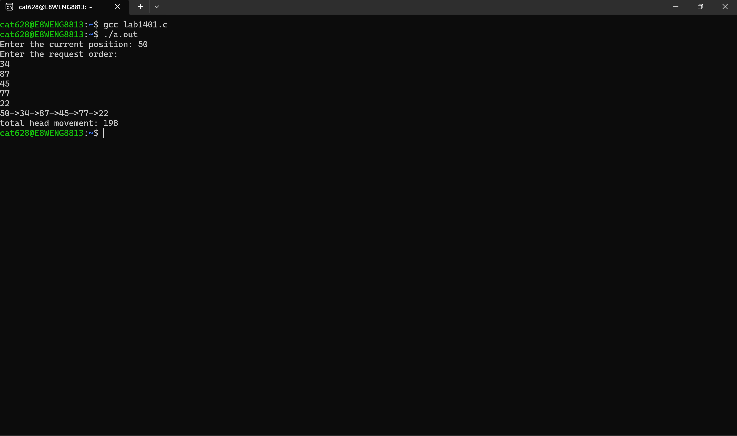

Task 2:
Write a program. According to the definition of the SSTF in chapter 37 of the textbook, the SSTF is used to implement disk scheduling in the program. The start track node and the request order lists are input from the user's end. After the disk scheduling is implemented, display both the request order and total distance on the screen.

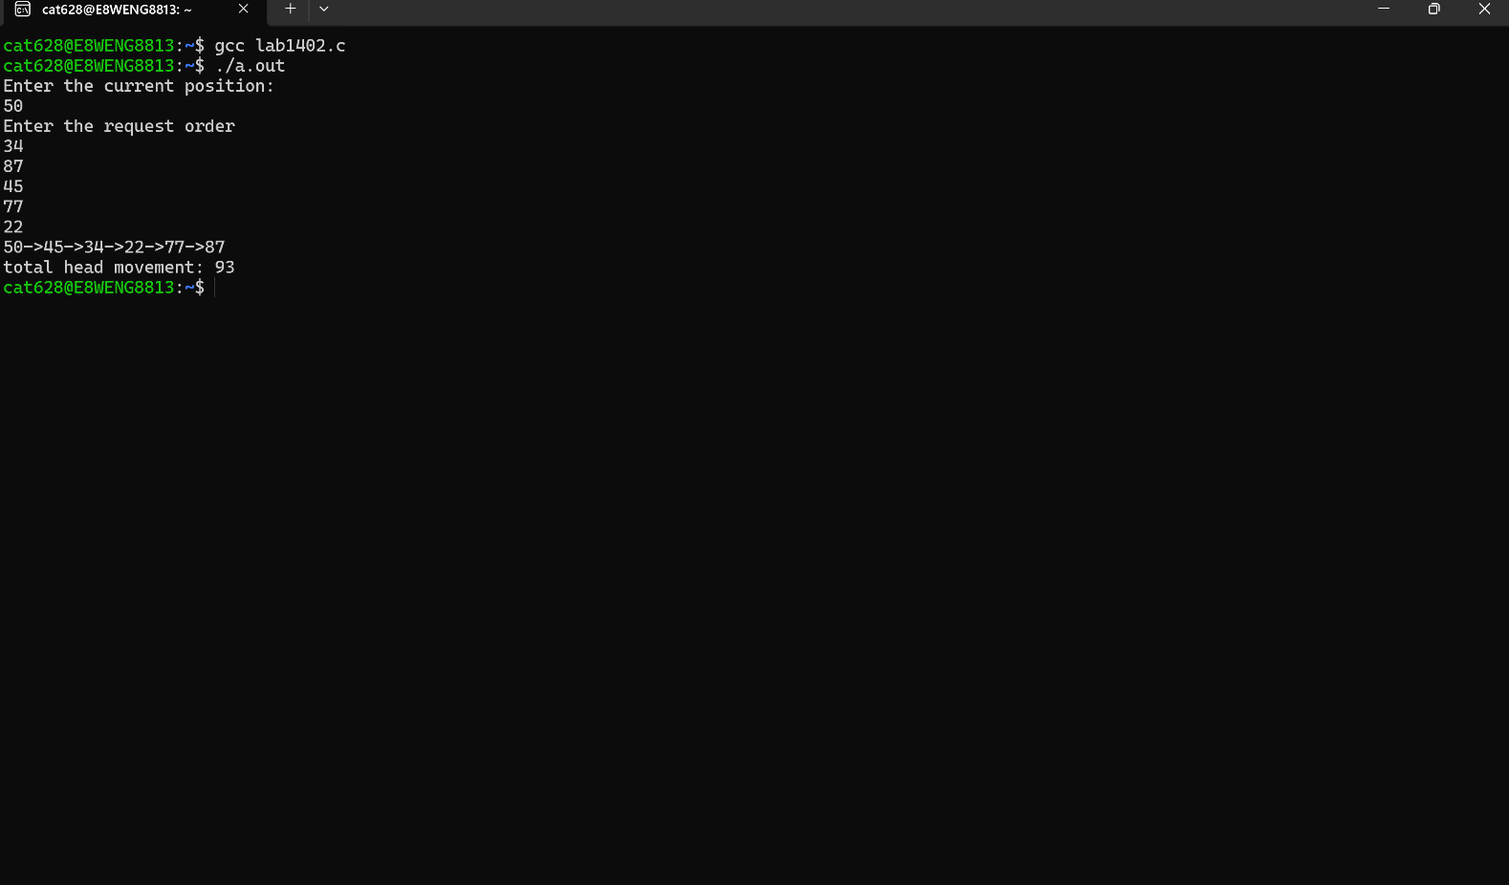
- Sample output:

SUBMISSION
Submit five C source code files. According to the sequence of tasks, the submission follows:
- the first C source code file is called “Lab1401_YourFirstnameLastname.c”.
- the second C source code file is called “Lab1402_YourFirstnameLastname.c”.
Submit the above files to the Dropbox of Canvas.

