CMPEN441 / CMPSC474: Operating System and System Programming
Lab 13: Philosopher Dining Problem (20 Points)

Objectives
By completing this lab, students should be able to:
- Familiarize with basic bash commands
- Use system calls for programming

Introduction
Problem Description
The philosopher's dining problem is raised in the following diagram, with the requirement that each philosopher can get forks for dinner. The constraints are listed below:
- Pi must hold two trajectory forks for eating.
- Pi won’t eat when calling think() and eating when calling eat().

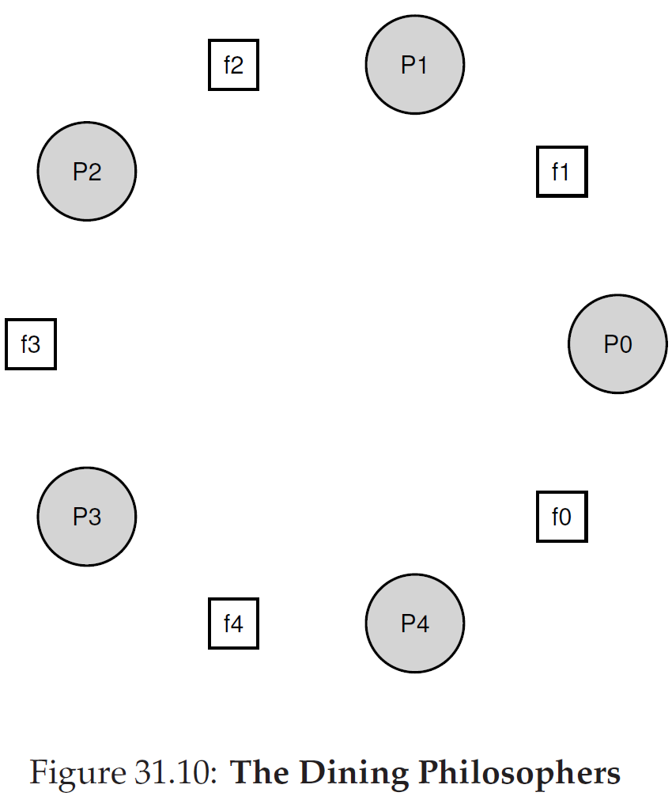
Pi: each philosopher
fi: each fork

The Tips to Implement the Program
Before implementing Lab 13, please study Lab 10(Race condition), Lab 11(Mutex lock), and Lab 12 (Condition variable and semaphores). Because the previous three labs can give you inspiration about how to implement Lab 13.

Lab instruction

Task 1:
Write a program. The thread functions can solve the philosopher dining issue in the program. To implement the philosopher dining problem, you are required to use the example code of the philosopher dining problem by using the semaphores in Chapter 31 of the textbook. Ultimately, display the philosopher dining sequences (including which one of the philosophers, the left(/right) fork pickup and returning, and the eat starting and finishing) on the screen.

- Sample output:
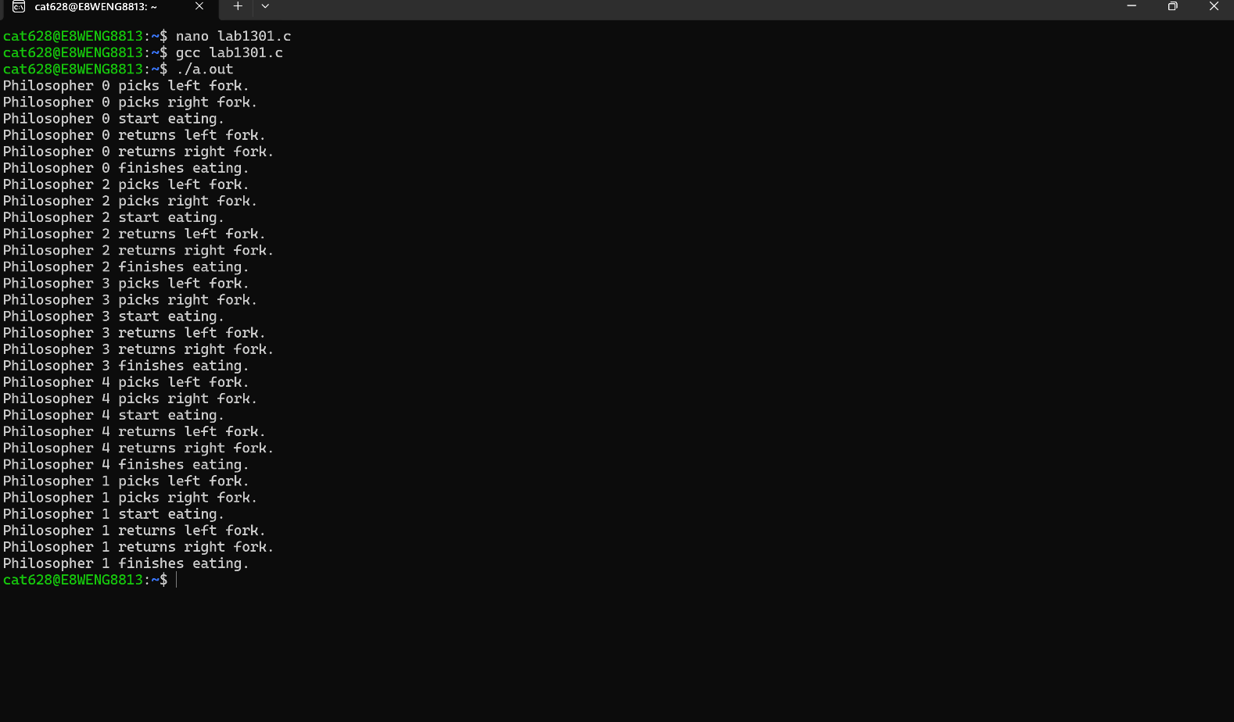

Task 2:
Write a program. The thread functions can solve the philosopher dining issue in the program. To implement the philosopher dining problem, you are required to use the example code of the philosopher dining problem by using the semaphores with the solution of breaking the dependency in Chapter 31 of the textbook. Ultimately, display the philosopher dining sequences (including which one of the philosophers, the left(/right) fork pickup and returning, and the eat starting and finishing) on the screen.

- Sample output:
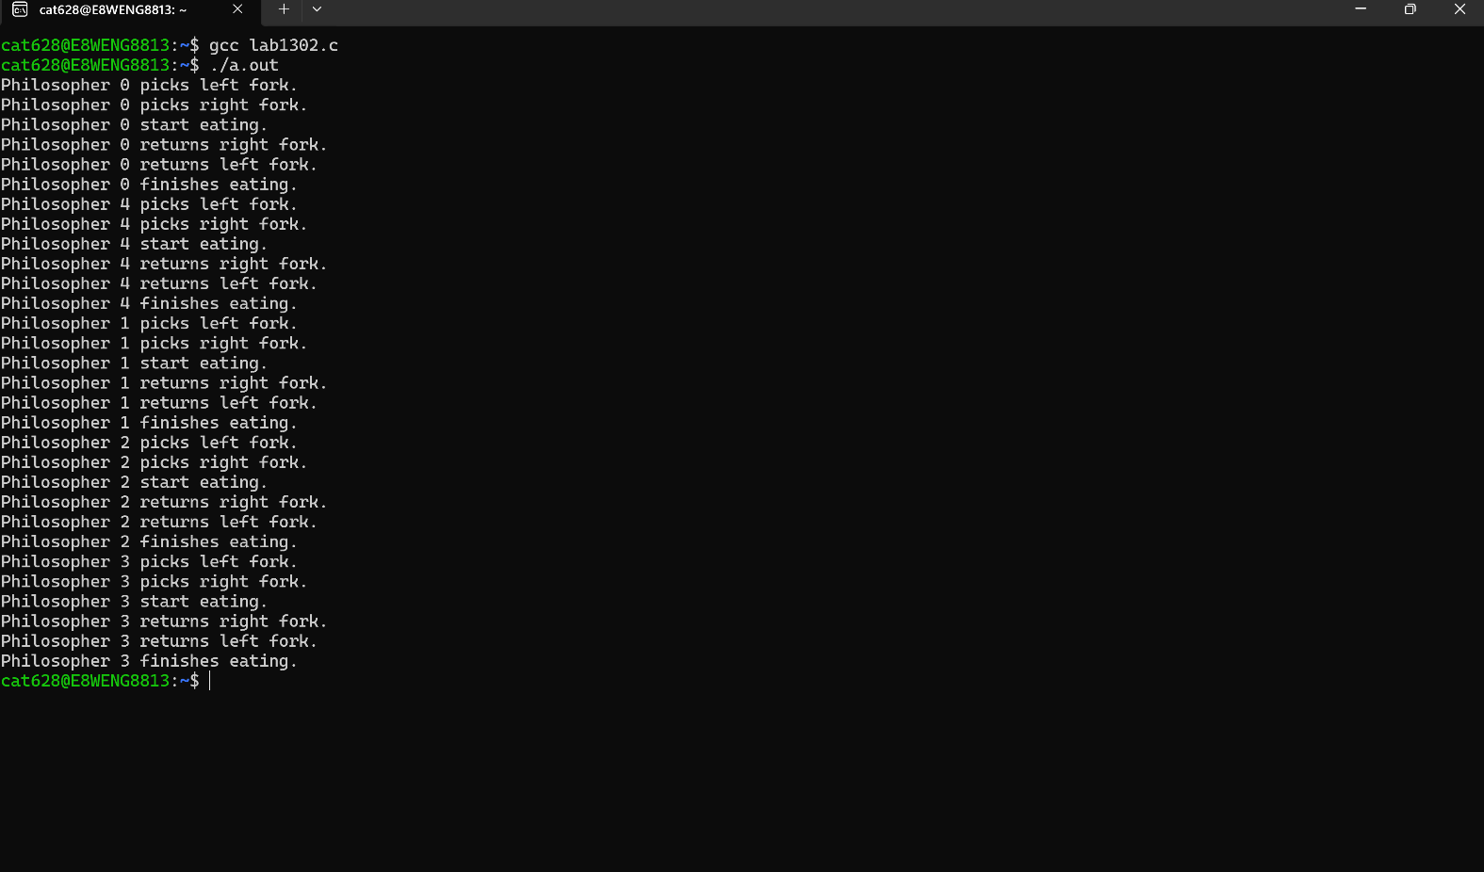

Task 3:
Compared with Task 1&2, let’s make result analyses and answer the following questions:
- In Task 1(or Task 2), are the outputs always the same throughout several executions? If not, can you explain the reason(s)?

- In both Tasks, why are the semaphores used, either for the issue of mutex lock, synchronization like the parent waiting for the child, or for the producer and consumer sharing the buffer?

- If the number of philosophers is changed by 1, What are the outputs for both tasks?

- What is the maximum number of philosophers, which means the output is blocked if it is over?

SUBMISSION
Submit five C source code files. According to the sequence of tasks, the submission follows:
- the first C source code file is called “Lab1301_YourFirstnameLastname.c”.
- the second C source code file is called “Lab1302_YourFirstnameLastname.c”.
- the third TXT file is called “Lab1303_YourFirstnameLastname.txt.
Submit the above files to the Dropbox of Canvas.

