CMPEN-441 / CMPSC-474: Operating System and System Programming
Lab 05: Inter-Process Communications (20 Points)

Objectives
By completing this lab, students should be able to:
- Familiarize basic bash commands
- Use system calls for programming

Introduction
- popen()
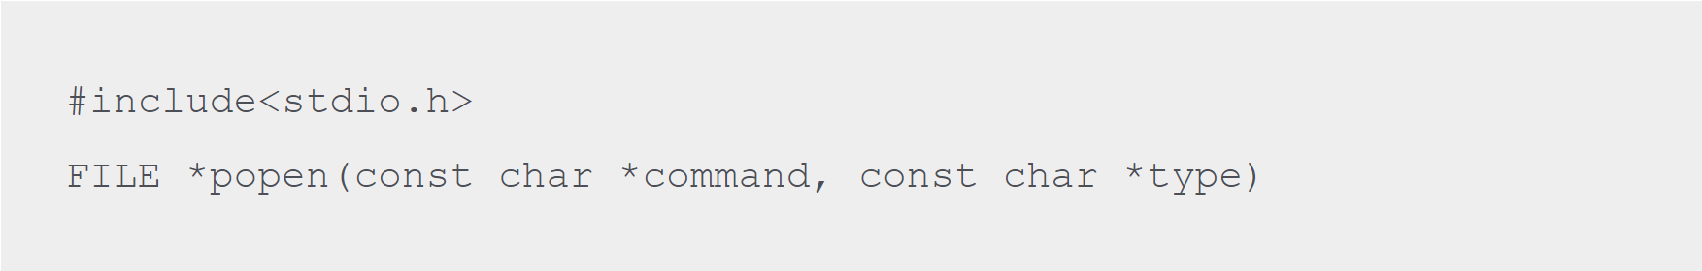
- Func: opens a pipe stream to or from a process
- Arg1: process for communication
- Arg2: sending or receiving data
- Return: file handler(pointer) on success.

- pipe(fd)
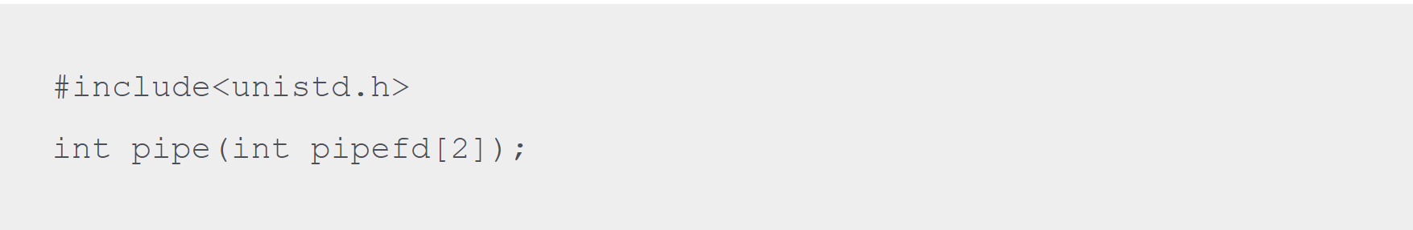
- Func: creates a unidirectional pipe
- pipefd[0]: reading end
- pipefd[1]: writing end
- Return: return -1 if failed.

- mkfifo( )
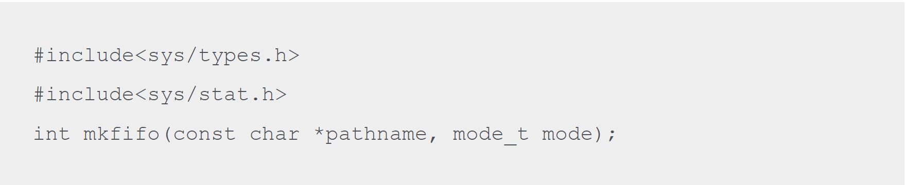
- Arg1: named pipe
- Arg2: working mode permission
- Return: 1). Return 0 on success; 2). Return -1 if failed.

- shmget()
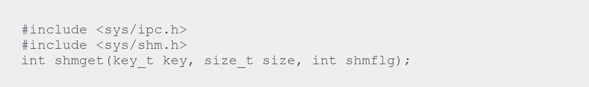
- Func: to create or locate a shared memory segment
- Arg1: the unique number identifying the shared segment
- Arg2: the size of the shared segment
- Arg3: the permissions on the shared segment
- Return: 1). Return the associated shared memory identifier if working; 2). Return -1 if failed.

- shmat()
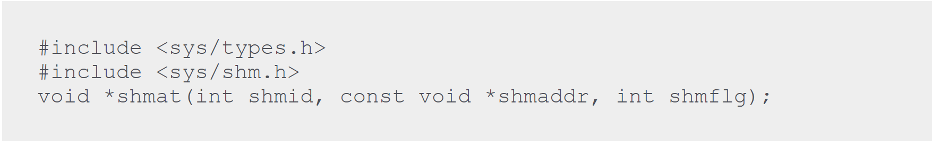
- Func: attaches a shared memory segment to a process's address space, allowing the process to access the memory contents.
- Arg1: the identifier which shmget() function returns on success
- *Arg2: the address where to attach it to the calling process. A NULL value of second parameter means that the system will automatically choose a suitable address.
- Arg3: the ‘0’ if the second parameter is NULL, otherwise, the value is specified by SHM_RND.
- Return: no return.

- msgget()
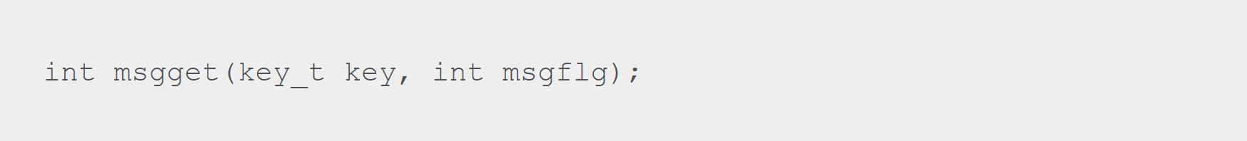
- Func: creates and access a message queue.
- Arg1: a key that names a message queue in the system.
- Arg2: The second parameter is used to assign permission to the message queue and is ORed with IPC_CREAT to create the queue if it doesn’t already exist. if the queue already exists then IPC_CREAT is ignored.
- Return: 1). Return a positive number which is the queue identifier on success; 2). Returns -1 if failed.

- msgsnd ()
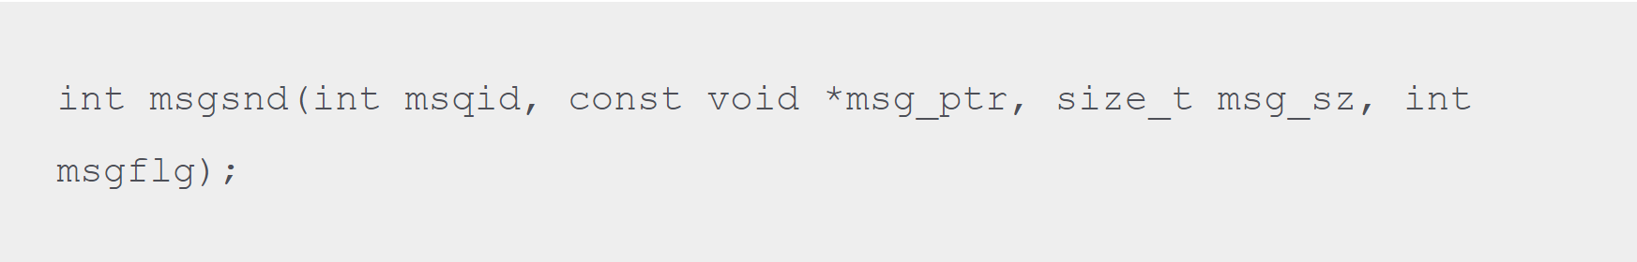
- Func: adds a message to the message queue.
- Arg1: the message queue identifier returned by the msgget function.
- *Arg2: is the pointer to the message to be sent, which must start with a long int type.
- Arg3: the size of the message
- Return: 1). Return returns 0 and place the copy of message data on the message queue on success; 2). Returns -1 if failed.

- msgrcv()
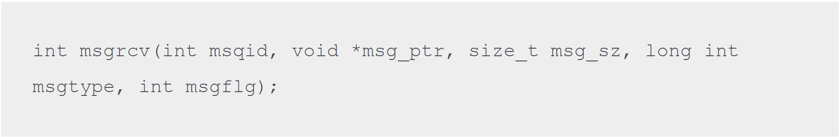
- Func: retrieves messages from a message queue.
- Arg1: the message queue identifier returned by the msgget function
- *Arg2: the pointer to the message to be received, which must start with a long int type.
- Arg3: the size of the message

- Arg4: The fourth parameter allows implementing priority. If the value is 0, the first available message in the queue is retrieved. But if the value is greater than 0 then the first message with the same message type is retrieved. If the value is less than 0 then the first message having the type value same as the absolute value of msgtype is retrieved. In simple words 0 value means to receive the messages in the order in which they were sent and non zero means receive the message with a specific message type.
- Arg5: The final parameter controls what happens if either the message queue is full or the system limit on queued messages is reached.
- Return: 1). Returns 0 and place the copy of message data on the message queue on success; 2). Returns -1 if failed.

- msgctl()
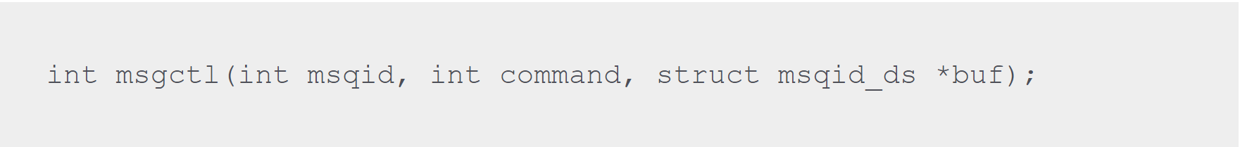
- Arg1: the identifier returned by msgget function
- *Arg2: the options are shown in following table.
- Arg3: set the ‘0’ by default.
- Return: 1). Returns 0 on success; 2). Returns -1 if failed.

Command | Description
IPC_STAT | Sets the data in the msqid_ds structure to reflect the values associated with the message queue.
IPC_SET | If the process has permission to do so, this sets the values associated with the message queue to those provided in the msqid_ds data structure.
IPC_RMID | Deletes the message queue.

Lab instruction

Task 1:
Write a program. The program should send a message to the parent process from the child process using pipe(). The message is input from the user's end.

Sample output:
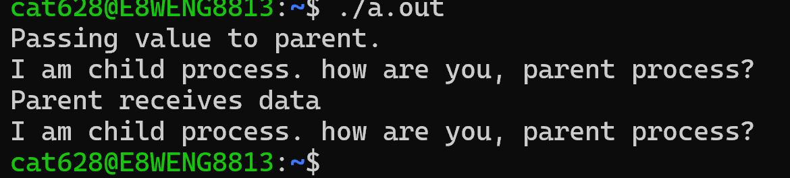

Task 2:
Q2. Write a program for inter-process communication by using mkfifo(). The entire IPC process will consist of three programs:
Program 1: to create a named pipe, “fifo2”
Program 2: a process that will write the text into the pipe (sender process). The text is “This is named pipe.”
Program 3: a process that will receive data from the pipe (receiver process).

- Sample output “lab0502_1.c”:
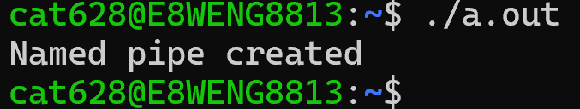

- Sample output “lab0502_2.c” and “lab0502_3.c”
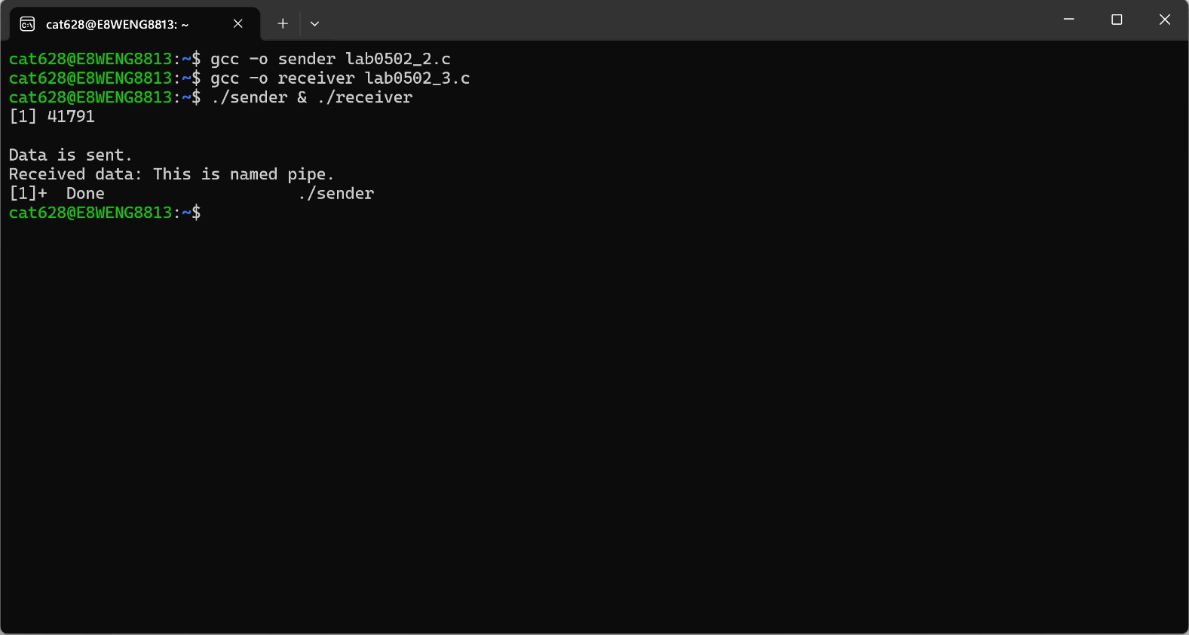

Sample F2(after writing):

- Sample of opening “F2.txt” (before writing):

Task 3:
Q3. Write a program to create a shared memory segment with a key value of 441 and a size of 2048 bytes. The content is written from user input. Then, create a child process that writes the content received by the parent process in the shared memory segment.

- Sample output:
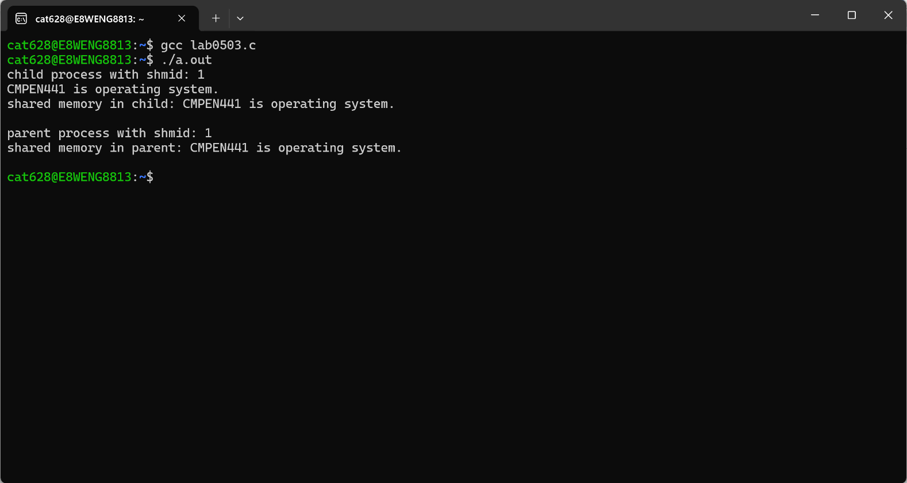

Sample F2(after writing):

Task 4:
Write two programs for inter-process communication by using message-related functions. The sender program should send a message and the receiver program will receive the message. The key value is 144 for the message. The message is input from the user's end and could repeat writing until the writing is “quit”.

- Sample output of sender program:
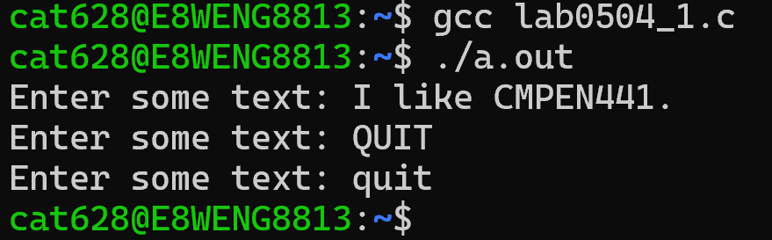

- Sample output of receiver program:
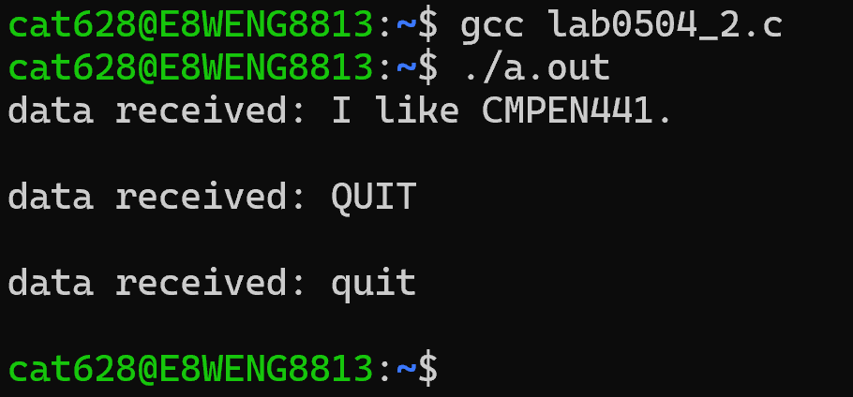

SUBMISSION
Submit four C source code file. According to the sequence of tasks, the submiss follows:
- the first C source code file is called “Lab0501_YourFirstnameLastname.c”.
- the second C source code files are called “Lab050201_YourFirstnameLastname.c”, “Lab050202_YourFirstnameLastname.c”, and “Lab050203_YourFirstnameLastname.c”.
- the third C source code file is called “Lab0503_YourFirstnameLastname.c”.
- the fourth C source code files are called “Lab050401_YourFirstnameLastname.c”, and “Lab050402_YourFirstnameLastname.c”.
Submitting files to the Dropbox of Canvas.

