CMPEN-441/CMPSC-474: Operating System and System Programming
Lab 06: Intro to Threads (20 Points)

Objectives
By completing this lab, students should be able to:
- Familiarize basic bash commands
- Use system calls for programming

Introduction
- pthread_create()
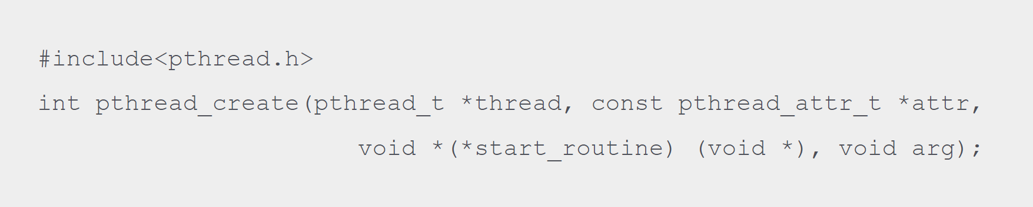
- Func: creates threads.
- *Arg1: the buffer containing the new thread's ID, if pthread_create is successful.
- *Arg2: The second parameter specifies the thread's attributes. It is generally NULL until you want to change the default settings.
- *Arg3: the name the function which the thread will execute. Hence, everything that you want the thread to do should be defined in this function.
- Arg4: the input to the function in the third parameter. If the function in the third parameter does not take any input then the fourth parameter is NULL.
- Return: 1). Returns 0 on success; 2). Returns Error number: An error occurred, and the contents of *thread are undefined.

- pthread_join()
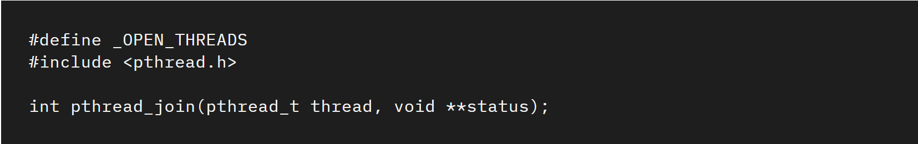
- Func: Allows the calling thread to wait for the ending of the target thread.
- Arg1: The new thread's ID.
- *Arg2: A pointer to the status argument passed by the ending thread as part of pthread_exit(). If the ending thread is terminated with a return, the status contains a pointer to the return value. If the thread was canceled, the status can be set to -1.
- Return: 1). Return 0 on success; 2). Return -1 if failed.

- pthread_exit( )
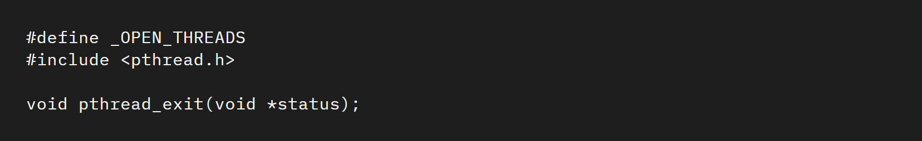
- Func: Ends the calling thread and makes status available to any thread that calls pthread_join() with the ending thread's thread ID.
- Arg1: A pointer to the status argument passed by the ending thread as part of pthread_exit().
- Return: No return.

Lab instruction

Task 1:
Q1. Write a program to create a thread T1. Thread T1 creates a file named Thread.txt while T1 writes “Hello” into the Thread.txt.

Sample output:
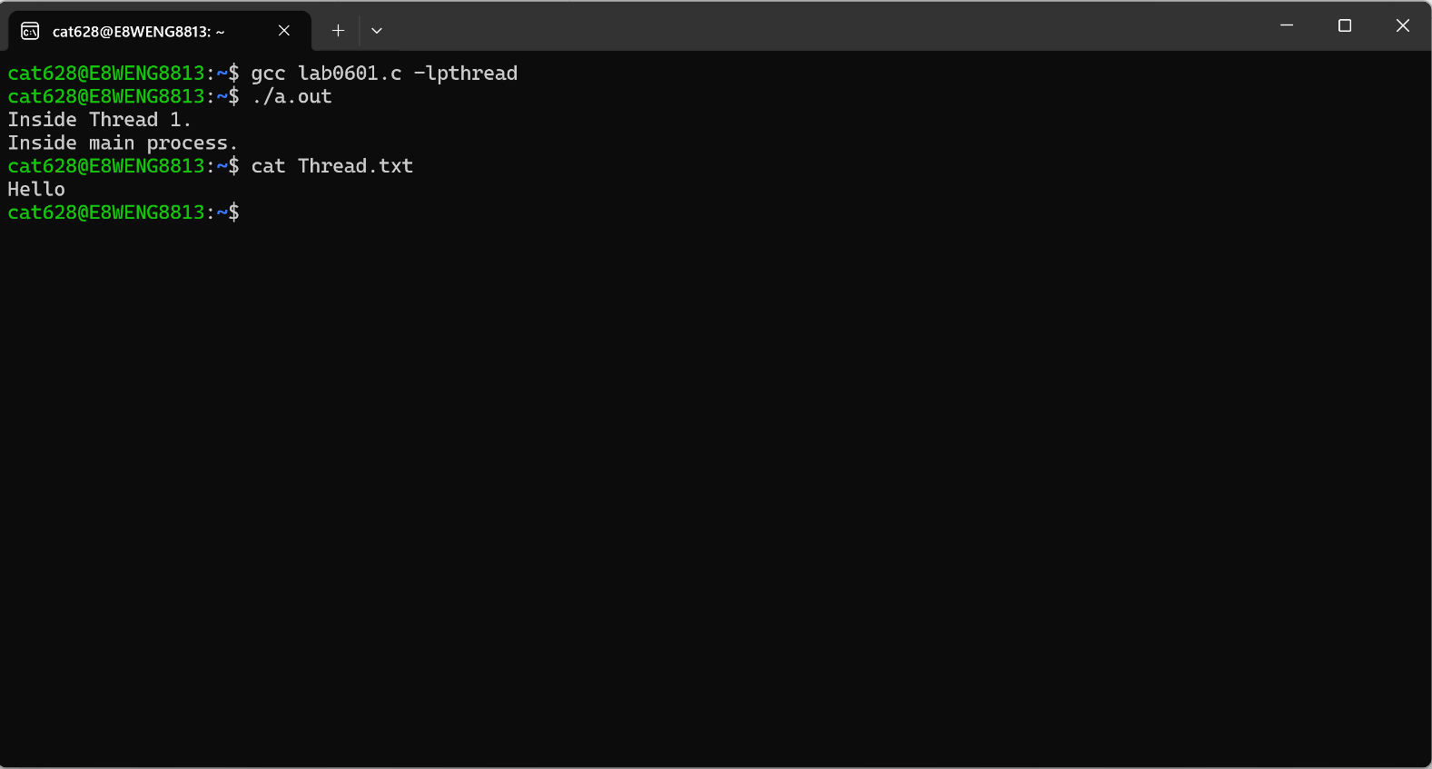

c

Task 2:
Q2. Write a program to create two Threads T1 and T2. Thread T1 creates a file named Thread.txt while T2 writes “Hello its T2” into the Thread.txt.

- Sample output:
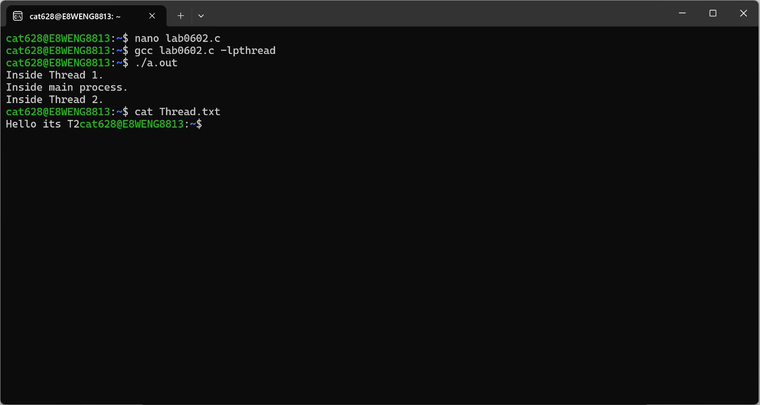

Task 3:
Q3. Write a program to create a thread T1. The main process passes two numbers to T1. T1 calculates the sum of these numbers and returns the sum to the main process for printing.

- Sample output:
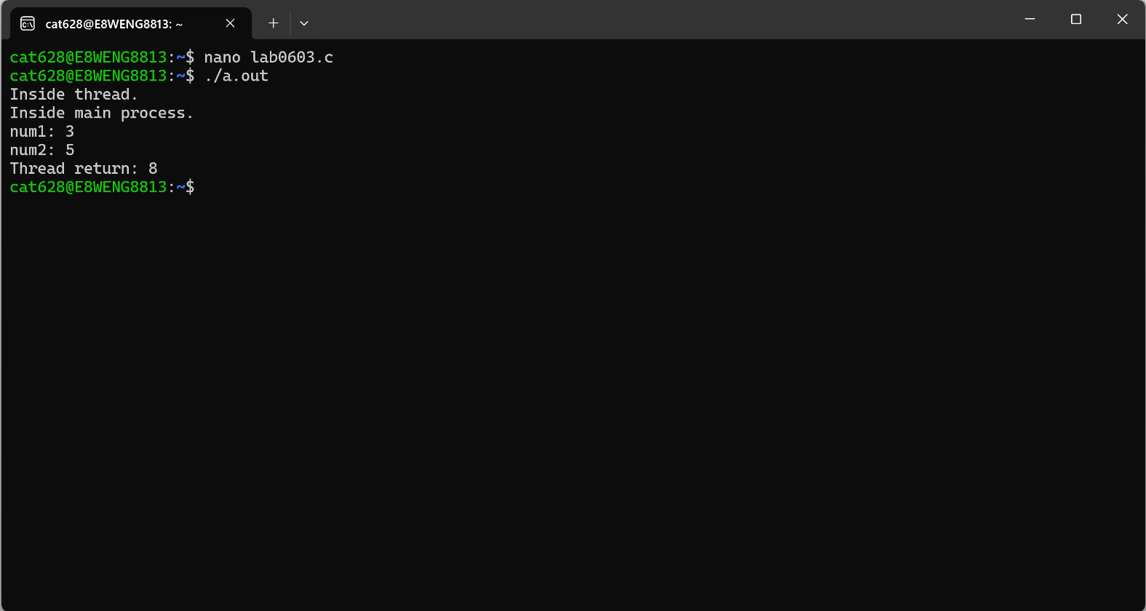

Task 4:
Q4. Write a program to create two Threads T1 and T2. Thread T1 creates a file named Thread.txt and returns the file descriptor of file “Thread.txt” to the main process. Thread T2 receives the file descript of file “Thread.txt” from the main process and directly writes the text “Hello, it's Task 4.” into the Thread.txt.
(Hint: After studying the threads, you should understand the data transferred between arguments in the calling process and parameters in the called threads. Hence, you are not allowed to use the system call “open( )” in the Thread2 function. )

Sample output:
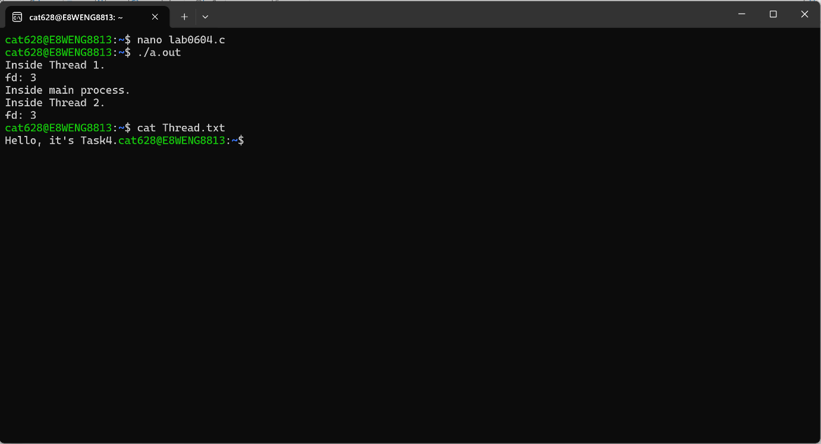

SUBMISSION
Submit four C source code files. According to the sequence of tasks, the submiss follows:
- The first C source code file is called “Lab0601_YourFirstnameLastname.c”.
- The second C source code files are called “Lab0602_YourFirstnameLastname.c”.
- The third C source code file is called “Lab0603_YourFirstnameLastname.c”.
- The fourth C source code files are called “Lab0604_YourFirstnameLastname.c”.
Submitting files to the Dropbox in Canvas.

