CMPEN-441: Operating System and System Programming
Homework 13: I/O Devices

Objectives
By completing this assignment, students should know:
- System architecture
- Communications between the OS and I/O devices

Implementation (20 points)
To test if your study meets the objectives, you are required to answer the following questions.

Question 1(2 points)
Basic Concept
What is the principal design rule for the modern system?
Answer: Separate mechanism from policy

Question 2(2 points)
Basic Concept
What is the polling in a canonical device?
Answer: CPU checks a device’s status register in a loop to determine if ready for I/O

Question 3(2 points)
Case study
Compare the following two options to use the CPU; which one is more efficient? Why?

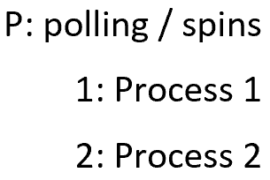

Option One:
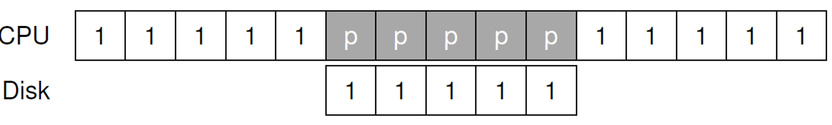

Option Two:
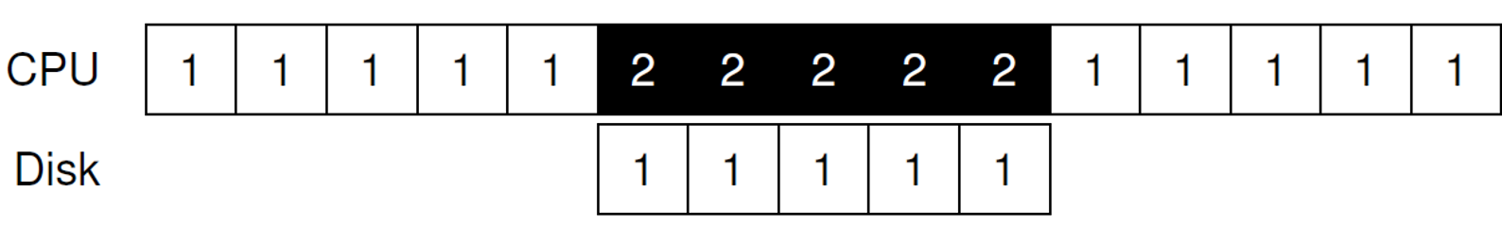
Answer: 2. avoids waiting

Question 4(2 points)
Basic Concept
Do you think polling (spins) is efficient for using CPU resources? If not, do you have an alternative?
Answer: No. DMA?

Question 5 (2 points)
Basic Concept
How does the interruption work?
Answer: A device sends an interrupt signal to the CPU when it needs attention. CPU stops current exec, saves state, executes interrupt handler, returns to prev. task

Question 6(2 points)
Basic Concept
What is the DMA (Direct Memory Access)? What is the purpose of using the DMA?
Answer: DMA allows devices to transfer data directly to/from memory without CPU involvement. Reduces CPU overhead.

Question 7 (8 points)
Case Study
In the following code of the xv6 IDE disk driver, answer the following questions:
- Is the data read from or written into the disk?
Answer: depends on b→flags &B_DIRTY

- What is the size of data for the data traffic?
Answer: 512b

- which method is used for data transmission, the polling or the interruption?
Answer: interrupt

- To protect the data traffic, which mechanism(s) is(are) used: the mutex-lock, the condition variable, or the semaphores?
Answer: mutex lock + cond var

Submission
Follow the name convection shown below and submit the file(s) to Canvas before the deadline:
- HW12_YourFirstnameLastname.doc
OR HW12_YourFirstnameLastname.docx

