bCMPEN-441: Operating System and System Programming
Homework 9: Free Memory Management

Objectives
By completing this assignment, students should know:
- External and internal fragmentation
- How to track the free memory list
- How to allocate varied-size memory blocks (First fit, Best fit, and worst fit)

Implementation (20 points)
To test if your study meets the objectives, you are required to answer the following questions.

Question 1(2 points)
Basic Concepts
1). What is the external fragmentation?
Answer: free mem split into small noncontiguous blocks of memory

2). What is the internal fragmentation?
Answer: allocated mem larger than requested

Question 2(3 points)
Basic Concepts
1). What is the Coalescing skill?
Answer: merging adjacent free blocks into one

2) What is the motivation to use the Coalescing skill for free memory management?
Answer: reduce ext. frag

Question 3(9 points)
Analytics and Calculation
Given Fig 17.7, complement the following questions
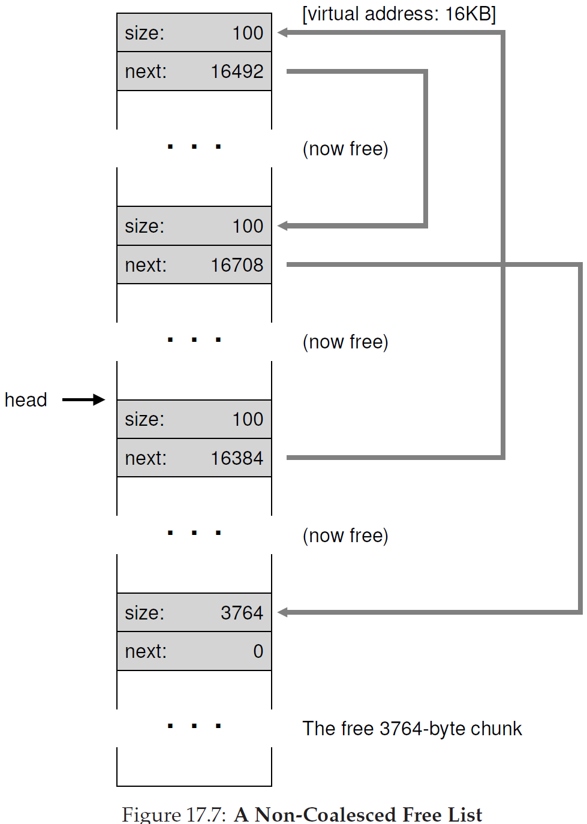
Please give the calculation process to explain how to get the following free block address:
- The “next” address in the first block

Answer: 16484
- What is the entry address of the first block
Answer: 16384
- The “next” address in the second block
Answer: 16592
- What is the entry address of the second block
Answer: 16492
- The “next” address in the third block
Answer: 16808
- What is the entry address of the third block
Answer: 16708

Question 4(6 points)
Analytics and Calculation
Given the following free list, assume an allocation request of size 40 at first and 75 at second. Please use different strategies to allocate free memory. And explain which strategy will cause either internal or external fragmentation.

60
40
80

(Hint: Similar examples are on page 192 of the textbook (paperback))
1). First fit
Answer: some external fragmentation, minimal int. frag.

2). Best fit
Answer: less ext. frag, no int. frag

3). Worst fit
Answer: ext frag no int frag

Submission
Follow the name convection shown below and submit the file(s) to Canvas before the deadline:
- HW9_YourFirstnameLastname.doc
OR
- HW9_YourFirstnameLastname.docx

