CMPEN 441 / CMPSC 474: Operating System and System Programming
Lab 07: Virtual Memory and Memory Address Translation (20 Points)

Objectives
By completing this lab, students should be able to:
- Familiarize basic bash commands
- Use system calls for programming

Introduction
- mmap()
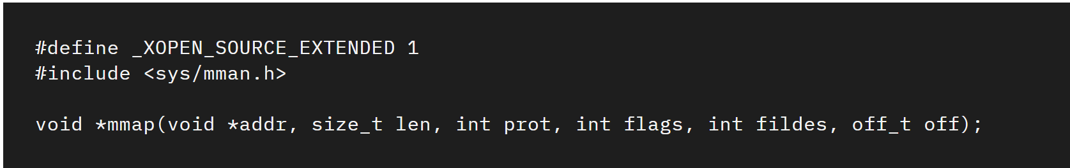
- Func: creates a new mapping in the virtual address space of the calling process.
- *Arg1: The starting address for the new mapping is specified in the address. If addr is NULL, then the kernel chooses the (page-aligned) address at which to create the mapping; this is the most portable method of creating a new mapping. If addr is not NULL, then the kernel takes it as a hint about where to place the mapping; on Linux, the kernel will pick a nearby page boundary (but always above or equal to the value specified by /proc/sys/vm/mmap_min_addr) and attempt to create the mapping there. If another mapping already exists there, the kernel picks a new address that may or may not depend on the hint. The address of the new mapping is returned as the result of the call.
- Arg2: The length argument specifies the mapping length (greater than 0). The contents of a file mapping (as opposed to an anonymous mapping; see MAP_ANONYMOUS below), are initialized using length bytes starting at offset offset in the file (or other object) referred to by the file descriptor fd. offset must be a multiple of the page size as returned by sysconf(_SC_PAGE_SIZE).
- Arg3: The prot argument describes the desired memory protection of the mapping (and must not conflict with the open mode of the file). It is either PROT_NONE or the bitwise OR of one or more of the following flags:

Prot Argument | Description
PROT_EXEC | Pages may be executed.
PROT_READ | Pages may be read.
PROT_WRITE | Pages may be written.
PROT_NONE | Pages may not be accessed.

- Arg4: The flags argument determines whether updates to the mapping are visible to other processes mapping the same region, and whether updates are carried through to the underlying file. This
behavior is determined by including exactly one of the following values in flags:

Flag values | Description
MAP_SHARED | Share this mapping. Updates to the mapping are visible to other processes mapping the same region, and (in the case of file-backed mappings) are carried through to the underlying file. (To precisely control when updates are carried through to the underlying file requires the use of msync(2).)
MAP_SHARED_VALIDATE | This flag provides the same behavior as MAP_SHARED except that MAP_SHARED mappings ignore unknown flags in flags. By contrast, when creating a mapping using MAP_SHARED_VALIDATE, the kernel verifies all passed flags are known and fails the mapping with the error EOPNOTSUPP for unknown flags. This mapping type is also required to be able to use some mapping flags (e.g., MAP_SYNC).
MAP_PRIVATE | Create a private copy-on-write mapping. Updates to the mapping are not visible to other processes mapping the same file, and are not carried through to the underlying file. It is unspecified whether changes made to the file after the mmap() call are visible in the mapped region.
MAP_32BIT | Put the mapping into the first 2 Gigabytes of the process address space. This flag is supported only on x86-64, for 64-bit programs. It was added to allow thread stacks to be allocated somewhere in the first 2 GB of memory, so as to improve context-switch performance on some early 64-bit processors. Modern x86-64 processors no longer have this performance problem, so use of this flag is not required on those systems. The MAP_32BIT flag is ignored when MAP_FIXED is set.
MAP_ANON | Synonym for MAP_ANONYMOUS; provided for compatibility with other implementations.
MAP_ANONYMOUS | The mapping is not backed by any file; its contents are initialized to zero. The fd argument is ignored; however, some implementations require fd to be -1 if MAP_ANONYMOUS (or MAP_ANON) is specified, and portable applications should ensure this. The offset argument should be zero. Support for MAP_ANONYMOUS in conjunction with MAP_SHARED was added in Linux 2.4.
MAP_DENYWRITE | This flag is ignored. (Long ago—Linux 2.0 and earlier—it signaled that attempts to write to the underlying file should fail with ETXTBSY. But this was a source of denial-of-service attacks.)
MAP_EXECUTABLE | This flag is ignored.
MAP_FILE | Compatibility flag. Ignored.
MAP_FIXED | Don't interpret addr as a hint: place the mapping at exactly that address. addr must be suitably aligned: for most architectures a multiple of the page size is sufficient; however, some architectures may impose additional restrictions. If the memory region specified by addr and length overlaps pages of any existing mapping(s), then the overlapped part of the existing mapping(s) will be discarded. If the specified address cannot be used, mmap() will fail.  Software that aspires to be portable should use the MAP_FIXED flag with care, keeping in mind that the exact layout of a process's memory mappings is allowed to change significantly between Linux versions, C library versions, and operating system releases. Carefully read the discussion of this flag in NOTES!

Flag values | Description
MAP_FIXED_NOREPLACE | This flag provides behavior that is similar to MAP_FIXED with respect to the addr enforcement, but differs in that MAP_FIXED_NOREPLACE never clobbers a preexisting mapped range. If the requested range would collide with an existing mapping, then this call fails with the error EEXIST. This flag can therefore be used as a way to atomically (with respect to other threads) attempt to map an address range: one thread will succeed; all others will report failure.  Note that older kernels which do not recognize the MAP_FIXED_NOREPLACE flag will typically (upon detecting a collision with a preexisting mapping) fall back to a “non- MAP_FIXED” type of behavior: they will return an address that is different from the requested address. Therefore, backward-compatible software should check the returned address against the requested address.
MAP_GROWSDOWN | This flag is used for stacks. It indicates to the kernel virtual memory system that the mapping should extend downward in memory. The return address is one page lower than the memory area that is actually created in the process's virtual address space. Touching an address in the "guard" page below the mapping will cause the mapping to grow by a page. This growth can be repeated until the mapping grows to within a page of the high end of the next lower mapping, at which point touching the "guard" page will result in a SIGSEGV signal.
MAP_HUGETLB | Allocate the mapping using "huge" pages. See the Linux kernel source file Documentation/admin-guide/mm/hugetlbpage.rst for further information, as well as NOTES, below.
MAP_HUGE_1GB | Used in conjunction with MAP_HUGETLB to select alternative hugetlb page sizes (respectively, 2 MB and 1 GB) on systems that support multiple hugetlb page sizes.  More generally, the desired huge page size can be configured by encoding the base-2 logarithm of the desired page size in the six bits at the offset MAP_HUGE_SHIFT. (A value of zero in this bit field provides the default huge page size; the default huge page size can be discovered via the Hugepagesize field exposed by /proc/meminfo.) Thus, the above two constants are defined as:  #define MAP_HUGE_2MB (21 << MAP_HUGE_SHIFT)  #define MAP_HUGE_1GB (30 << MAP_HUGE_SHIFT)  The range of huge page sizes that are supported by the system can be discovered by listing the subdirectories in /sys/kernel/mm/hugepages.
MAP_LOCKED | Mark the mapped region to be locked in the same way as mlock(2). This implementation will try to populate (prefault) the whole range but the mmap() call doesn't fail with ENOMEM if this fails. Therefore major faults might happen later on. So the semantic is not as strong as mlock(2). One should use mmap() plus mlock(2) when major faults are not acceptable after the initialization of the mapping. The MAP_LOCKED flag is ignored in older kernels.
MAP_NONBLOCK | This flag is meaningful only in conjunction with MAP_POPULATE. Don't perform read-ahead: create page tables entries only for pages that are already present in RAM. Since Linux 2.6.23, this flag causes MAP_POPULATE to do nothing. One day, the combination of MAP_POPULATE and MAP_NONBLOCK may be reimplemented..)

Flag values | Description
MAP_NORESERVE | Do not reserve swap space for this mapping. When swap space is reserved, one has the guarantee that it is possible to modify the mapping. When swap space is not reserved one might get SIGSEGV upon a write if no physical memory is available. See also the discussion of the file /proc/sys/vm/overcommit_memory in proc(5). Before Linux 2.6, this flag had effect only for private writable mappings.
MAP_POPULATE | Populate (prefault) page tables for a mapping. For a file mapping, this causes read-ahead on the file. This will help to reduce blocking on page faults later. The mmap() call doesn't fail if the mapping cannot be populated (for example, due to limitations on the number of mapped huge pages when using MAP_HUGETLB). Support for MAP_POPULATE in conjunction with private mappings was added in Linux 2.6.23.
MAP_STACK | Allocate the mapping at an address suitable for a process or thread stack.  This flag is currently a no-op on Linux. However, by employing this flag, applications can ensure that they transparently obtain support if the flag is implemented in the future. Thus, it is used in the glibc threading implementation to allow for the fact that some architectures may (later) require special treatment for stack allocations. A further reason to employ this flag is portability: MAP_STACK exists (and has an effect) on some other systems (e.g., some of the BSDs).
MAP_SYNC | This flag is available only with the MAP_SHARED_VALIDATE mapping type; mappings of type MAP_SHARED will silently ignore this flag. This flag is supported only for files supporting DAX (direct mapping of persistent memory). For other files, creating a mapping with this flag results in an EOPNOTSUPP error.  Shared file mappings with this flag provide the guarantee that while some memory is mapped writable in the address space of the process, it will be visible in the same file at the same offset even after the system crashes or is rebooted. In conjunction with the use of appropriate CPU instructions, this provides users of such mappings with a more efficient way of making data modifications persistent.
MAP_UNINITIALIZED | Don't clear anonymous pages. This flag is intended to improve performance on embedded devices. This flag is honored only if the kernel was configured with the CONFIG_MMAP_ALLOW_UNINITIALIZED option. Because of the security implications, that option is normally enabled only on embedded devices (i.e., devices where one has complete control of the contents of user memory).

- Arg5: Virtual address to file descriptor
- Arg6: Offset of the file the virtual address accesses
- Return: 1). Returns a pointer to the mapped area on success; 2). Returns -1 if failed.

- munmap()
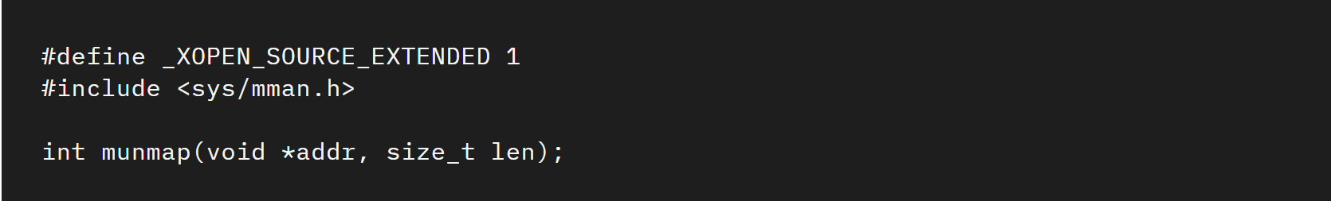
- Func: deletes the mappings for the specified address range, and causes further references to addresses within the range to generate invalid memory references. The region is also automatically unmapped when the process is terminated. On the other hand, closing the file descriptor does not unmap the region.
- *Arg1: must be a multiple of the page size (but length need not be). All pages containing a part of the indicated range are unmapped, and subsequent references to these pages will generate SIGSEGV. It is not an error if the indicated range does not contain any mapped pages.
- Arg2: The length argument specifies the mapping length (greater than 0).
- Return: 1). Return 0 on success; 2). Return -1 if failed.

Lab instruction

Task 1:
Q1. Write a program. The program uses mmap() and munmap() to create a file “alphabet.txt” and write an alphabet in the file.

Sample output:
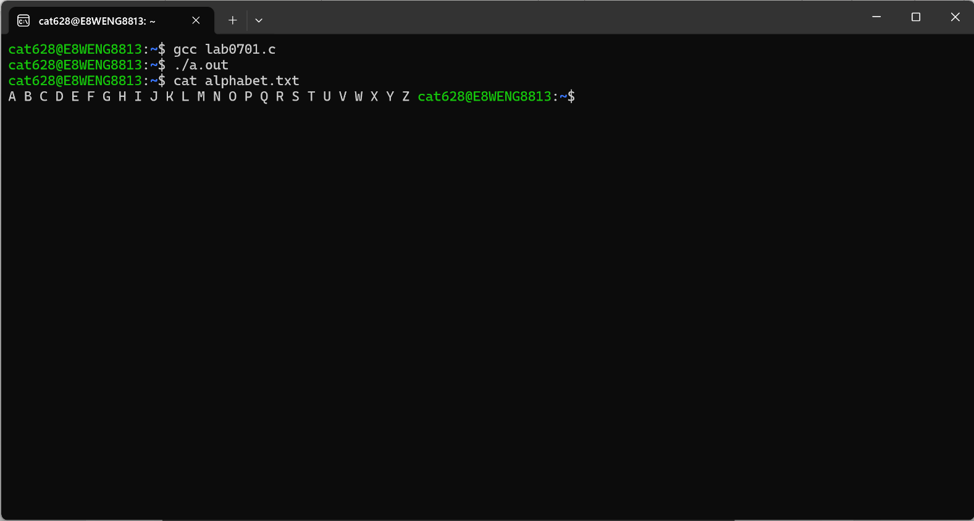

Task 2:
Q2. Write a program. The program uses mmap() and munmap() to create a file “hello.txt” and write the text “Hello!” in the file.

- Sample output:
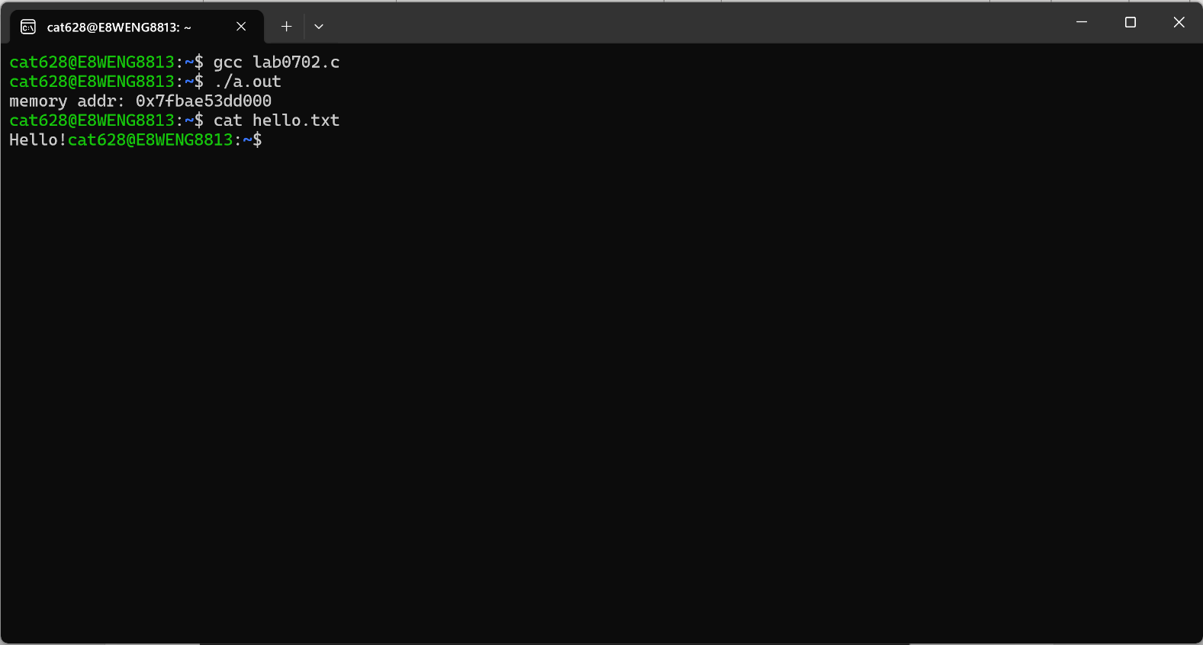

Task 3:
Q3. Write a program. The program uses mmap() and munmap() to read from the file “hello.txt” and display the file content on the screen.

- Sample output:
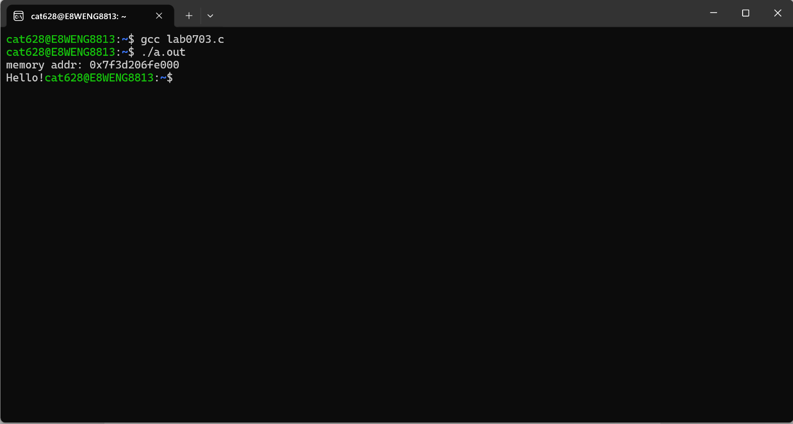

SUBMISSION
Submit four C source code file. According to the sequence of tasks, the submiss follows:
- the first C source code file is called “Lab0701_YourFirstnameLastname.c”.
- the second C source code files are called “Lab0702_YourFirstnameLastname.c”.
- the third C source code file is called “Lab0703_YourFirstnameLastname.c”.
Submitting files to the Dropbox of Canvas.

