System Architecture and Data Flow
The original monolithic application has been refactored into a modern microservice architecture to enhance scalability, separation of concerns, and maintainability. The system now consists of a React frontend, two independent backend microservices, and a shared SQLite database.

Architecture Diagram
The diagram below illustrates the high-level architecture. The frontend client only communicates with the Client Service, creating a secure boundary where administrative functions are not exposed to the public-facing application. Both backend services interact with the same shared database for data consistency.
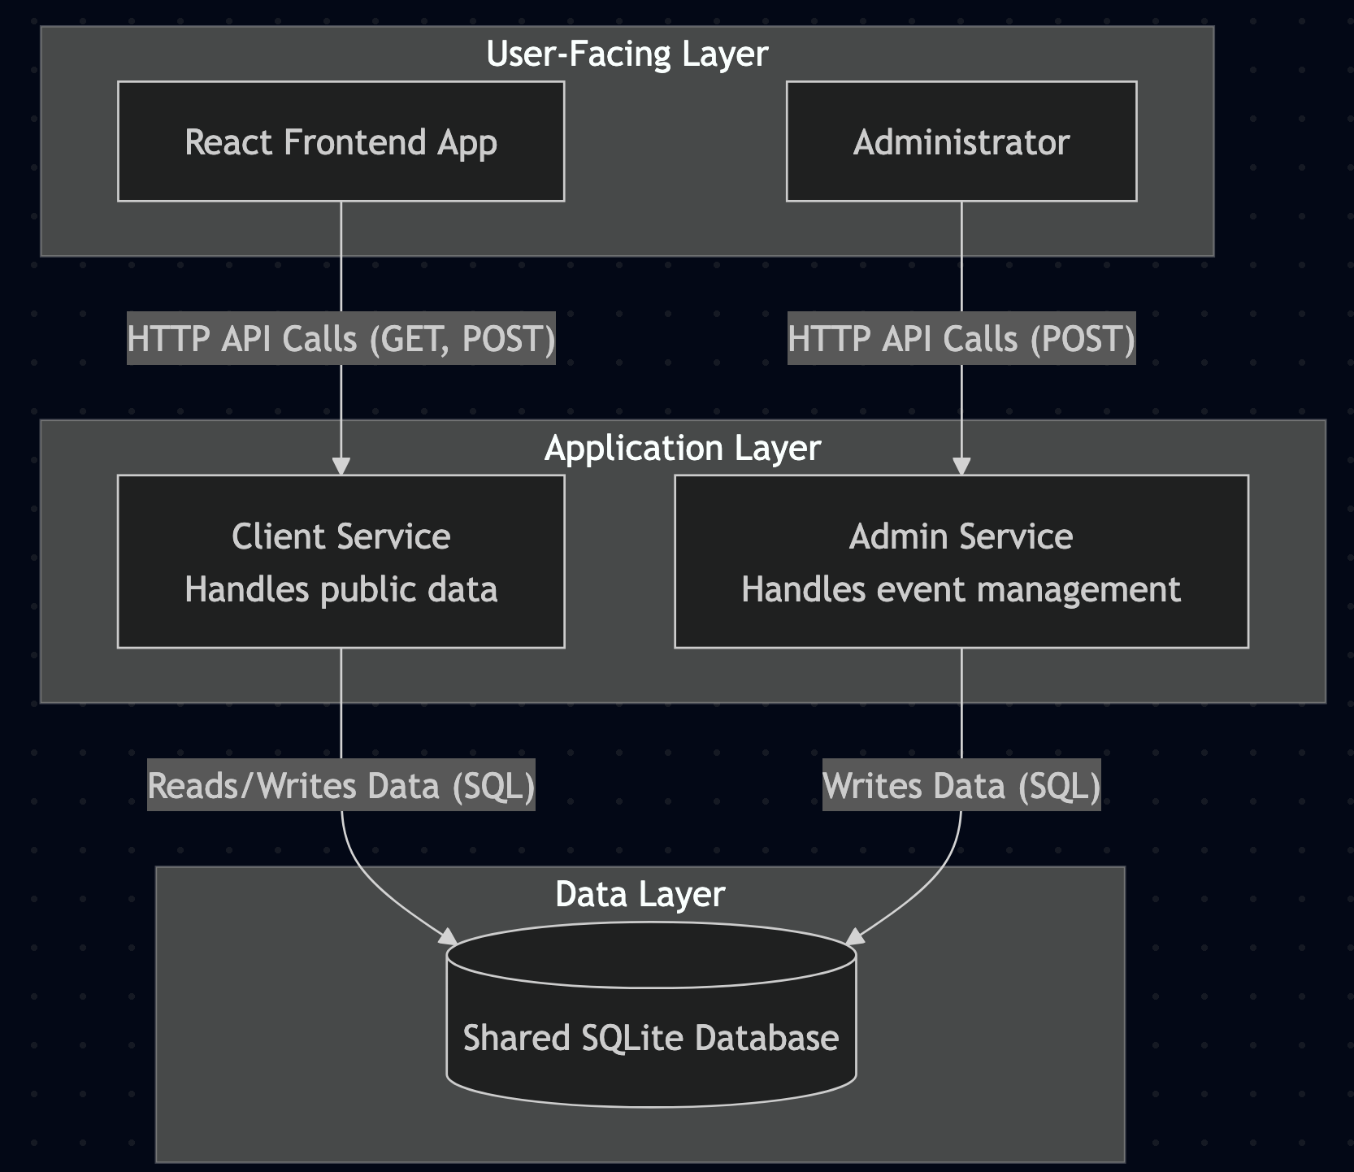

Data and Request Flow
A typical user interaction follows this sequence:
- Viewing Events:
  - The user opens the React frontend application in their browser.
  - A useEffect hook in the App.js component triggers a GET request to the Client Service at http://localhost:6001/api/events.
  - The Client Service’s router maps this request to the listEvents controller.
  - The controller calls the getAllEvents function in its model, which queries the shared database.sqlite file.
  - The database returns the list of events, which is sent back through the service as a JSON response to the frontend.
  - The frontend updates its state, re-rendering the UI to display the list of events.
- Purchasing a Ticket:
  - The user clicks the “Buy Ticket” button for a specific event.
  - An onClick handler triggers a POST request to the Client Service at http://localhost:6001/api/events/:id/purchase.
  - The service’s buyTicket controller calls the purchaseTicket model function.
  - The model initiates an SQL transaction to safely decrement the ticket count in the database.
  - Upon successful completion, the service returns a success message.
  - The frontend receives the success response, shows a confirmation alert, and re-fetches the event list to display the updated ticket count.

Concurrency Handling
In a system where multiple users can attempt to purchase tickets simultaneously, preventing race conditions is critical. For example, two users might try to buy the last available ticket at the exact same time, potentially resulting in overselling.

This system handles concurrency by using SQL Transactions within the purchaseTicket model function in the Client Service.

- The entire process of checking the ticket count and updating it is wrapped in a BEGIN TRANSACTION and COMMIT block. This ensures the operation is atomic, it either completes fully or not at all.
- The sqlite3 library, combined with the transaction, effectively locks the relevant database row during the operation. When one user’s request initiates the transaction, a second user’s request must wait until the first is complete before it can read the ticket value.
- If the ticket count is read and found to be zero, or if any other error occurs, a ROLLBACK command is issued. This instantly aborts the transaction and reverts any changes, preventing the database from entering an inconsistent state (negative ticket count).

Accessibility Implementation
The frontend was enhanced to be more accessible for users with disabilities, particularly those who rely on screen readers.
- The application uses proper HTML5 tags (<header>, <main>, <h1>,<li>,<button>). This provides a clear and predictable structure for assistive technologies and enables default browser features like keyboard navigation.
- The “Buy Ticket” button includes a descriptive aria-label attribute. While a sighted user sees “Buy Ticket,” a screen reader will announce, “Buy one ticket for Clemson Football Game,” providing context.
- A visually hidden div with role=”status” and aria-live=”polite” was added. When a ticket is purchased, a confirmation message is placed in this div. Screen readers automatically announce content changes in a live region.
- By using the native <button> element, all interactive controls are focusable and activatable using a keyboard (Tab to navigate, Enter/Space to click) without extra effort. The disabled attribute is used on the button for sold-out events, preventing keyboard interactions.

Code Quality Standards
This project was developed in accordance with the provided code quality standards
- Explanatory inline comments used to clarify complex logic, such as React hooks or accessibility features.
- All variables and functions use clear, descriptive camelCase names to maximize readability.
- The architecture is fundamentally modular, adhering to the MVC pattern with each microservice.
- Both backend and frontend include robust error handling.
- The entire codebase uses consistent indentation and spacing.
- The API has a clear contract, exclusively using JSON for requests and responses. ALL I/O operations are handled asynchronously using callbacks in Node.js and fetch in React.

