Testing Strategy
This section outlines the testing approach for the TigerTix application. It includes microservices, frontend, and the new LLM-driven features.

Testing Levels
The Unit Tests aim to ensure that individual functions and components work correctly in isolation. Backend (admin, client, llm-service) tests business logic within models and controllers (database interactions, data manipulation, prompt construction). We will use Jest with an in-memory SQLite database. For the Frontend we will test React components’ rendering, state, and props using React Testing Library and Jest.

The Integration Tests ensure that different components of the system work together as expected. We will verify microservices can communicate correctly (ex: llm-service correctly triggers a booking in client-service). As well as confirm that the React frontend can fetch data from and send commands to the backend microservices via their REST APIs.

End-to-End tests simulate real user journeys from start to finish in a production-like environment. We will use Playwright for its robustness in browser automation, network interception, and built-in accessibility checks. We will cover critical user flows, such as viewing events, and booking tickets through both the standard UI and the new LLM chat interface.

Specific Feature Testing
The microservices (admin, client) will have API endpoint validation (correct status codes, request/response formats). We will manually test simultaneous ticket purchase attempts to ensure the database correctly handles race conditions and prevents overselling.

The llm-service will have automated unit tests for the LLM response-parsing logic, ensuring it correctly handles valid JSON, malformed JSON, and different intents. We will manually conduct tests with a wide range of natural language queries (text and voice) to check the LLM’s understanding and response accuracy.

The voice interface will be manually tested because it is highly dependent on browser APIs and user environment. Automated tests will include verification of microphone activation, accurate speech-to-text transcription, and text-to-speech output of the bot’s responses.

Accessibility automated tests will use Playwright’s integrated accessibility testing tools to catch common violations (missing labels, poor color contrast). Manually we will test keyboard-only navigation and using a screen reader to verify a coherent and logical user experience for visually impaired users.

Description | Type | Expected | Actual | Status
Standard Purchase | Auto | Ticket count decrements by 1 | Ticket count decrements by 1 | Pass
LLM Text Booking | Auto | Ticket count decrements by 1 | Ticket count decrements by 1 | Pass
Accessibility Scan | Auto | No violations found | No violations found | Pass
Database event creation | Auto | Create new test event | Created new test event | Pass
Test Api fail | Auto | Display error message if api error | An error message is displayed. | Pass
Voice Booking | Manual | Successful booking via voice | Successful booking via voice | Pass
Keyboard Navigation | Manual | All elements are focusable | All elements are focusable in logical order | Pass
DB Concurrency | Manual | Only one booking succeeds | Only one booking succeeds; the other failed correctly | Pass
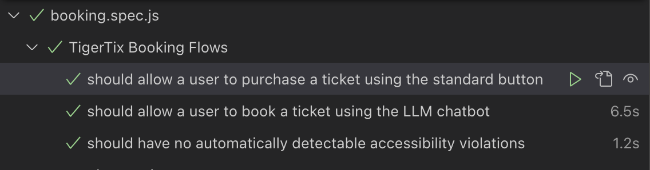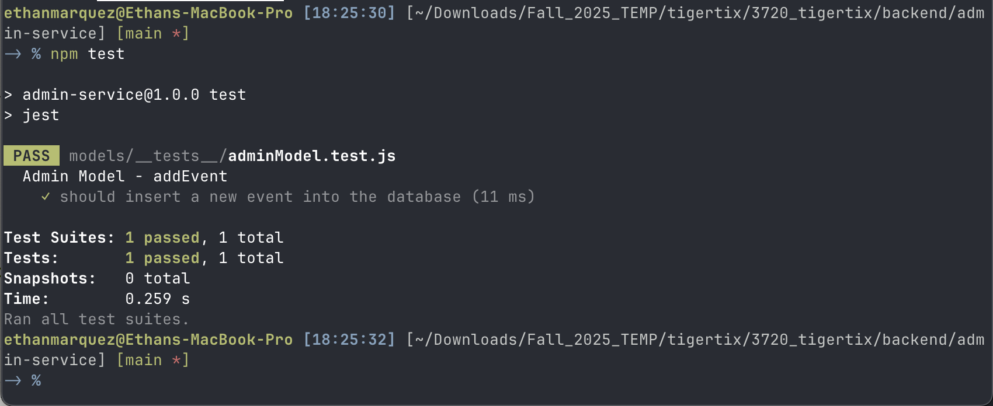
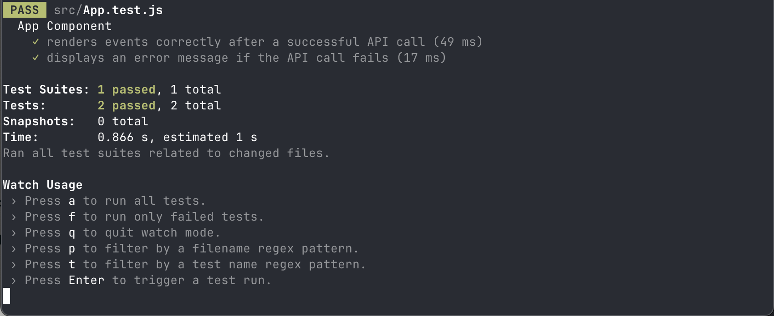

Bugs discovered
After testing, Accessibility testing initially failed. This was caused by the color settings in the css file not having enough contrast from each other. This bug was easily remedied by increasing the contrast between colors.

System Architecture and Flow

Architecture Diagram

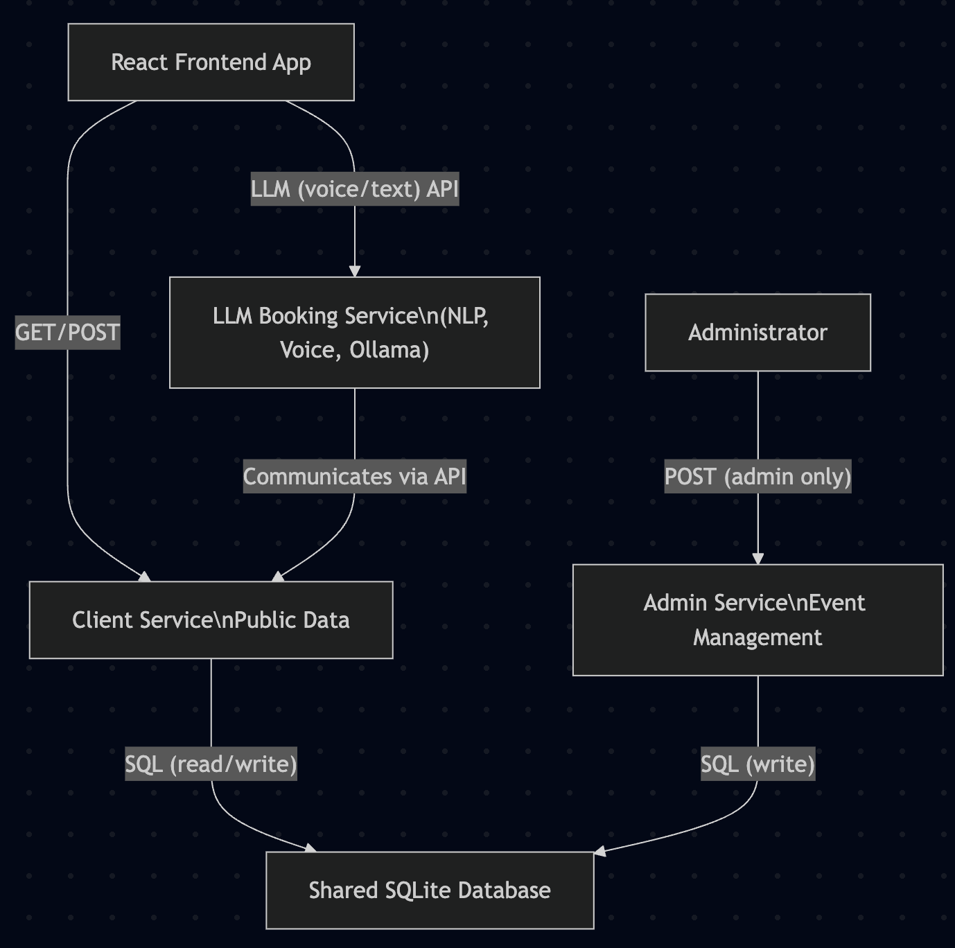

Architecture Description
TigerTix has evolved into a robust microservice-based ticketing system. The architecture is composed of four main components: A React Frontend, A Client microservice (ticket purchasing/events listing), An Admin microservice (event creation/administration), An LLM-driven booking service (natural language and voice interface for smart ticket bookings). All backend services utilize a shared SQLite database to maintain data consistency and handle concurrency safely.

The Frontend communication only with the Client Service and the LLM Service, protecting administrative endpoints from public access. The Admin Service is exclusively for privileged operations. The LLM Service Integrates Ollama (llama3.1:8b) for voice/text automation, parsing semantic ticket requests and confirming bookings through the Client Service.

Data Flow Overview
- User views events: The frontend issues a GET request to Client Service, which returns available events from the shared database.
- User books ticket (standard): User clicks “Buy Ticket” on the event list; Client Service atomically decrements ticket count in the database.
- User books via LLM (voice/text): The LLM Service parses user intent, confirms selection, and submits the corresponding booking request to Client Service, handling user-friendly, natural language interactions.
- Admin workflows: Event creation endpoints are secured and handled by Admin Service, which directly modifies the shared event tables.

Accessibility for Visually Impaired Users
TigerTix supports visually impaired users through multiple WCAG and ARIA-compliant design features.

Semantic HTML ensures every interactive element (<header>,<main>,<ul>,<li>,<button>) is tagged for maximum compatibility with assistive technology and proper keyboard navigation order. Descriptive ARIA labels ensure buttons have clear, context-sensitive aria-labels which screen readers announce, providing context beyond visual cues. Live Region Announcements makes all system status messages (ticket purchase confirmation) route to visually hidden regions. Users of screen readers are immediately notified upon system changes. Color choices for backgrounds, borders, and focus indicators meet accessibility AA/AAA standards. A recent test revealed a contrast bug, which was fixed by increasing color variable contrast in the CSS.

Code Quality Standards
TigerTix maintains strict code quality across all microservices and frontend layers.

All variables, functions, and components use camelCase, with descriptive names. MVC separation is enforced for each microservice; models handle database logic, controllers deal with business rules, and routes connect the REST API endpoints. Nontrivial logic is explained with comments directly above usage. All I/O operations and API handlers provide robust try/catch logic with user friendly error messages and status codes. Spacing and indentation are uniform throughout the codebase. Every REST call is typed and returns/accepts JSON. Unit, Integration, and end-to-end tests are present, leveraging Jest, React Testing Library, and Playwright. The database is mocked as :memory: for speed and repeatability. Accessibility-releated code is called out and explained.

