Multi-layered Authentication System

The Sprint 3 authentication work is implemented as a dedicated user-authentication microservice plus new React UI components. The goal is to provide secure registration, login, logout, and token-based protection for sensitive routes.

User Registration & Login
On the frontend, we added Login and Register React components and wrapped the main App with an AuthProvider (AuthContext.js). These components render simple forms for email and password and use fetch to POST to the backend. On the backend, the user-authentication service exposes Express routes /auth/register and /auth/login (authRoutes.js, authController.js). The userModel (userModel.js) uses bcrypt.hash(password, 10) to store only a password_hash column in the shared SQLite users table—no plaintext passwords are ever persisted. On successful registration or login, authController generates a JSON Web Token (JWT) and returns it alongside the user data to the frontend.

Token-based Authentication
JWTs are issued with the jsonwebtoken library in authController.js. Each token contains the user id and email and is configured to expire after 30 minutes. The token is set in an HTTP‑only token cookie so it is not directly readable by frontend JavaScript; the AuthProvider also keeps the current user in React state so components can conditionally render authenticated UI. A shared authMiddleware function verifies incoming JWTs on protected routes by reading either the Authorization: Bearer ... header or the token cookie; if verification fails or the token is expired, the request is rejected with 401. The frontend periodically calls /auth/me on page load to restore the current user; if that call fails with 401 (for example, due to a 30‑minute expiry), the UI falls back to the unauthenticated state and prompts the user to log in again.

Logout & Session Handling

Logout is implemented end‑to‑end. On the backend, /auth/logout simply clears the token cookie and returns a confirmation message. On the frontend, the logout function in AuthContext calls this endpoint and then resets user and token in React state. The header in App.js always reflects the current session: when authenticated it shows “Logged in as user@example.com” and a Logout button; when no user is present it shows “Not logged in” and displays the Login and Register forms. This combination of cookie-based JWTs, React session state, and clear header text provides a simple multi-layered experience: secure credential storage (bcrypt), stateless token-based backend protection, and visible session status in the UI.

Testing Strategy

This section outlines the testing approach for the TigerTix application across microservices, the React frontend, and the new LLM- and authentication-related features.

Testing Levels
Unit tests verify that individual functions and components work correctly in isolation. On the backend this includes models and controllers in the admin, client, LLM, and new user-authentication microservices. Examples are the userModel functions (createUser, findUserByEmail) that interact with the users table and enforce hashed passwords and email uniqueness. On the frontend, unit tests (React Testing Library + Jest) validate component rendering, state updates, and error handling in isolation from the network. Where possible we run these unit tests against a predictable SQLite schema initialized from init.sql so tests are repeatable and independent.

Integration tests ensure that multiple pieces of the system work together as expected. For the backend, Jest + supertest tests exercise real HTTP endpoints, database access, and middleware as a group—for example, hitting /auth/register, /auth/login, /auth/me, and /auth/logout to validate that controllers, JWT token generation/verification, and SQLite persistence all behave correctly together. At the microservice level we verify that the LLM service can still trigger bookings in the client service and that the client service correctly updates ticket counts in the shared database. On the frontend side, integration tests confirm that React components correctly call backend REST APIs and render responses or errors.

End-to-end (E2E) tests simulate real user journeys from the browser through all relevant microservices in a production-like environment. We use Playwright for its robust browser automation, network inspection, and integrated accessibility tooling. E2E coverage includes viewing events, standard “Buy Ticket” flows, LLM-driven booking through the chatbot, accessibility scans, and the new authentication journey (registering a user, seeing “Logged in as …” in the header, and logging out). We keep these tests high-level and scenario-focused, using unit and integration tests to catch lower-level edge cases more efficiently.

Why Unit, Integration and End-to-End Tests
TigerTix uses three levels of testing because each one catches different classes of bugs in the new authentication and booking features. At the unit level, userModel.test.js exercises createUser and findUserByEmail directly, confirming that a user row is inserted, that password_hash does not equal the plain-text password, and that duplicate emails correctly trigger a SQLite UNIQUE constraint error—these tests isolate database logic and hashing behavior without involving HTTP or React. At the integration level, auth.test.js uses Jest + supertest against the real Express app and SQLite database, calling /auth/register, /auth/login, /auth/me, and /auth/logout end-to-end within the user-authentication service; this verifies that controllers, JWT issuance/verification, cookies, and DB access all work together. At the end‑to‑end level, Playwright specs such as booking.spec.js and auth-login.spec.js drive a real browser through complete user journeys: standard and LLM-based ticket booking, plus the new auth flow that registers a user, displays “Logged in as …” in the header, and logs out. Unit tests alone would miss issues like misconfigured middleware, incorrect HTTP status codes, or cookie handling, while E2E tests alone would be too slow and coarse-grained to pinpoint low-level logic or DB errors. Using all three levels lets us quickly catch fine-grained bugs in isolation and still prove that the full stack behaves correctly from the user’s perspective.

Specific Feature Testing

The microservices (admin, client, user-authentication) have API endpoint validation to check status codes, request/response formats, and error conditions. For example, we assert that duplicate registration attempts return 409, bad login credentials return 401, and protected endpoints such as /auth/me reject missing or invalid JWTs. We also manually test simultaneous ticket purchase attempts from different browsers to ensure the shared SQLite database correctly handles race conditions and prevents overselling.

The LLM service has automated logic tests around response parsing and booking confirmation, ensuring it can robustly handle valid JSON, malformed responses, and different booking intents. We supplement this with manual tests using a wide range of natural language queries (text and voice) to check the LLM’s understanding, disambiguation prompts, and confirmation messages before a booking is actually created.

The voice interface is primarily manually tested because it depends heavily on browser APIs and end-user hardware. Where feasible, automated checks verify that microphone controls can be toggled, that speech-to-text results are surfaced in the chat input, and that important bot responses can be read back via text-to-speech.

Accessibility testing combines automated and manual approaches. Automated tests use Playwright together with axe-core to detect common violations such as missing labels, improper heading structure, and low-contrast text. These scans now cover both the main event listing and the new authentication header and forms. Manual testing includes keyboard-only navigation through all interactive elements, checking logical focus order, and using a screen reader to validate that visually impaired users receive clear announcements for ticket purchases, login state changes, chatbot responses, and error messages.

Description | Type | Expected | Actual | Status
Standard Purchase | Auto | Ticket count decrements by 1 | Ticket count decrements by 1 | Pass
LLM Text Booking | Auto | Ticket count decrements by 1 | Ticket count decrements by 1 | Pass
Accessibility Scan | Auto | No violations found | No violations found | Pass
Database event creation | Auto | Create new test event | Created new test event | Pass
Test Api fail | Auto | Display error message if api error | An error message is displayed. | Pass
Voice Booking | Manual | Successful booking via voice | Successful booking via voice | Pass
Keyboard Navigation | Manual | All elements are focusable | All elements are focusable in logical order | Pass
DB Concurrency | Manual | Only one booking succeeds | Only one booking succeeds; the other failed correctly | Pass
User Auth API | Auto | Register/login/me/logout behave correctly (status + cookies) | Just + supertest auth tests pass | Pass
User Auth E2E | Auto | Register via UI -> “Logged in as…” -> Logout | Playwright [auth-login.spec.js] passes; header reflects user state | Pass
User DB Transactions | Auto | Passwords hashed; duplicate email causes constraint error | userModel.test.js confirms hased password and UNIQUE email enforcement | Pass

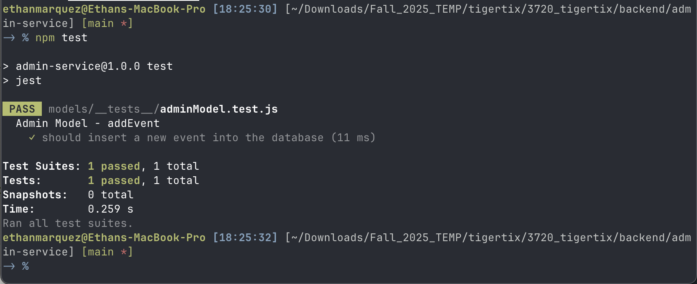
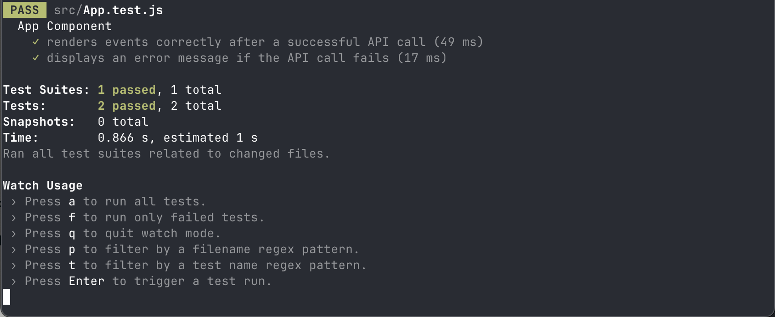
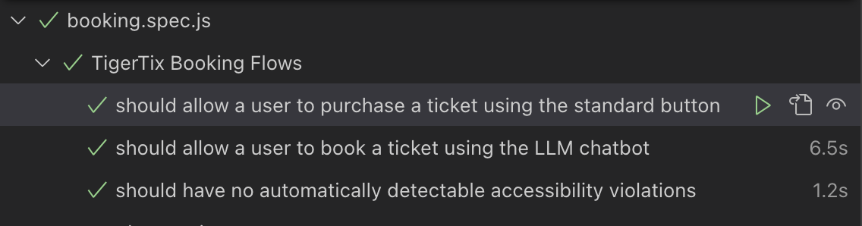
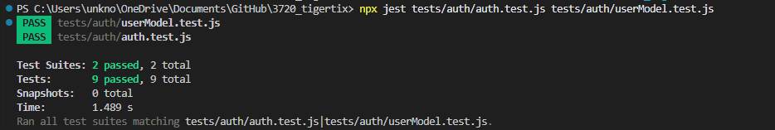
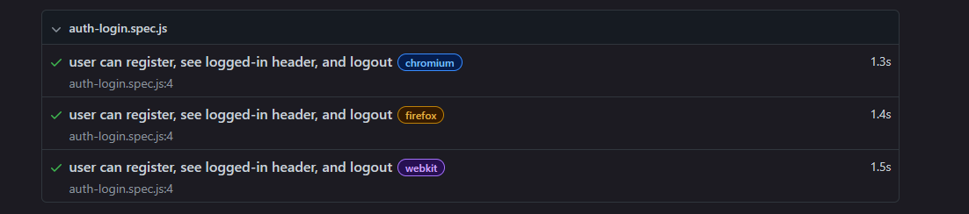

Architecture Description

TigerTix has evolved into a robust microservice-based ticketing system. The architecture is composed of five main components: a React Frontend, a Client microservice (ticket purchasing/events listing), an Admin microservice (event creation/administration), a User Authentication microservice (registration/login/logout and JWT issuance), and an LLM-driven booking service (natural language and voice interface for smart ticket bookings). All backend services utilize a shared SQLite database to maintain data consistency and handle concurrency safely.

The Frontend communicates with three public-facing services: the Client Service for events and ticket purchases, the User Authentication Service for registration and login/logout, and the LLM Service for conversational booking. Administrative endpoints in the Admin Service remain protected and are not exposed directly to end users. The User Authentication Service manages the users table in the shared SQLite database, stores only bcrypt‑hashed passwords, and issues 30‑minute JSON Web Tokens (JWTs) that are stored in HTTP‑only cookies and validated via shared middleware before protected routes are executed. The LLM Service integrates Ollama (llama3.1:8b) for voice/text automation, parsing semantic ticket requests and confirming bookings through the Client Service.

Data Flow Overview

User views events: The frontend issues a GET request to the Client Service, which returns available events from the shared database.

User registers / logs in: The frontend submits credentials to the User Authentication Service. The service validates the credentials against the users table (using hashed passwords), issues a JWT on success, and returns it in an HTTP‑only cookie; the frontend reflects the current user state (e.g., “Logged in as user@example.com”).

User books ticket (standard): A logged-in user clicks “Buy Ticket” on the event list; the Client Service optionally verifies the JWT via auth middleware and atomically decrements the ticket count in the database to prevent overselling.

User books via LLM (voice/text): The LLM Service parses user intent (possibly using the user’s authenticated identity), confirms the selected event and quantity, and submits the corresponding booking request to the Client Service, handling user-friendly, natural language interactions while still relying on the same DB-backed ticket update logic.

Admin workflows: Event creation and management endpoints are secured and handled by the Admin Service, which directly modifies the shared event tables. Admin operations are not exposed to the public frontend and can also be protected with the same JWT-based authentication layer if needed.

Accessibility for Visually Impaired Users

TigerTix’s Sprint 3 features were built with visually impaired users in mind, integrating both traditional WCAG guidelines and new multimodal interaction features. The voice-enabled booking interface allows users to navigate the system without relying on visual elements. A microphone activation cue signals when recording begins, and speech input is converted to text through the SpeechRecognition API before being processed by the LLM. All responses from the LLM are automatically vocalized through the Speech Synthesis API, enabling the entire interaction loop (query, confirmation, booking proposal) to be completed through audio alone. This significantly reduces reliance on screen-based interfaces and supports users with low or no vision.

The system ensures that LLM-driven interactions remain safe and cognitively manageable. The LLM never books tickets automatically; instead, it proposes actions and requires explicit user confirmation, preventing accidental purchases and promoting clarity. Spoken responses are paced for accessibility, reducing cognitive load and allowing users to absorb information without needing rapid visual scanning or reading.

The visual interface remains WCAG-aligned for users who depend on assistive technology. Semantic HTML elements (<header>, <main>, <ul>, <li>, <button>) preserve logical navigation for screen readers, while descriptive aria-labels ensure that all controls—including microphone, send message, and confirmation buttons—are fully interpretable. Live region announcements alert screen-reader users when system states change, such as when tickets are booked or errors occur. Color contrast ratios for backgrounds, borders, focus states, and alerts adhere to AA/AAA standards, resolving earlier contrast issues detected during accessibility scans.
In addition to the existing accessible event and chatbot interfaces, the new Sprint 3 authentication UI is designed with the same accessibility principles. The login and registration forms use semantic headings and button elements consistent with the rest of the page, so screen readers can quickly navigate between “Login” and “Register” regions. The header that shows the user’s state (“Logged in as user@example.com” or “Not logged in”) is plain text in a prominent landmark area, making it easy for keyboard and screen-reader users to confirm whether they are authenticated. Combined with the existing live region for status messages, these changes ensure that both ticket purchase feedback and authentication state changes are announced to visually impaired users without relying solely on visual cues.

Code Quality Standards
TigerTix maintains strict code quality across all microservices and frontend layers.

All variables, functions, and components use camelCase, with descriptive names. MVC separation is enforced for each microservice; models handle database logic, controllers deal with business rules, and routes connect the REST API endpoints. Nontrivial logic is explained with comments directly above usage. All I/O operations and API handlers provide robust try/catch logic with user friendly error messages and status codes. Spacing and indentation are uniform throughout the codebase. Every REST call is typed and returns/accepts JSON. Unit, Integration, and end-to-end tests are present, leveraging Jest, React Testing Library, and Playwright. The database is mocked as :memory: for speed and repeatability. Accessibility-releated code is called out and explained.

