Drawing Inspiration

Ethan Mick
Cloudmine Project Proposal
10/9/2012

Introduction 2

Use Cases 2

Interface 2

Ideas For Future Use 2

Constraints 2

Introduction
The moments pass. You stare blankly at the computer screen, hoping for something to strike you. Some inspiration to begin work. But with nothing to jog your memory, the screen stays blank.

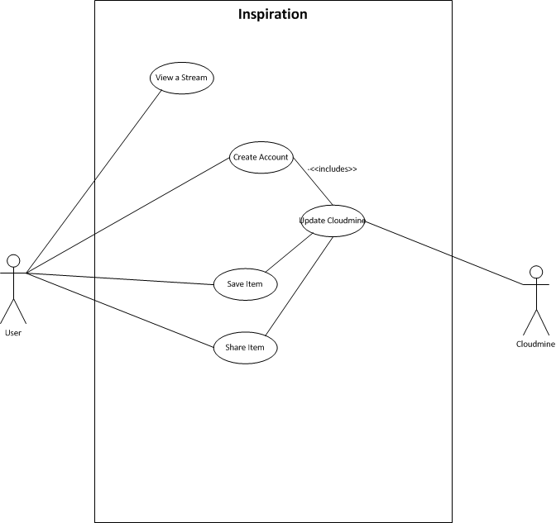
Enter, Inspiration. A program designed to bring out the creativity in people, a program that is meant to make you inspired to great things. The program can be tuned toward different people, who need to be inspired in different things. But it’s aim is for creativity people to have someplace to draw creativity from, as well as save it for later.

Use Cases

- View Stream
Description: View a stream of inspiration from a source.

Pre Condition:
The app is installed.

Main flow of events:
- The user opens the app
- The user selects view other streams option
- The user selects which stream to view
- The stream is presented to the user.

Post Condition:
The user is viewing the stream they selected.

Alternative Flows:
Once the user has opened the app, the are content with the stream picked for them.

- Create an Account
Description: Create an account for the user to store information.

Pre Condition:
The app is open.
The user is signed out of all accounts.

Main flow of events:
- The user selects the option to access their account.
- The user is presented with the ability to log in or create a new account
- The user selects, create a new account option.
- The user enters their details
- The account information is verified.
- The account is created, and the user is automatically logged in.

Post Condition:
A user account has been created.

Alternative Flows:
1. The account fails to be created, the user is shown the error message.

- Save an Item
Description: Save an item to the users account.

Pre Condition:
The user is signed in to their account.

Main flow of events:
- The user sees a piece of inspiration they want to save.
- The user taps on the piece of inspiration.
- The user is shown the piece of inspiration larger, with option displayed.
- The user selects the save option.
- The inspiration is saved to the user account.
- The user is notified that the action was successful.

Post Condition:
The user has saved the piece of inspiration.

Alternative Flows:
- The user is not logged in to an account, they are asked to log in or create an account.
- The user does not wish to save that piece, they dismiss it.
- If the item has already been saved to the users account, the item is not saved again, but the user is still informed of a success.

- Share an Item
Description: The user wants to share an item.

Pre Condition:
The user has found an image they wish to share.
The image is selected.

Main flow of events:
- The user taps the share icon.
- The user selects “share with user” action.
- The user selects which user, on Inspiration, they wish to share the piece with.
- The app shares the inspiration.
- The user is notified of success or failure.

Post Condition:
An item has been shared.

Alternative Flows:
- The user selects to share the item via some other avenue.
- The user wants to share it with someone not using Inspiration yet, so the sharing fails.
- The sharing fails for some other reason.

- Update Cloudmine
Description: Update the Cloudmine server.

Pre Condition:
The user has Internet.

Main flow of events:
- An action is completed which requires updating cloudmine.
- The call is made to update Cloudmine.
- Cloudmine is updated.

Post Condition:
The cloud has been updated.

Alternative Flows:
1. The user tries to update but gets a failure.

Interface
A basic interface

Ideas For Future Use
- When the user pinches the screen, change the overall size of the objects on the screen, to get bigger or smaller (up to a certain size).

Constraints

- iPad Only

