HW4 Scenarios Screenshots

1. 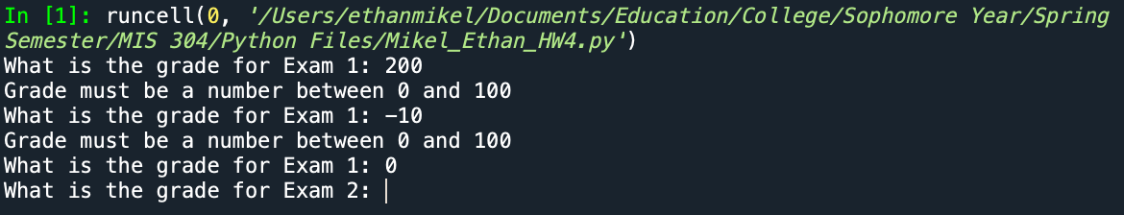
2. Text

   Description automatically generated
3. Text

   Description automatically generated
4. Text

   Description automatically generated