HW7 Screenshots

First Scenario

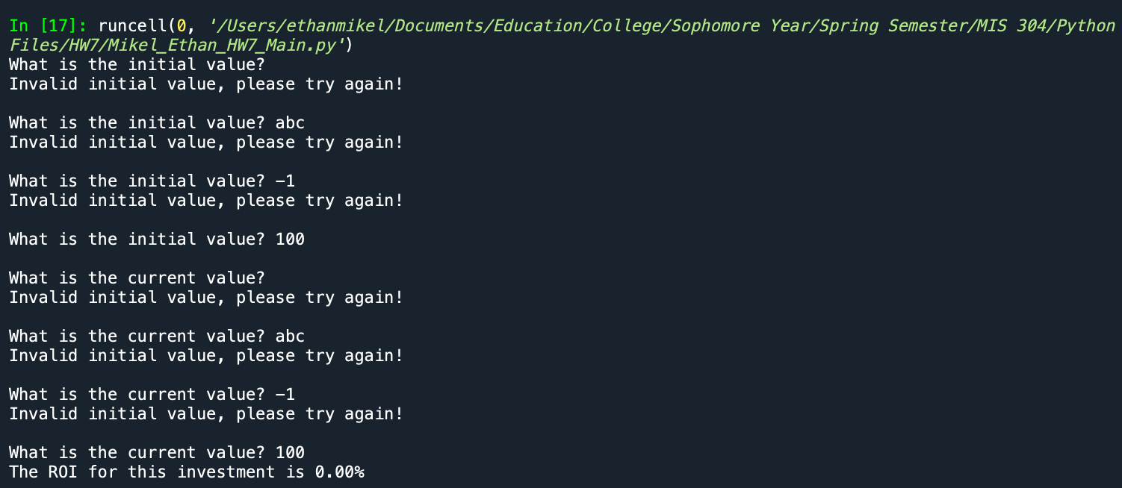

Second Scenario 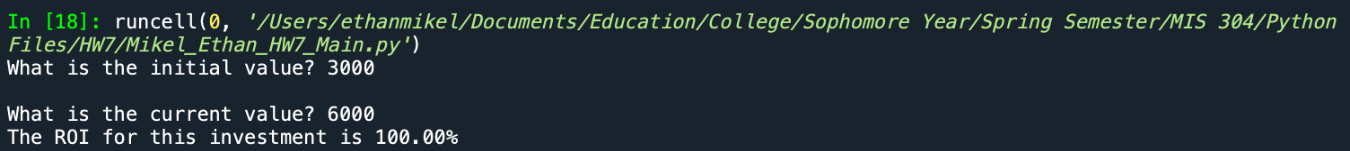

Third Scenario

