**Math 170 - Spring 2021 Quiz 1 Functions, Rate of Change**

**Name: Ethan May Section: 4001**

This quiz is due on **Wednesday, January 20**.

**Section: 07** This quiz is due on **Thursday, January 21**.

1. The table below gives an object’s temperature (*T*, in degrees Celsius, ◦C) as a function of time (*t*, in minutes), over a twenty minute time span.

|  |  |  |  |  |  |  |  |  |  |  |  |
| --- | --- | --- | --- | --- | --- | --- | --- | --- | --- | --- | --- |
| *T* (◦C) | 25.0 | 27.9 | 30.0 | 31.5 | 32.5 | 33.3 | 33.8 | 34.1 | 34.4 | 34.6 | 34.7 |
| *t* (min) | 0 | 2 | 4 | 6 | 8 | 10 | 12 | 14 | 16 | 18 | 20 |

Answer the following questions. Be accurate to three decimal places.

* 1. What is the object’s temperature change from *t* = 8 to *t* = 12 minutes?

**33.8 - 32.5 = 1.3 change in temperature**

* 1. Write a phrase that states the meaning of ∆*T/*∆*t* and compute ∆*T/*∆*t* on the

[10*,*12] minute interval.

**The change in temperature measured by degrees of Celsius, divided by the change in time measured by minutes is 33.8-33.3 = 0.5 divided by 12 – 10 = 2. This evaluates to 0.25 rate of change measured by temperature change per minute.**

* 1. Estimate the instantaneous rate of change of *T* at *t* = 10 minutes. Write a computation process that shows your thinking.
  2. Write a sentence that clearly states your answer to part (c) in the context of the problem.

1. The graph provided below shows the volume of water in a tank (*V* , in gallons) as a function of time (*t*, in minutes). **Use a straightedge** for lines that you draw in this problem.

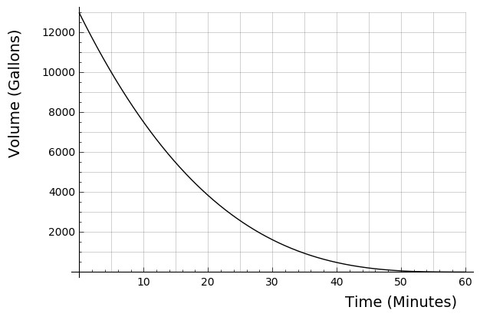

* 1. Estimate the average rate of change in volume on the [0*,*20] minute interval. **Draw and label** a corresponding secant line on the graph.

**-500**

* 1. Estimate the instantaneous rate of change in volume at *t* = 20 minutes. **Draw and label** a corresponding tangent line on the graph.
  2. Estimate the time when the volume is decreasing at the rate of 200 gallons per minute, to the nearest whole minute. Briefly justify or explain your thinking.