Ethan Murray

Dr. Jen Kay

ATOC 5860: Objective Data Analysis

Application Lab 2 Write Up

**Red Noise in Fort Collins Weather Data:**

1) Start with the default settings in the code. In other words – Read in the data and find the air temperature every 24 hours (every midnight) over the entire year. Calculate the lag-1 autocorrelation using np.correlate and the direct method using dot products. Compare the python syntax for calculating the autocorrelation with the formulas in Barnes. Equation numbers are provided to refer you back to the Barnes Notes. What is the lag-1 autocorrelation?

The lag 1 autocorrelation refers to the correlation between the current time series and the time series shifted by one timestep. This autocorrelation coefficient can be used to calculate useful things like

2) Calculate the autocorrelation at a range of lags using np.correlate and the direct method using dot products. Compare the python syntax for calculating the autocorrelation with the formulas in Barnes. Equation numbers are provided to refer you back to the Barnes Notes. How does the autocorrelation change as you vary the lag from -40 days to +40 days?

3) Calculate the effective sample size (N*) and compare it to your original sample size (N). Equation numbers are provided to refer you back to the Barnes Notes. How much memory is there in temperature sampled every midnight?

4) Now you are ready to tinker … i.e., make minor adjustments to the code with the parameters set in the code to see how your results change. Suggestion: Make a copy of the notebook for your tinkering so that you can refer back to your original answers and the unmodified original code. For example: Repeat steps 1-3) above with a different variable (e.g., relative humidity (RH), wind speed (wind_mph)). Repeat steps 1-3) above with a different temporal sampling frequency (e.g., every 12 hours, every 6 hours, every 4 days). How do you answers change?

**AR1 Regression on the AO Lab:**

Non-exhaustive Questions to guide your analysis:

1) Start with the default settings in the code. First read in the Arctic Oscillation (AO) data. Look at your data!! Plot it as a timeseries. Save the timeseries plot as a postscript file and put it in this document.

The plot below shows how the monthly Arctic Oscillation has varied over the past 70 years.

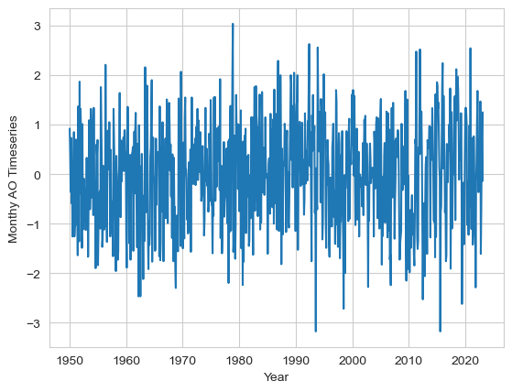

2) Calculate the lag-one autocorrelation (AR1) of the AO data and record it here. Use two methods (np.correlate, dot products). Check that they give you the same result. Interpret the value. How much memory (red noise) is there in the AO from month to month?

Using the two methods listed above, I calculated the lag-one autocorrelation and both methods returned a value of .19699. This means that AR1 explains only (.19699)^2 = This is a relatively low value of autocorrelation and suggests that

3) Calculate and plot the autocorrelation of the AO data at all lags. Describe your results. How red are the data at lags other than lag=1? Is there any interesting behavior of the autocorrelation as a function of lag? What would you expect for red noise timeseries with an AR1=value reported in 2)?

4) Generate a synthetic red noise time series with the same lag-1 autocorrelation as the AO data. Your synthetic dataset should have different time evolution but the same memory as the AO. Plot the AO timeseries and the synthetic red noise time series. Put the plot below.

5) Do you expect to find any correlation between the two datasets, i.e., the synthetic red noise and the actual AO data? What is the correlation between the synthetic red noise and the actual AO data? Calculate a regression coefficient and other associated regression statistics.

6) Next -- Have some fun and go “fishing for correlations”. What happens if you try correlating subsets of the two datasets many times? When you try 200 times -- what is the maximum correlation/variance explained you can obtain between the synthetic red noise and the actual data? *Note: you are effectively searching for a high correlation with no a priori reason to do so.... **THIS IS NOT good practice for science** but we are doing it here because it is instructive to see what happens :)*

7) Calculate the correlation statistics for the highest correlation obtained in question 6). Two methods are provided - they should give you the same answers. Place a confidence interval on your correlation. Because you have found a correlation that is not equal to 0, use the Fisher-Z Transformation. Did your "fishing" for a statistically significant correlation work? Is your highest correlation statistically significant (i.e., can you reject the null hypothesis that the correlation is zero)? Write out the steps for hypothesis testing and use the values you calculate to formally assess.

8) You went searching for correlations, you searched long and hard (200 times!) You should have been concerned that the largest correlation you found would be a false positive. Do you think you found a false positive? Explain what you found and potentially why you think it is important statistically but not physically. What lessons did you learn by “fishing for correlations”?

FOR FUN: Check out these __[spurious correlations](https://www.tylervigen.com/spurious-correlations)__