**All XY Distances for Eye Passes vs Intensity:**

* TD = 3115 heights, TS = 4964, WH = 2775, SH = 1143

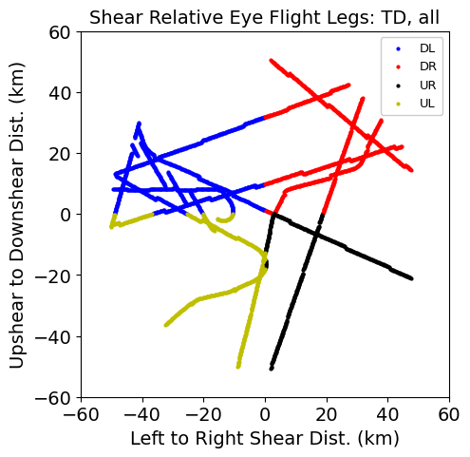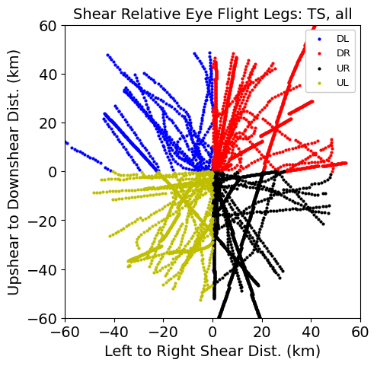

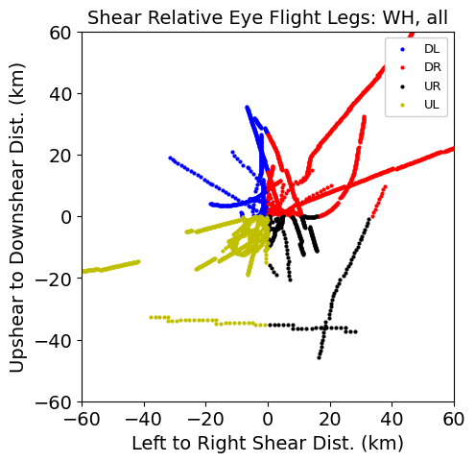 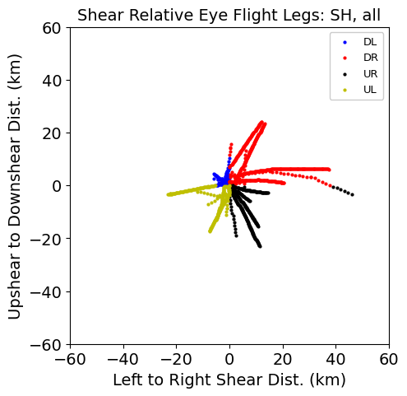

**TC Shear Quadrant Vs Intensity Plots:**

* TD:
* TS:
* WH:
* SH:

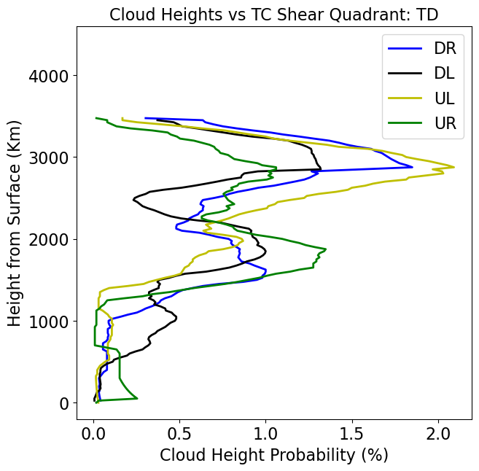 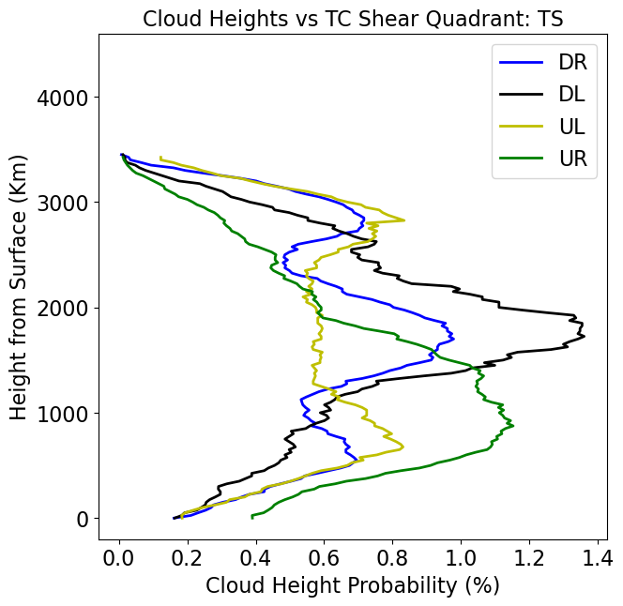

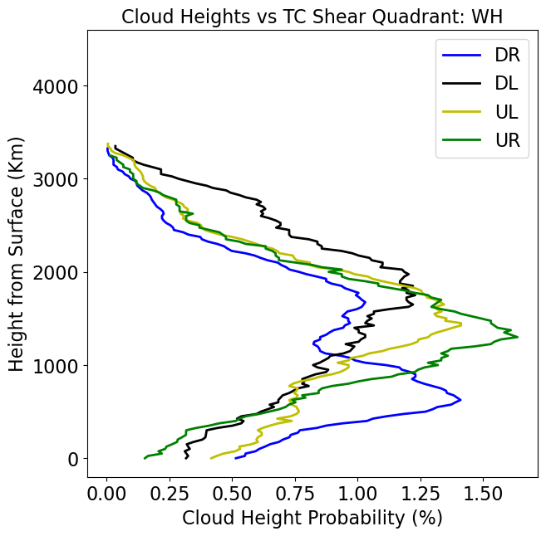 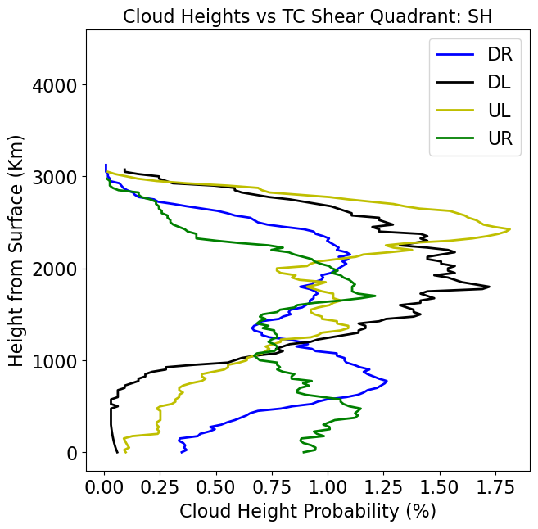

**TC shear magnitude vs intensity plots (original definition):**

* TD:
* TS:
* WH:
* SH:

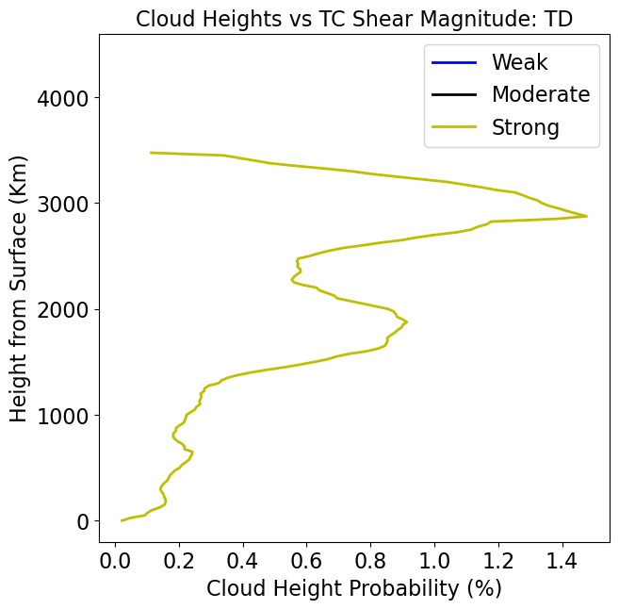 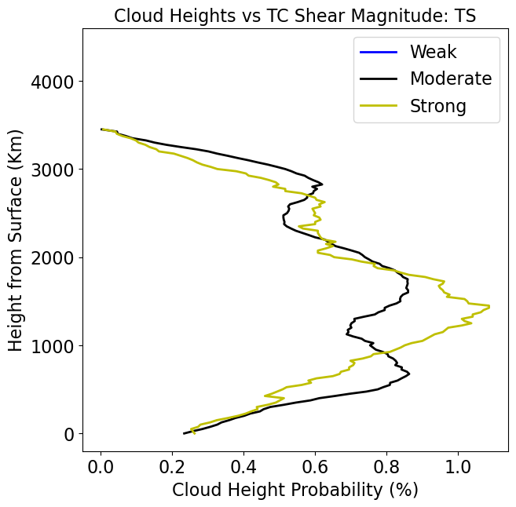

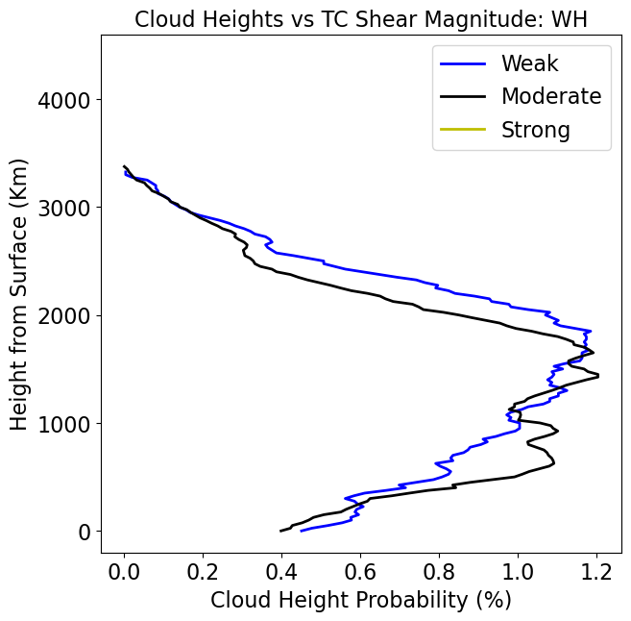 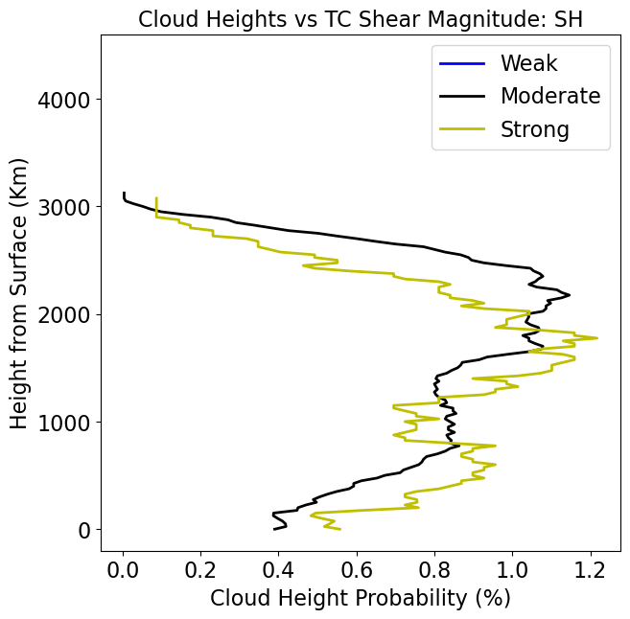

**TC intensification vs intensity:**

* TD:
* TS:
* WH:
* SH:

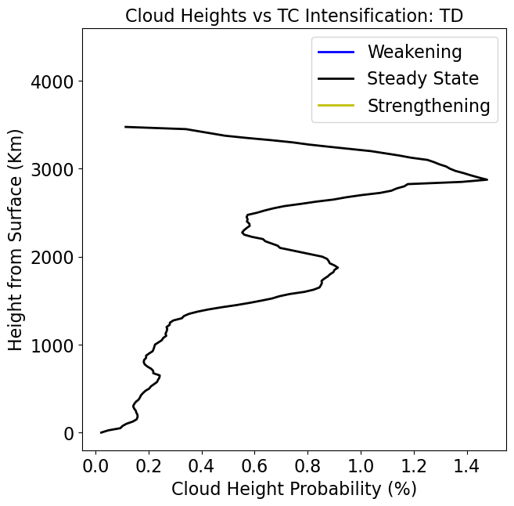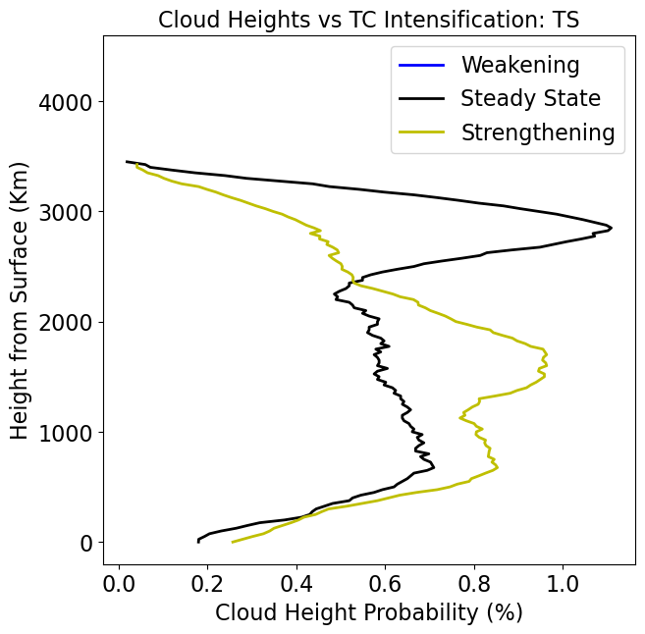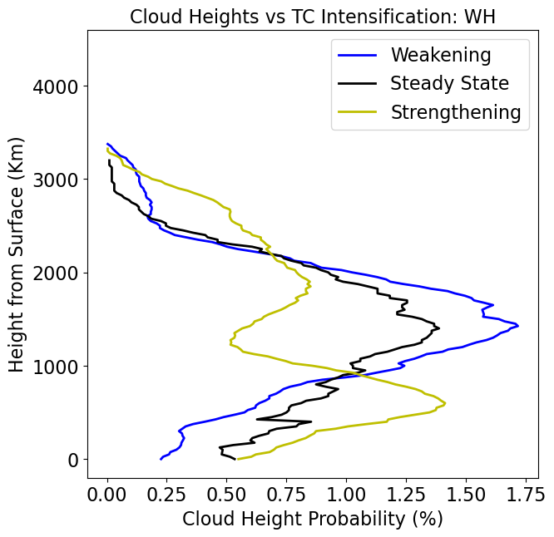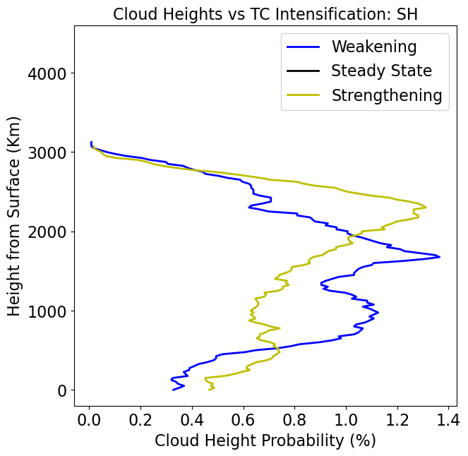

**TC shear magnitude vs intensity (rogers categories):**

* TD: 12 strong cases, 3115 data points
* TS: 8 moderate (2094 points), 30 strong cases (2870)
* WH:16 moderate (1824), 5 strong (951)
* SH: 7 moderate (937), 8 strong (206 points)

 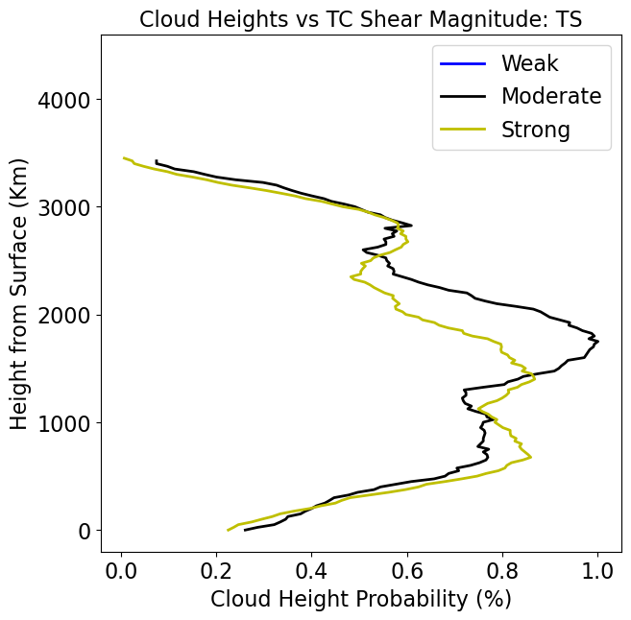

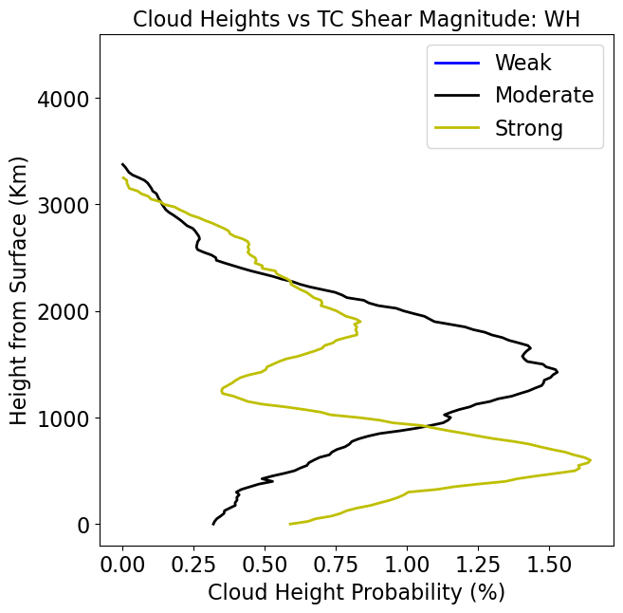 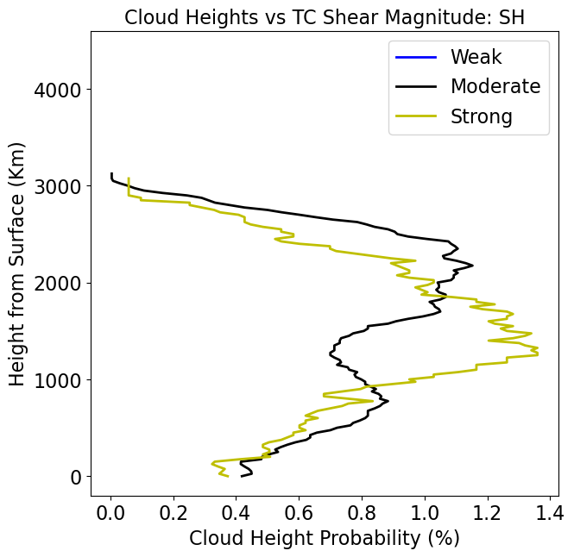

**Two Intensity Categories passes:**

55 kt turning point:

* Low intensity: 48 cases, 7271 data points
* High intensity: 38 cases, 4726 data points

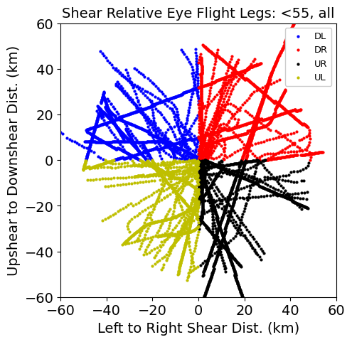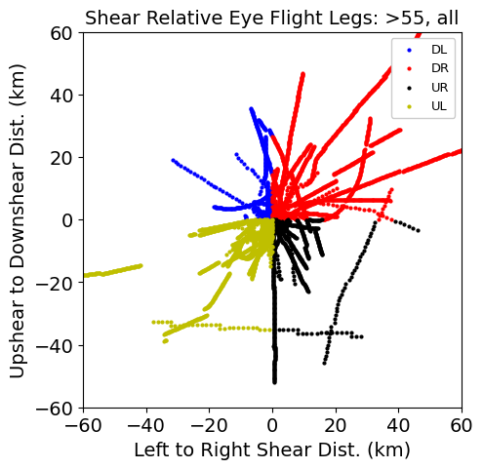

63 kt turning point (TD + TS vs WH + SH):

* Low intensity: 50 cases, 8079 data points
* High intensity: 36 cases, 3918 data points

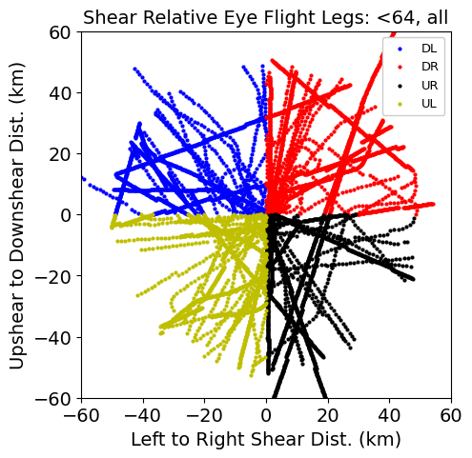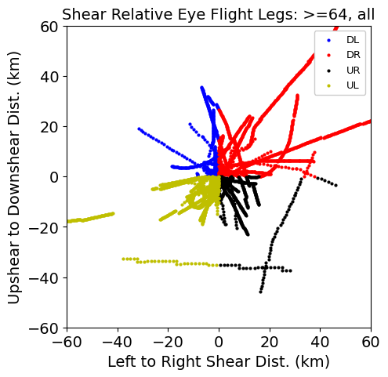

**Defined vs Undefined eyewall passes:**

* Undefined: 33 passes, 5464 data points
* Defined: 53 passes, 6533 data points

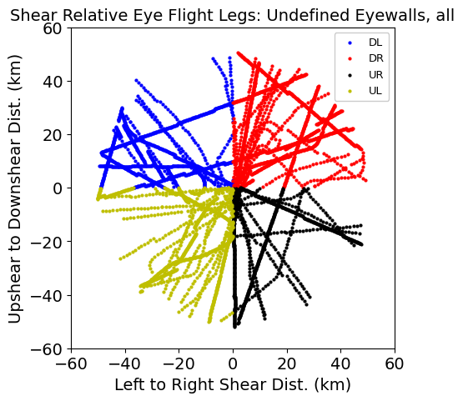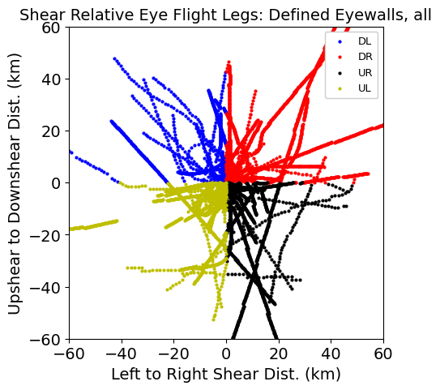

**Monte Carlo Tests:**

**Jackknife Tests:**

