SOP-151 Filter Element Change
Halcyon HX-2 portable fluid pump. Revision B. SYNTHETIC TRAINING DOCUMENT: all names, parts, limits and records are fictional demo data.

1 Scope
Replace the inline filter element of an HX-2 pump. Use element HX2-420 only.

2 Warning
WARNING: Relieve line pressure before opening the filter bowl. Never open the bowl while the pump runs.

3 Torque values
Fastener | Size | Torque
Bowl clamp screw | M5 | 3 N-m
Drain plug | M10 | 8 N-m
Table 1. Torque values for the filter assembly.
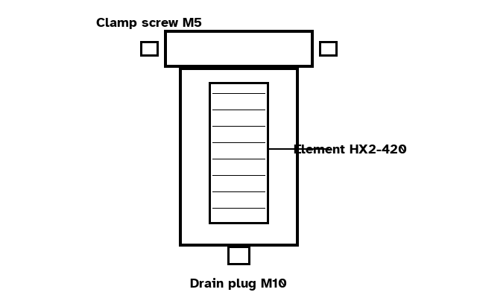
Figure 1. Filter bowl, element and clamp screws.

4 Procedure
1. Stop the pump and close inlet valve V1 and outlet valve V2.
2. Place a drip tray under the bowl and remove the drain plug to drain about 0.5 L of fluid.
3. Loosen the two M5 bowl clamp screws and remove the filter bowl.
4. Replace the filter element with a new element HX2-420 (25 µm rating).
5. Refit the bowl and torque the two M5 bowl clamp screws to 3 N-m (Table 1).
6. Refit the drain plug and torque it to 8 N-m (Table 1).
7. Open V1, then V2, and watch the bowl seam for leaks for 60 s.

