# Document

**Chaining return-into-libc calls**

1. “esp lifting” method
2. Frame faking
3. Inserting null bytes

**PaX features**

1. PaX basics
2. PaX and return-into-libc exploits
3. PaX and mmap base randomization

**The dynamic linker’s dl-resolve() function**

1. A few ELF data types
2. A few ELF data structures
3. How dl-resolve() is called from PLT

**Defeating PaX**

1. Requirements
2. Building the exploit

**Misc**

1. Portability
2. Other types of vulnerabilities
3. Other non-exec solutions
4. Improving existing non-exec schemes
5. The versions used

# Practice

Babystack from 0ctf 2018

PREPARE:

* JMPREL
* SYMTAB
* STRTAB

STRTAB 0x80484f8 the location of string table (type char *)

SYMTAB 0x8048268 the location of symbol table (type Elf32_Sym*)

typedef uint32_t Elf32_Addr ;

typedef uint32_t Elf32_Word ;

typedef struct

{

Elf32_Addr r_offset ; /* Address */

Elf32_Word r_info ; /* Relocation type and symbol index */

} Elf32_Rel ;

#define ELF32_R_SYM(val) ((val) >> 8)

#define ELF32_R_TYPE(val) ((val) & 0xff)

typedef struct

{

Elf32_Word st_name ; /* Symbol name (string tbl index) */

Elf32_Addr st_value ; /* Symbol value */

Elf32_Word st_size ; /* Symbol size */

unsigned char st_info ; /* Symbol type and binding */

unsigned char st_other ; /* Symbol visibility under glibc>=2.2 */

Elf32_Section st_shndx ; /* Section index */

} Elf32_Sym ;

// call of unresolved read(0, buf, 0x100)

_dl_runtime_resolve(link_map, rel_offset) {

Elf32_Rel * rel_entry = JMPREL + rel_offset ;

Elf32_Sym * sym_entry = &SYMTAB [ ELF32_R_SYM ( rel_entry -> r_info )];

/* Check… */

char * sym_name = STRTAB + sym_entry -> st_name ;

_search_for_symbol_(link_map, sym_name);

// invoke initial read call now that symbol is resolved

read(0, buf, 0x100);

}

The following is the simplified dl-resolve() algorithm:

1) calculate some_func's relocation entry

Elf32_Rel * reloc = JMPREL + reloc_offset;

2) calculate some_func's symtab entry

Elf32_Sym * sym = &SYMTAB[ ELF32_R_SYM (reloc->r_info) ];

3) sanity check

assert (ELF32_R_TYPE(reloc->r_info) == R_386_JMP_SLOT);

4) late glibc 2.1.x (2.1.92 for sure) or newer, including 2.2.x, performs

another check. if sym->st_other & 3 != 0, the symbol is presumed to have

been resolved before, and the algorithm goes another way (and probably

ends with SIGSEGV in our case). We must ensure that sym->st_other &

3 == 0.

5) if symbol versioning is enabled (usually is), determine the version table

index

uint16_t ndx = VERSYM[ ELF32_R_SYM (reloc->r_info) ];

and find version information

const struct r_found_version *version =&l->l_versions[ndx];

where l is the link_map parameter. The important part here is that ndx must

be a legal value, preferably 0, which means "local symbol".

6) the function name (an asciiz string) is determined:

name = STRTAB + sym->st_name;

7) The gathered information is sufficient to determine some_func's address.

The results are cached in two variables of type Elf32_Addr, located at

reloc->r_offset and sym->st_value.

8) The stack pointer is adjusted, some_func is called.

Note: in case of glibc, this algorithm is performed by the fixup() function,

called by dl-runtime-resolve().

For demonstration purposes only, let us suppose that:

* JMPREL @ 0x0
* SYMTAB @ 0x100
* STRTAB @ 0x200
* controllable area @ 0x300

We need to craft our Elf32_Rel and Elf32_Sym somewhere within the controllable area and provide a rel_offset such that the resolver reads our special forged structures. Let's suppose that the controllable (stack after pivotation ??? ) are has the following layout.

+--------+

r_offset |GOT | 0x300

r_info |0x2100 | 0x304

alignment |AAAAAAAA| 0x308

st_name |0x120 | 0x310

st_value |0x0 |

st_size |0x0 |

others |0x12 |

sym_string |"syst | 0x320

|em\x00" |

+--------+

When _dl_runtime_resolve ( link_map , 0x300) is called, the 0x300 offset is used to get the Elf32_Rel* rel = JMPREL + 0x300 == 0x300.  
Secondly, the Elf32_Sym is accessed using the r_info field from 0x304.

Elf32_Sym* sym = &SYMTAB[(0x2100 >> 8)] == 0x310.  
The last step is to compute the address of the symbol string. This is done by adding st_name to STRTAB : const char *name = STRTAB + 0x120 == 0x320.  
Note that SYMTAB access its entries as an array, therefore ELF32_sym should be aligned to 0x10 bytes. Now that we control st_name, we can basically force the resolver to relocate  system and call system('sh') to a own the system :)  
Writing the payload should be easy now that we have a clear image of the forged memory layout.

# Ret-into-dl_resol x64

What is the difference between the x86 and x64 Elf32_Rel, Elf32_Sym structure instead of using a Elf64_Sym structure Elf64_Rela,.

The important thing here is that the change in the size of the structure.

* The size of the structure (8 byte) → Elf32_Rel Elf64_Rela structures, size (24-byte)
* The size of the Elf32_Sym structure (16 byte) → Elf64_Sym The size of the structure (24-byte)

Because of this reloc_offset value is an array of non-offset address Elf64_Rela structures should be an index.

typedef uint32_t Elf64_Word;

typedef uint64_t Elf64_Xword;

typedef int64_t Elf64_Sxword;

typedef uint64_t Elf64_Addr;

typedef uint16_t Elf64_Section;

typedef struct

{

Elf64_Addr r_offset; /* Address */

Elf64_Xword r_info; /* Relocation type and symbol index */

Elf64_Sxword r_addend; /* Addend */

} Elf64_Rela;

typedef struct

{

Elf64_Word st_name; /* Symbol name (string tbl index) */

unsigned char st_info; /* Symbol type and binding */

unsigned char st_other; /* Symbol visibility */

Elf64_Section st_shndx; /* Section index */

Elf64_Addr st_value; /* Symbol value */

Elf64_Xword st_size; /* Symbol size */

} Elf64_Sym;

**r_info**

This member gives both the symbol table index, with respect to which the relocation must be made, and the type of relocation to apply. For example, a call instruction's relocation entry will hold the symbol table index of the function being called. If the index is STN_UNDEF, the undefined symbol index, the relocation uses 0 as the symbol value.

Relocation types are processor-specific. A relocation entry's relocation type or symbol table index is the result of applying ELF32_R_TYPE or ELF32_R_SYM, respectively, to the entry's r_info member:

#define ELF32_R_SYM(info) ((info)>>8)

#define ELF32_R_TYPE(info) ((unsigned char)(info))

#define ELF32_R_INFO(sym, type) (((sym)<<8)+(unsigned char)(type))

#define ELF64_R_SYM(info) ((info)>>32)

#define ELF64_R_TYPE(info) ((Elf64_Word)(info))

#define ELF64_R_INFO(sym, type) (((Elf64_Xword)(sym)<<32)+ \

(Elf64_Xword)(type))

For Elf64_Rel and Elf64_Rela structures, the r_info field is further broken down into an 8-bit type identifier and a 24-bit type dependent data field:

#define ELF64_R_TYPE_DATA(info) (((Elf64_Xword)(info)<<32)>>40)

#define ELF64_R_TYPE_ID(info) (((Elf64_Xword)(info)<<56)>>56)

#define ELF64_R_TYPE_INFO(data, type) (((Elf64_Xword)(data)<<8)+ \

(Elf64_Xword)(type))

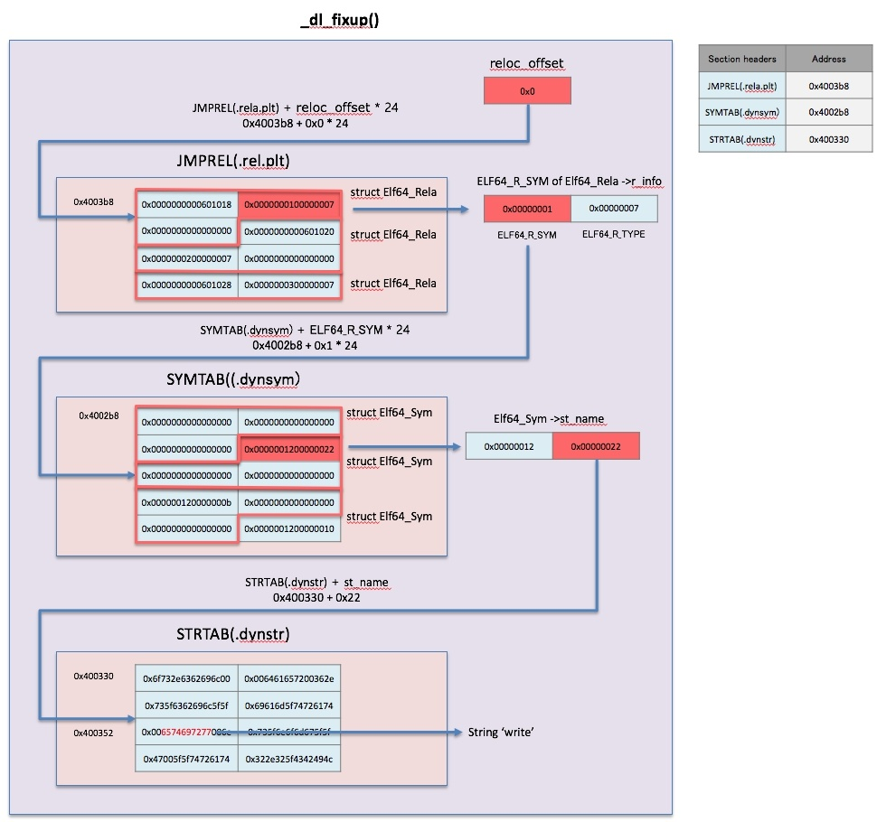

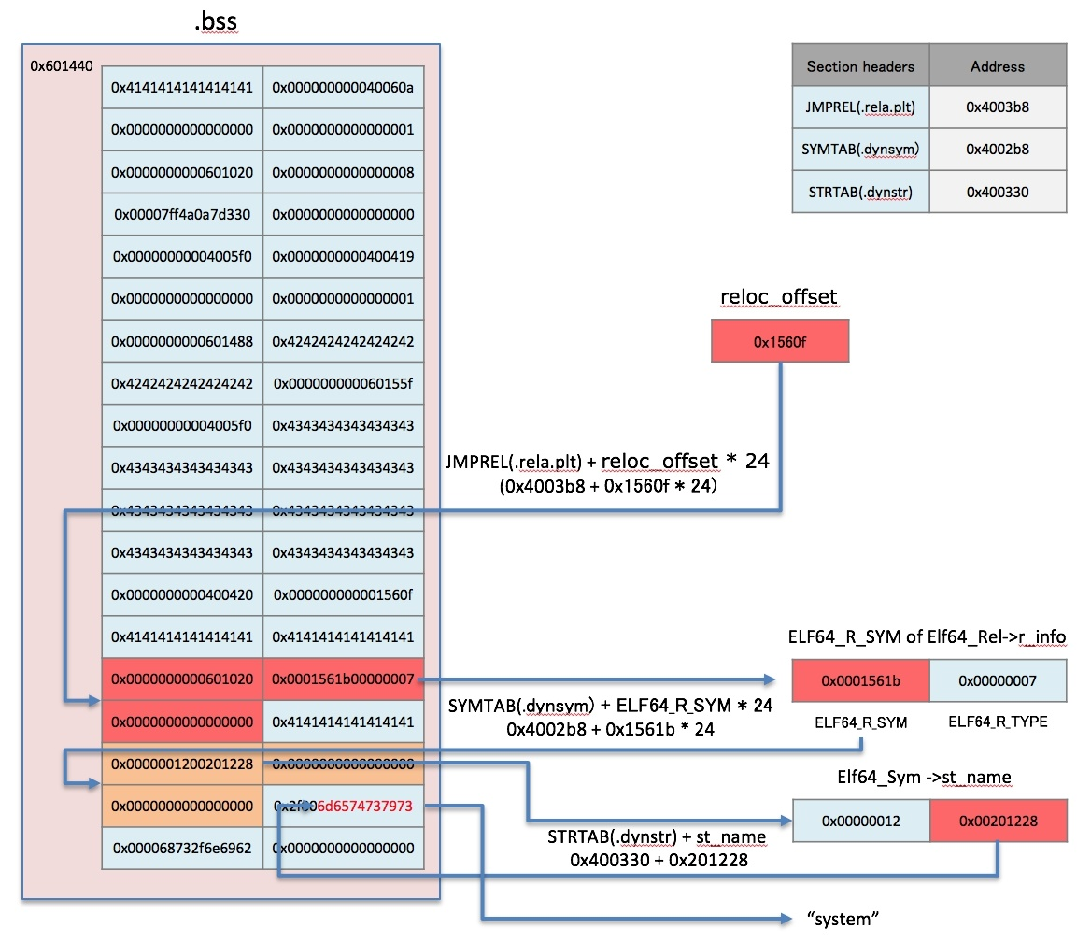

# Return-to-csu

Command

objdump -M intel -d ./prog

**4005f0:   4c 89 ea                mov    rdx,r13**

**4005f3:   4c 89 f6                mov    rsi,r14**

**4005f6:   44 89 ff                mov    edi,r15d**

**4005f9:   41 ff 14 dc             call   QWORD PTR [r12+rbx*8]**

  4005fd:   48 83 c3 01             add    rbx,0x1

  400601:   48 39 eb                cmp    rbx,rbp

  400604:   75 ea                   jne    4005f0 <__libc_csu_init+0x40>

  400606:   48 83 c4 08             add    rsp,0x8

**40060a:   5b                      pop    rbx**

**40060b:   5d                      pop    rbp**

**40060c:   41 5c                   pop    r12**

**40060e:   41 5d                   pop    r13**

**400610:   41 5e                   pop    r14**

**400612:   41 5f                   pop    r15**

**400614:   c3                      ret**

 We can take advantage of the gadget of __libc_csu_init

* We can control rdx, rsi, edi with r13, r14, r15 register

The important thing is that in 64bit, the argument is saved in register.

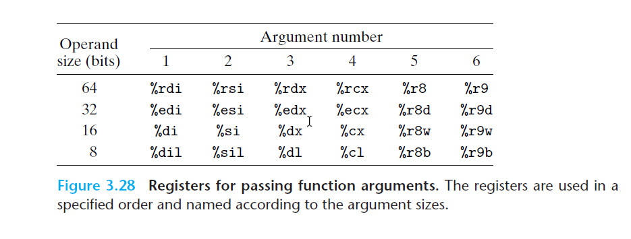

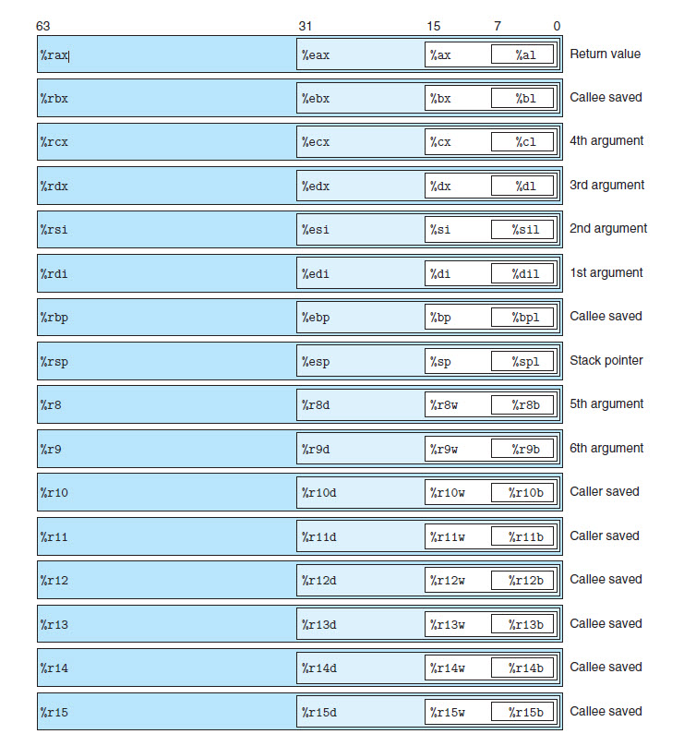

*Reference:*

1. [*http://lia.deis.unibo.it/Courses/SicurezzaM1011/BufferoVerflow.pdf*](http://lia.deis.unibo.it/Courses/SicurezzaM1011/BufferoVerflow.pdf)
2. *Chapter 7: Linker CSAPP*
3. [*https://gist.github.com/ricardo2197/8c7f6f5b8950ed6771c1cd3a116f7e62*](https://gist.github.com/ricardo2197/8c7f6f5b8950ed6771c1cd3a116f7e62)
4. [*http://phrack.org/issues/58/4.html?fbclid=IwAR3H6sjm3ouNN6rPlUuo2n1RIu9JB-00SggAlP2fzokcGtT-hYOe0fj6jsQ*](http://phrack.org/issues/58/4.html?fbclid=IwAR3H6sjm3ouNN6rPlUuo2n1RIu9JB-00SggAlP2fzokcGtT-hYOe0fj6jsQ)
5. [*https://kileak.github.io/ctf/2018/0ctf-qual-babystack/*](https://kileak.github.io/ctf/2018/0ctf-qual-babystack/)
6. [*http://inaz2.hatenablog.com/entry/2014/07/15/023406*](http://inaz2.hatenablog.com/entry/2014/07/15/023406)
7. [*http://inaz2.hatenablog.com/entry/2014/07/27/205322*](http://inaz2.hatenablog.com/entry/2014/07/27/205322)
8. [*https://www.lazenca.net/pages/viewpage.action?pageId=19300744*](https://www.lazenca.net/pages/viewpage.action?pageId=19300744)