Sample analysis
Synthetic one-page source

1. Termination
Section 9.3 allows termination for cause with a 30-day cure period.
[Source: source.pdf, page 1 -- highlighted: "30-day cure period"]
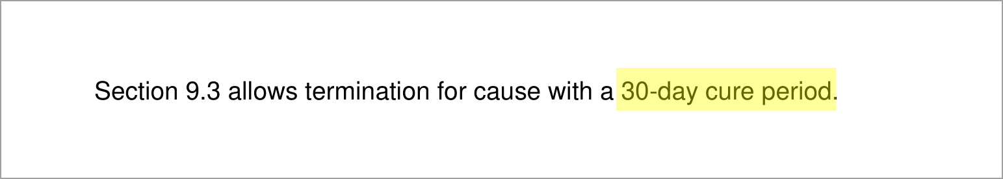

Generated by Eyeball. Each screenshot is captured from the source document with cited text highlighted in yellow. Screenshots are dynamically sized to cover the full range of text referenced in the analysis. Review the highlighted source material to verify each assertion.

