Machine Learning vs. Deep Learning
A Self-Contained Comparative Analysis

Ethan Tan Wee En
P2012085
DAAA/2B/03
School of Computing
Singapore Polytechnic
ethantan.20@ichat.sp.edu.sg

Abstract — Following the discovery and development of deep neural networks, deep learning has become the de facto standard for computer vision and other related problems involving unstructured data. This study aims to compare the approach of classic machine learning algorithms (logistic regression) with that of convolutional neural networks with respect to solving the same task of image classification.
Keywords — machine learning, deep learning, image classification, computer vision, Fashion MNIST

Introduction
In the last few decades, technology has undergone rapid advancement, mostly due to the improvement of computing resources. Self-driving cars, biometric validation systems and almost-humanlike chatbots are all made possible through the implementation of deep learning technologies.
Are classic machine learning algorithms therefore not an option at all for tasks like image classification? If it were even possible, how would one proceed to one to model such data? Most classic machine learning algorithms deal with single-dimensional data (i.e., each input sample is simply a one-dimensional array of values) whilst images have 2, or even 3 dimensions.
Without further ado, let’s rediscover how one might go about to achieve the above…

Related Works
Whilst this study is completely original, it was heavily inspired by 3Blue1Brown’s video on the usefulness of infinite math [1], the similarity between neural networks and classic linear regression models and is by no means the first of its kind [2].

Experiment Overview
- Data Preparation
- Exploratory Data Analysis
- Parallel model evaluation

Experiment

Data Preparation
The first thing to do in any machine/deep learning workflow is to obtain the relevant data. For the purposes of this study, the dataset of choice will be the Fashion MNIST dataset, a counterpart to MNIST’s very well-known dataset of handwritten digits. To keep things simple, the grayscale version will be used.
The data is imported from TensorFlow’s inbuilt datasets.
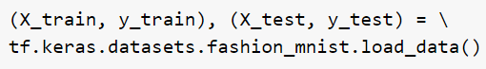

Exploratory Data Analysis
No machine learning project can escape EDA. Since this is an image classification dataset, the data will be of image pixel values.
The shape of the data can be easily inspected.
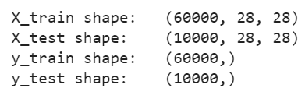
There are 60,000 and 10,000 samples in the training and testing data partitions respectively.
Each sample has a shape of (28, 28), which implies that they have the dimension 28 pixels by 28 pixels.
The images can just as easily be visualized using the Matplotlib package.
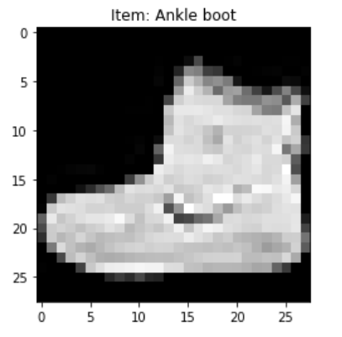
The first sample of the training data is labelled “ankle boot”. Looking at the image rendered, it is indeed the image of an ankle boot or some other similar footwear.
These are the first 6 samples of the training data partition:
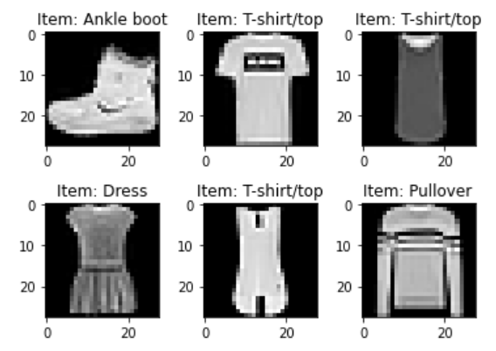

Parallel Model Evaluation
Data cleaning/pre-processing will be done in parallel with model evaluation to compare the differences with and without them.

Baseline Models
To begin, baseline CNN and Logistic Regression models will be compared using raw data. The code for the CNN is:
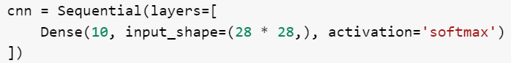
while the code for the Logistic Regression model is simply:

Technically, the deep learning model is currently just a deep feed-forward Artificial Neural Network (ANN) and not a Convolutional Neural Network (CNN); nevertheless, the final model in mind is a CNN, which we’re going to be working towards. Hence, to avoid confusion, it will be referred to as CNN.
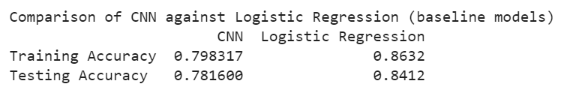
Initially, the Logistic Regression model outperforms the ANN for both the training and testing data partitions. This is likely due to the ANN underfitting the data. I.e., the ANN model is too simple. Without any activation functions, the ANN model is but a simple Linear Regression model whilst the Logistic Regression model can model non-linear patterns in the data.

Data Normalization
The next step would be to compare the models’ performance on normalized data instead. All the pixel values are divided by 255.0, which is the maximum value (indicating white).
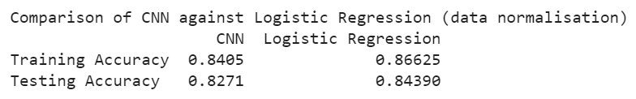
After data normalization, both models improved, with the CNN’s improvement more significant than that of the Logistic Regression model. Normalizing the data is especially crucial for the CNN as it reduces the magnitude of the weights, thus smoothing out the learning curve and improving convergence.

Feature Engineering
The current Logistic Regression model is very prone to overfitting. This is due to the training data having numerous features. Namely, there are 784 features (28 * 28), 1 for each pixel in each sample. This is a huge problem if the dataset was not very clean.
To mitigate this problem, pooling will be employed to reduce the size of the data, and thus the tendency to overfit.
Since the linear regression model deals with 1-Dimensional data, hence, to keep the comparison fair, the data has to be converted from 2-Dimensional to 1-Dimensional (each sample is 1D, so the total data is 2D). A trivial solution would be to simply reshape the data using Numpy.
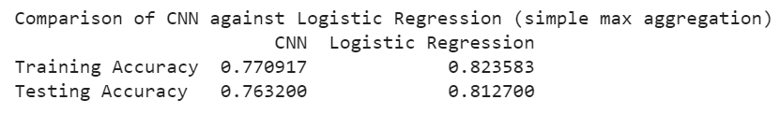
The number of features has been drastically reduced, from 784 to 196.
It’s no surprise that the models performed poorer – there’s less data for the models to learn from.
Nevertheless, data reduction helps to alleviate the problem known as the Curse of Dimensionality, especially for the Logistic Regression model. It simplifies the data to expedite model training and mitigate overfitting.
An alternative to using max pooling is mean pooling, which uses the mean of each chunk instead of the maximum value.
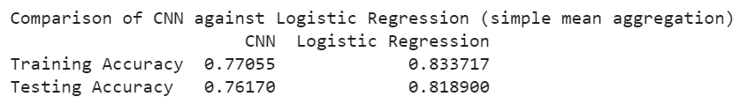
Not much better.
To improve the models’ scores, it would be helpful to understand the underlying workings behind pooling and its effects.
Pooling works like this behind the scenes: closely related columns can be aggregated. For this example, chunks of size 4 will be aggregated by max along the flattened X arrays.
What that means is that every 4 data points will be replaced with the largest value among them. This essentially reduces the size of data by a factor of ¼ (since the data has been flattened). In Keras, this is known as MaxPooling (namely, MaxPooling1D for data with 1-Dimensional samples).
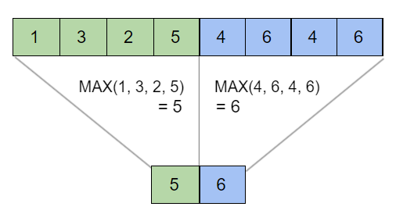
The code used is shown below. Currently the data is merely being reshaped with Numpy.
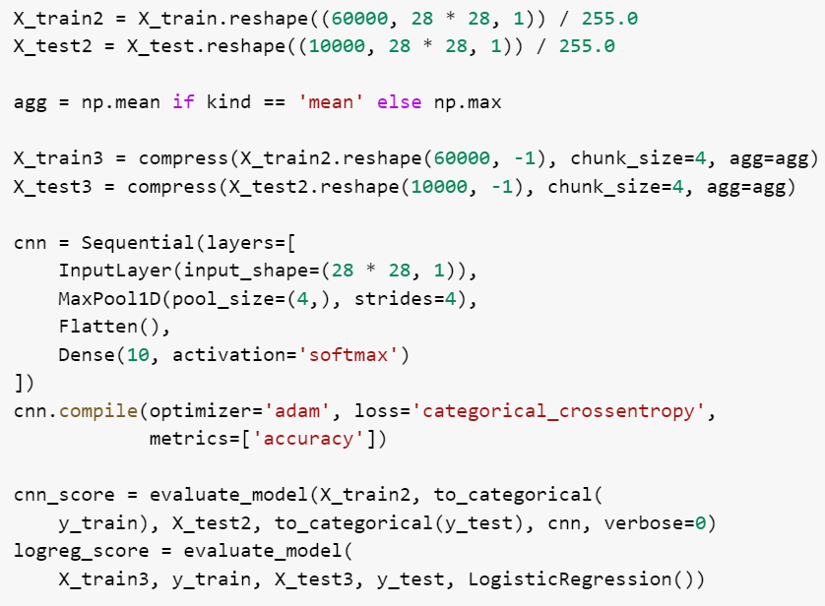
Inspecting the code, the CNN’s approach and the Logistic Regression’s are implemented differently but essentially achieve the same task. “compress” is a custom function written that pools chunk_size consecutive data points using a specified aggregation function.
Currently, the data is being flattened with a trivial reshaping. What this looks like behind the scenes looks like:
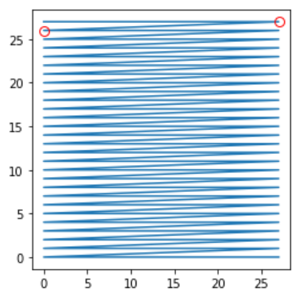
The 2 red points are adjacent after flattening but they were not close in the original 2D data. In fact, they were situated on opposite ends of the image.
If one were to graph the images before and after pooling, they would look like this:
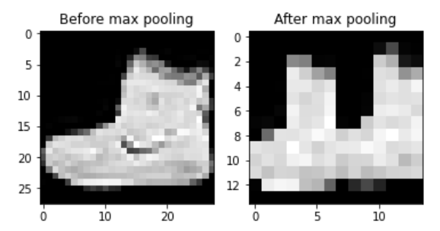
The single ankle boot split into 2 copies. This is a rather interesting observation and might explain the poor performance of the models after pooling.
Another sample (shirt) looks just as bizarre:
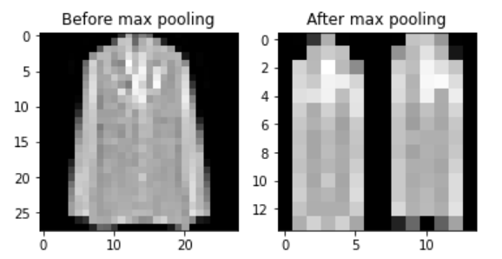
To resolve this duplicity issue, another method will have to be used.
An alternative method would be to use a snake-like encoding function to flatten the data (the encoding function maps input positions to output positions and shows how the data would be unraveled when flattened). It looks like this:
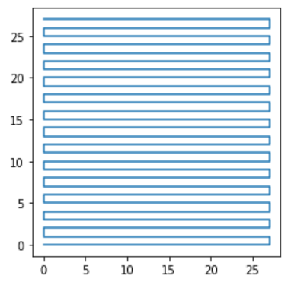
This new method looks promising. Data points remain close to one another after transformation.
Unfortunately, this pattern is only linear, and thus the transformation does not really reassemble well.
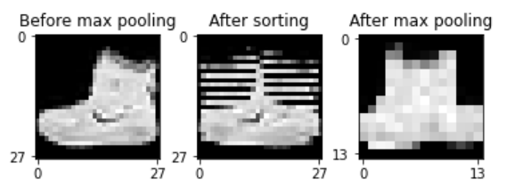
The ankle boot is no longer recognizable after pooling.
☹
The same goes for any other sample.
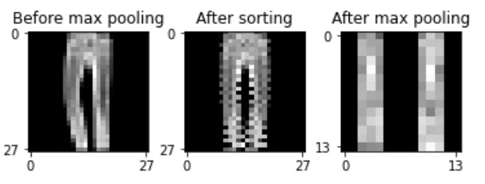
The performance does not improve as well.
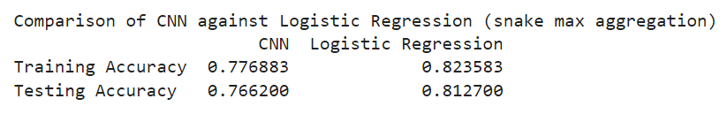
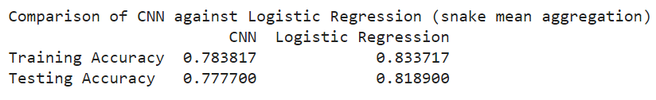
Hmmm. All is not lost.
There is a concept in infinite mathematics known as space-filling curve. TL;DR, it’s all about using 1-D lines to fill 2-D spaces. The idea is that points in proximity in the original data will stay in proximity after flattening. The curve of choice is called a Pseudo-Hilbert Curve (PHC), which is a finite implementation of the bona fide Hilbert Curve developed by David Hilbert in 1891 [3].
This is how the encoding looks like:
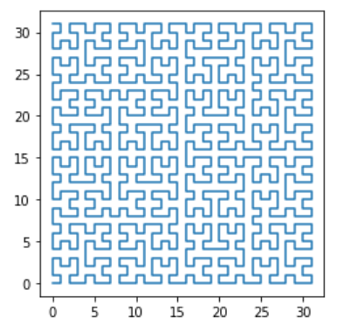
There is only one problem: a PHC requires data with square dimensions and side lengths which are a power of 2.
The solution to this would be to pad the image with zeroes, or null data so that the dimensions fit the requirement for a PHC encoding function.
For example, here is the ankle boot before padding and after padding 0, 8 (no horizontal padding and 8 pixels padding above and below):
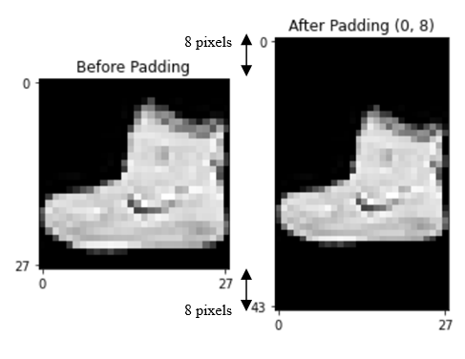
For the practical application, horizontal and vertical paddings of 2 each will be used as
28 + 2 * 2 = 32
32 is the smallest integral power of 2 larger than 28. After padding, the original image will shrink in size. The transformation will look something like this:
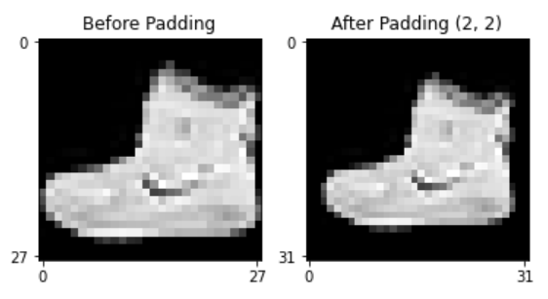
And this is how the flattening and reassembling using the PHC appears:
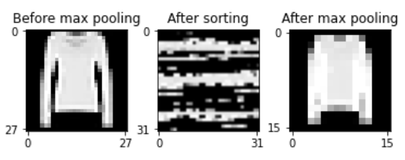
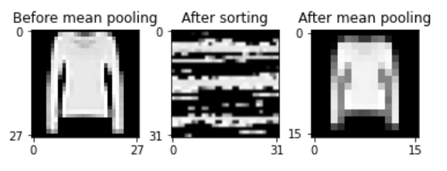
These are the new scores:
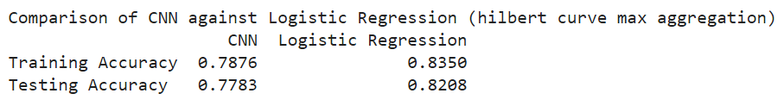
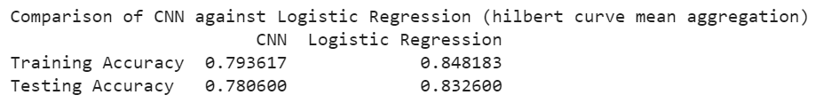
Not bad. The results have improved across the board, especially for the mean pooling version.
For the CNN, data normalization is likely to be useful as it removes potential initial bias in the gradient descent process. It can be achieved by dividing all the values by 255.0 (which is the maximum value, indicating the white).

Simple Hyper-Parameter Tuning
After some minor tuning on both models, they are roughly on par now in terms of accuracy.
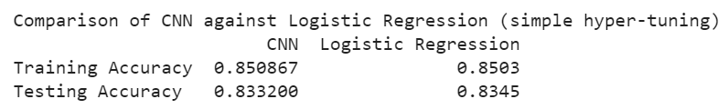
A 1-D convolutional layer was added to the CNN, and it was fitted for 10 epochs and with a batch size of 50.
The LR model used the ‘newton-cg’ solver, with a stronger regularization of 0.5 and max iterations of 10.

Data Augmentation
Data augmentation is a process whereby the data undergoes various transformations to allow the model to recognize the same object in different states.
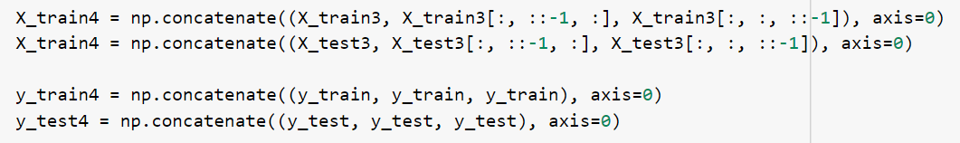
This simple code flips the data horizontally, vertically, as well as retains the original data, essentially tripling the amount of training data and permutes the states of the images.
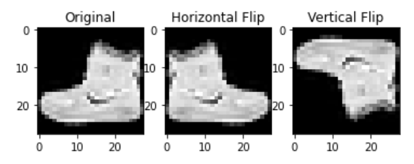

Complex Hyper-Parameter Tuning
Now, this is where Logistic Regression and Convolutional Neural Networks diverge, both in and capability and complexity.
Logistic Regression is extremely simple, and hence is limited in drafting complex models. There are much fewer hyper-parameters to tune. Its models cannot be scaled either horizontally or vertically.
Allow me to explain.
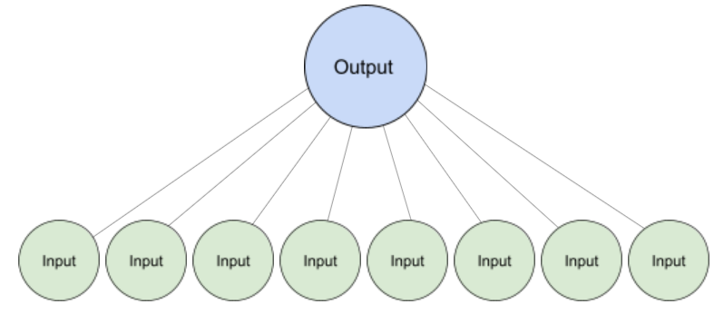
This is how a typical Logistic Regression model looks like, with as many green nodes as features in the input data.
However, it can only grow more complex by adding more green nodes.
A convolutional neural network, on the other hand is something like this.
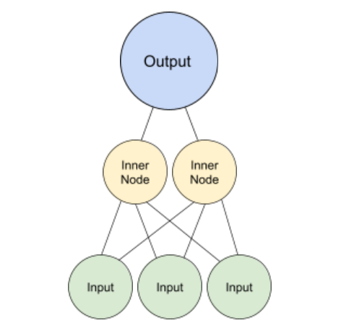
To increase the complexity of a neural network, more hidden layers of inner nodes can be added.
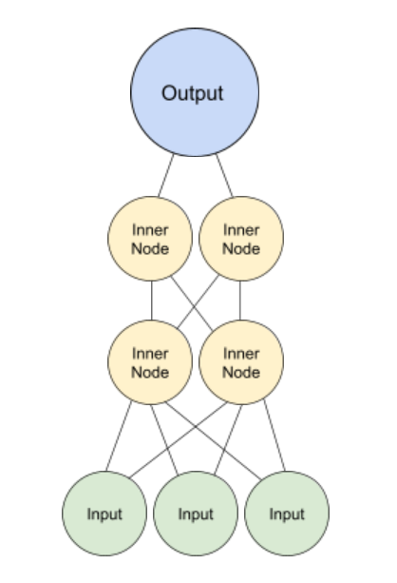
I call this vertical scaling as it resembles the notion of vertical scaling in distributed/parallel computing.
A neural network can also be scaled horizontally, which would yield a structure like this:
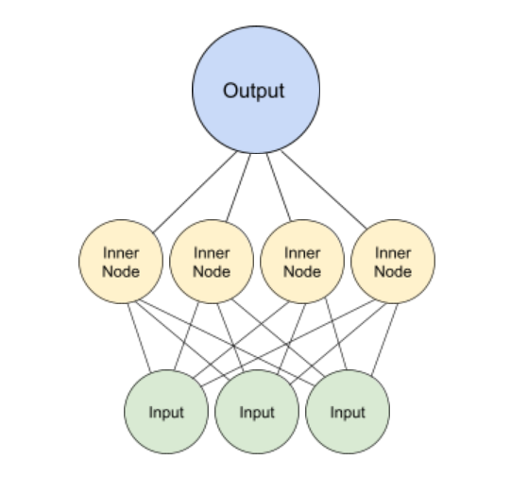
As a result of the infinite configurations and structural designs, deep learning neural networks are much more susceptible to overfitting.
This also enables neural networks to capture trends in much more complicated data than classic machine learning algorithms can cope with.
It’s up to the data scientist to balance the trade-off between complexity and overfitting.

Discussion

Are neural networks the only option for complex data?
Well, no. As seen above, a simple Logistic Regression model can achieve stunning results on an image classification task as well. Nevertheless, there are limits to the ability of simpler algorithms to model complex data.

How do classic machine learning algorithms deal with 2D data?
The template is used to format your paper and style the text. All margins, column widths, line spaces, and text fonts are prescribed; please do not alter them. You may note peculiarities. For example, the head margin in this template measures proportionately more than is customary. This measurement and others are deliberate, using specifications that anticipate your paper as one part of the entire proceedings, and not as an independent document. Please do not revise any of the current designations.

Conclusion
In machine learning, and often with many other things in life, there is more than one way to solve a problem. While the solution may not be conspicuous, the inquisitive ones will search it out and, on their quest, discover many interesting new things.
Deep learning with all its impressiveness really ought to be commended. Nevertheless, none should forget the roots that led to this insightful discovery.

References
- 3Blue1Brown. (2017) Hilbert's Curve: Is infinite math useful? 21 July. Available at: https://www.youtube.com/watch?v=3s7h2MHQtxc [Accessed 22 November 2021]
- Chopra, K., and Srimathi, C. (2018) Logistic ‘Regression and Convolutional Neural Networks Performance Analysis based on Size of Dataset’, International journal of Engineering development and research (IJEDR), 6(1), pp. 292-295. https://www.ijedr.org/papers/IJEDR1801048.pdf [Accessed 22 November 2021]
- ‘Hilbert curve’ (2021) Wikipedia. Available at: https://en.wikipedia.org/wiki/Hilbert_curve [Accessed 22 November 2021]

