**TikTok Data Collection Sheet**

This guide will help you collect two pieces of information from your TikTok app:

1. Your TikTok screen time for today.
2. The number of videos you watched during the study period.

Please follow the below steps and call the experimenter for assistance if you experience any issues.

**1: Record your TikTok screen time**

1. 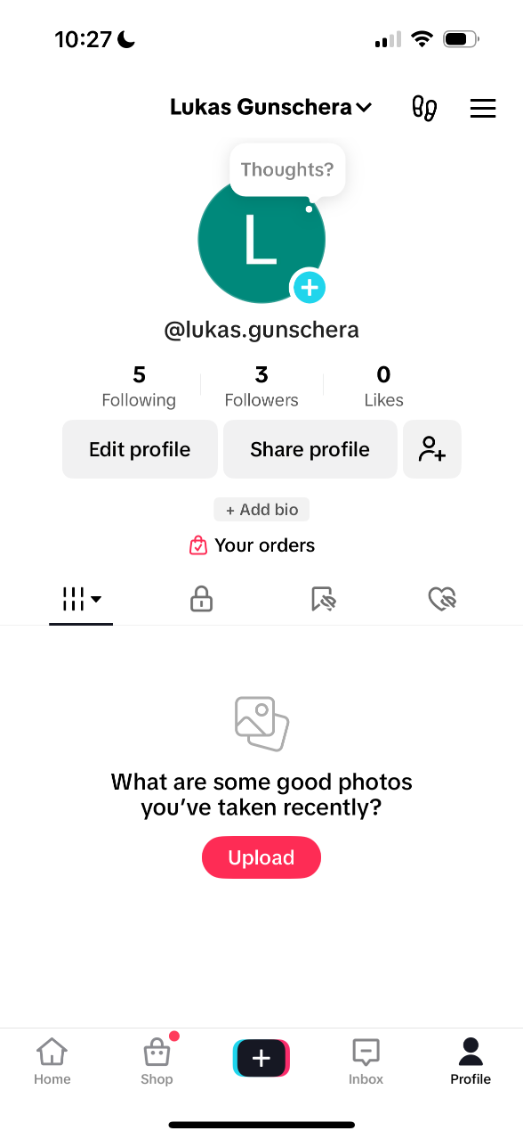Open TikTok.
2. 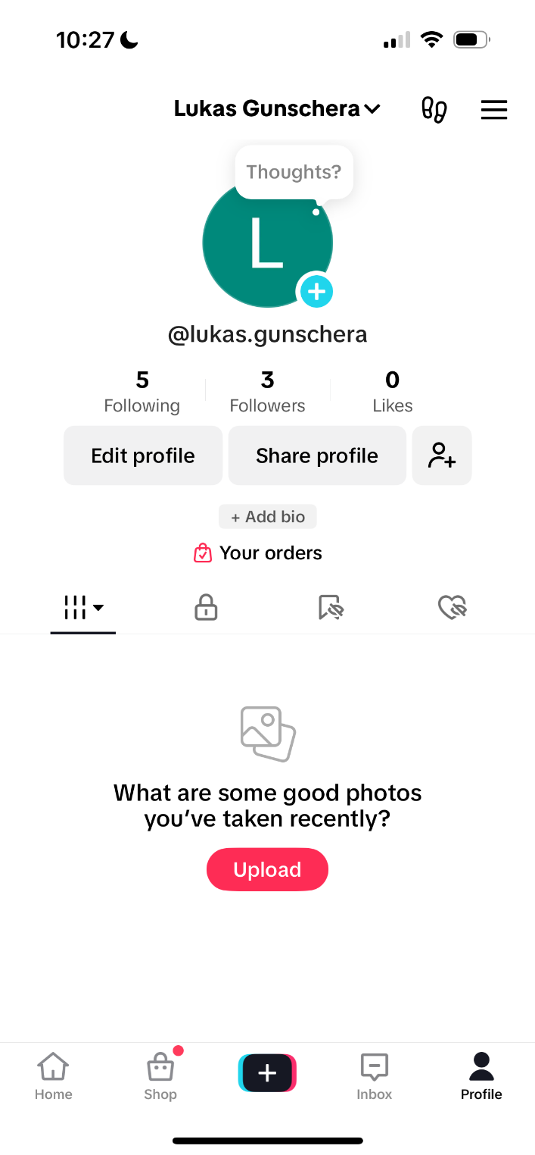Tap the **profile icon** in the bottom right corner of your home screen.
3. 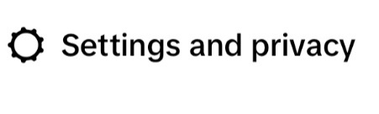Tap the **menu icon** in the top-right corner.
4. 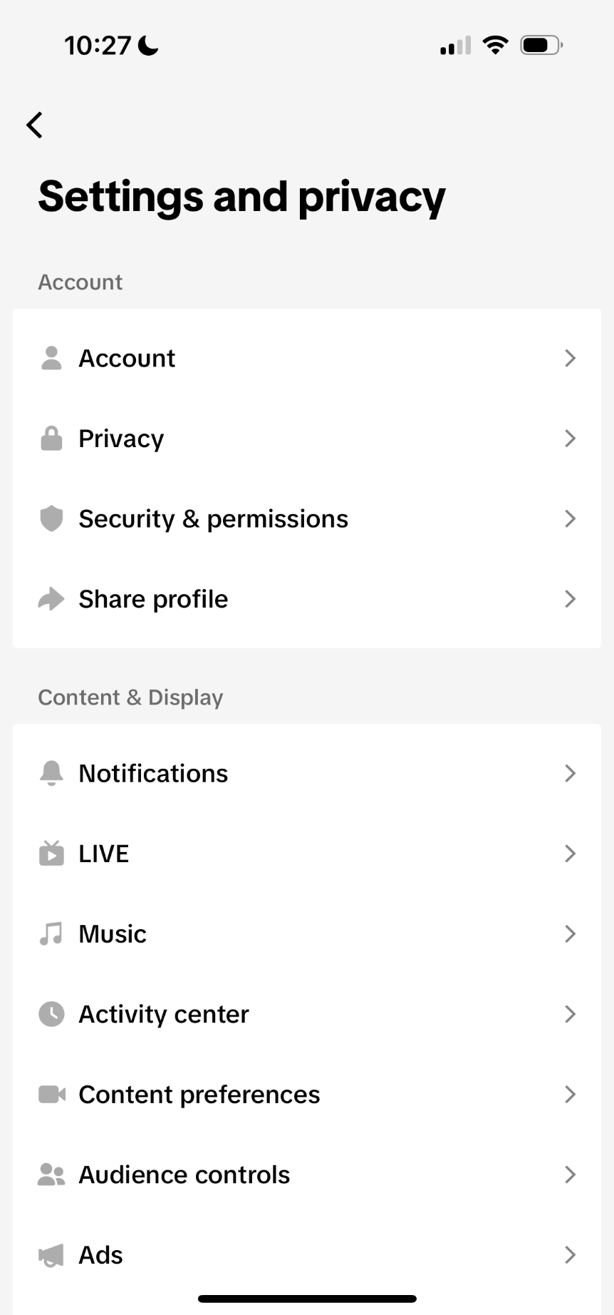Select
5. 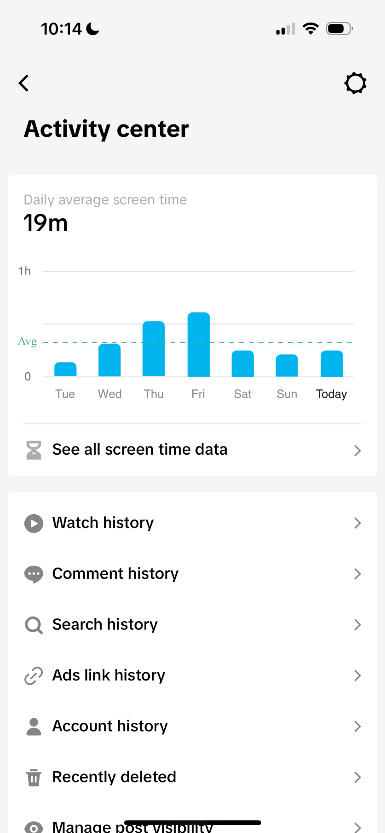Tap
6. Select
7. A screenshot of a screenshot of a calendar

   Description automatically generatedTap the bar corresponding to **today.**
8. **Note down the *hours* and *minutes* shown for today (daytime only).**

**2: Record number of watched videos**

1. 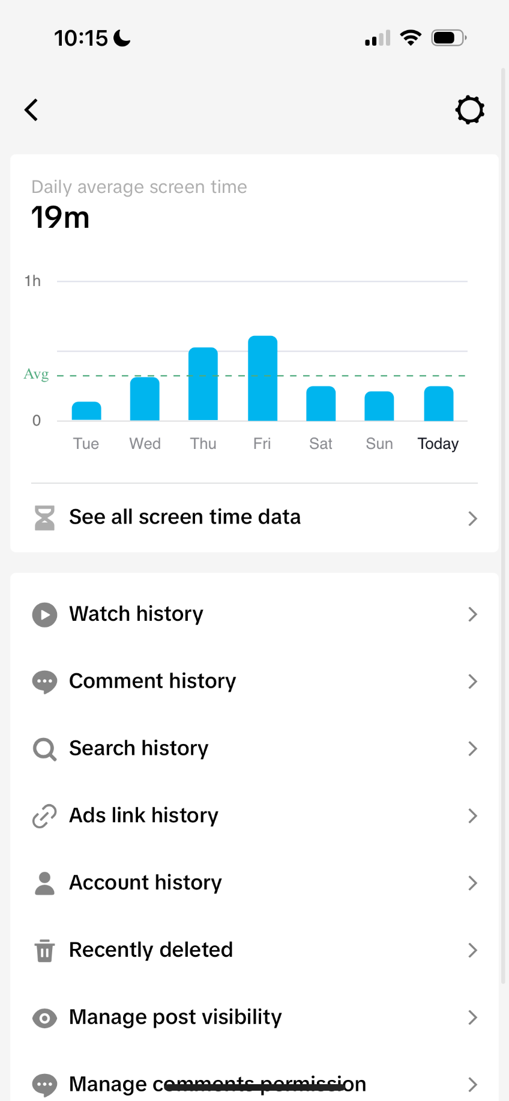Return to
2. Tap
3. 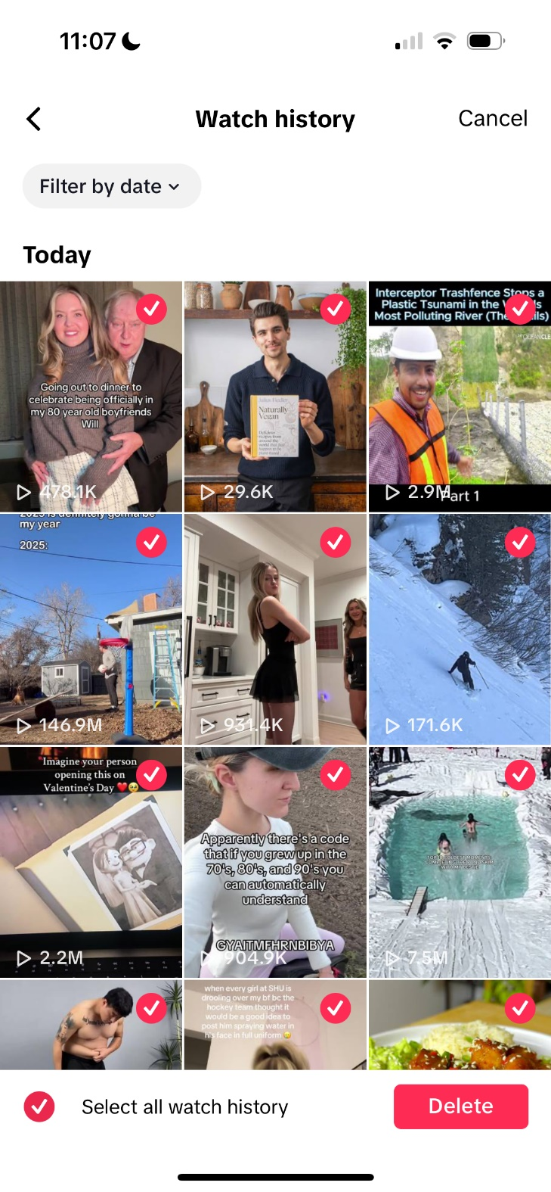**Scroll down in your watch history until no more videos load.**
4. Tap **Select**, then tap
5. 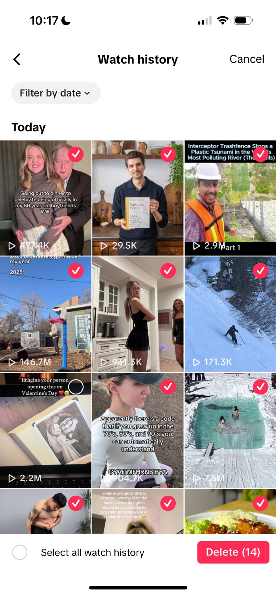**Deselect the last video.**
6. **Note down the** **number next to Delete.**