**TikTok Data Collection Sheet**

This guide outlines the steps you need to take inside the TikTok application to proceed with the study:

1. Delete your TikTok watch history.
2. Record your average time spent on TikTok.
3. Record your time spent on TikTok today.

Please follow the below steps and note down information when indicated. Please call the experimenter for assistance if you experience any issues.

**1: Delete TikTok watch history**

1. 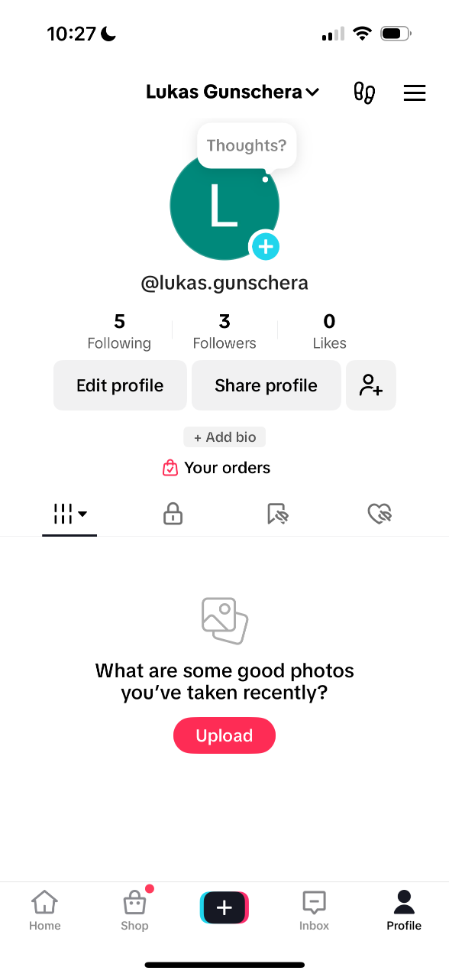Open TikTok.
2. 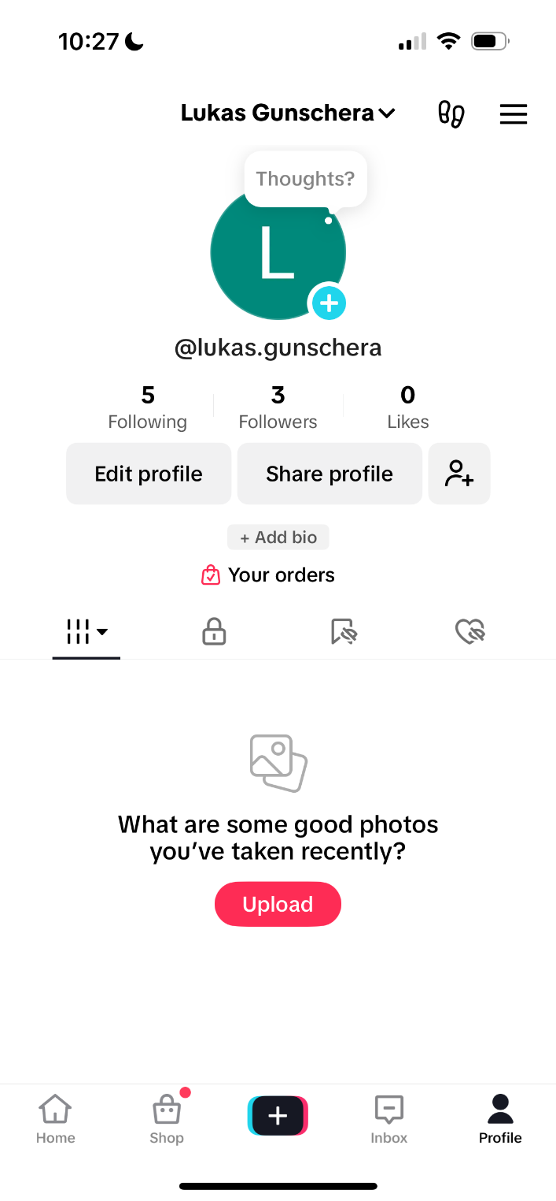Tap the **profile icon** in the bottom right corner of your home screen.
3. 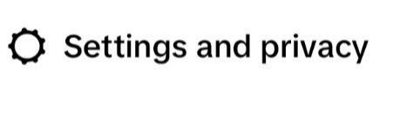Tap the **menu icon** in the top-right corner.
4. 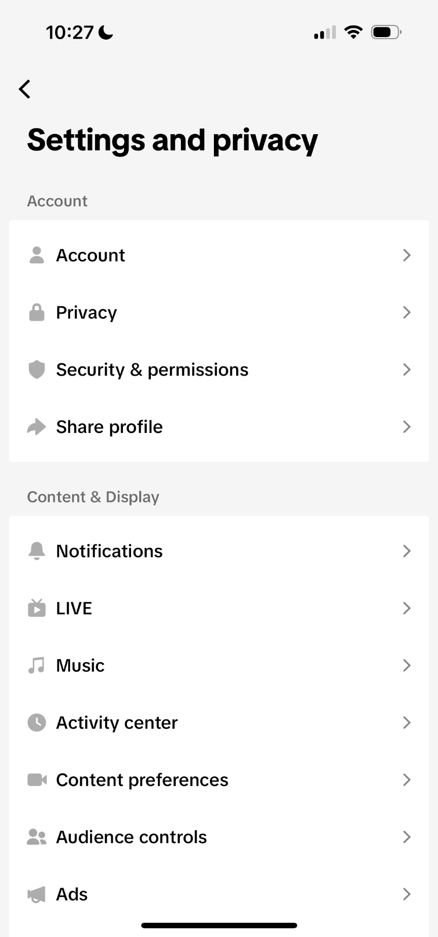Select
5. 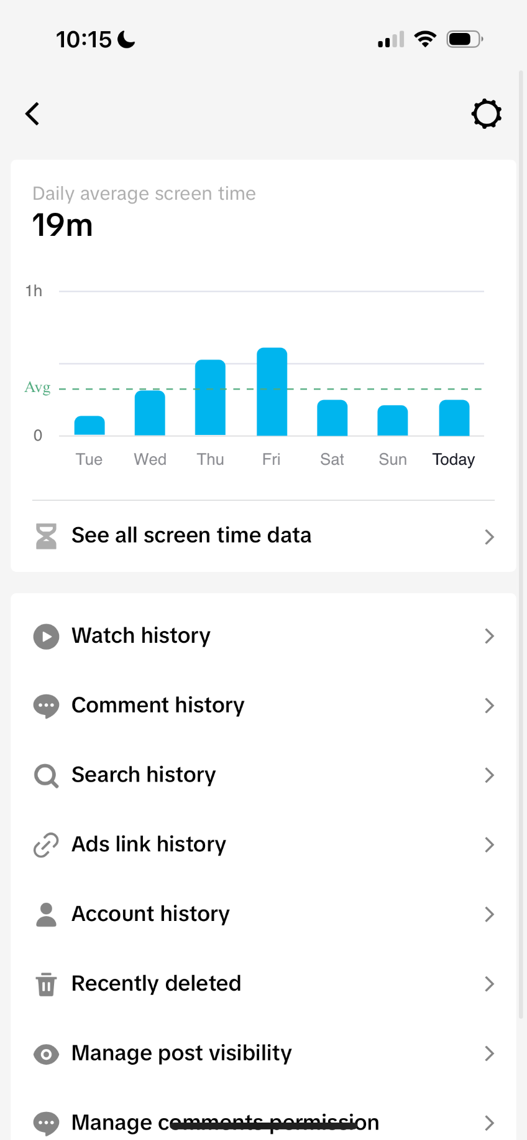Tap
6. 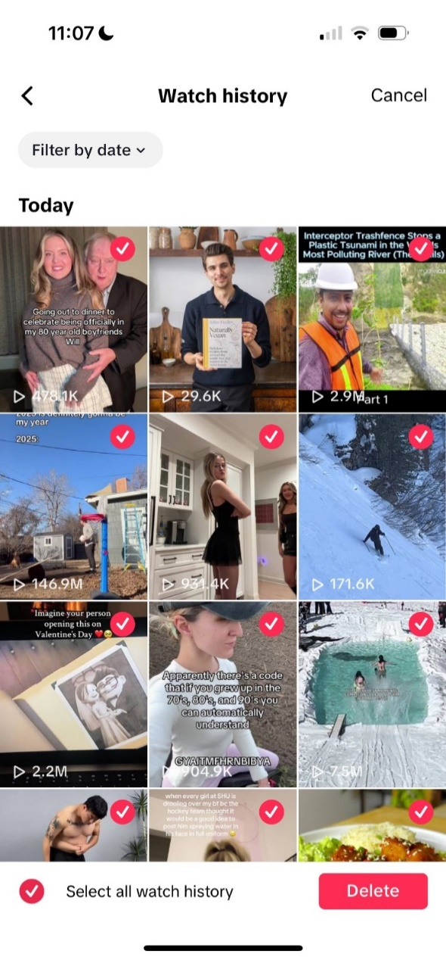Tap
7. 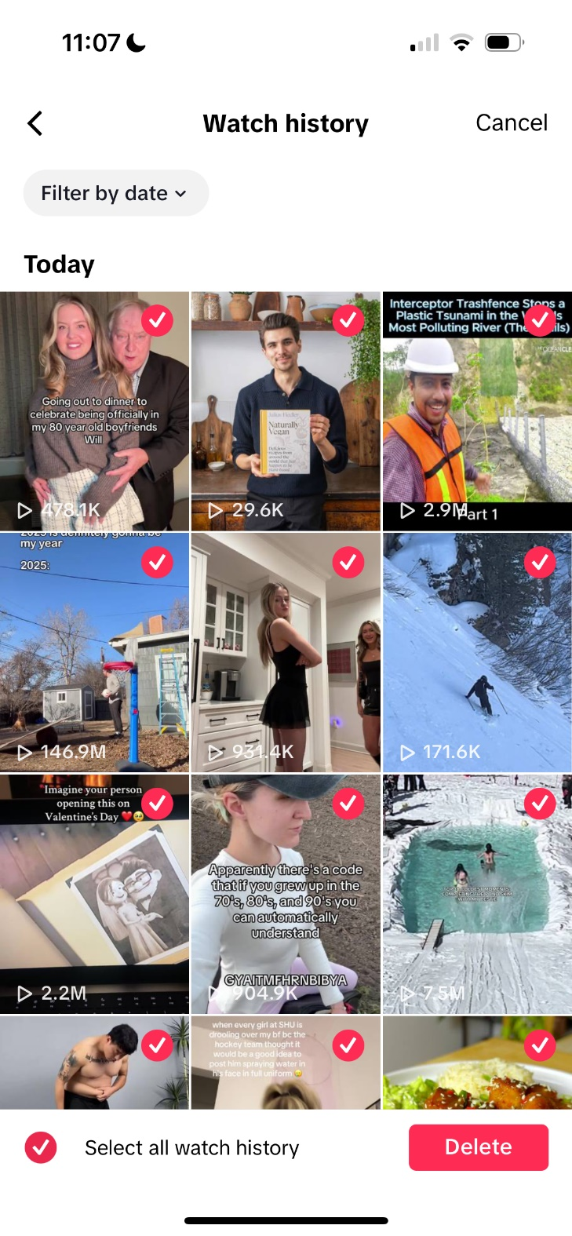Tap **Select**, then tap **Select all watch history**
8. Tap **Delete**

**2: Record average TikTok screen time**

1. A close-up of a white background

   Description automatically generatedReturn to the
2. **Screens screenshot of a phone

   Description automatically generatedNote down the *hours* and *minutes* displayed under**

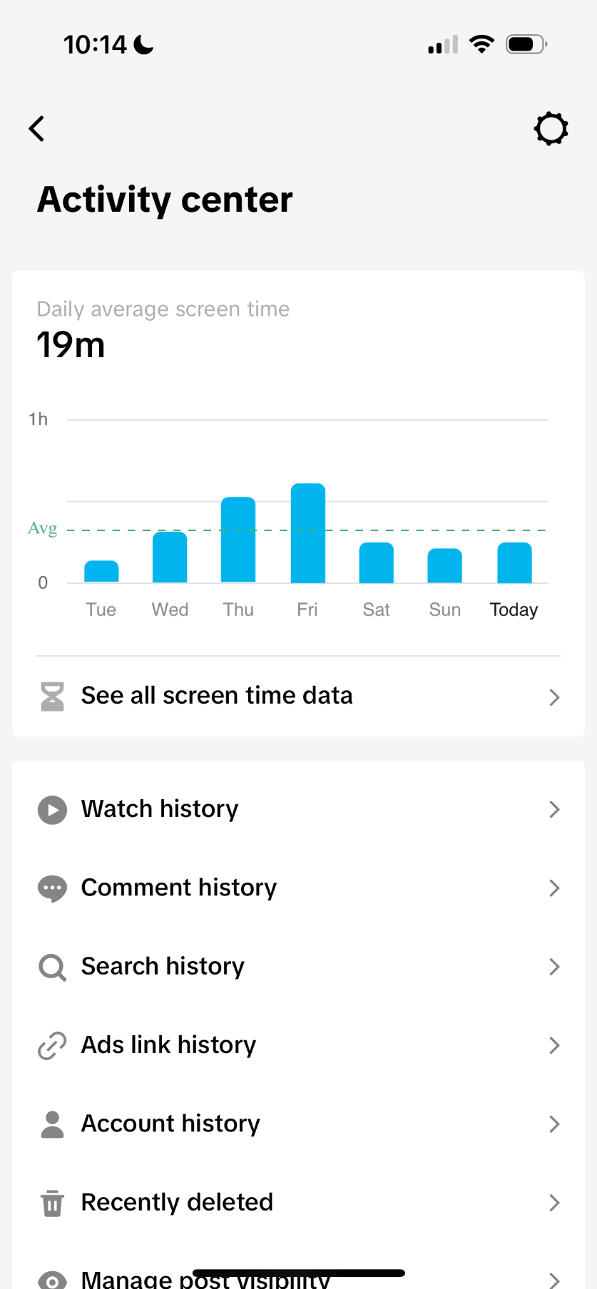**3: Record today’s TikTok screen time**

1. Select
2. A screenshot of a screenshot of a calendar

   Description automatically generatedTap the bar corresponding to **today.**
3. **Note down the *hours* and *minutes* shown for today (daytime only).**
4. Close the TikTok application and put your phone away.