Untitled
Amanda Zellmer
2025-02-04
# results <- read.csv("../Output/model_results.csv")
# parameters <- read.csv("../Output/model_parameters.csv")
# library(ggplot2)
#
# ggplot()+
# geom_bar(data=results, aes(x=model, y=AICwt, fill=Target), stat="identity")+
# facet_grid(Species~Range+By)+
# theme_bw()
#
# ggsave("../Output/model_results.jpg", height=8, width=5, units="in", dpi=600)
logit_to_prob <- function(logit) {
exp(logit) / (1 + exp(logit))
}
#
# parameters$Est_tr <- logit_to_prob(parameters$Est)
#
# library(dplyr)
#
# summary_df <- parameters %>%
# group_by(Species, Model, parameter) %>%
# summarize(Diff_Est = diff(Est[Treatment %in% c("human", "md")]),
# Diff_Est_tr = diff(Est_tr[Treatment %in% c("human", "md")]),
# Diff_SE = diff(SE[Treatment %in% c("human", "md")]),
# .groups = "drop")
#
# ggplot()+
# geom_point(data=subset(summary_df, Model == "m2"), aes(x = Diff_Est_tr, y=reorder(Species, Diff_Est_tr)))+
# facet_grid(parameter~.)+
# ylab("Species")+
# theme_bw(base_size = 8)
#
#
# ggplot()+
# geom_point(data=summary_df, aes(x = Diff_SE, y=reorder(Species, Diff_SE)))+
# facet_grid(parameter~Model)+
# ylab("Species")+
# theme_bw(base_size = 8)
#
# ggplot()+
# geom_point(data=subset(parameters, Model == "m2"), aes(x = Est, y=Species, color=Treatment), alpha=0.5, position = position_dodge(width = 0.5))+
# geom_errorbar(data=subset(parameters, Model == "m2"), aes(x = Est, y=Species, color=Treatment, xmin = Est - SE, xmax = Est + SE), width = 0.2, alpha=0.5, position = position_dodge(width = 0.5)) + # SE bars
# facet_grid(.~parameter, scales="free_x")+
# xlab("Estimate")+
# ylab("Species")+
# theme_bw(base_size = 8)
#
# ggsave("../Output/Parameters.jpg", height=5, width=8, units="in", dpi=600)
#
#
# ggplot()+
# geom_point(data=subset(summary_df, Model == "m2"), aes(x = Diff_Est_tr, y=Species), alpha=0.5, position = position_dodge(width = 0.5))+
# facet_grid(.~parameter)+
# xlab("Change in Estimated Probability")+
# ylab("Species")+
# theme_bw(base_size = 8)
#
# ggsave("../Output/Parameters_Diff.jpg", height=5, width=7, units="in", dpi=600)
# library(dplyr)
# library(tidyr)
# library(purrr)
# library(ggplot2)
#
# # Filter for Model "m2" and select relevant parameters
# filtered_params <- parameters %>%
# filter(Model == "m2", parameter %in% c("psi - (Intercept)", "psi - Impervious",
# "rho - (Intercept)", "rho - Impervious")) %>%
# select(Species, parameter, Est, Treatment)
#
# # Pivot so we have separate columns for intercept and slope
# param_wide <- filtered_params %>%
# pivot_wider(names_from = parameter, values_from = Est)
#
#
#
# # Define urbanization levels (0 to 40% impervious)
# urbanization_levels <- seq(0, 40, length.out = 100)
#
# # Expand grid for predictions
# predicted_values <- expand.grid(Species = unique(param_wide$Species),
# Treatment = unique(param_wide$Treatment),
# urbanization = urbanization_levels) %>%
# left_join(param_wide, by = c("Species", "Treatment")) %>%
# rowwise() %>%
# mutate(
# psi_est = plogis(`psi - (Intercept)`[[1]] + `psi - Impervious`[[1]] * urbanization),
# rho_est = plogis(`rho - (Intercept)`[[1]] + `rho - Impervious`[[1]] * urbanization)
# ) %>%
# ungroup() %>%
# pivot_longer(cols = c(psi_est, rho_est), names_to = "parameter", values_to = "Est_tr")
#
# # Plot estimated occupancy and detection vs. impervious surface, faceted by Treatment
# ggplot(predicted_values, aes(x = urbanization, y = Est_tr, color = Treatment)) +
# geom_line() +
# facet_grid(parameter ~ Species, scales = "free_y",
# labeller = labeller(
# parameter = c(psi_est = "Occupancy (ψ)", rho_est = "Detection (ρ)"))) +
# labs(x = "Impervious Surface (%)", y = "Estimated Probability") +
# theme_bw(base_size=8)
#
# ggsave("../Output/Impervious.jpg", height=5, width=12, units="in", dpi=600)
#parameters_t <- read.csv("../Output/all_parameters.csv")
filepath <- params$path
#filepath <- "../Output/URIL/"
city <- params$location
#city <- "URIL"
parameters_t <- read.csv(paste0(filepath, "model_parameters.csv"))
parameters_t$Est_tr <- logit_to_prob(parameters_t$Est)
summary_df_t <- parameters_t %>%
group_by(Species, Model, parameter, Threshold) %>%
summarize(Diff_Est = diff(Est[Treatment %in% c("human", "md")]),
Diff_Est_tr = diff(Est_tr[Treatment %in% c("human", "md")]),
Diff_SE = diff(SE[Treatment %in% c("human", "md")]),
.groups = "drop")
ggplot()+
geom_line(data=subset(summary_df_t,
parameter == "psi - (Intercept)" & Model == "m1"),
aes(x = Threshold, y=Diff_Est_tr), alpha = 0.25)+
geom_point(data=subset(summary_df_t,
parameter == "psi - (Intercept)" & Model == "m1"),
aes(x = Threshold, y=Diff_Est_tr))+
facet_wrap(Species~.)+
ylab(paste0("(", city, ") Difference in Estimated Occupancy"))+
theme_bw(base_size = 8)
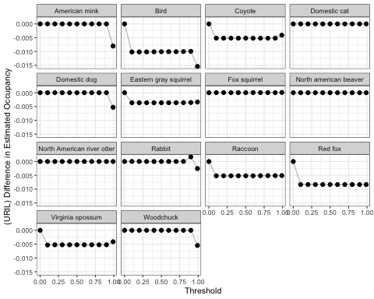
ggsave(paste0(filepath, "Threshold_Occupancy.jpg"), height=5, width=6, units="in", dpi=600)
ggplot()+
geom_line(data=subset(summary_df_t,
parameter == "rho - (Intercept)" & Model == "m1"),
aes(x = Threshold, y=Diff_Est_tr), alpha = 0.25)+
geom_point(data=subset(summary_df_t,
parameter == "rho - (Intercept)" & Model == "m1"),
aes(x = Threshold, y=Diff_Est_tr))+
facet_wrap(Species~.)+
ylab(paste0("(", city, ") Difference in Estimated Detection"))+
theme_bw(base_size = 8)
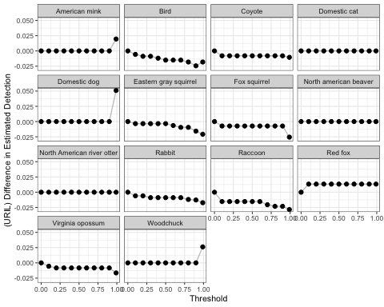
ggsave(paste0(filepath, "Threshold_Detection.jpg"), height=5, width=6, units="in", dpi=600)
ggplot()+
geom_line(data=subset(summary_df_t,
Model == "m2"),
aes(x = Threshold, y=Diff_Est_tr, color=Species), alpha = 0.25)+
geom_point(data=subset(summary_df_t,
Model == "m2"),
aes(x = Threshold, y=Diff_Est_tr, color=Species), alpha = 0.25)+
facet_grid(parameter~., scales="free_y")+
ylab(paste0("(", city, ") Difference in Estimated Detection"))+
theme_bw(base_size = 8)
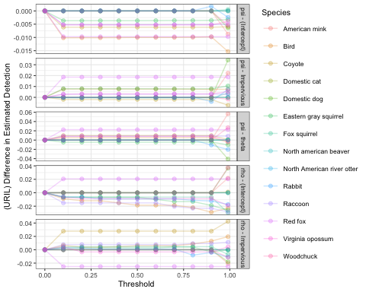
ggsave(paste0(filepath, "Threshold_Parameters_Color.jpg"), height=5, width=4, units="in", dpi=600)
ggplot()+
geom_line(data=subset(summary_df_t,
Model == "m2"),
aes(x = Threshold, y=Diff_Est_tr), alpha = 0.25)+
geom_point(data=subset(summary_df_t,
Model == "m2"),
aes(x = Threshold, y=Diff_Est_tr), alpha = 0.75)+
facet_grid(Species~parameter)+
ylab(paste0("(", city, ") Difference in Estimated Detection"))+
theme_bw(base_size = 8)
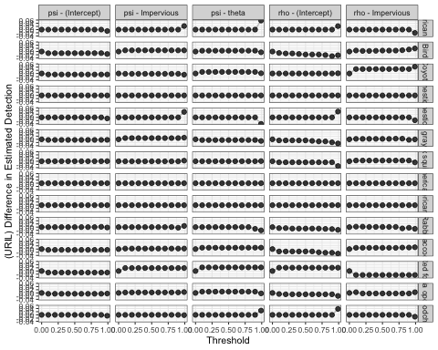
ggsave(paste0(filepath, "Threshold_Parameters.jpg"), height=12, width=10, units="in", dpi=600)

