Problem 1

1. [1.8,0,0.8]
2. Mean = 1.74 var = 3.221
3. 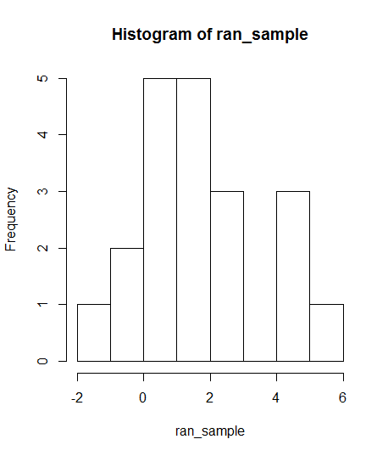
4. See r script
5. See r script

Problem 2

1. See r script
2. 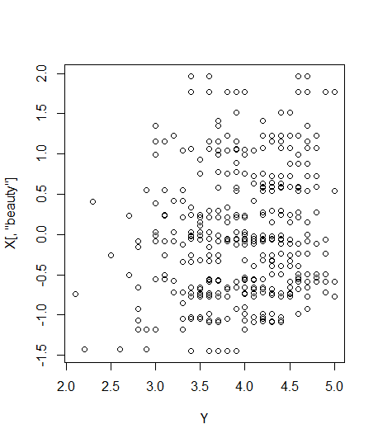

Beta hat = [3.98,.134,.0029] for residual see r script. Mean = -4.817, var = .297

1. Var(y) = .308 R^2 = 1.02
2. Beta_beauty = .134 this means rating of teachers increases slightly if they are better looking
3. See attached r script