A+ Computer Science Lists – Dodging Enemies Lab Lab Value - 100

Lab Goal : This lab was designed to teach you how to use lists, loops and ifs.
Files Needed ::
dodgeRunner.py
enemies.py

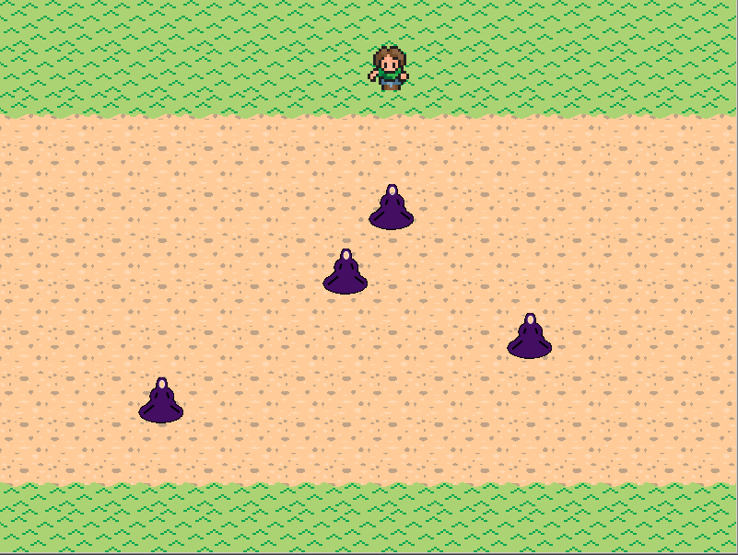
Lab Description : Write a program that uses lists to keep track of enemies on the screen.

Part One :: In the drawAndCollision() method of enemies.py, go through the list of enemies. For each enemy, call it’s move() and draw() methods.

Before and after you call the move() and draw() methods, get each object’s rectangle (use the getRec() method) and add it to the list changedrecs. The changedrecs list keeps track of what areas of the screen have changed and need to be updated.


Part Two :: In the drawAndCollision() method, use the guy parameter’s collide() method to determine if guy has hit any of the enemies. Return True if any enemies collide with guy.

Part Three :: In the drawAndCollision() method, if an enemy has gone off the screen, remove it from the list of enemies. HINT: the enemy method getRect() returns the tuple (x, y, width, height)

Part Four :: In the addEnemy() method, create a new enemy and add it to the list of enemies. The enemy constructor is enemy(x,y,speed)

In the numEnemies() method, return the length of the list of enemies.

