A+ Computer Science Python Basics – Moving Lab Lab Value - 100

Lab Goal : This lab was designed to teach you how to use classes and methods.
Files Needed ::
labRunner.py
person.py
dude.gif

Lab Description : Write a class that creates an object and moves it around the screen

Part One :: In person.py, create a class called person.

Create a constructor with the parameters newX and newY (don’t forget to automatically add a self parameter to all class methods).

You will use the newX and newY parameters to set the person’s x and y. Then load dude.gif into self.img

Create a draw method with the parameter window. Use the surface method blit to draw self.img at position (self.x, self.y).

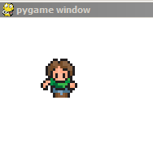

Part Two :: Replace the pass in the moveLeft, moveRight, moveUp, and moveDown methods. In each method adjust self.x and self.y to make the person move in the correct direction.

NOTE: The pass keyword allow you to test Part 1 without errors.

