A+ Computer Science Ifs – Collide Lab Lab Value - 100

Lab Goal : This lab was designed to teach you how to use if-elses.

Lab Description : Write a program that will prevent your person from walking through another object.
Files Needed ::
wallRunner.py
person.py
wall.py
Part One :: In wall.py, fill in the methods. It will use wall.gif for self.img.
Wall variables:
x
y
img

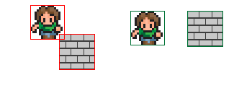
Part Two :: Fill in the collide method to your person. It will return True if there is a collision and False if there is not.

You will use bounding box collision detection to check if your person has run into something. This algorithm sees objects as rectangles and determines if the rectangles of two objects intersect.

Use the getRec() method of person and wall to get the width and height of both the person and the wall as well as the wall’s x and y position

otherRec = other.getRec()
otherX = otherRec[0]
otherY = otherRec[1]
otherWidth = otherRec[2]
otherHeight = otherRec[3]

Collision Detection Algorithm Help:

if person is right of the object
person and object do not intersect

elif person is left of the object
person and object do not intersect

elif person is above the object
person and object do not intersect

elif person is below the object
person and object do not intersect

else
person and object do intersect

