A+ Computer Science Loops – Squares and Circles Lab Lab Value - 100

Lab Goal : This lab was designed to teach you how to use while loops and variables to draw multiple squares and circles

Lab Description : Write a program that draws shrinking squares and circles.

Part One :: In the drawSquares method in squares.py, use a loop to draw a series of squares that shrink. The first square is at (0,0) and has a height and width of 100 pixels. Each square is separated by 10 pixels and is 10 pixels smaller than the previous square.
Files Needed ::
squaresAndCircles.py
squareRunner.py

The code for drawing a rectangle is below – remember r,g, and b represent the color and must be a number 0-225.

pygame.draw.rect(window, (r,g,b), (x,y,width,height))

Part One Output :

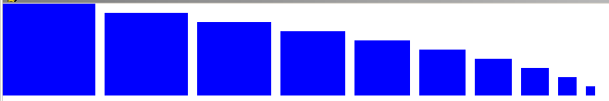

Part Two :: In the drawCircles method in squares.py, use a loop to draw a series of circles that shrink. The first circle is at (300,300) and has a radius of 100 pixels. To show that there are multiple circles store green as a variable equal to 255 and subtract 25 from it every time the circle shrinks

The code for drawing a circle is below.

pygame.draw.circle(window, (r,g,b), (x,y), radius)

Part Two Output :

