|  |
| --- |
|  |
| JavaScript Cheat Sheet |
| P_Bulles |

|  |
| --- |
| EthanAymeric Schafstall  07/11/2023 |

Table des matières

# Browser

## Messages

Messages are little pop up windows that apear in the internet browser.

### Alert

An alert message is just a box containing some info.

Message Example:

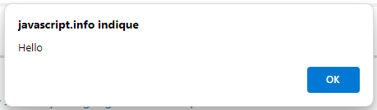

Code Example :

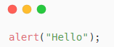

### Prompt

A prompt is a message, where the user is expected to input a value.

Message Example :

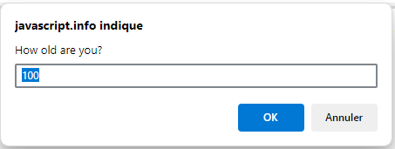

Code Example :

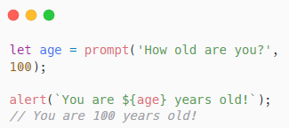

### Confirm

A confirm is a message where the user is given two option buttons to click on.

Message Example :

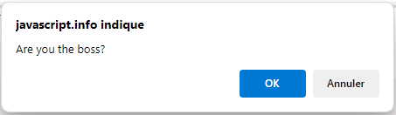

Code Example :

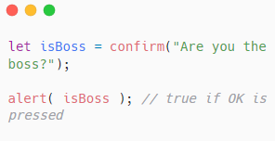

# Classes

## Access Modifier : Private

To make a class variable/function **private** a hashtag(#) is needed in front.

Example :

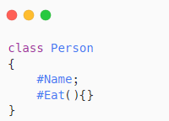

## Constructors

Constructors using the keyword constructor.

Example :

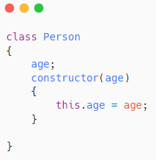

## Import/Export

To use a class you have to import it to the current .js file. To do that there are two methods.

### Import

With import you have write the import line of code at the top of the file

Example :

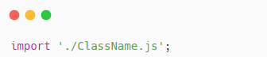

### Export

To export you have to write export infront oft he class and then when using the class VScode with automaticly add an import to the file.

Example:

